Monday 25.1.2016 – Marmolejo
On Monday we visited the town hall in Marmolejo. There we met the mayor, who introduced the history of Marmolejo. We got some leaflets and nice bracelets from him.
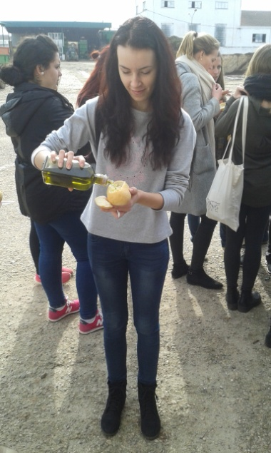
Then the teachers separated us into several groups. Each group got instructions according to which we were to find certain places in the town. There were different places and tasks for us to complete, for example to sing a song in our native language or do a specific photo. After completing all these tasks we came to target place and it was an olive oil factory. We visited the factory and saw how olive oil is produced. After the visit we tasted fresh olive oil with bread.

Viktoria Lebedová

Tuesday 26.1.2016 – Granada

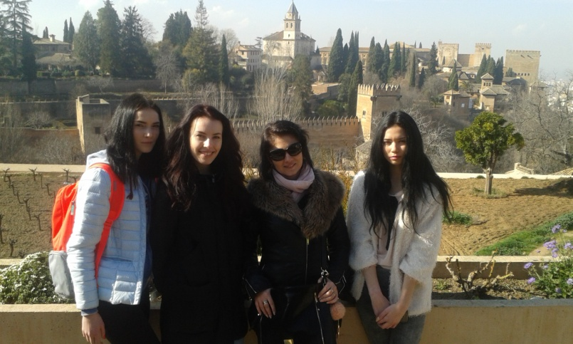
On Tuesday morning we set off to a beautiful city of Granada. I didn´t know that it is called a city of contrasts. It is because of its climate – hot in summer, but cold , sometimes with snow, in winter, due to Sierra Nevada. In this province there is also a tropical coast in the south.
The most famous historical sight is La Alhambra, built by Arabic rulers. Since 1984 it has been a part of The World Heritage. The interior has more parts – La Alcazaba – a military residence, Los palacios – the palaces and La medina –Moslim area, and El Generalife – gardens which must be beautiful in summer.
All the sights really impressed me. I would like to come back in summer and admire all these places in hot weather and then cool down in the sea.
Our journey finished late afternoon. Though we were tired, it was worth seeing.

Nikola Fedoriková

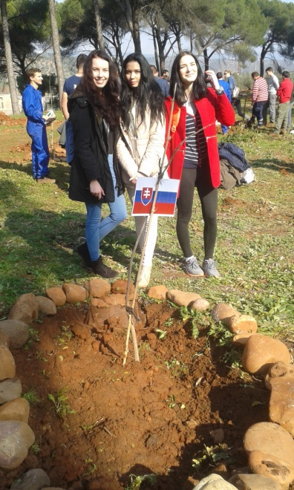
Wednesday 27.1.2016 – Marmolejo
On Wednesday morning we went to school. We did some etwinning exercises about our countries and the founding fathers of The European Union. We made presentations about their lives and assets for European Union. During the breaks we walked around the school where we could see a lot of domestic animals and agricultural machines.
After the school we went to plant a tree in the outskirts of Marmolejo. Each country planted their own tree. While planting the tree, we were told to wish for something and that this would come true in a year´s time. Well, we did and we hope it will come true.
After this activity we went home to families and we enjoyed the free time. In the evening we had a common dinner with all the Spanish families and foreign students.

Nikola Fedoriková

Thursday 28.1.2016 - Cordoba
On Thursday morning we travelled by bus to the city of Cordoba. I haven´t visited it before, so I was surprised by its historical sights. We visited The Cathedral. It was exciting to see how different religions could exist in one place. I liked Arabic decorations and I was fascinated by the size of the Cathedral
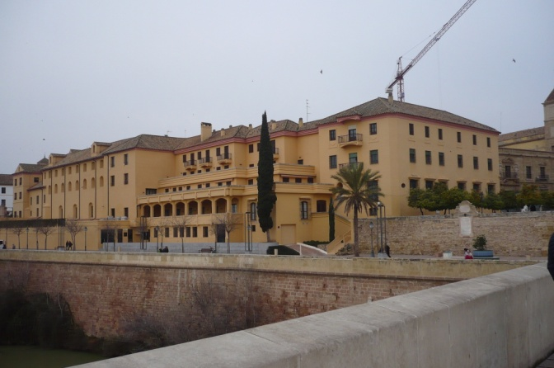
Later we were walking in the streets of the city and we went up the hill to have a beautiful view of the city.
We returned at about seven P.M. back to Marmolejo. We spent the evening together with Spanish families.

Diana Macková

Friday 29.1.2016 – Marmolejo
Friday was the last day for our Slovak group in Marmolejo. We spent it at school. At first we watched a short educational film about the importance of education as a basic right for everyone. After watching this film we made some activities in etwinning. After the short break the teachers made some presentations about migration in European Union. They explained to us the importance of cultural migration as the means of society development.
After these activities we had a flamenco lesson. Each student could try the dance and the whole workshop had a pleasant atmosphere. It was nice and funny activity. After the dance while listening to Spanish music we had a lunch of traditional Spanish food. It was prepared by our families.
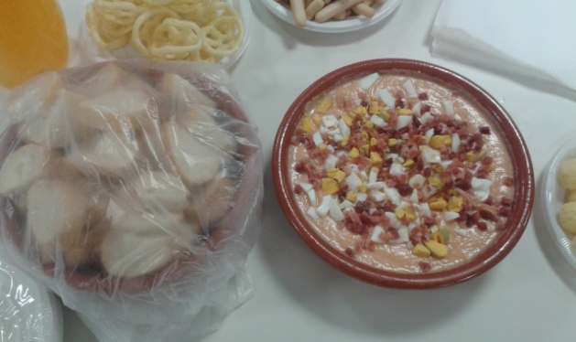
At last we made some videos, where we talked about us, the students and we made a dialogue as a language tool for other students. Then we said goodbye to our families and friends and set off for journey home.

Viktoria Lebedová

