EXPERIMENT PLAN

MAKING GRAVITY and FORCE EXPERIMENT

COUNTRY:Turkey

SCHOOL : Erzurumlu İbrahim Hakkı Ortaokulu

EXPERIMENT NUMBER: 2

NAME OF EXPERIMENT: Gravity direction

AIM OF EXPERIMENT : To have knowledge about the gravitational force by experimenting

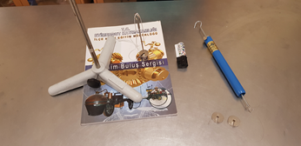
MATERIALS: Three Legs,Support Bar,Connector With Hook, Nylon Rope, lighter

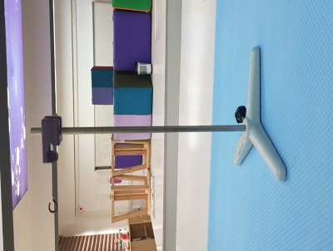
MAKING EXPERIMENT:
1-Install the device in the picture.

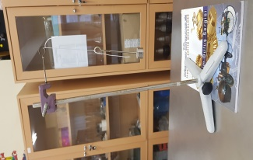
2- Hang the hooked coupling piece to the other hooked coupling piece with a rope and hang the 50gr mass.

3- Pay attention that the rope is taut and vertical. Consider the reason for this.
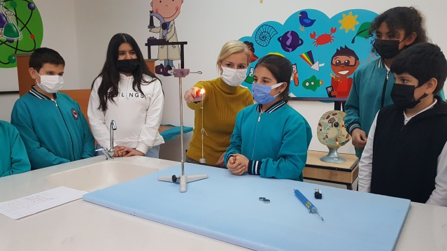
4- Light the rope with the flame of a match.

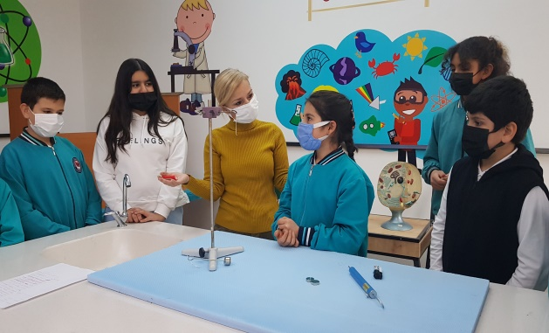
5- Has the hooked fastener fallen to the ground?

RESULT:
The reason why the rope in our experiment, with a weight hanging on the end, is taut and vertical is the force of gravity. The direction of the rope is the direction of the gravitational force. The gravitational force pulls all objects towards the center of the earth.
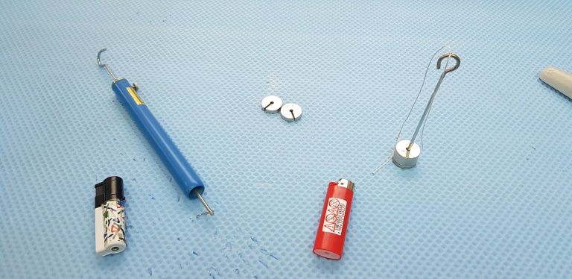
PHOTOS:

