EXPERIMENT PLAN

MAKING GRAVITY and FORCE EXPERIMENT

COUNTRY: Turkey

SCHOOL :Erzurumlu İbrahim Hakkı Ortaokulu

EXPERIMENT NUMBER: 1

NAME OF EXPERIMENT: Gravity and force relation

AIM OF EXPERIMENT :
To show by experiment that as the mass of the substance increases, the gravitational force acting on the mass increases in direct proportion.

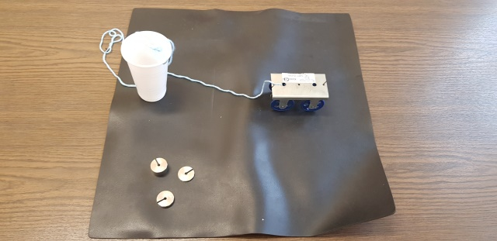
MATERIALS:
solid rope
Car
pet cup
10-20-50 grams

MAKING EXPERIMENT:
1- Let's connect the pet glass and the car with a rope as seen in the picture.
2-Let's release the pet glass so that it hangs from the end of the table.
3- After keeping the car and the glass in balance, let's put 10gr, 20gr and 50gr pet glasses in order.
4-Did the car accelerate as the masses in the pet glass increased? Why is that?
5-Discuss the results.
RESULT:
As we saw in our experiment, when we left 10 gr in the pet glass, our car moved slowly, faster at 20 gr and very fast at 50 gr.
Since the gravitational force is towards the center of the earth; As the mass increased, it pulled our car with more force. As a result, our car moved faster.
We observed that the gravitational force is directly proportional to the mass.

PHOTOS:
