The time before Christmas

The customs before Christmas started on St. Martin (November 11), when he used to arrive on a white horse. It was a sign that the autumn was definitely over. On Sunday people were eating “Martin” geese. The children were looking forward to the first snow, the farmers finished working outside, housewives began to prepare for Christmas. Whole families met when they were crushing feathers, spinning, embroidering, peeling corn, smashing nuts. They enjoyed their work by talking, singing and often using magical practices.

https://bratislava.dnes24.sk/kym-bol-naozaj-martin-na-bielom-koni-a-co-sa-dialo-v-kudelnej-izbicke-255276

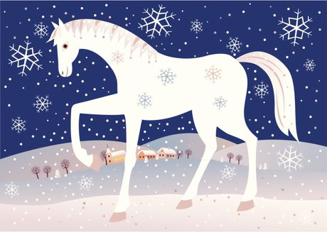
https://www.rodinka.sk/vazne-veci/tradicie/martin-na-bielom-koni-11-november/

In ancient times people believed that on certain days witches come to people. These days they were also called "withes days". They included: St. Catherine (25 November), St. Andrew(30 November), St. Barbara (4 December), St. Lucy (13 December) and St. Thomas (21 December).
For example, on Catherine (St. Catherine - patron of millers, young girls, nurses, philosophers ) the man should enter the house first, because the woman could bring damage for the next year. On this day it was not allowed to work with everything that had wheels. The girls put cherry into a vase and they poured it by water from the brook. If cherry flourishes on Christmas Eve, the girl could look forward to a wedding.
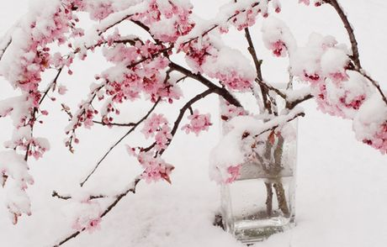
https://www.rodinka.sk/vazne-veci/tradicie/barbora-taha-sane-do-dvora-4-december/
In the life of farmers, it was the day when the herding of cattle was over and the shearing of sheep began. Also, the last dancing was held, there was a kind of "women's right" where women chose dancers .
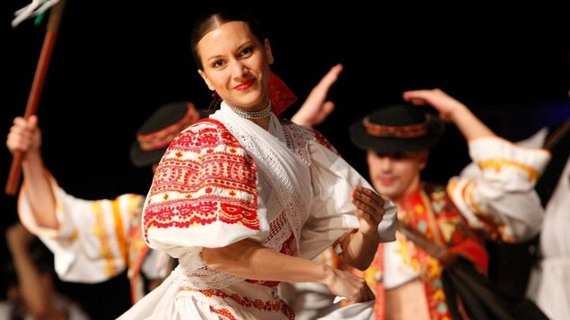
http://www.kultura.kezmarok.sk/klient-285/kino-76/stranka-1587/film-274291

The girls were shaking fences on Saint Andrew and they were telling: “I am shaking fence, Saint Andrew, please, let me know whom I will stand at the altar."

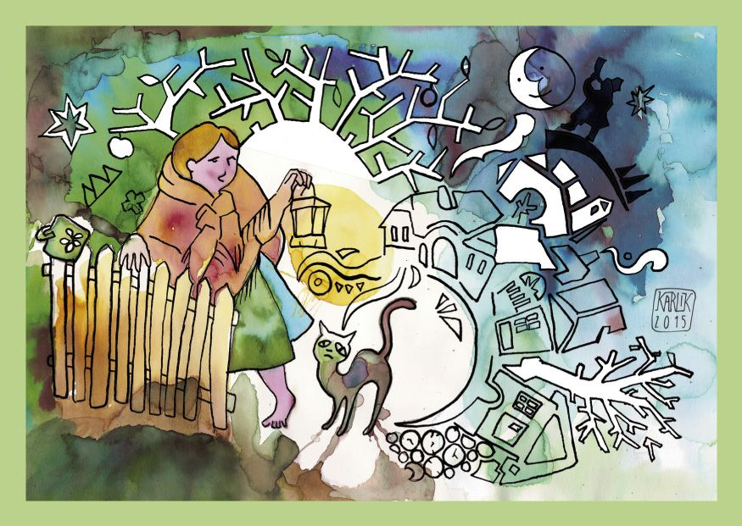
https://www.pinterest.fr/pin/544161567456436871/

In addition, molten lead has been pouring and depending on the shape that has been formed the girl could know what profession her husband would have. St. Andrew was considered a patron of the brides

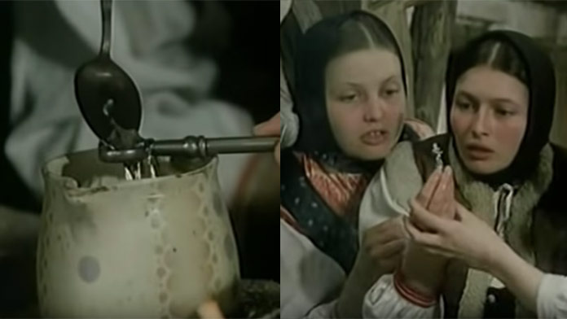
https://peepl.sk/ondrej-bol-plny-zvykov-a-tradicii-tretia-mohla-dokonca-predpovedat-smrt/

Advent comes from the Latin word "adventus", ie arrival or expectation. In Christian terminology it is a time of reflection for every person. . During this time people were expecting of Jesus Christ. Nice custom was going to "roráty" – it means everyday St. mass to honour of the Virgin Mary. They started around 6 am. Children liked lightening an Advent candle of different shapes.

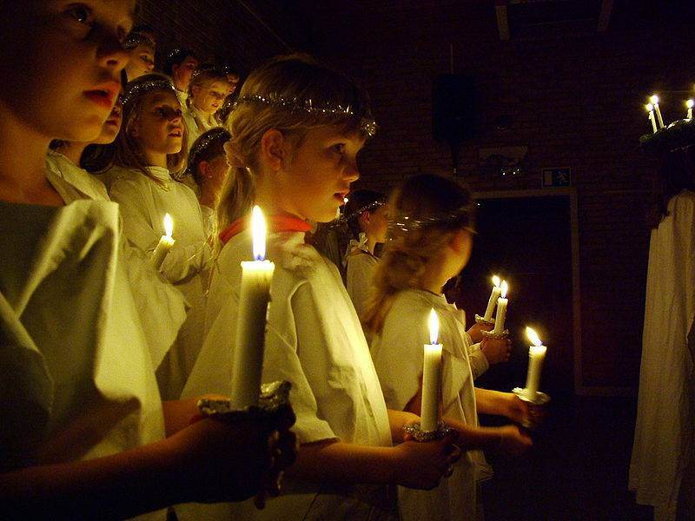
https://www.cirkev.cz/archiv/111130-co-jsou-to-roraty

The "Advent wreath with four candles" was held to the churches. Advent was also called a small fast. Everywhere was silent, the music and noisy behaviour stopped and there was a kind of sacred silence.

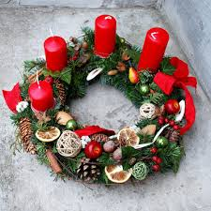
https://www.sashe.sk/DEKOART/detail/velky-prirodny-adventny-veniec

St. Barbara was the festival on December 4. The girls were completely covered with a white sheet and their face covered with a towel. They walked in with a goose feather around the houses, where they symbolically swung saucers and mugs hung on the walls. The future bride could get into the house of her future husband.

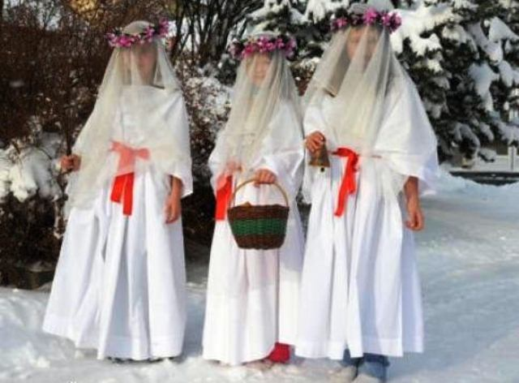
http://stastny-usmev.cz/vanocni-tradice-barborky/

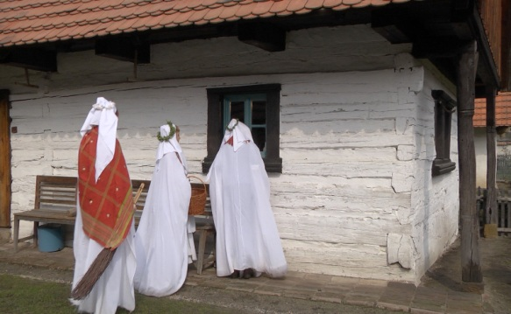
https://www.ceskatelevize.cz/porady/10519120758-nase-tradice/212562260400002-svata-barbora-a-svata-lucie/

St. Nicholas, December 6, was very special day. Boys were dressed like Saint Nicholas, angel and devil and they were walking from the house to house. The children sang songs and tell some short poems. St. Nicholas gave them sweets. The night before children put their boots on the windows. The next morning there was a package with prunes, apples, nuts, and some sweet candy. The children thought were that St. Nicholas had given it to them.

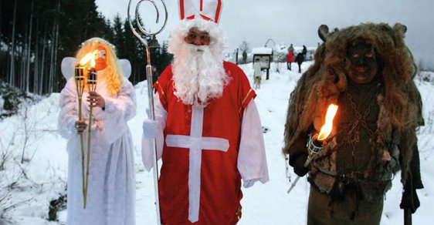
https://slovenske-zvyky.webnode.sk/kalendar-akcii/zima/na-mikulasa/

Several customs are associated with the name Lucy, December 13. She was considered to be the main witch and people protected themselves in different way. They protected cattle by herbs and putting straws in the door.
The girls walked around the houses dressed in white clothes and their faces were painted with flour, so t no one could recognize them. They had a bucket in one hand and a whitening house with brush.
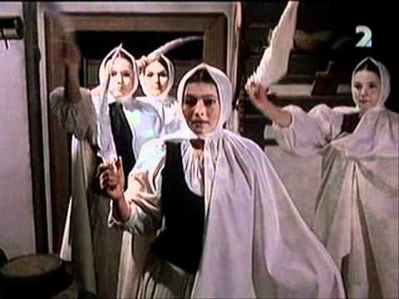
https://www.bystricoviny.sk/titulka/tradicne-zvyky-sviatok-svatej-lucie/

People used to make “Lucy table". It was made from Lucy to Christmas. The owner brought it to the church and he recognized all witches. Then he quickly rushed home from the church.

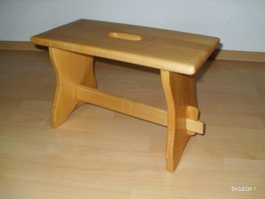
https://eslovaquianews.wordpress.com/2012/12/13/el-13-de-diciembre-costumbres-del-dia-de-santa-lucia/

On St. Thomas, December 21, people wished to each other happiness, health, good harvest, compassion, affection, love. On the last day before Christmas, little schoolboys were distributing Christmas wafers around the houses.
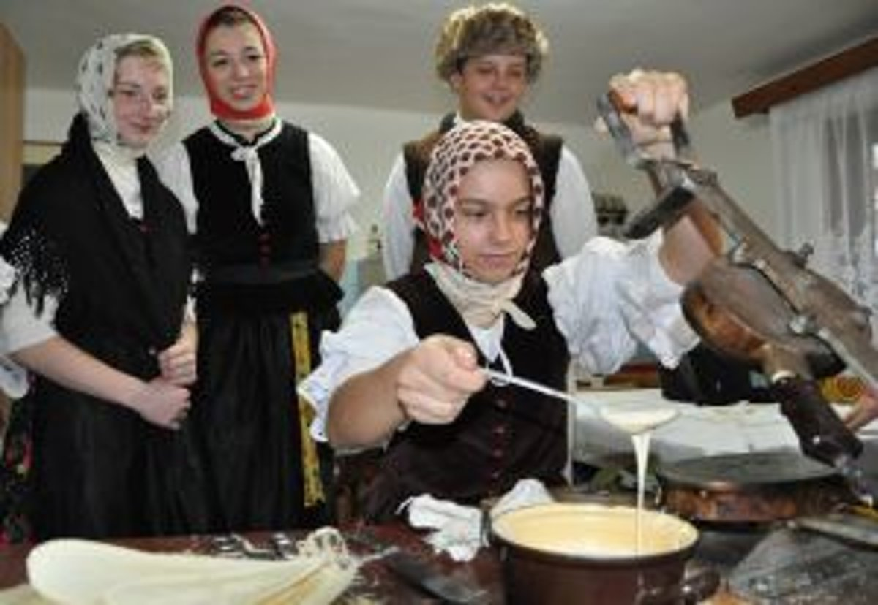
https://slovenske-zvyky.webnode.sk/rocne-zvyky-a-tradicie/

All this time before Christmas people lived peacefully and they were preparing to the Christmas Eve.

