SUMMER FESTIVALS IN TURKEY
MODEF INEGÖL FURNITURE FAIR
The wood industry is developing rapidly in the Bursa-Inegöl area,the third most important furniture production region,which is surrounded by forest areas.
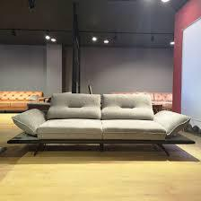
source of picture:tr.pinterst.com
The furniture industry of the Inegöl area is small sized but has great potential to improve itself.

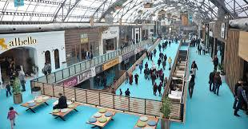
source of picture: furniturenews.net
So, Inegöl Modef Furniture Fair is organized twice a year.But this year it was postponed due to covid restrictions and it will be held in summer months this year.

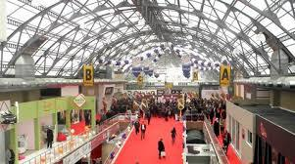
source of picture:yapi.com.tr
It is an international exibition industry.Modef is an international platform for furniture and home decor industries.It features an exhibit of all kinds of modern, classic avantgrade,country style home furniture and much more.The leading turking furniture manufacturers are all under one roof.

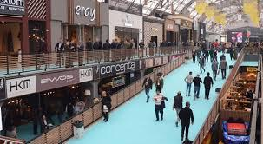
source of picture:m.türkiyegazetesi.com.tr
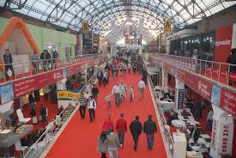
source of picture:sehirmedya.com

