SAINT NICHOLAS DAY
Saint Nicholas was a Christian bishop who helped the needy. After his death, the legend of his gift-giving grew. Saint Nicholas transformed into the legendary character called Santa Claus, who brings Christmas presents to children around the world.
In Slovakia Saint Nicholas Day – 6. December has been associated with a belief in wealth. Merchants liked to close their deals that day. Saint Nicholas was considered as a patron of a happy marriage, so girls were praying to give them a good groom.
The most spread habit is giving presents to all children . During the night before this holiday, a man with a white beard visits children and gives them presents . If children were naughty and undisciplined , he can also punish them but very kindly.
Saint Nicholas used to have a large parade consisting of masked figures, later the parade was reduced to an angel and devil. Saint Nicholas wore the traditional clothing of the bishop, consisting of a coat with a fur hood, a tall paper cap on his head and a crutch in his hand. The angel wore white shirts and the devil wore a long-haired fur coat girded with a chain and a bell on it. The children had to kneel down before them and pray. After praying the Saint Nicholas gave them sweets. 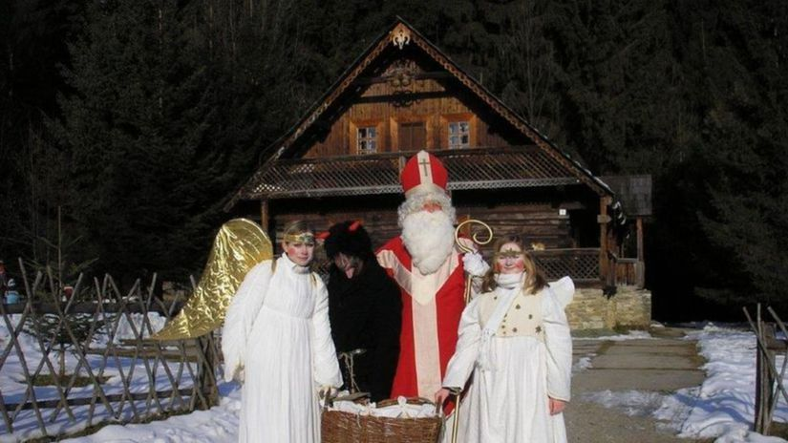

In the past Saint Nicholas markets were held in Slovakia. Craftsmen were selling various baked goods and small toys typical for that time. The toys were made of dried fruit, clay or pieces of wood. The tradition of St. Nicholas festival has been applied for centuries to nowadays and it very popular.
Our students like this holiday very much and every year they prepared some small presents for their friends and teachers.

