MIDSUMMER’S EVE
SAINT JOHN’S CAKE (“Coca de Sant Joan”)
INGREDIENTS:
Custard cream
- One egg
- 250 ml whole milk
- 80 gr sugar
- 20 g cornstarch
- ½ teaspoon vanilla extract

Coca de Sant Joan

- 500 gr strength flour
- 120 ml milk
- 10 gr yeast
- 10 gr salt
- 80 gr sugar
- Three eggs
- 85 gr butter

Garniture

- 50 g pine nuts
- Some cherries in light syrup

ELABORATION
Coca mass
1.We prepare the coca mass. In a bowl, we put all the ingredients except the butter. We knead by hand or with a robot, and we let stand 10 minutes.
2.We add the butter, kneading until absorbed. We make a ball with it, put it in a greased container, cover and let it double de volume.
3.We put the pine nuts to soak in cold water.
4.When the dough has fermented, we pass it to the counter, crushing it with our hands, we let it rest for 10 minutes.
5.We stretch it with a roller and we let it relax once in a while.
6.We stretch the dough until it is 1 cm thick, we put it on the baking sheet and we make some cuts.
7.On top of the cuts we put the pastry cream.
8.We take the pine nuts and the cherries and we spread them over the “coca” and cover it and let it double de volume.
9.We preheat the oven to 190 ºC (without air), we introduce the “coca” in the oven and leave it for 30-35 minutes.
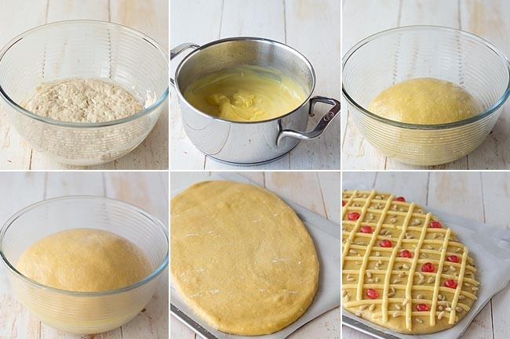
Photo: https://www.directoalpaladar.com/postres/receta-de-coca-de-san-juan
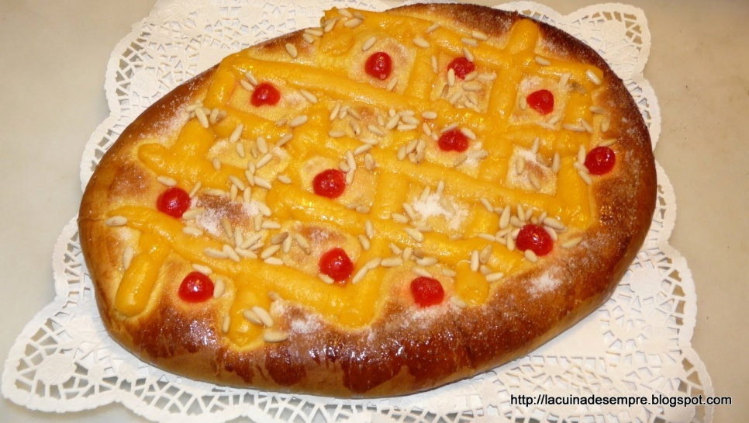
Photo: http://lacuinadesempre.blogspot.com/2011/01/coca-de-crema-de-sant-joan.html

Judit Gascón
Karima Clemente
David Valverde
English, GES-2 (morning group)

