Typical Christmas Traditions in Slovakia

The most beautiful habits are held from Christmas to New Year. They are the religious holidays of the Birth of Jesus Christ and the celebration of winter solstice.
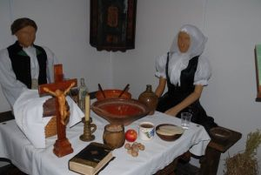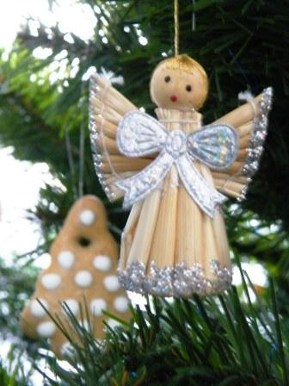

https://slovenske-zvyky.webnode.sk/kalendar-akcii/zima/stedry-den/

Christmas Eve - 24. 12.

During Christmas Eve on December 24, people did not eat to the evening and they believed in magic relating to health, achievements, future crops, and personal life. The strange woman was not allowed to enter the house, because it would mean misfortune. Fasting ended when the first star came out in the sky.
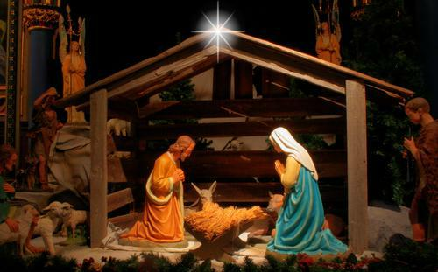
https://slovenske-zvyky.webnode.sk/kalendar-akcii/zima/stedry-den/
Christmas pastries had the magical power. Ceremony pastries had to be ready before sunrise and housewives gave pastries as a gift for carol singers. The housewives rubbed their hands on the fruit trees to give a lot of fruit next year. They often threw bread to chicken to lay eggs well.

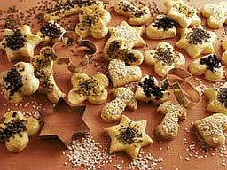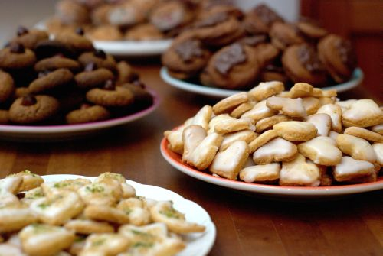
https://slovenske-zvyky.webnode.sk/kalendar-akcii/zima/stedry-den/

On Christmas Eve everybody could eat a lot. Leaving the table with a little eating meant that the family will have a bad year, so Christmas meals were specially respected. Nothing could be thrown out of the Christmas Eve table.
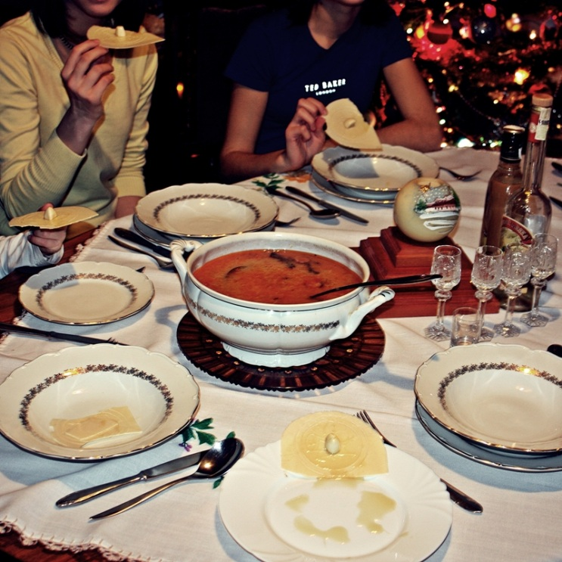
https://slovenske-zvyky.webnode.sk/kalendar-akcii/zima/stedry-den/
During the day people eat a little food, especially vegetarian meals. In some areas it was custom to eat only milk and cakes. Strict fasting was often required until the first star appeared in the sky. In the 14th century a table cloth was put on the table. It was believed that the dead ancestors could share the Christmas Eve with the living people , so it was the seat prepared for them. During Christmas Eve, no one was allowed to sit in front of the door to the street, because it meant that someone of the family could die. The traditional dishes were homemade bread and cooked pasta, boiled peas, lentils, cabbage soup with mushrooms, beet and root vegetable soup. The porridge was very tasty , too. Fish was characteristic especially for the rich urban population.
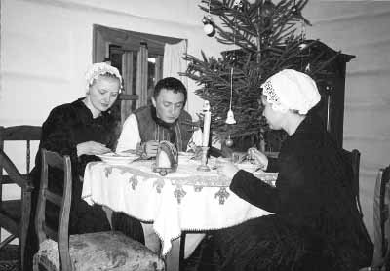
https://slovenske-zvyky.webnode.sk/kalendar-akcii/zima/stedry-den/

An iron object was put under the Christmas table . It was believed that who puts his foot on it during the evening, he will be happy next year. All the legs of the table were wrapped with a thick chain to ensure family cohesion next year. In many places in Slovakia they put straw under the table to ensure a good crop the following year.
After dinner people cut an apple and predicted their fate according to the shape of the core. If the apple core was star-shaped, happiness and wealth were expected in the family, and if it was cross-shaped, illness and even death could be expected. Candles were glued to the walnut shells and sent on water in a sink . If the boat sailed far, it was supposed that some person will go abroad. Whose boat was sank, he was supposed to die.
After dinner the young people, servants and shepherds were singing Christmas songs. In Catholic families, Christmas Eve ends with a midnight mass.
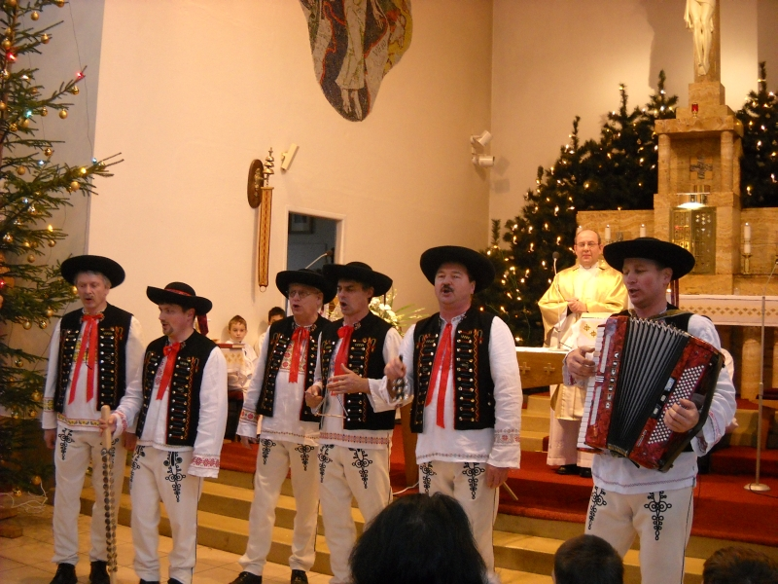
https://slovenske-zvyky.webnode.sk/kalendar-akcii/zima/stedry-den/

The Birth of Jesus Christ - 25. 12.

December 25th is the day of Christ's birth . During whole day families and friends are visiting each other.

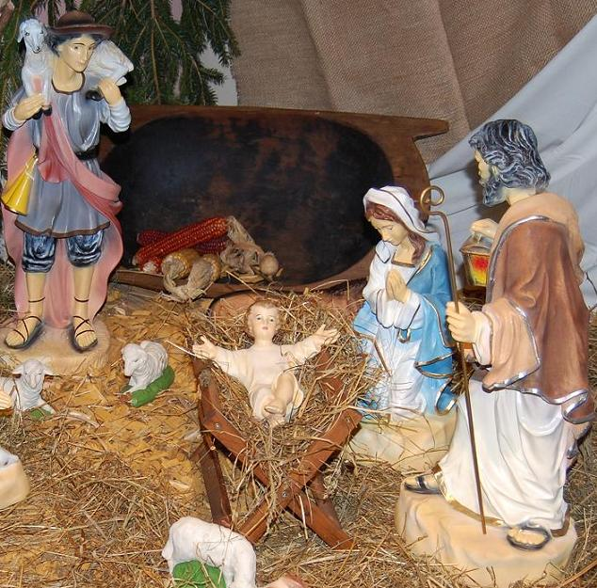
https://slovenske-zvyky.webnode.sk/kalendar-akcii/zima/stedry-den/
According to the ancient customs people were igniting the fire in every house, because fire had an extraordinary protective power. All family members stayed at home . During that day carol singers used to go from house to house and wished a good and happy future year.

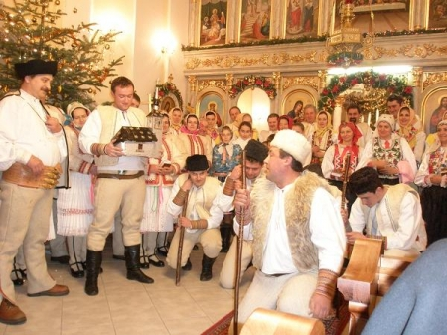

https://slovenske-zvyky.webnode.sk/kalendar-akcii/zima/stedry-den/

.
St. Stephen Day – 26.12.
On December 26th, St. Stephen's carol singers went from house to house and people gave them some presents. The atmosphere in families and homes used to be more relaxed and cheerful. Early in the morning the young men went to wade horses. This custom was related to the fact that St. Stephen was the patron of horses. A common practice was washing in cold water to ensure health and strength next year.
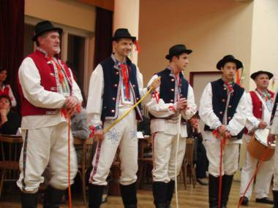
https://slovenske-zvyky.webnode.sk/kalendar-akcii/zima/stedry-den/

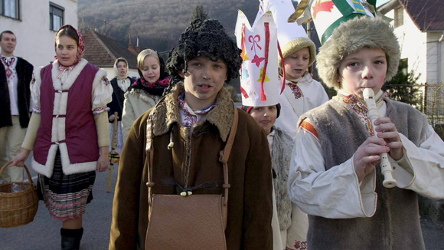

https://slovenske-zvyky.webnode.sk/kalendar-akcii/zima/stedry-den/

The evening was reserved for entertainment, dancing and singing.
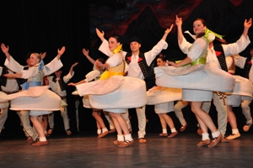
https://slovenske-zvyky.webnode.sk/kalendar-akcii/zima/stedry-den/

ac tu: https://slovenske-zvyky.webnode.sk/kalendar-akcii/zima/na-stefana/
Viac tu: https://slovenske-zvyky.webnode.sk/kalendar-akcii/zima/bozie-narodenie/
New Year's Eve -Dec 31
In the past believers met in the church in the evening to thank God for the past year . On New Year's Eve the festival dinner was prepared, meat could be eaten on this evening. There was the same tablecloth and bread on the tables as at Christmas. The atmosphere of the evening of the last day of the year was already completed by young men shooting and whipping. Ceremonial washing and dressing in clean clothes were also common.
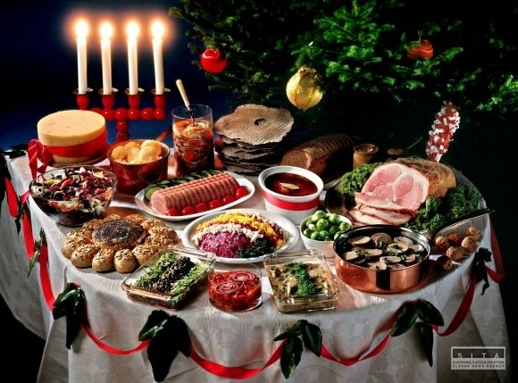
https://slovenske-zvyky.webnode.sk/kalendar-akcii/zima/stedry-den/
During the New Year's Eve, pig slaughtering were held, which were the feast of the whole family.
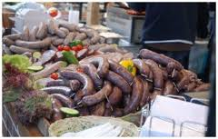
https://slovenske-zvyky.webnode.sk/kalendar-akcii/zima/stedry-den/
New Year - 1.1
.
According to our ancestors New Year's rituals were to reveal the future, protect from disasters, contribute prosperity and bring happiness. In Slovakia people believed that small pig brings happiness , so geese or pheasant and poultry could not be on the table because all the property would fly away in the New Year.
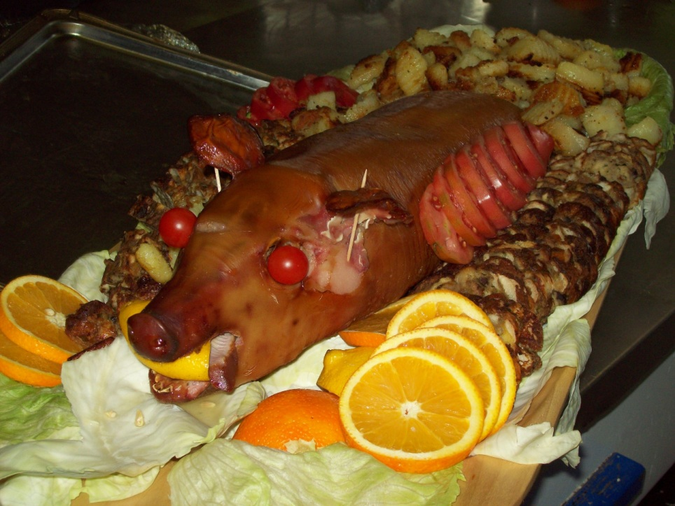
https://slovenske-zvyky.webnode.sk/kalendar-akcii/zima/stedry-den/
Lentils and poppy meals were also served as they symbolized money. The women went to church in white clothing to secure the harvest . The most natural beginning of the New Year was the winter solstice, when the dark night sold power to a light day. The New Year was about to get up early. The main New Year superstition is that this day has an impact on beginning of the year, so everyone tried to avoid disputes and trying to be in the best possible mood. It was considered a good sign if a young woman or child entered the New Year's house.

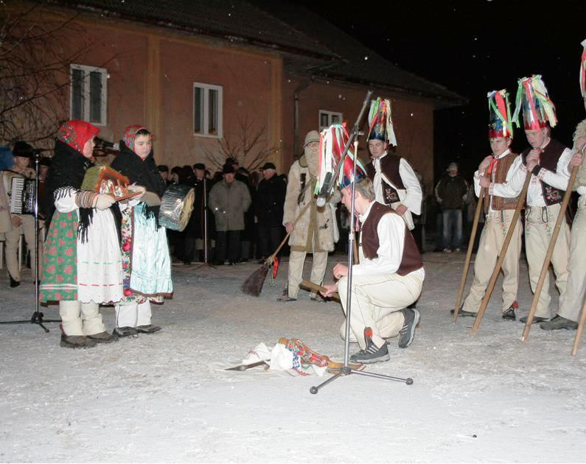

https://slovenske-zvyky.webnode.sk/kalendar-akcii/zima/stedry-den/

Three Kings - 6. 1.

Christmas season ended by that day. Small boys were dressed as the Three Kings, passing households and blessing the house by writing the first letters of the three kings on the door. They wished prosperity and happiness for all next year.

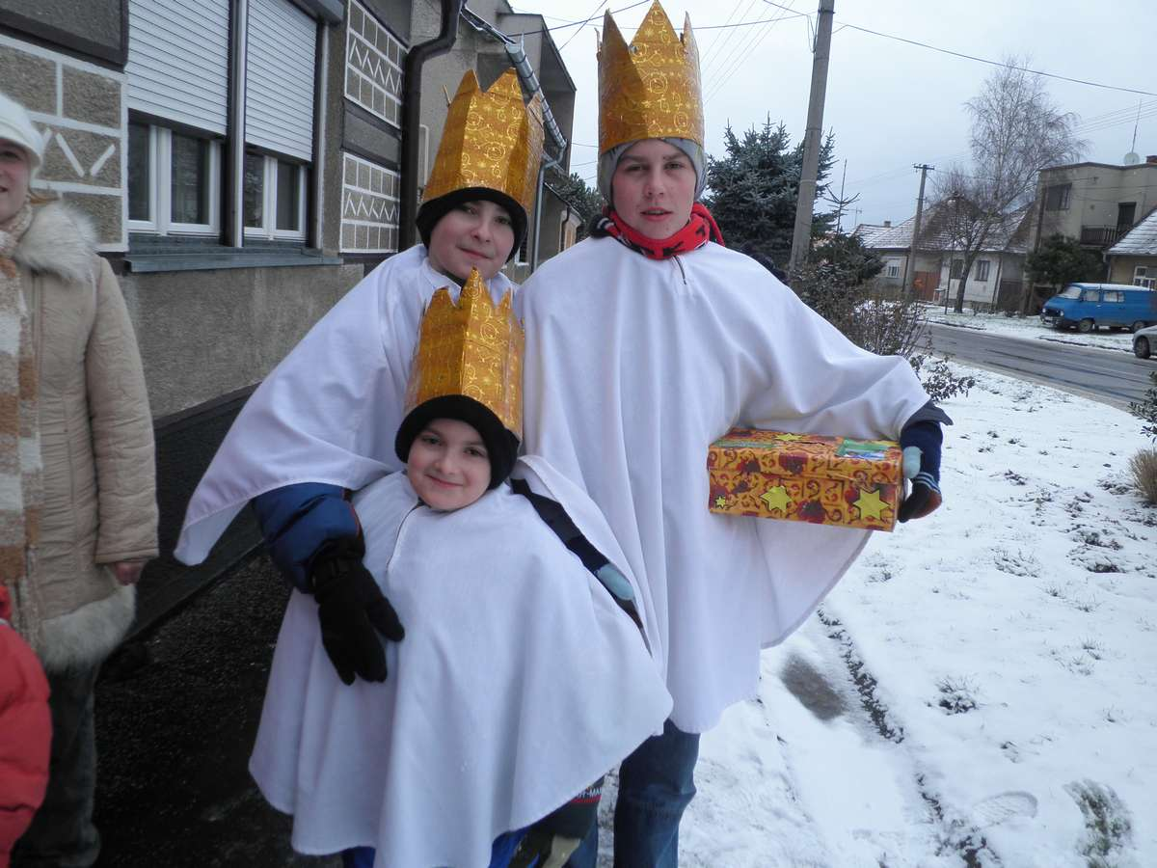

https://slovenske-zvyky.webnode.sk/kalendar-akcii/zima/stedry-den/

- Viac tu: https://slovenske-zvyky.webnode.sk/kalendar-akcii/zima/tri-krale/
Viac tu: https://slovenske-zvyky.webnode.sk/kalendar-akcii/zima/na-silvestra/

