EASTER IN SLOVAKIA
The first spring day means that everyone on Earth will have the same day as the night.
The arrival of the most beautiful season in Slovakia has always been associated with various folk traditions. One of them, which has its roots in the pre-Christian era, is the removal of Morena , a straw figure dressed in women's dresses. Morena symbolized the Slavic goddess of winter and death. Morena was worn by people in the village, set fire and threw it into the stream. They believed that in this way they would take away diseases, even death. Morena was the personification of death and its liquidation was supposed to ensure the prosperity of the whole village. The habit of saying goodbye to winter and welcoming spring was typical by singing the verse: ,, Morena, Morena! Who did you die for? "
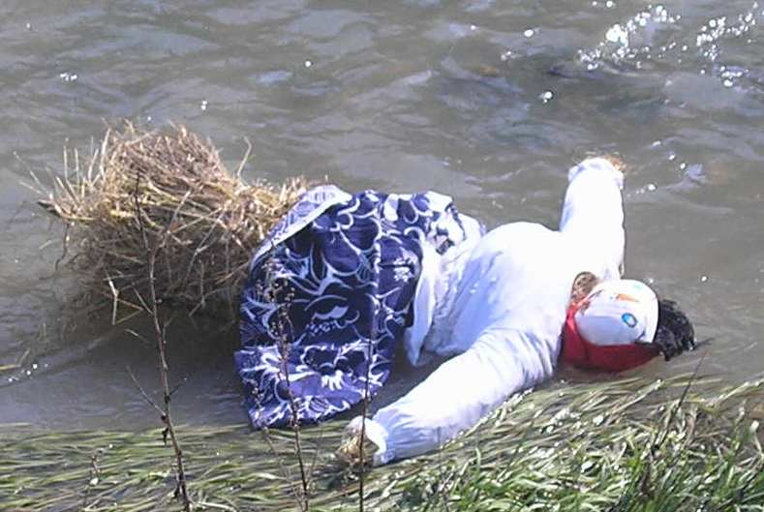
Source of picture: https://slovenske-zvyky.webnode.sk/kalendar-akcii/jar/smrtna-nedela/

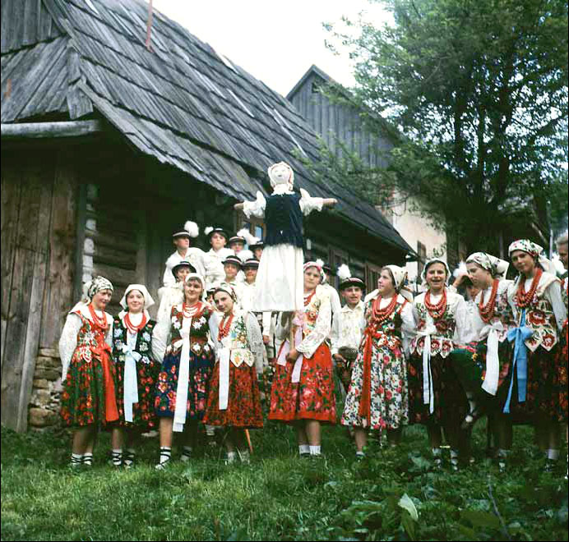
Source of picture: https://www.zilinsky-kraj.sk/kysucke-muzeum-pozyva-na-jarne-tvorive-dielne-alebo-vynasanie-moreny/
The term Easter is not constant, it changes every year. Easter started on the first Sunday after the first full moon of the month - after March 21. Easter week lasts from Palm Sunday to White Saturday, during it Christians commemorates suffering and death of Jesus Christ.
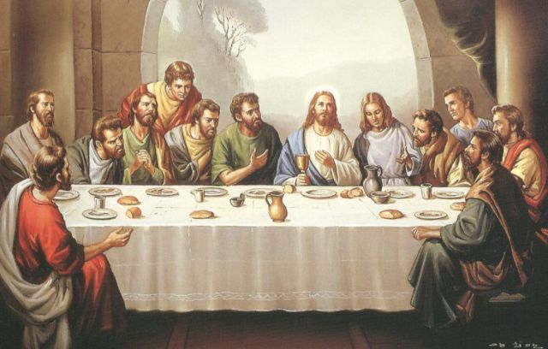
Source of picture: https://slovenske-zvyky.webnode.sk/kalendar-akcii/jar/smrtna-nedela/

PALM SUNDAY
Boys and girls from house to house, have a branch of willow and tell some verses to housewives. The children receive the Easter eggs and go to the next house or family. In fact, it was custom typical for welcoming Easter holidays, but people welcomed and celebrated the coming spring. The egg as a gift was also a symbol of the birth of a new life.
On Palm Sunday people brought willow sticks to the church and the priest sanctified them with prayers. At home they put them on the celling or behind the paintings to protect them from storms. During a thunderstorm the branches were thrown into the fire to protect people. . In Orava region they put willow branches on the first furrow and in eastern Slovakia they put them into the first potato planted. In Hont they stuck branches on the graves of their loved ones to awake the souls of their relatives.

. 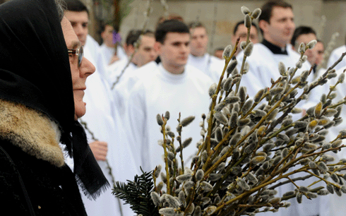
Source of picture: https://slovenske-zvyky.webnode.sk/kalendar-akcii/jar/kvetna-nedela/

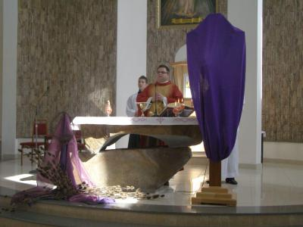
Source of picture: https://slovenske-zvyky.webnode.sk/kalendar-akcii/jar/kvetna-nedela/

GREEN THURSDAY
On Green Thursdays men, women and adolescents went to wash their faces in the stream. It started before the morning ringing. The girls believed that after washing they would be as fresh as swallows, they would not have freckles on their faces and if they washed their hair, they would grow faster. They sang: “Pure water, you wash the banks, roots, so wash me too, because I am only poor sinful creature.”
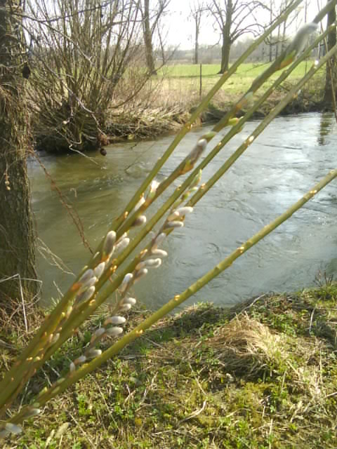
Source of picture: https://slovenske-zvyky.webnode.sk/kalendar-akcii/jar/zeleny-stvrtok/

The Easter water was buried in the foundations of the new house because life would flourish in this house. Before sunrise, the housewives had to wash all the dishes and especially the milk containers to milk the cows well. Horses were tied with red thread in their tails - protection against dying, cattle was sprinkled with eggs. People had laid eggs on the doorstep, and if a cow broke it, it meant her rapid death.

At night from Green Thursday to Good Friday witches were meeting together. People believed that their harmful activity was directed against cattle, and so they painted the doors of the stables with garlic in the evening. Just as the wounds of animals were to heal quickly, the damaged areas on the plants were also to heal quickly - that's why young trees were grafted on this day.
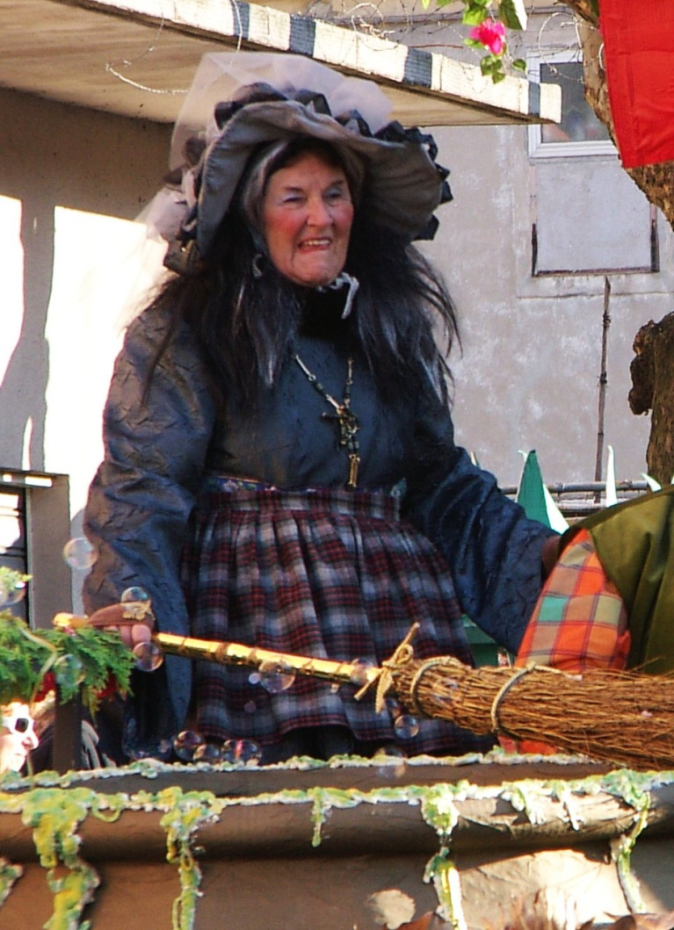
Source of picture: https://slovenske-zvyky.webnode.sk/kalendar-akcii/jar/zeleny-stvrtok/

GOOD FRIDAY

Christians commemorate the death of Jesus Christ on the cross on Good Friday. The Protestants regard it as the most important feast because the Son of God has completed the work of redemption of the world. Jesus Christ was crucified on the top of Golgotha. There is no Mass in the Roman Catholic temples on this day. In some places it does not ring, just raps from Thursday to Saturday evening. During this day meat is not eaten.

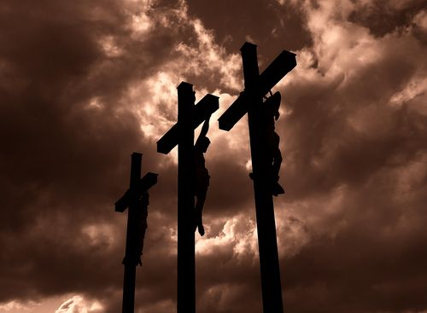
Source of picture: https://slovenske-zvyky.webnode.sk/kalendar-akcii/jar/velky-piatok/
On Good Friday, people who suffered from diseases and various ailments walked early in the morning to wash up in the stream. The water in the stream had a miraculous power and cured the wounds. According to superstition Good Friday was Sabbath for withes. It was believed that they made butter on the cross roads to take milk from the cows.
Full fasting was maintained and meals were similar to Green Thursday. Legumes and potato dumplings with poppy seeds were cooked. Smoked fish, potatoes and sauerkraut water were consumed.
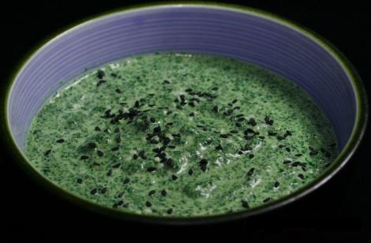
Source of picture: https://slovenske-zvyky.webnode.sk/kalendar-akcii/jar/velky-piatok/

WHITE SATURDAY
On White Saturday people were cooking and baking ceremonial meals as pork and ham. The fat of ham was put aside for healing wounds and they believed that it also protects against snake bites. In several areas, lambs were prepared for Easter, while in the southern parts of central and western Slovakia, a lamb was prepared from eggs, buns and sausages. When the housewife swept the dough, she did not clean her hands and went to stroke the trees that were supposed to give birth for the first time.
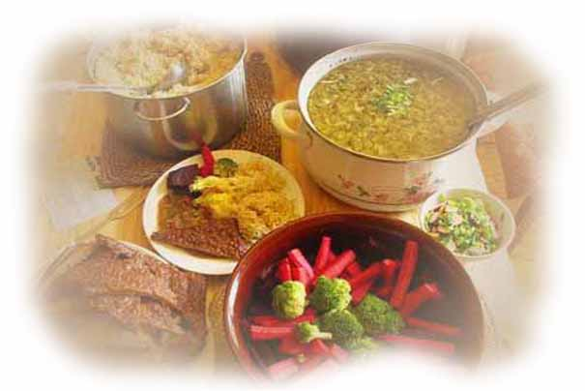
Source of picture: https://slovenske-zvyky.webnode.sk/kalendar-akcii/jar/biela-sobota/

An important role had fire which was ignited on White Saturday. A new fire lighted an eternal lamp and an Easter candle called Paškál.
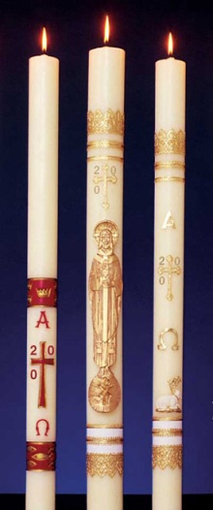
Source of picture: https://slovenske-zvyky.webnode.sk/kalendar-akcii/jar/biela-sobota/
The fire was supposed to have magic-protective power. People took carbons from this fire and circled their houses three times to protect them from flooding. They poured the ash on the winter crops to be destroyed by storms. White Saturday was considered a happy day for planting and sowing. Somewhere on this day, a round cake was rolled across the field to flourish the crop.

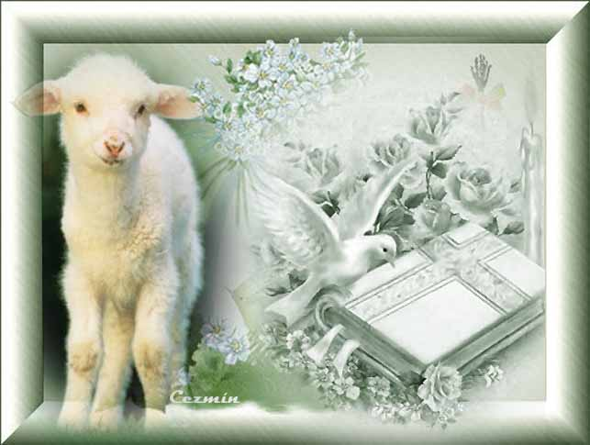
Source of picture: https://slovenske-zvyky.webnode.sk/kalendar-akcii/jar/biela-sobota/

EASTER SUNDAY
Easter Sunday was considered the best holiday of the year, so it was not allowed to cook or even cut with a knife. Therefore everything was prepared on White Saturday. Ceremonial Easter meals were prepared in a basket and were taken to Holy Mass.
Dining on that day was similar to Christmas Eve. The first course was an egg, which the farmer divided among all. The main course was poultry meat. Everyone was supposed to eat well, to be full all year long. The blessed food had to be consumed, so that nothing was wasted. Crumbs were also eaten, because if they were not eaten, the crop would be at risk. Food which was not consumed was thrown into the furnace and burned. On Easter Sunday was also fun for the youth.
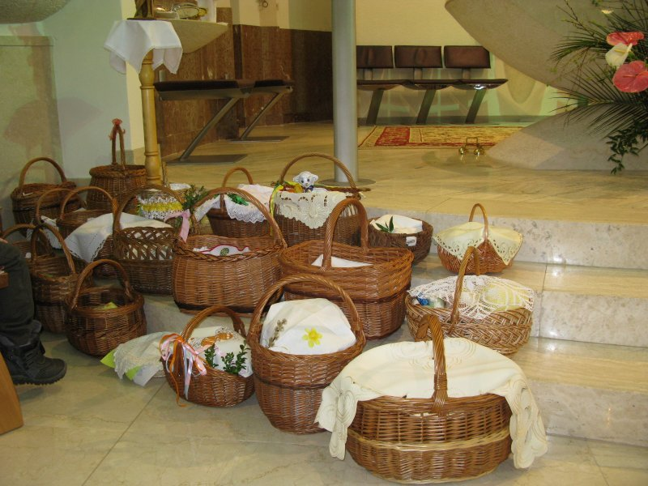
Source of picture: https://slovenske-zvyky.webnode.sk/kalendar-akcii/jar/velka-noc/

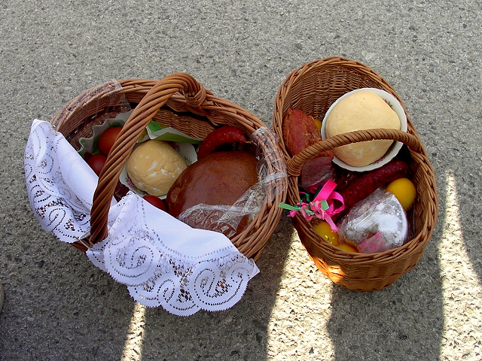
Source of picture: https://slovenske-zvyky.webnode.sk/kalendar-akcii/jar/velka-noc/
EASTER MONDAY
The biggest feast of the boys was Easter Monday, when they walked to the houses where they had girls and boys watered them with fresh cold water which was a symbol of healthy life. The boys did not save water and girls received a good dose of water. In some areas it was common that girls were witched with a string to be healthy all the year. Girls gave boys beautiful coloured Easter eggs which they prepared by using various techniques. Nowadays it is common to go from house to house and pour girls by perfumes.
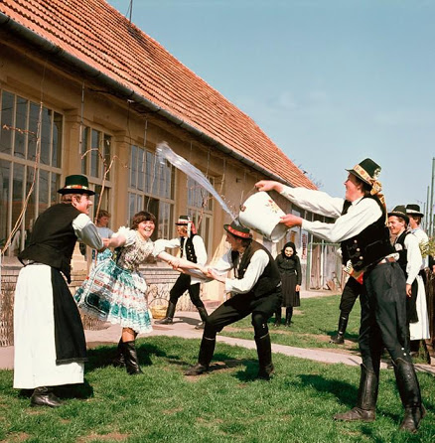
Source of picture: http://www.jankohrasko.sk/clanok/16662/velkonocne-zvyky-a-tradicie/

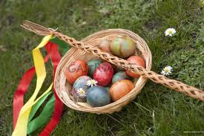
Source of picture: https://slovenske-zvyky.webnode.sk/kalendar-akcii/jar/velkonocny-pondelok/
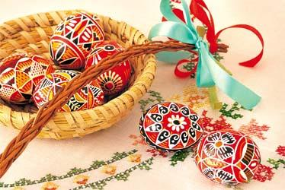
Source of picture: https://slovenske-zvyky.webnode.sk/kalendar-akcii/jar/velkonocny-pondelok/

In Nová Baňa boys dressed in folk costumes are meeting on Easter Sunday and go from house to house to pour girls. They are singing and dancing, eating well and drinking some glasses of wine or home plum brandy.
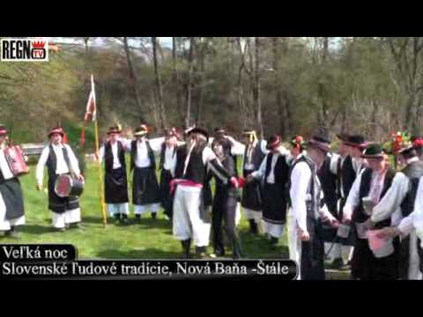
Source of picture and video: https://panoramapro.sk/nekomentovane/v-velkonocna-oblievacka-na-staloch-20-21-4-2014/

