“together; equal in dignity and rights”

Prologue
In this project we dealt with human rights and in particular with human’s rights in education. Also, we discovered what is valid especially about refugees in regard to education. Finally, we found out some pieces of information about the provided education for those people in Greece.

What does right mean?
Right: something that is entitled to someone or is allowed to them and results from written and unwritten laws. In essence, rights are guaranteed liberties.
Human rights: fundamental rights that are entitled to everyone from their birth, just because they are human beings.

Universal Declaration of Human Rights
The Universal Declaration of Human Rights was authorized by the United Nations General Assembly at 1948. The purpose of this declaration was not to be ever repeated such awful incidents as these of Second World War. Even though, this resolution was not mandatory, nowadays, it is applied as customary law. The universal declaration refers to rights such as freedom, equality, education and many others.

Eleanor Roosevelt was the representative of U.S.A at U.N.O and president of the committee of human rights in the organization.

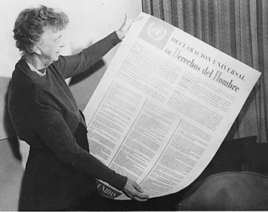

Who is a refugee?
A refugee is every person who is outside the country of his nationality and due to a well-founded fear of being persecuted for reasons of race, religion, nationality, membership of a particular social group, or political opinion and additionally they are unable to avail themselves of the protection of that country.
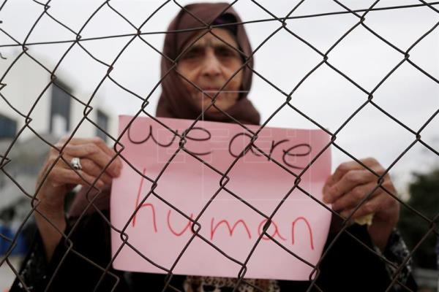

What are the rights of refugees?
Refugees are entitled;
- To claim asylum, that secures not only physical protection but also equal treatment as any other foreigner, who lives permanently in the country
That means thoroughly;
- Freedom of thought
- Access in health system
- Access in education
- Right in employment

What is valid in our country?
The right in education is a fundamental human right that is respected, secured and forwarded by the Greek state. According to European law every child has right to education and especially every child that is a refugee.
With aim to incorporate these children in our society, our state was obligated to give them the opportunity to be educated. As a result, the first reception structures were created in 2016.
The school programme of refugees includes; Greek language, maths, English, physical education, informatics and art.
Detailed data
- More than 60.000 refugees have been educated in our country and from them 40% are children.
- About 4.000 live in specific structures (ΚΦΠ και ΚΥΤ δεν ξέρω πώς να τα μεταφράσω)
- About 2.500 unaccompanied minors are under the responsibility of competent national structures
- According to Unicef 2.000 refugees live out of registered national structures.

A message from Unicef
Without education a whole generation of refugees will grow up in Greece without having the appropriate abilities to contribute to our country and its economy, dealing with increased danger of being marginalized. Education is a fundamental right for every child and their only hope to create their own future.

Epilogue
In conclusion, it is perceivable that all humans should have the same rights, without any differentiation. The refugee-children have the right to dream for a better life. So, all children should always be educated not only for their own good, but also for a better humanity.

