Student code report

Activity name: Untitled

Date saved: Tue May 31 2022

Number of students: 11
User | Present this session | Status
Teacher
apostolia | Absent | Work in progress
Artemis | Absent | Work in progress
Bασίλης Μαγκλάρας | Absent | Work in progress
Basilhs.K | Absent | Work in progress
dimitris | Absent | Work submitted. Student feeling: 😀
elena | Absent | Work in progress
eri | Absent | Work in progress
georgiana | Absent | Work submitted. Student feeling: 😀
Ilias | Absent | Work submitted. Student feeling: 😀
tzei | Absent | Work submitted. Student feeling: 🙂
Vasilis Ba | Absent | Work in progress

Teacher

apostolia
Absent this session
Work in progress
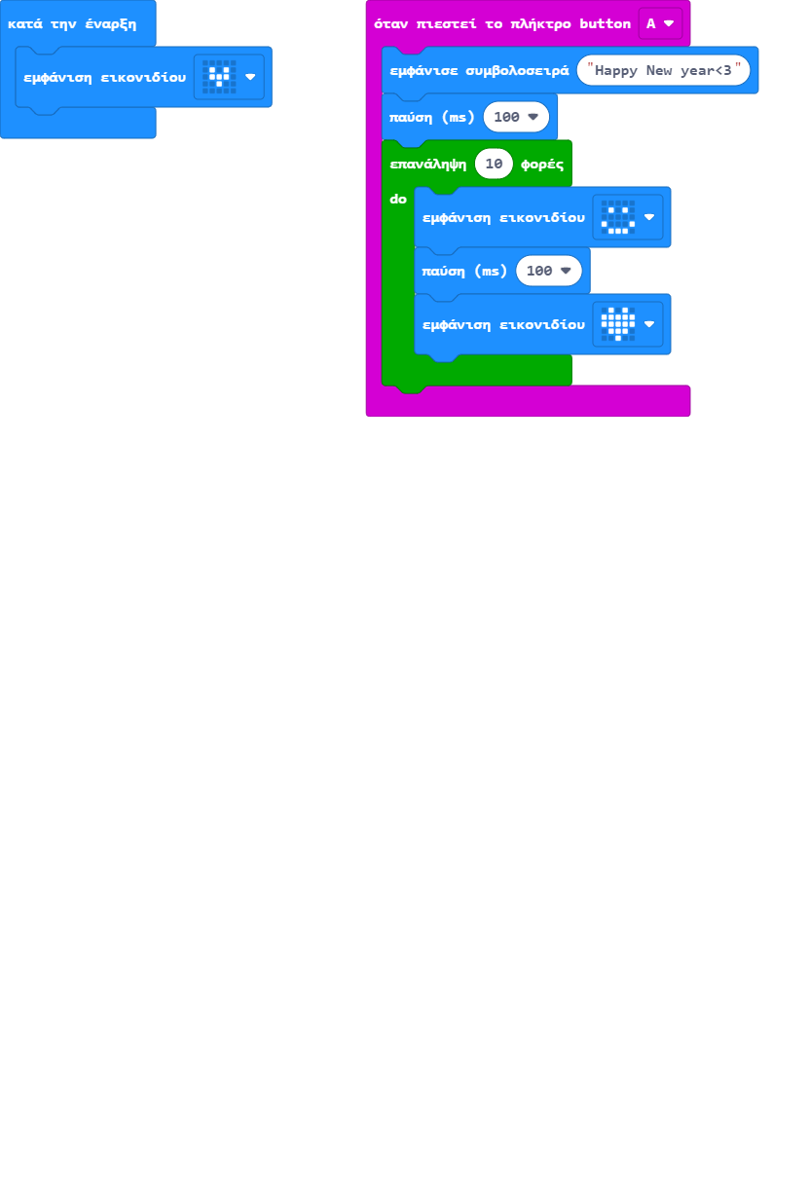

Artemis
Absent this session
Work in progress
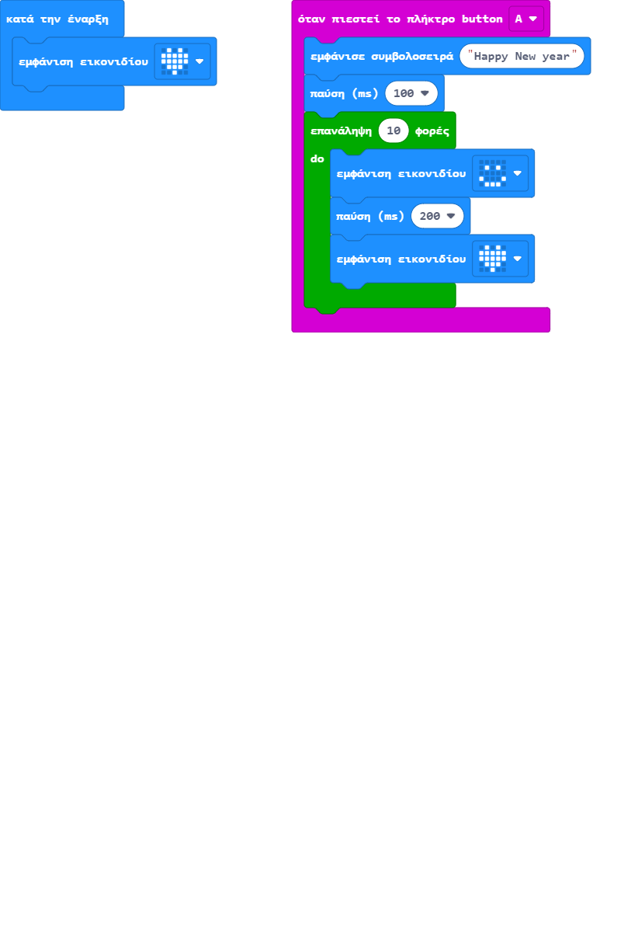

Bασίλης Μαγκλάρας
Absent this session
Work in progress
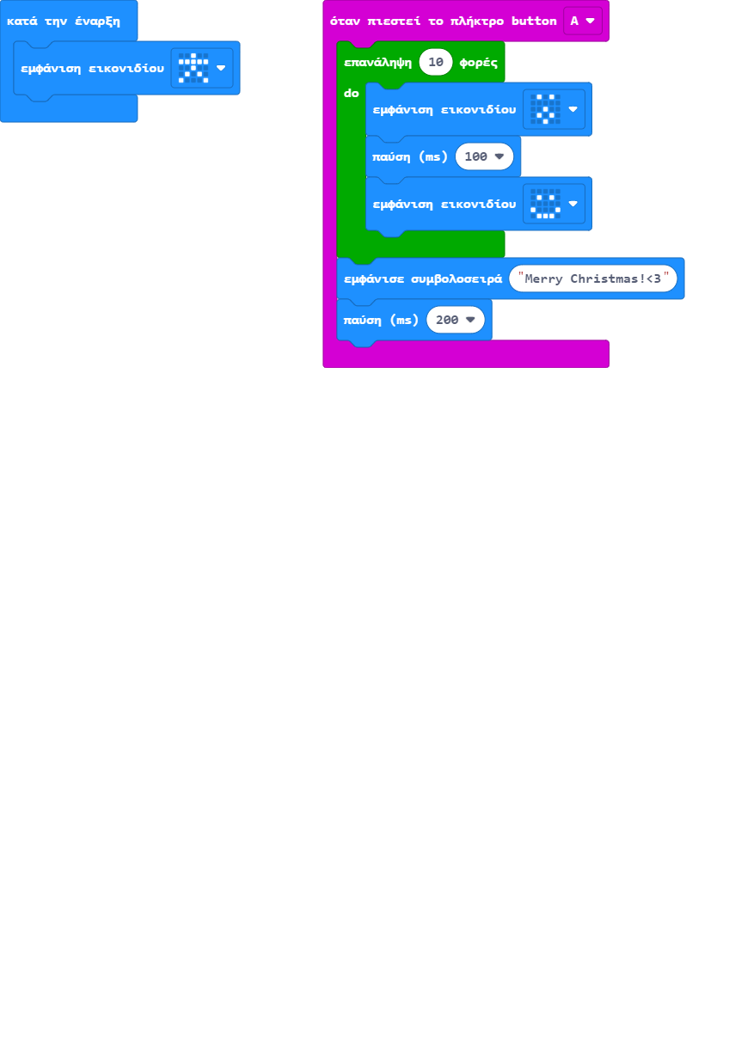

Basilhs.K
Absent this session
Work in progress
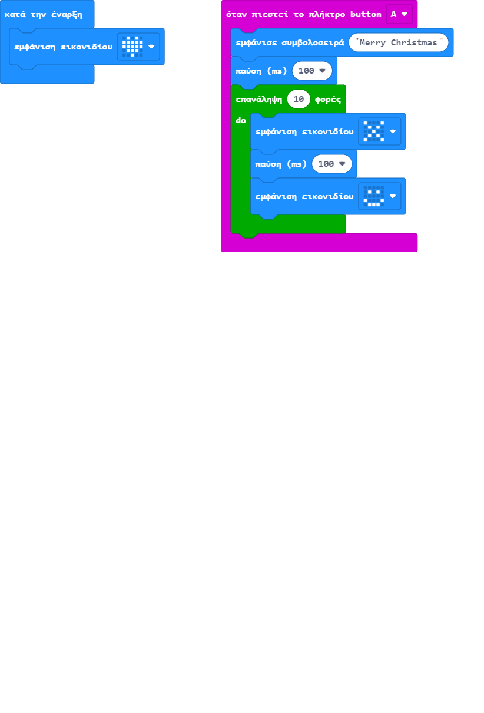

dimitris
Absent this session
Work submitted. Student feeling: 😀
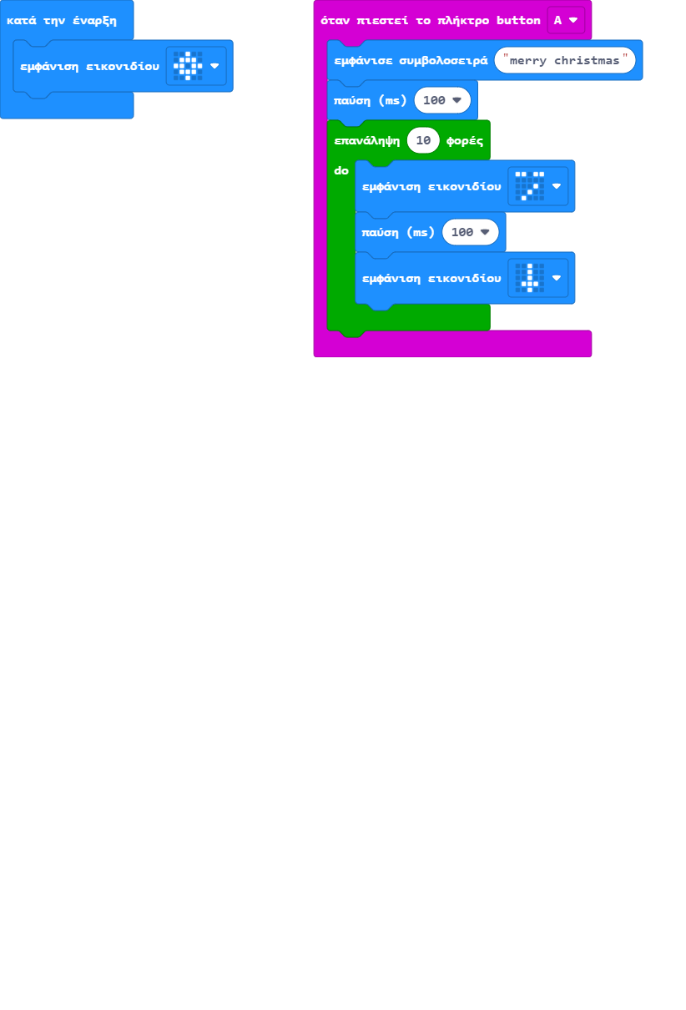

elena
Absent this session
Work in progress
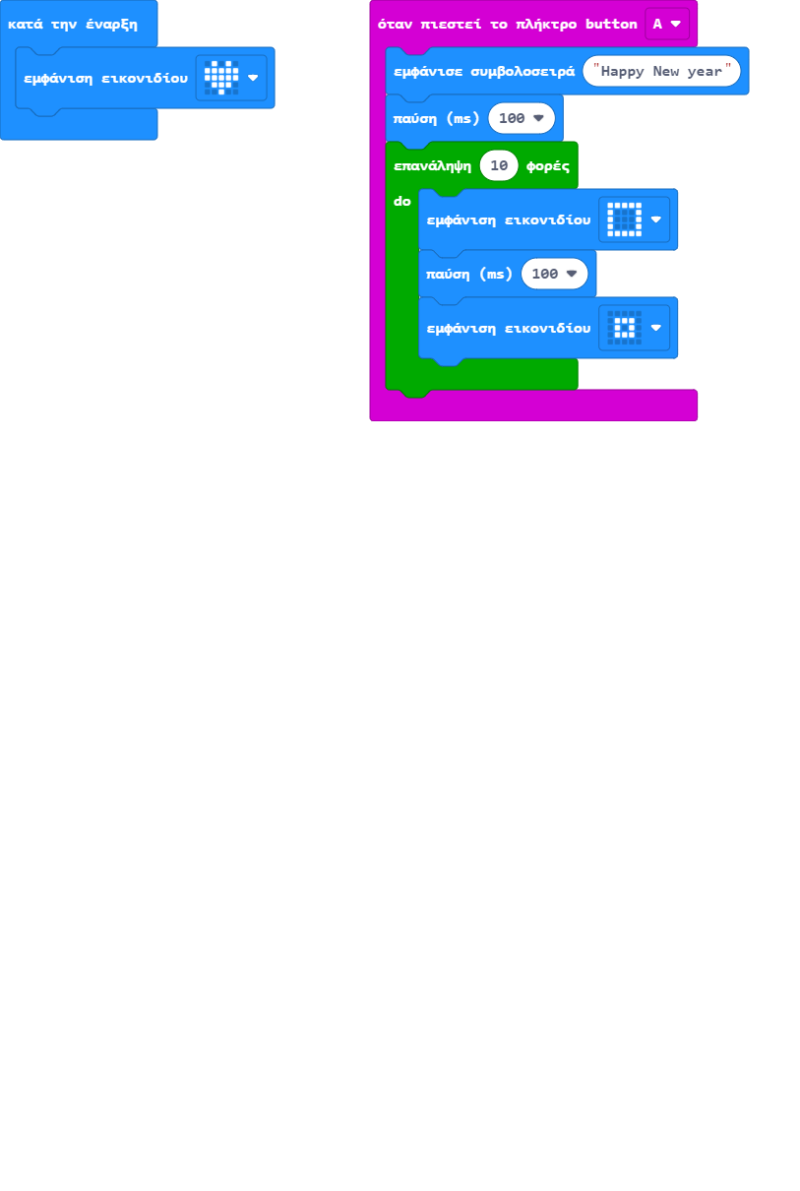

eri
Absent this session
Work in progress
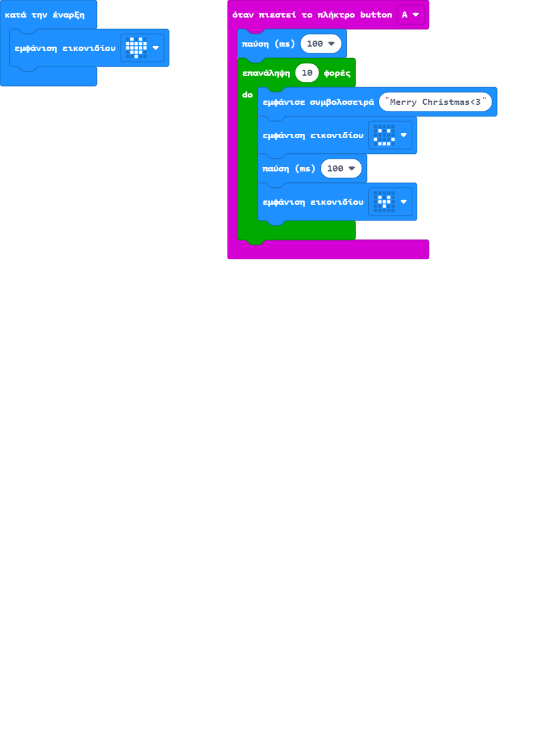

georgiana
Absent this session
Work submitted. Student feeling: 😀
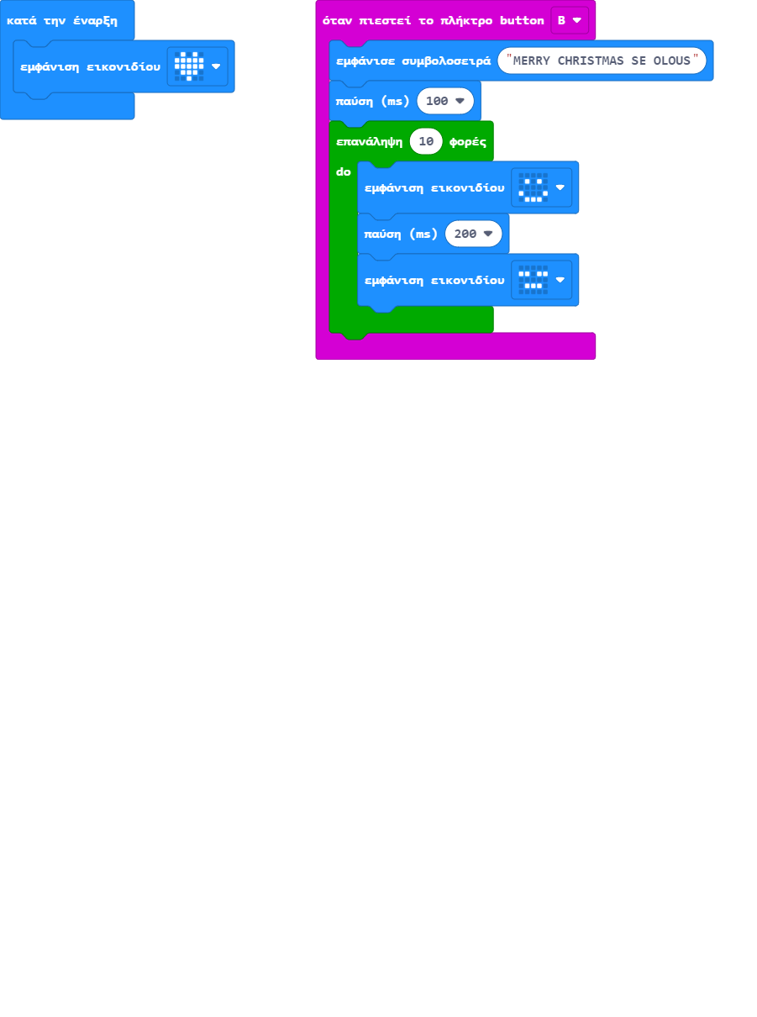

Ilias
Absent this session
Work submitted. Student feeling: 😀
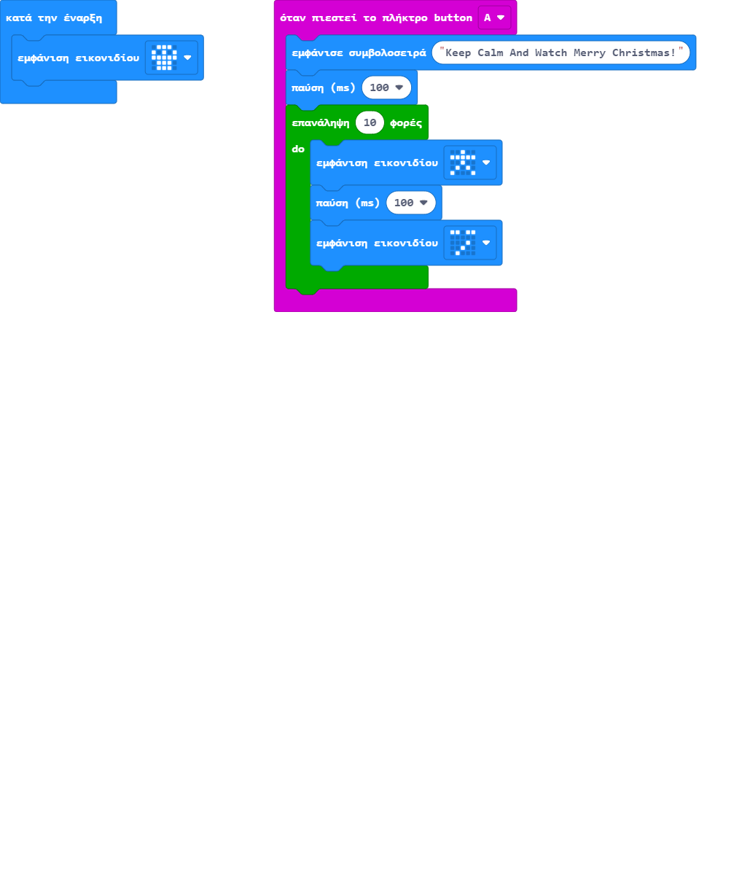

tzei
Absent this session
Work submitted. Student feeling: 🙂

Vasilis Ba
Absent this session
Work in progress

