Chain fountain
Leaping up out of a jar in an arc before falling to the floor, the fountain-like motion of a chain of beads has puzzled millions around the world with its apparently gravity-defying behaviour. Now physicists think they have an explanation. And it is far from intuitive.

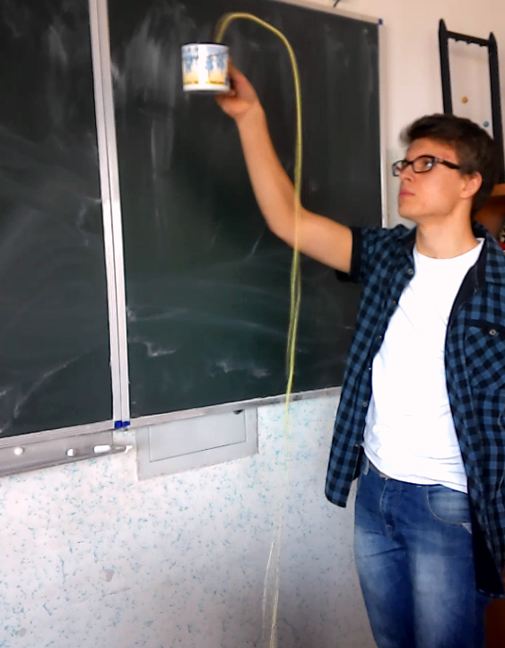

If a chain is initially at rest in a beaker at a height h1 above the ground, and the end of the chain is pulled over the rim of the beaker and down towards the ground and then released, the chain will spontaneously ‘flow’ out of the beaker under gravity. Furthermore, the beads do not simply drag over the edge of the beaker but form a fountain reaching a height h2 above it.
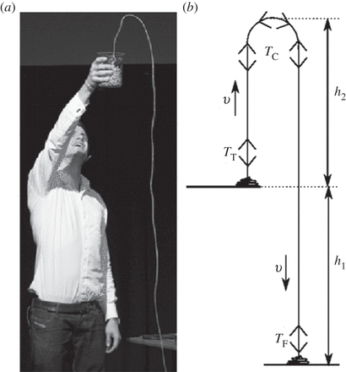

British science presenter Steve Mould, who made the experiment famous with a video that went viral on the Internet, explained the phenomenon as simply one of inertia: the falling chain has downward momentum, causing an upward momentum in beads leaving the pot. This, in turn, makes them leap before gravity can slowly reverse their momentum.
Mould’s explanation was clever, but wrong, says physicist John Biggins of the University of Cambridge, UK. If inertia were causing the flowing fountain, the chain would be stationary at the top of the curve, says Biggins, in the same way that a ball tossed into the air is stationary at its highest point. “If that were true, it would mean the chain would pile up in the top region, which we don’t see,” he adds.

We show that the formation of a fountain requires that the beads come into motion not only by being pulled upwards by the part of the chain immediately above the pile, but also by being pushed upwards by an anomalous reaction force from the pile of stationary chain.
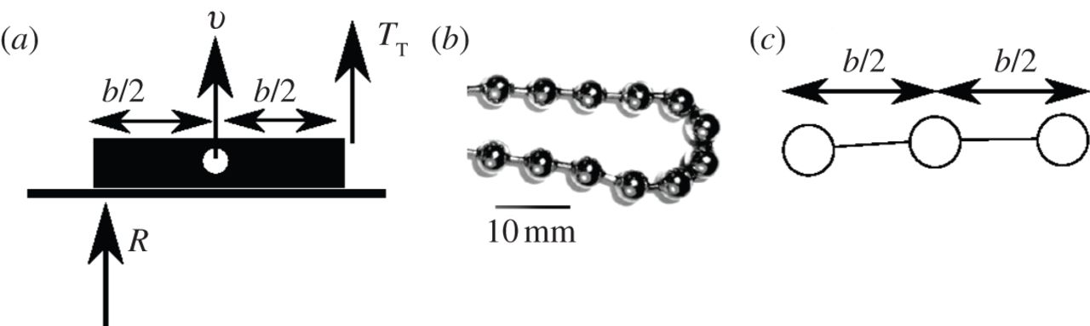

(a) A rigid rod of mass m and moment of inertia I lies on a horizontal surface (in practice the pile of chain) and is picked up via a vertical force TT applied at one end causing the rod's centre of mass to rise at a speed v. In order for the rod not to penetrate the surface, the surface must also provide a vertical reaction force R on the opposite end of the rod. (b,c)
Unfortunately , this problem still has got lots of secrets.

Full explanation

Understanding the chain fountain
J. S. Biggins , M. Warner
DOI: 10.1098/rspa.2013.0689 Published 15 January 2014

http://rspa.royalsocietypublishing.org/content/470/2163/20130689.full.pdf+html

