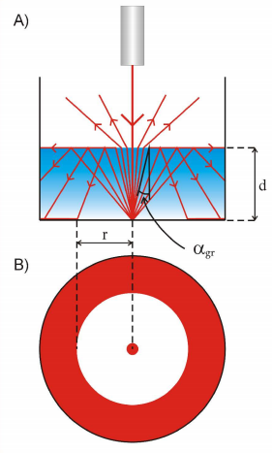
Total internal reflection
Determination of the refractive index of water
by calculation of the critical angle
In this experiment we will use

a white cylindrical cup or mug with flat matt bottom

a laser pointer

water

a ruler

The whys and wherefores
The laser light scatters at the bottom of the mug and reflects at different angles. The reflected rays which fall on the water-air boundary at a smaller angle than the critical angle go into the air. However, the reflected rays which fall on the boundary at a greater angle than the critical angle reflect from it back to the bottom and form a ring of light which has an inner diameter of 2r.

Steps
- Pour the water into a dish to a height of 1cm.
- Hold the laser pointer straight and light the bottom of the dish to see a typical picture of complete inner reflection. If the bottom is too slick the picture may not appear. In this situation you should put a circular piece of white paper at the bottom.
- Measure the radius of the unlit ring (r) and then measure the depth of the water (d).

Calculations
We know that
$$\sin{α_{ critical}}=\frac{1}{n_{ water}}$$

and by observation of the light scattering effect and the reflection on the water-air boundary, we can show the following formulae:

$\frac{r}{2d}=tgα_{ critical}$ and $n_{ water }=\sqrt{1+{\left(\frac{2d}{r}\right)}^{2}}$

Now we have to calculate $n_{ water}$ .

We use this formula to calculate the refractive index of water uncertainty.

$$∆n_{ water}= \frac{1}{2} ∙ \left\{\sqrt{1+{\left[\frac{2∙\left(d+∆d\right)}{r-∆r}\right]}^{2}}-\sqrt{1+{\left[\frac{2∙\left(d-∆d\right)}{r+∆r}\right]}^{2}}\right\}$$

In the end we have to compare the value of the refractive index of water ( $n_{ water}$ ) we have obtained with the real value of the refractive index of water ($n_{ real}$). We can find our results compatible if:
$$\left|n_{ water}-n_{ real}\right| ≤ ∆n_{ water}$$

Our experiment
We conducted an experiment for 2 different laser lights: red and green.
For both lights
d = 17 mm
Δd = 1 mm
For red laser light
r = 38 mm
Δr = 1 mm
$$n_{ water }=\sqrt{1+{\left(\frac{2*17 mm}{38 mm}\right)}^{2}}≈1,34$$

$∆n_{ water}= \frac{1}{2} ∙ \left\{\sqrt{1+{\left[\frac{2∙\left(17 mm+1 mm\right)}{38 mm-1mm}\right]}^{2}}-\sqrt{1+{\left[\frac{2∙\left(17 mm-1 mm\right)}{38 mm+1 mm}\right]}^{2}}\right\}$ $≈$0,06
$$n_{ water}=(1,34 ±0,06$$
(It is a maximum measurement uncertainty)
$$n_{ real for red laser light}=1,3311$$

$$\left|1,34-1,3311\right| ≤ 0,06$$
$$\left|0,0089\right| ≤ 0,06$$
This is true.

You can see that the value of the refractive index of water is compatible with the real value of the refractive index of water for red laser light.

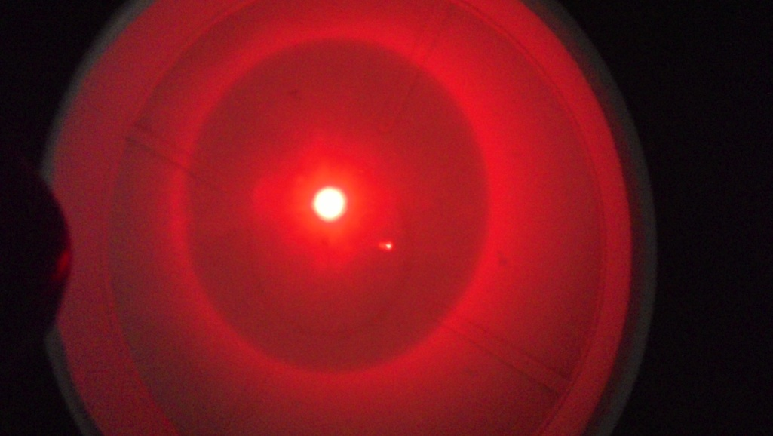
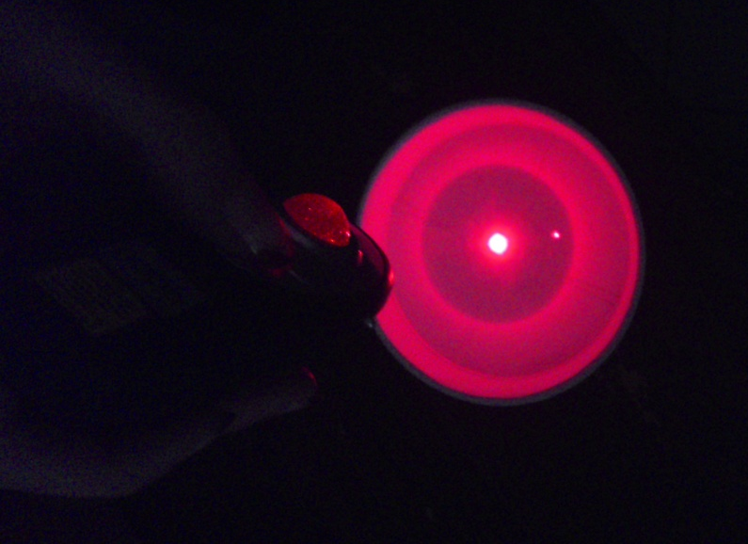

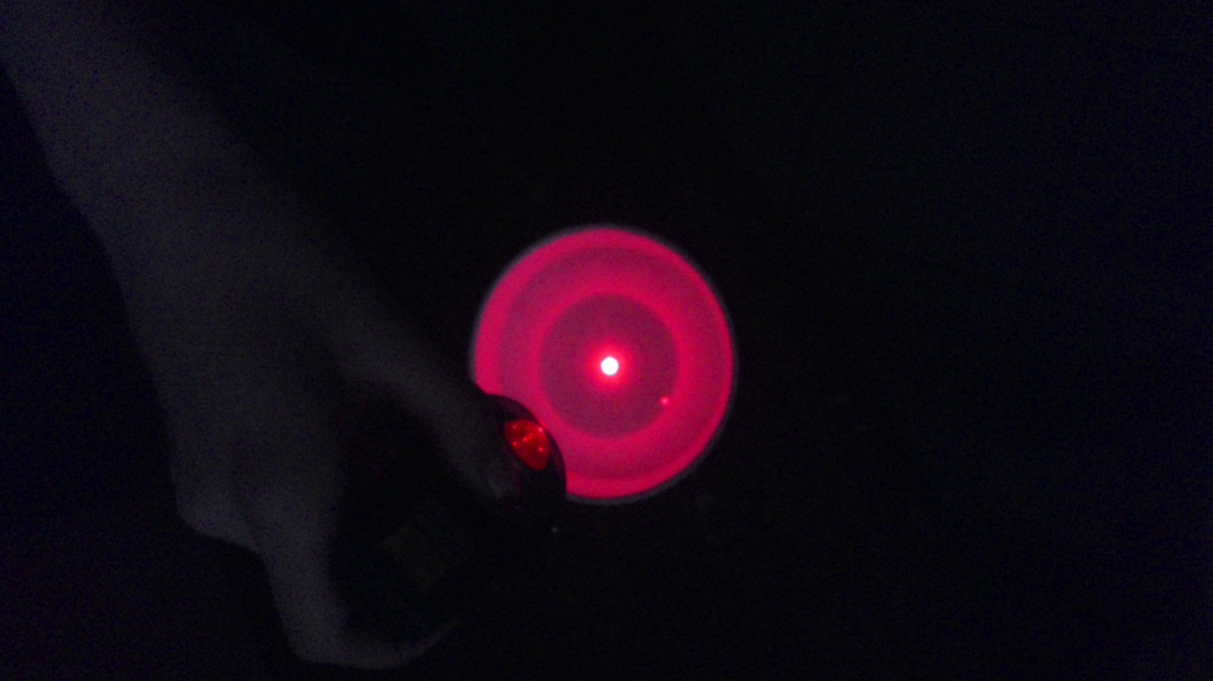

For green laser light
r = 37 mm
Δr = 1 mm
$$n_{ water }=\sqrt{1+{\left(\frac{2*17 mm}{37 mm}\right)}^{2}}≈1,36$$

$∆n_{ water}= \frac{1}{2} ∙ \left\{\sqrt{1+{\left[\frac{2∙\left(17 mm+1 mm\right)}{37 mm-1mm}\right]}^{2}}-\sqrt{1+{\left[\frac{2∙\left(17 mm-1 mm\right)}{37 mm+1 mm}\right]}^{2}}\right\}$ $≈$ 0,06
$$n_{ water}= 1,36 ±0,06$$
(It is a maximum measurement uncertainty)
$$n_{ real for green laser light}=1,3363$$

$$\left|1,36-1,3363\right| ≤ 0,06$$

$$\left|0,0237\right| ≤ 0,06$$

$$0,0237 ≤ 0,06$$

This is true.

You can see that the value of the refractive index of water is compatible with the real value of the refractive index of water for green laser light, too.
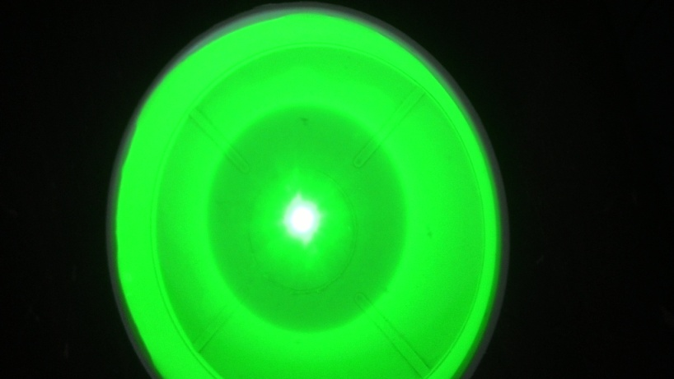
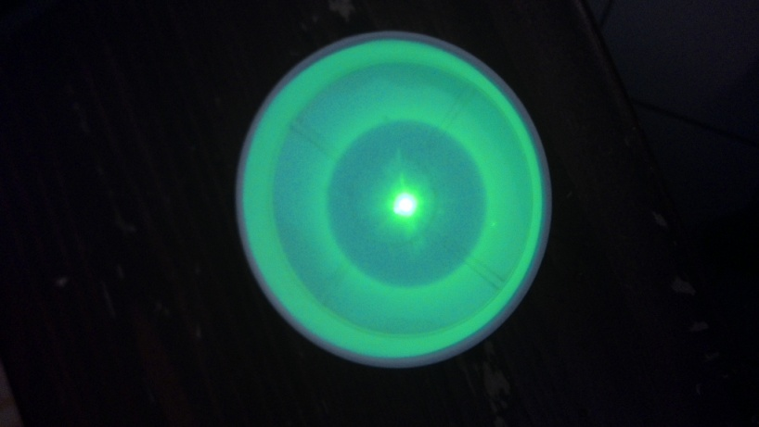

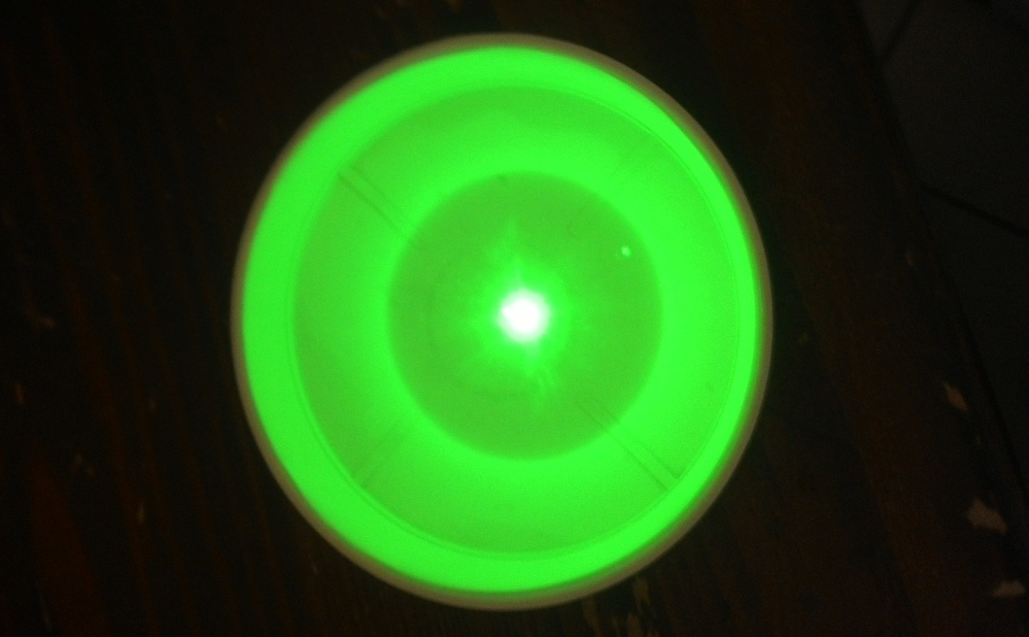

Weronika Mucha,
student of „Tadeusz Kosciuszko” High School of General Education in Wielun, Poland

