How to determine the refractive index of a semi disc?

First method
Draw a straight line and fixe the semi disc like in figure 1.
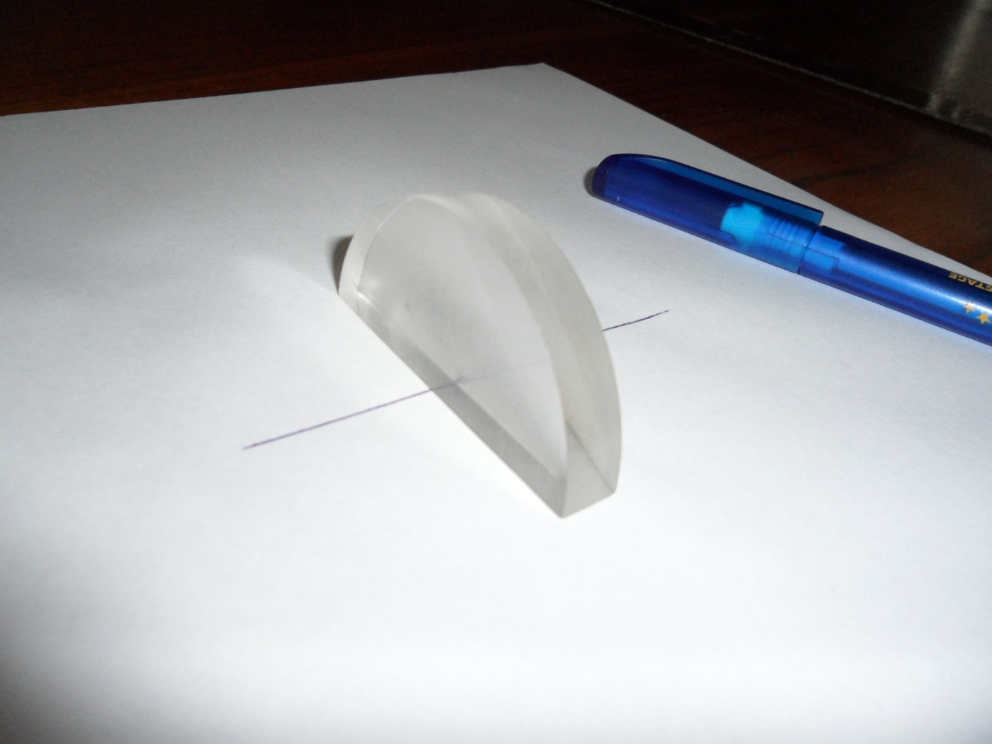

Look at the line through the curved face of the semi disk and mark on it with a pencil the limit of the dark region, corresponding to the maximum refraction angle.
Put the semi disk like in the figure 2 and determine the limit angle of refraction.

Now you can calculate the refractive index of the semi disc:
$$n=\frac{1}{sinl}$$
Second method

The classical method is to use a pointer and a graph paper. You can determine the values of sini and sinr by measuring the distances (see figure 3).
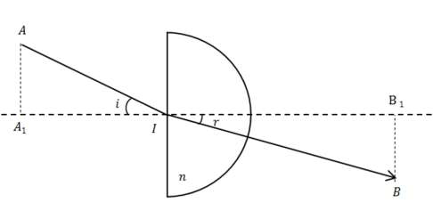
In this case the refractive index is:
$$n=\frac{AA_{1}*IB}{AI*BB_{1}}$$

Third method

Draw a straight line and fixe the semi disc like in figure 1.
Shift the semi disc to the drawn line with a distance a like in figure 4.
b
a
I
i
r

You’ll see the image of the line shifted with the distance b. The I point has to be collinear with the image and your position of observation.
In this case:

$$n=\frac{sinr}{sini}=\frac{b\sqrt{a^{2}+R^{2}}}{a\sqrt{b^{2}+R^{2}}}$$

