Determination of the speed of light
Speed of light is also speed of every electromagnetic waves like microwaves, which are utilized in microwave oven. Everybody can determine speed of these waves in very easy way.
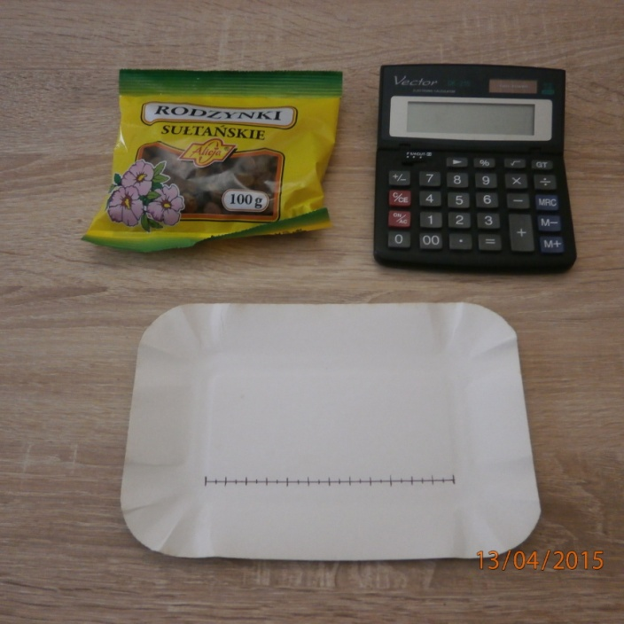
We need to determination:
- microwave oven,
- raisins,
- two paper plates,
- ruler,
- calculator.

Step I
Set the raisins on paper plate and it is important to set them in regularly way along the paper plate.

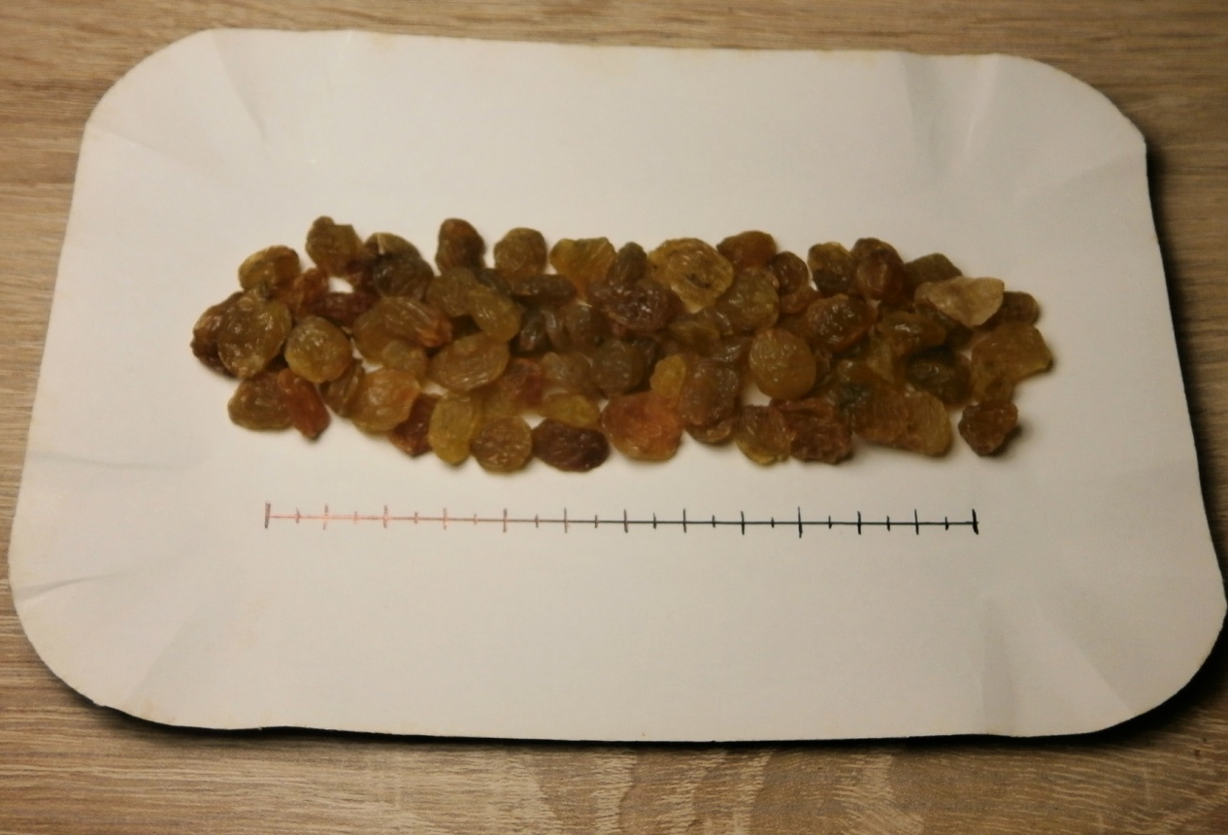

Step II
Withdraw the glass plate from microwave oven then make the special construction, which is made of the other paper plate to bring the paper plate with raisins to standstill. It provides you that the paper plate with raisins won’t turn. Put paper plate, which is prepared like in step I, into the microwave oven on above described construction. You can see it in the photos below. Set the microwave oven on the highest power for several dozen seconds and then just turn it on.
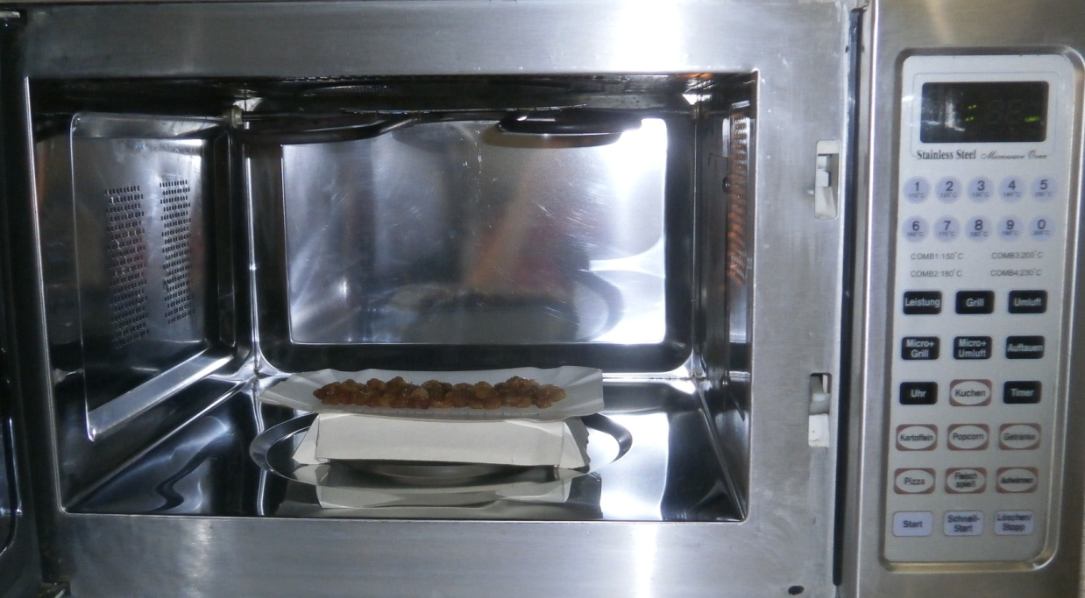

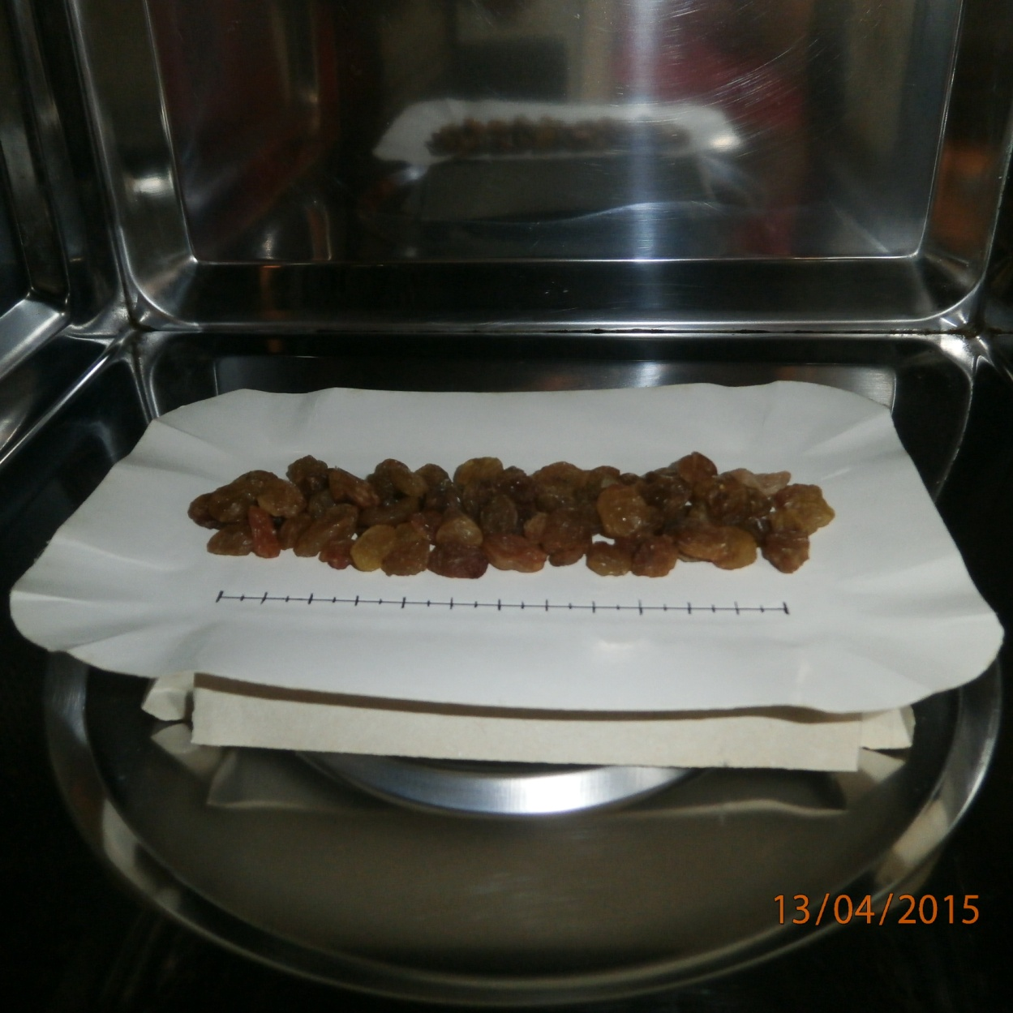

Step III
When you can hear characteristic sound like crack or can see smoke, which is pluming from burned raisins from microwave oven it is a sigh that you have to turn off the microwave oven and take paper plate out very carefully.
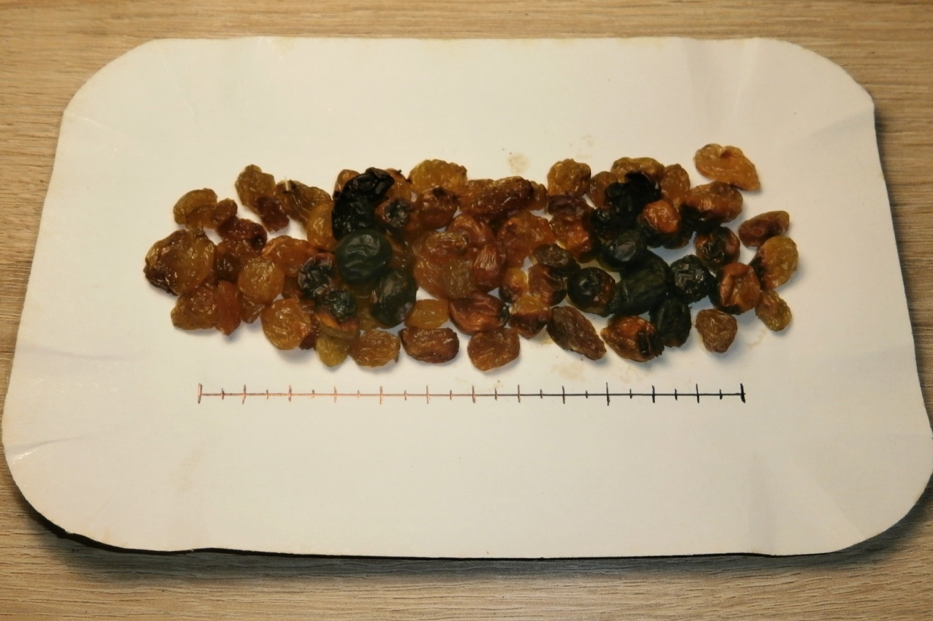

Step IV
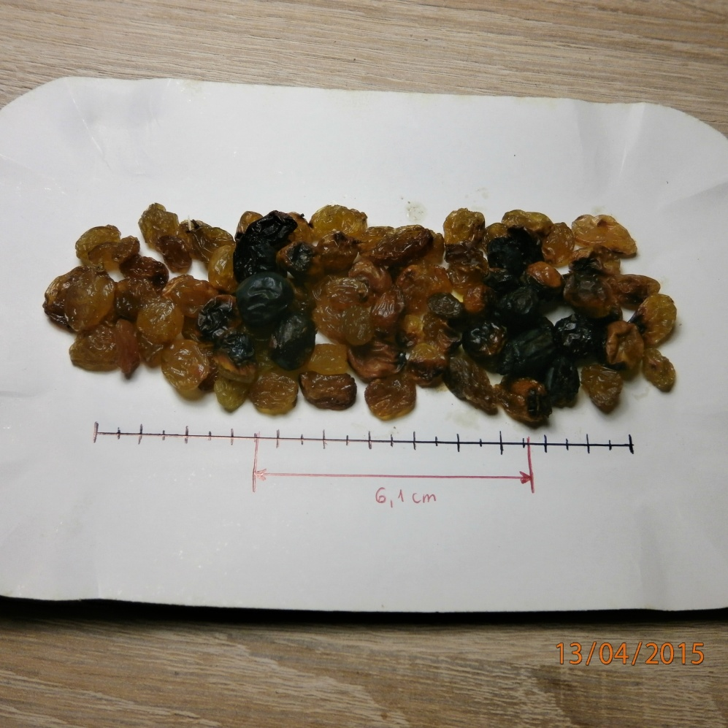
And now measure the length between two midpoints of burned places of raisins.

Step V
Read the frequency of emitted waves from tally, which is in the back of the microwave oven.
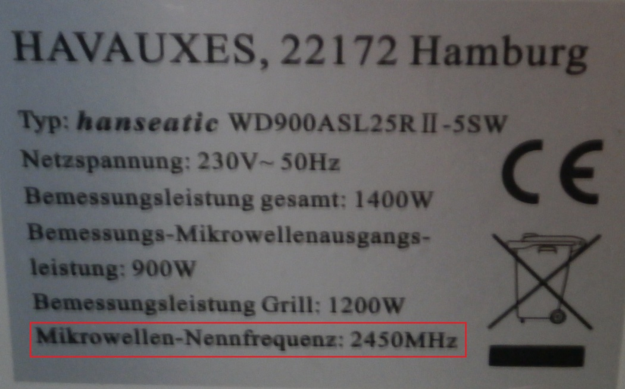

Step VI – calculations
Frequency of generator in microwave oven amounts to 2450 MHz so f=2450 MHz = 2.450.000.000 Hz.
The length between midpoints of two antinodes amounts to d=6,1cm, so d=0,061 m.
We can compute the wavelength in following way:
We know, that λ = c/f (c - the speed of light; f – frequency of wave; λ – the length of wave) =>
c = λ . f
The length from antinode to antinode amounts to:
d=1/2 λ => λ=2d
Δd=0,010 m, so d_{average}=0,061m; d_{min}=0,051m; d_{max}=0,071m
λ_{average}= 2*d_{average}= 2*0.061 m = 0.122 m
λ_{max}= 2* d_{max} = 2*0.071 m = 0.142 m
λ_{min}=2*d_{min}= 2* 0.051 m = 0.102 m
We have all to determine the speed of light:
c_{average} =λ _{average}*f = 0.122 m * 2 450 000 000 Hz = 298 900 000 m/s .
c_{max} = λ_{max}*f= 0.142m * 2 450 000 000 Hz = 347 900 000 m/s
c_{min}= λ_{min}*f = 0.102 m * 2 450 000 000 Hz = 249 900 000 m/s
∆c= (c_{max}-c_{min})/2= ( 347 900 000 m/s – 249 900 000 m/s)/2= 49 000 000 m/s
c= (298 900 000 ± 49 000 000) m/s
(It is a maximum measurement uncertainty)
Made by students of “Tadeusz Kosciuszko” High School in Wielun (Poland):
Adrian Szczesny and Kinga Pecherz.

