Measuring the Earth’s Magnetic Field

Magnetic fields surround electric currents, so we assume that circulating electric currents in the Earth's molten metallic core are the origin of the magnetic field. A current loop gives a field similar to that of the Earth. The magnetic field magnitude measured at the surface of the Earth is about half a Gauss and dips toward the Earth in the northern hemisphere. The magnitude varies over the surface of the Earth in the range 0.3 to 0.6 Gauss.

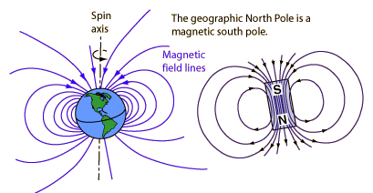

The purpose of our experiment was to measure the horizontal magnetic field of the Earth. To that end we used a tangent galvanometer.
We had to measure the number of coils, the angles and exertions and later use the formulas.
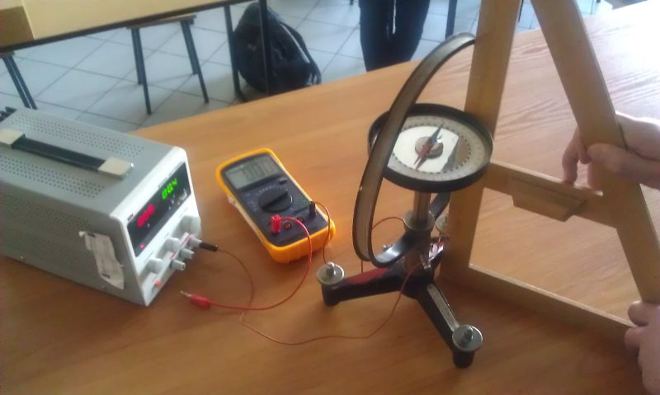
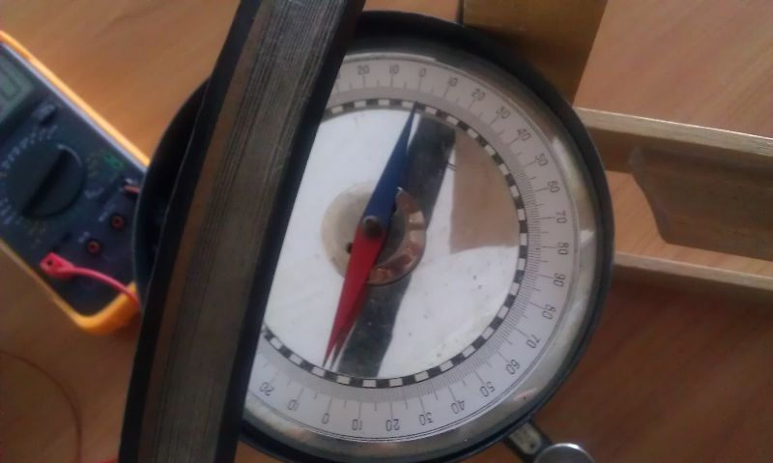

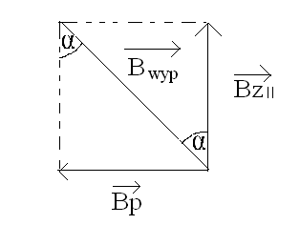
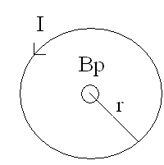

Formulas needed:

$B=\frac{μ_{0}I}{2r}$ $μ_{0}=4π∙{10}^{-7}\frac{N}{A^{2}}$
$I=I_{A}̣∙n$

$B=\frac{μ_{0}I_{A}n}{2r}$ $B_{zII}=\frac{nμ_{0}I}{2rtgα}$

Lp. | Number of coils |  | Angle α [ ˚ ] | tgα | current I [A] | Bz_{II} [µT]
1. | 40 |  | 59 | 1,664 | 0,23 | 20,38
2. | 24 |  | 56 | 1,483 | 0,37 | 22,13
3. | 24 |  | 73 | 3,271 | 0,89 | 24,12
4. | 12 |  | 45 | 1 | 0,45 | 21,6
5. | 12 |  | 63 | 1,963 | 1 | 22,58
6. | 12 |  | 11 | 0,194 | 0,09 | 20,56

$$B_{zII}=\left(21,9±1,9 \right)μT$$

D. Struzik, P.Kaczmarek – “Tadeusz Kosciuszko” High School in Wielun Poland

