The Science on Stage Project

Make Physics More Enjoyable in Our Schools

Coordinators:
Zenona Stojecka Corina Toma
I Liceum Ogólnokształcące Computer Science High School
im. Tadeusza Kościuszki „Tiberiu Popoviciu”
Wieluń, Poland Cluj Napoca, Roamania

The second project meeting was held between 6 -11 April 2014 in Wieluń, Poland.
16 Polish students and 16 Romanian students worked together with 4 teachers: Zenona Stojecka and Corina Toma (Physics teachers), Mariola Jureńczyk (English teacher) and Simona Haidu (Computer Science teacher).
The entire project was a success, because the students had to learn more in formal or nonformal environment. They were astonished of the many applications new technology has to offer in understanding Physics phenomena. Last but not the least, teachers have exchanged ideas and learned from one other, hence new teaching methods can be implemented in their future teaching units.
On the first day, the Romanian group was warmly welcomed at ”Tadeusza Kościuszki” High School.

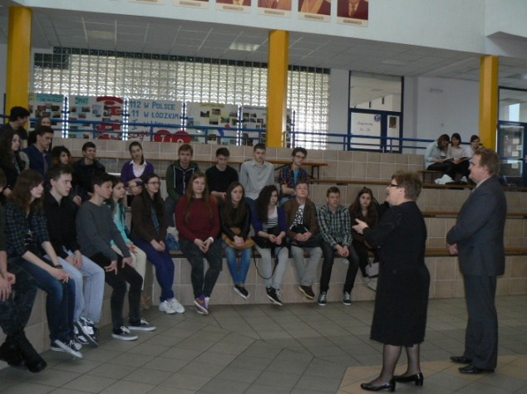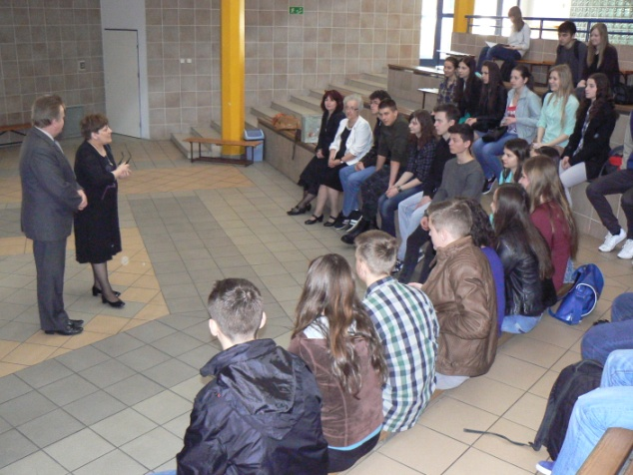

Afterwards, Filip Boancă presented the “Tiberiul Popoviciu” Computer Science High School’s activity to Polish teachers.

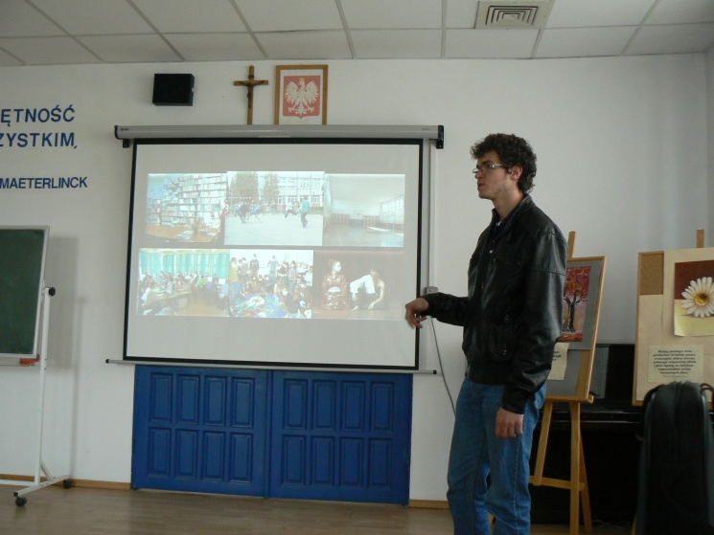

An extended visit of the laboratories, library and the school’s museum was organized. The Romanian students learned about the history of this important Polish educational establishment. It was obvious that the school is a modern one, very nice, clean and well equipped with the latest technology. Everywhere one could notice the extensive care for detail, beauty for the place and functional at the same time.

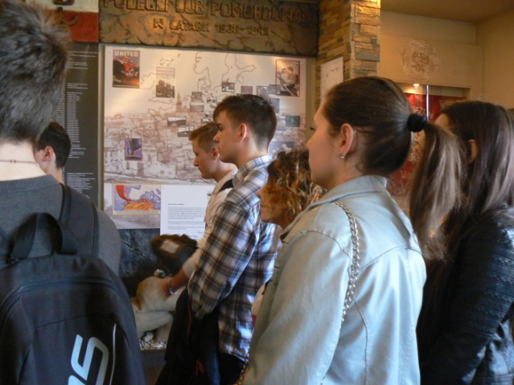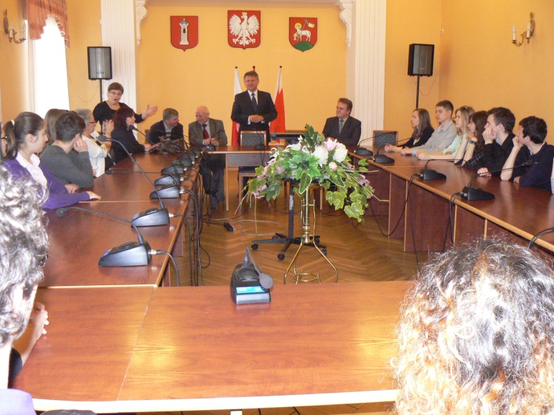

All the project’s participants were invited to the district officials, who presented the county. At the same time everyone appreciated the importance of this international educational project for the broadening of students’ horizon.

The highlight of the first day was the Polish students’ showcase of the first part of Physics experiments.
The Polish students have presented a wide variety of experiments, which proves the high quality of the taught Physics curricula. An exceptional experiment was the levitation of a ferromagnetic object. Afterwards the resistance of a Da Vinci’s bridge was put to the test.

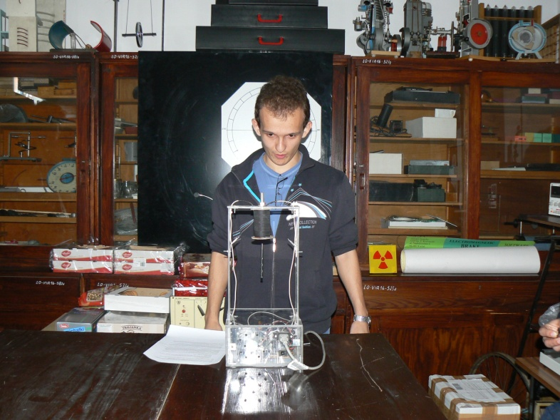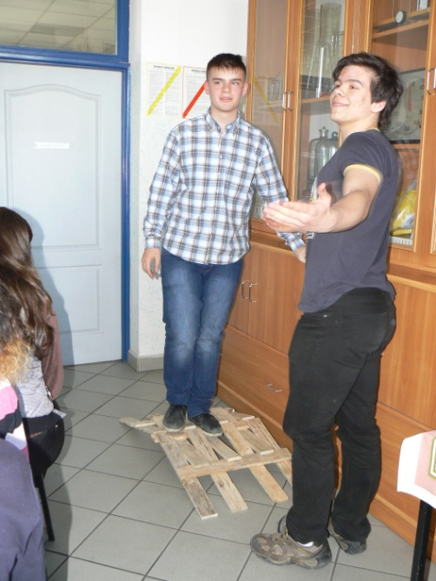

Equally interesting were the experiments where CoachLab II interface was employed. This represents a multifunctional and interactive interface, for real time measurement and display of different physical parameters.

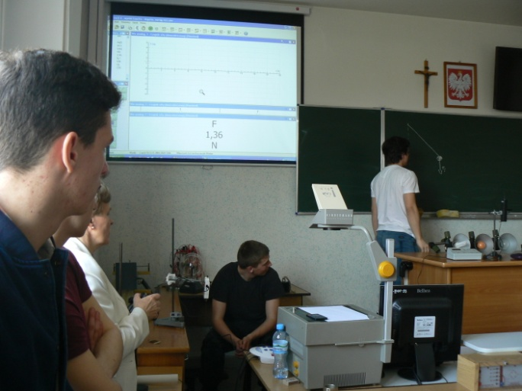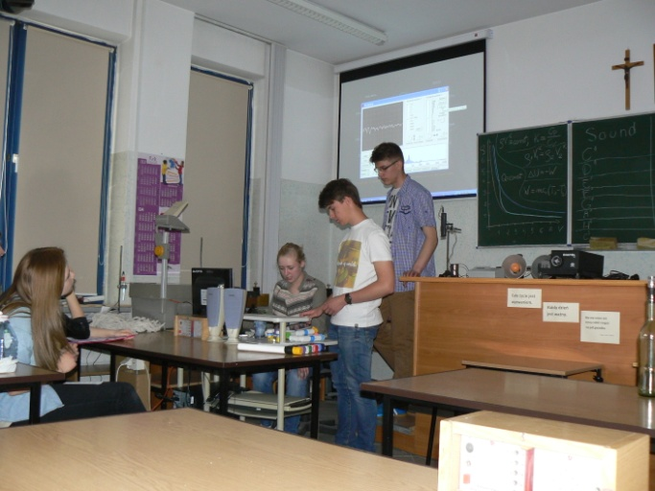

It was evident that Mrs Zenona Stojecka has worked a lot with her students for this project to be a success. Her student have presented 13 different experiments:
- Levitation of a ferromagnetic object;
- Model of the lungs and their inner workings;
- Spectroscopy. Spectra observation using self-made spectroscopes;
- Fun with sound. Measurements of sound frequencies using homemade pipes;
- Adiabatic process;
- Leonardo da Vinci bridge;
- Infinity Machine;
- Convection;
- Does a candle flame create a shadow?
- Boiling under reduced-pressure;
- Hertz Sparker;
- Strength of Paper;
- Czochralski’s method of producing silicon crystals;
- Watching crystal structures using the microscope)
And an extra 5 experiments employing CoachLabII and motion, force, radioactivity sensors:
- Distance-time graphs, velocity – time graphs and acceleration in a rectilinear motion using the air track;
- Force of static and kinetic friction;
- Oscillation of the pendulum: force, distance, velocity, period determinations;
- Electromagnetic brake. Measurement of electromotive force EMF;
- The measurements of the natural radioactivity of environment;
- Protection against radiation
Finally everything ended with an amazing photo show “Physical Phenomena around us”.

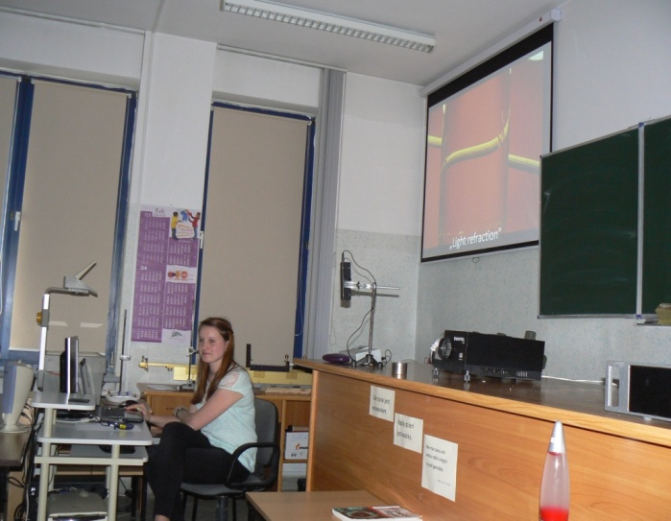
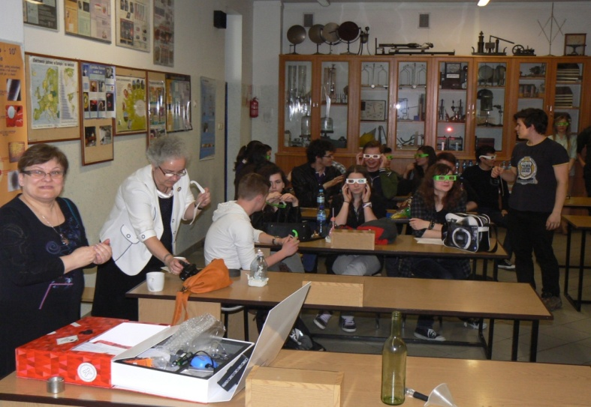

The Romanian students have presented several new experiments that were using the smartphone, such as:
- finding distances and heights using the pressure sensors
- determining the Earth magnetic field using Helmholtz coils.
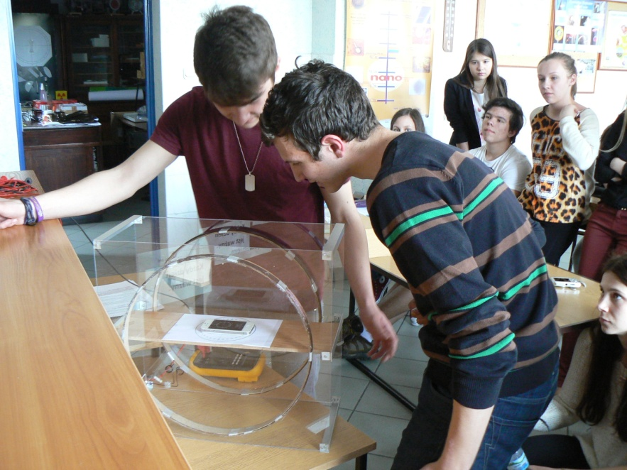
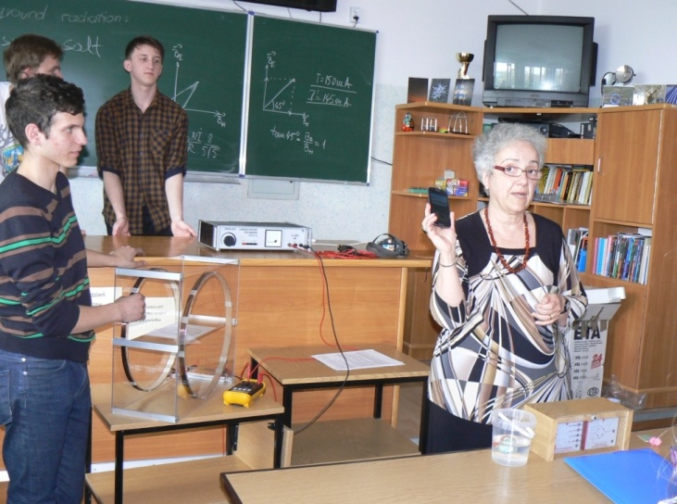
A casual atmosphere ensued as students engaged in a game of voley ball attended by the principals of the two high schools.
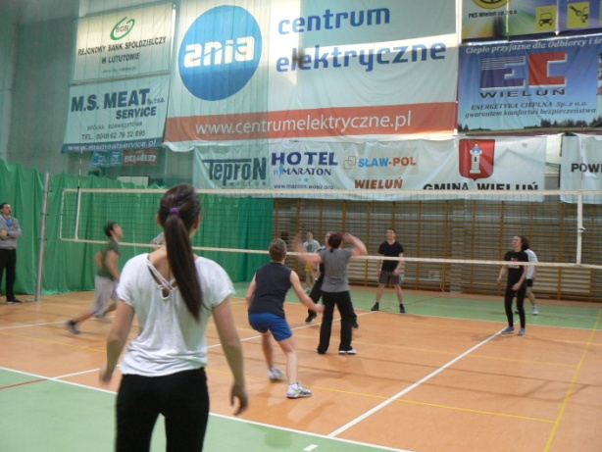

CoachLabII Multifunctional lab interface for computerised measurement and control was showcased and used during the visit to the Computer Aided Education and IT Centre in Warsaw. Experiments involving temperature variations were presented by Mrs. Elżbieta Kawecka.
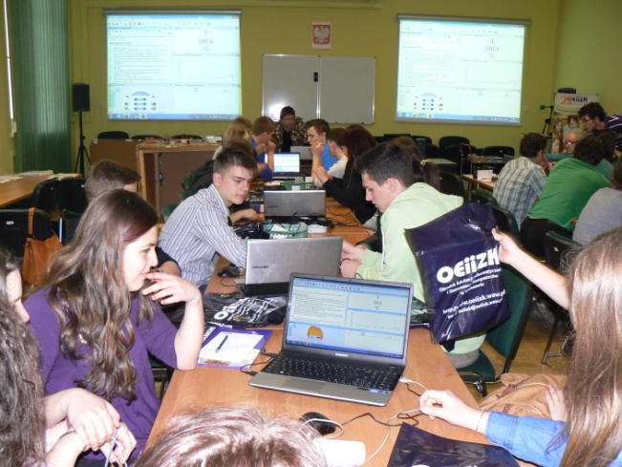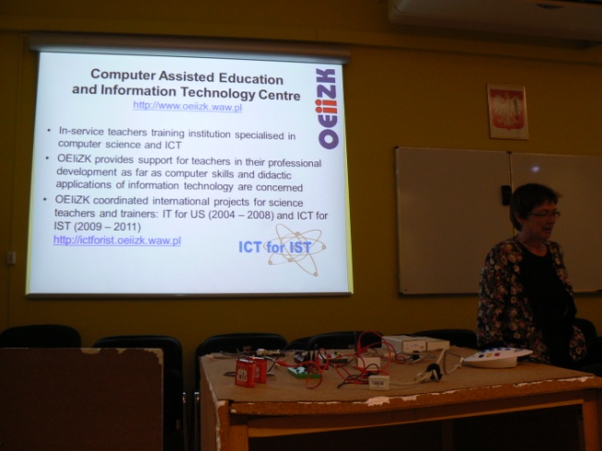
One of the main attractions of the exchange was the visit to Copernicus Science Center, Warsaw. Couple of hours of interactive fun followed, and the sutdents were ‘playing’ with the different ‘toys’ on display. A visit to such a center stirrs the desire to explore the worlds of Physics, Biology and Chemistry.
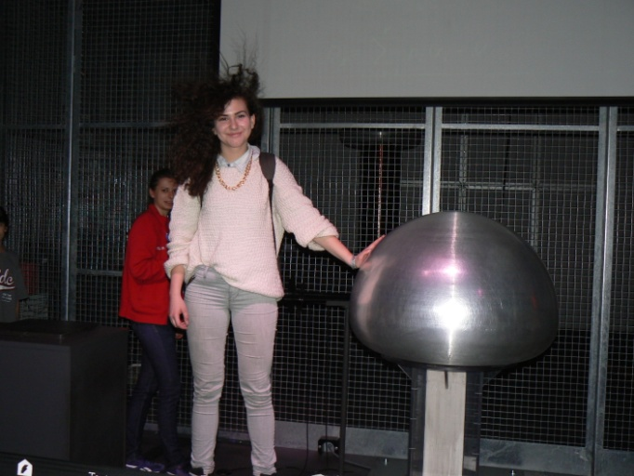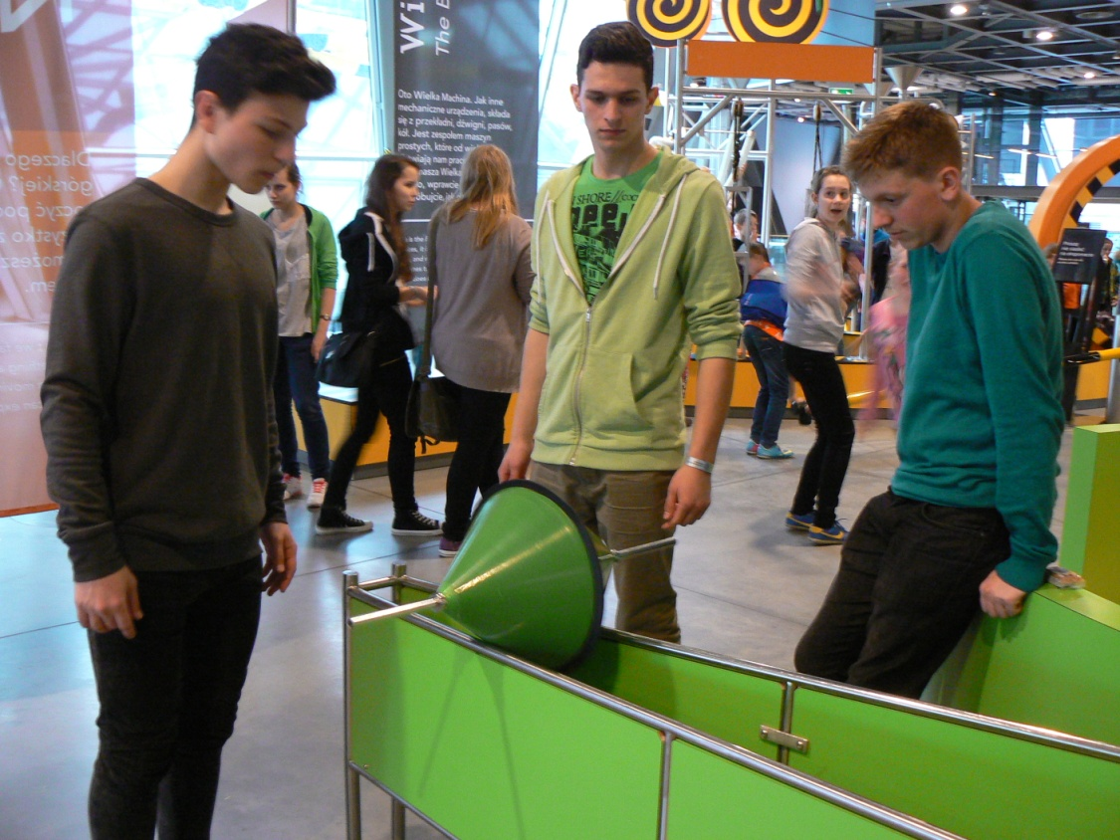
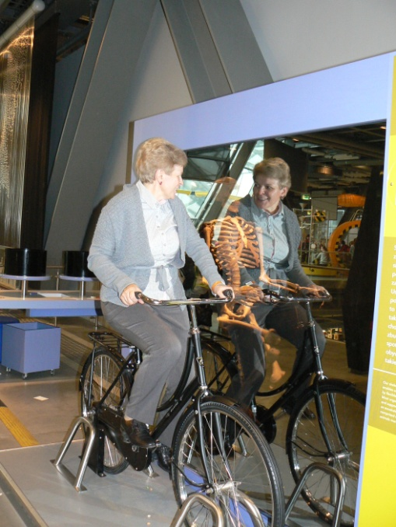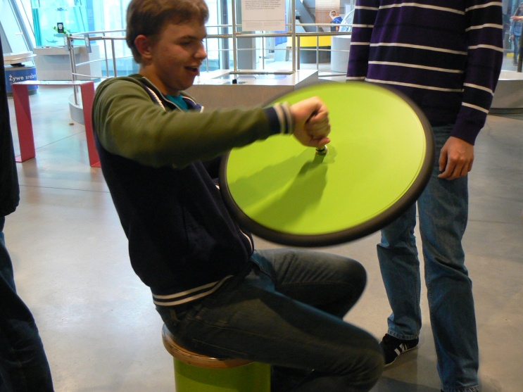
Being part of this project also meant visiting Wielun and Warsaw. Hence we learned about the history of the place and we were impressed by both the medieval and modern architecture:
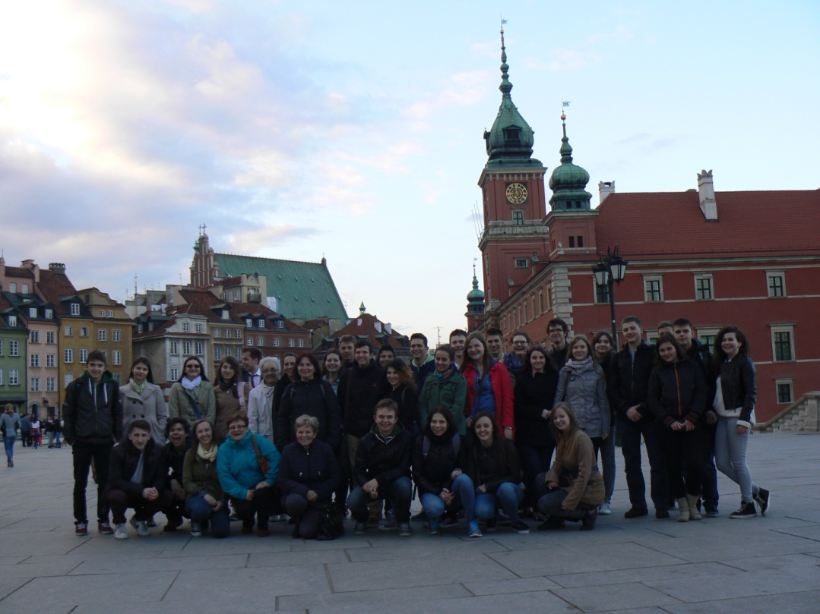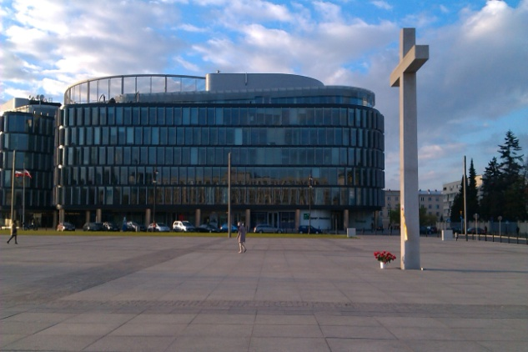
Royal Palace, Warsaw METROPOLITAN Business Centre of Norman Foster
Everyone was rather sad on the last day in Wielun, being aware that there were few moments left before departure. However the Polish students have prepared a surprise. Without us knowing they’ve set up a music show with a rock band and a lot of players. The surprise was even greater when they played ”Dragostea din tei”, a wellknown Romania pop hit, for which they’ve learned the Romanian lyrics.
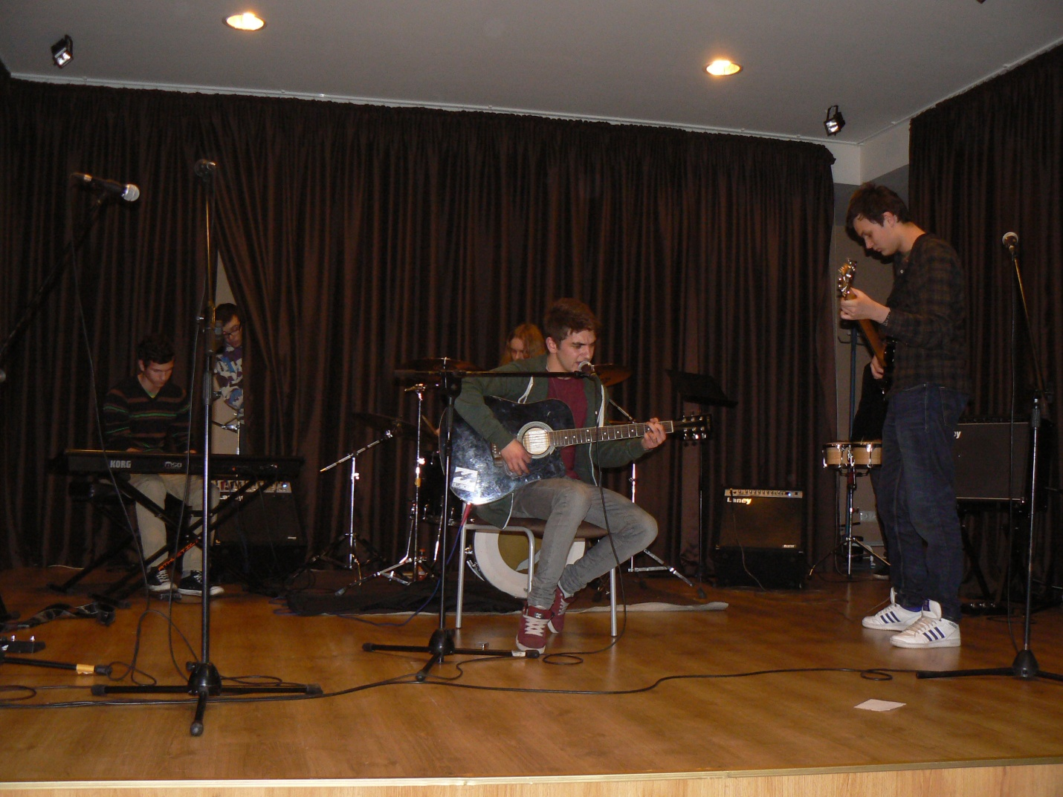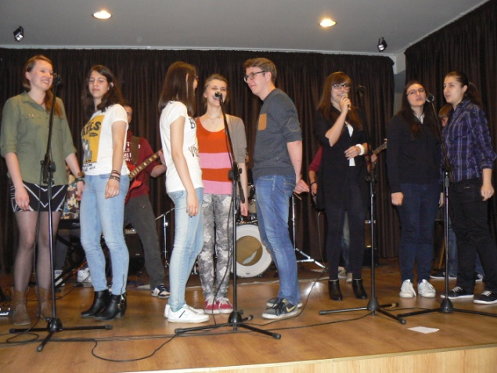
Dan Roman and Cătălin Mateș have joined the Polish musicians and together they have played tunes, while everyone around was cheering loudly.

The memories of the wonderful days spent among the students and teachers from Wielun, the experiences and the shared ideas, will remain with us. A lot was learned about Poland and the Polish education system. The student’s knowledge of Physics was further expanded and we felt welcomed amongst friends. Hopefully there will be the opportunity to see each other soon, maybe in a different exchnage project.

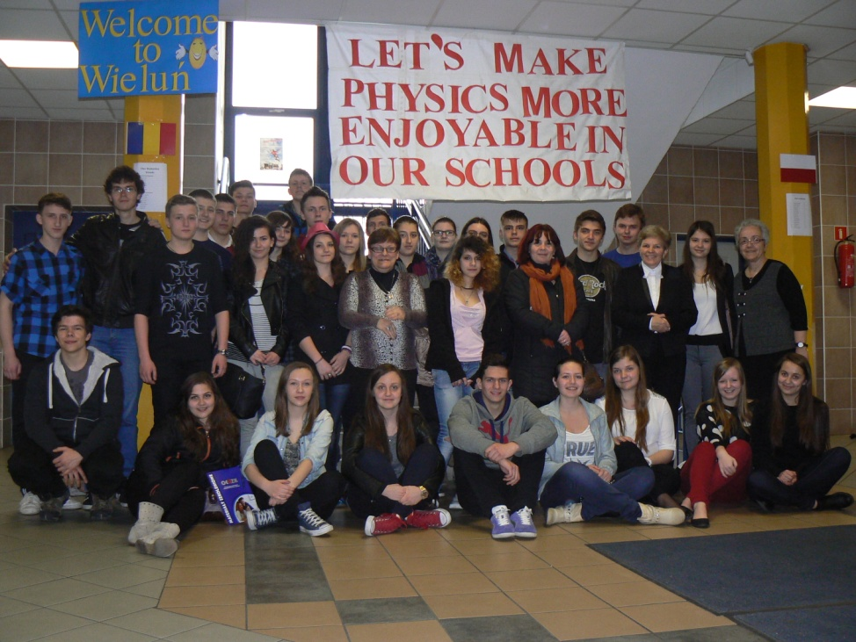
After the two exchange visits, Cluj-Napoca October 2013 and Wieluń April 2014, I believe that the objectives and expectations of the Science of Stage Deutschland project were not only met, but exceeded. The project meant a lot for everyone involved both students and teachers. Most importantly the students gained Physics and English knowledge, while teachers exchanged their tutoring experience discussing new teaching methods that could be applied in the classroom. Such a project involves comparing and discussing two different teaching systems debating the pros and cons of each of them and trying to find ways of improving and avoiding mistakes. Last but not least this project led to building new ties between teachers that would further extend the cooperation between the two schools.
Thank you Science on Stage Deutschland and SAP for this opportunity to participate in such an interesting project.
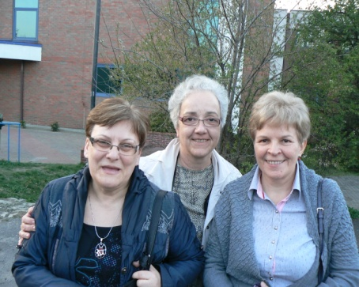

Corina Toma Zenona Stojecka

