NOISE IN WIELUN

A study of the intensity of sound in Wieluń
The intensity of sound – the measurement of the energy of acoustic waves with the units W/m².
Noise - sounds of too great an intensity for a particular place and/or time, perceived as "pointless, troublesome, unpleasant and harmful". It might be dangerous for our health.
Researchers who study hearing loss in the workplace have found that a person who is exposed to noise levels at 85 decibels or higher for a prolonged period of time is at risk for hearing loss. For this reason, these workers are required to wear hearing protectors, such as earplugs or earmuffs, while they are on the job. Many devices that children use today have noise levels much higher than 85 decibels. For example, an MP3 player at maximum level is roughly 105 decibels. That's 100 times more intense than 85 decibels! Scientists recommend no more than 15 minutes of unprotected exposure to sounds that are 100 decibels. In addition, regular exposure to sounds at 110 decibels for more than one minute risks permanent hearing loss.
Average values of sounds in everyday life:
Painful
150 dB = fireworks at 3 feet
140 dB = firearms, jet engine
130 dB = jackhammer
120 dB = jet plane takeoff, siren
Extremely Loud
110 dB = maximum output of some MP3 players, model airplane, chain saw
106 dB = gas lawn mower, snowblower
100 dB = hand drill, pneumatic drill
90 dB = subway, passing motorcycle
Very Loud
80–90 dB = blow-dryer, kitchen blender, food processor
70 dB = busy traffic, vacuum cleaner, alarm clock
Moderate
60 dB = typical conversation, dishwasher, clothes dryer
50 dB = moderate rainfall
40 dB = quiet room
Faint
30 dB = whisper, quiet library

Measurements:
For the measurements we used a Sony Xperia J mobile phone with a sound meter ver. 1.6 app. During the taking of readings we kept the phone covered to minimise the disruptive effects of the wind.
We divided the map of the town into 4 parts and drew a grid over each of them. Later, we walked round the town and measured the intensity of sound in the places near the junctions of the grid lines. The results are presented in the tables below.
Map I
point of measurement | date | time | maximal value (db) | average value (db)
1 ( ul. Wodna) | 17.01.2015 | 10:10 | 95 | 72
2 ( ul. Moniuszki) | 17.01.2015 | 10:20 | 65 | 52
3 | 17.01.2015 | 10:53 | 85 | 76
4 ( ul. Fabryczna) | 17.01.2015 | 11:07 | 91 | 70
5 ( ul. Fabryczna) | 17.01.2015 | 11:16 | 77 | 66
6 ( ul. Rymarkiewicz) | 17.01.2015 | 11:25 | 88 | 40
7 ( ul. Rymarkiewicz) | 17.01.2015 | 11:34 | 97 | 81
8 ( ul. Przemysłowa) | 17.01.2015 | 11:40 | 82 | 81
9 ( ul. Warszawska) | 17.01.2015 | 11:51 | 92 | 78
10 ( ul. Poprzeczna) | 17.01.2015 | 12:11 | 78 | 62
11 ( ul. Błońska) | 17.01.2015 | 12:27 | 89 | 75
12 ( ul. Ciepłownicza) | 17.01.2015 | 12:35 | 64 | 49
13 ( ul. Wodna) | 17.01.2015 | 12:42 | 66 | 54

Map II
point of measurement | date | time | maximal value (db) | average value (db)
1 ( ul.Wrocławska) | 23.12.2014 | 09:51 | 96 | 82
2 ( ul. Wrocławska) | 23.12.2014 | 10:00 | 102 | 86
3 ( ul. Gen Wysockiego) | 23.12.2014 | 10:18 | 84 | 69
4 (ul. Sieradzka) | 23.12.2014 | 10:30 | 86 | 71
5 ( ul. Miła) | 23.12.2014 | 11:52 | 103 | 84
6( ul. Wyspiańskiego) | 23.12.2014 | 11:00 | 102 | 86
7 ( ul. Sieradzka) | 23.12.2014 | 10:40 | 102 | 85
Rynek | 23.12.2014 | 12:11 | 93 | 81

Map III
point of measurement | Date |  | time |  | maximal value (db) |  | average value (db)
1(Park Miejski) | 30.12.2014 |  | 13:11 |  | 55 |  | 38
2(ul. Wojska Polskiego) | 30.12.2014 |  | 13:25 |  | 69 |  | 54
3(ul. Graniczna) | 30.12.2014 |  | 14:00 |  | 50 |  | 34
4(ul. Kijak) | 30.12.2014 |  | 14:15 |  | 87 |  | 64
5(ul. Wiśniowa) | 30.12.2014 |  | 14:23 |  | 54 |  | 41
Map IV
point of measurement |  | date |  | time |  | maximal value (db) | average value (db)
1(ul. Agrestowa) |  | 05.01.2015 |  | 14:12 |  | 69 | 55
2(ul. 18 stycznia) |  | 05.01.2015 |  | 14:25 |  | 86 | 72
3(ul. gen. Kościuszki) |  | 05.01.2015 |  | 14:33 |  | 78 | 63
4(ul. Wspólna) |  | 05.01.2015 |  | 14:47 |  | 71 | 55
5(ul. POW) |  | 05.01.2015 |  | 15:00 |  | 87 | 74
6(ul. POW) |  | 05.01.2015 |  | 15:05 |  | 84 | 70
7(os. Wyszyńskiego) |  | 05.01.2015 |  | 15:17 |  | 70 | 57
8(ul. Moniuszki) |  | 05.01.2015 |  | 15:29 |  | 90 | 78
9(Plac Legionów) |  | 05.01.2015 |  | 15:42 |  | 78 | 65
10(ul. Św. Barbary) |  | 05.01.2015 |  | 15:46 |  | 93 | 78
11(Park Żwirki i Wigury) |  | 05.01.2015 |  | 16:00 |  | 68 | 54
12(ul. 3-go Maja) |  | 05.01.2015 |  | 16:05 |  | 92 | 77
13(ul. 18 stycznia) |  | 05.01.2015 |  | 16:23 |  | 78 | 67
14(ul. Częstochowska) |  | 05.01.2015 |  | 16:32 |  | 84 | 70
15(ul. Sadowa) |  | 05.01.2015 |  | 16:41 |  | 65 | 31
16(ul. Sadowa) |  | 05.01.2015 |  | 16:50 |  | 78 | 64
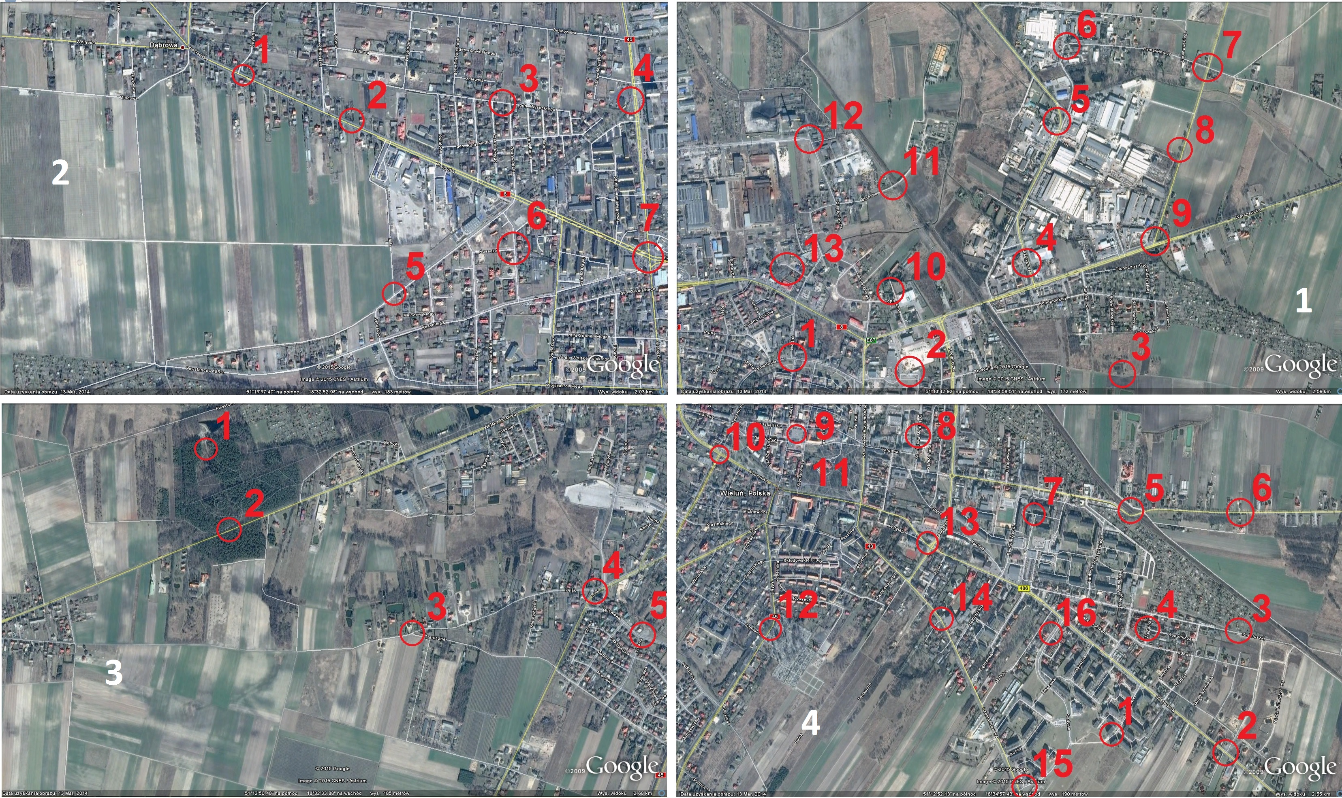

Map 1 is meanly industrial area of Wieluń. The biggest noticed values (maximal and average) appear near big factories on the suburbs. The other place of intensified noise is by a big route leading out of the city.
Map 2 presents the biggest values of intensity of sound, because of routes of big importance to the communication of the city.
Map 3 shows quiet places on fields and housing estates, which makes the values this little. Average values are much smaller here than in different parts of city.
Map 4 brings the biggest amount of measurements, because it takes a big part of city including both big roads and housing estates. The biggest values were visible near the big roads.

Results:
The highest intensity of sound and noise occurred near congested main roads and public places.
The uncertainties of measurements may have been caused by the lack of an anti-wind cover on the appliance.

K. Kalczynska, W. Kiejnach, M. Pekala "Tadeusz Kosciuszko" High School in Wielun, Poland)

