Visit of Polish students and teachers in Cluj Napoca

I organised the first meeting of the project from October 13 to 18 in Cluj Napoca. 16 Polish students and 16 Romanian students worked together with 3 teachers, Zenona Stojecka, Corina Toma (Physics teachers) and Mariola Jureńczyk (English teacher).
I think this project was a fruitful one because all students had to learn more in formal or nonformal environment. They were astonished of so many applications of new technology in understanding Physics phenomena.

In the first day we worked in school. At first it was the welcome meeting where we introduced each other and we proposed the program. Then we have visited my school.
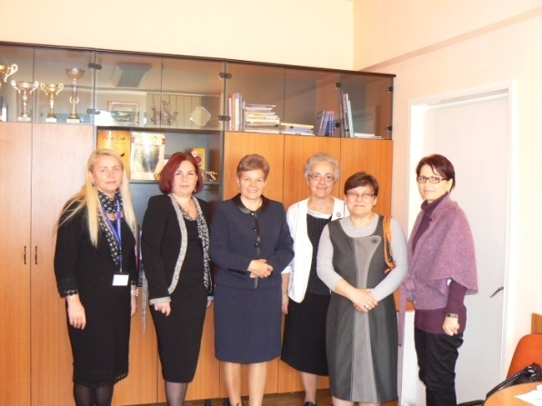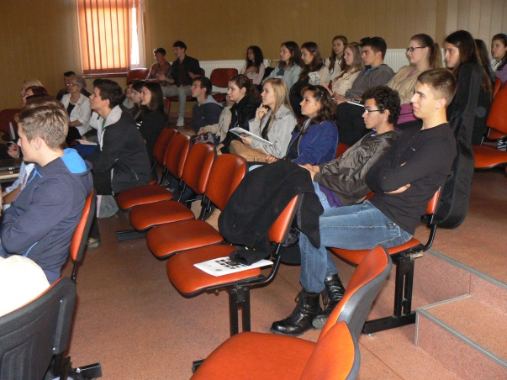

In the Physics laboratory, my students and I, we presented some of the most interesting experiments like: how to light a candle with a piece of glass, to measure the rotational frequency with the Smartphone, Kirlian effect, convection, the principle of coloured television, etc.

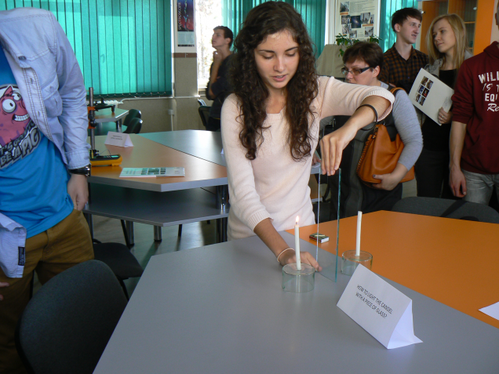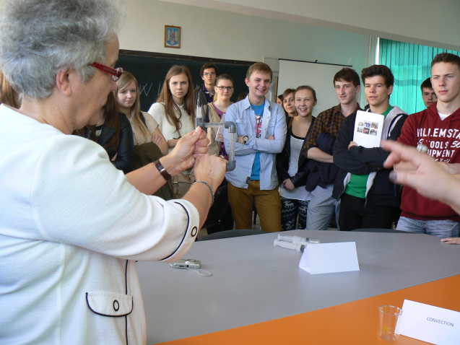
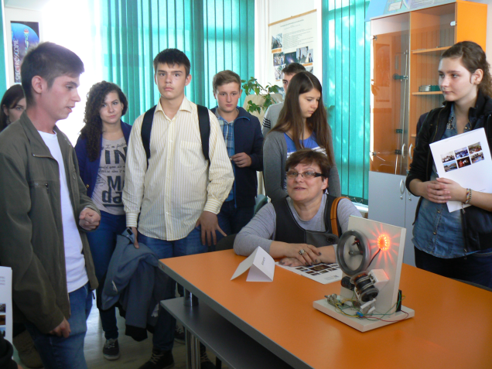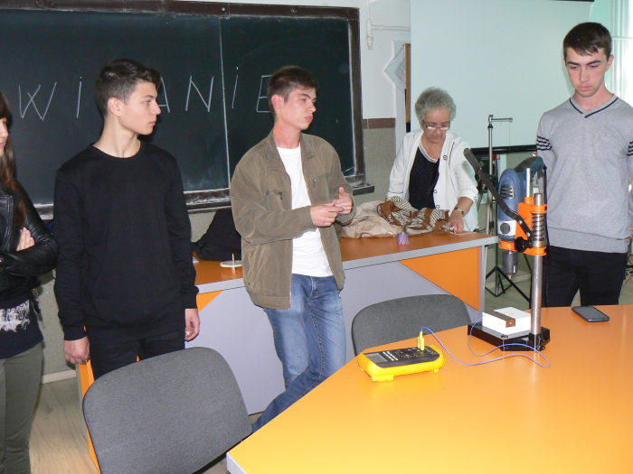

After a break we continued to work in computer lab, where I presented the lesson Total reflexion, using in the same time real experiments and virtual ones, created with the soft Crocodile Physics. We discussed the advantages of virtual experiments in this case. The students saw that they can create their own experiments with this soft in optics, electricity and mechanics.
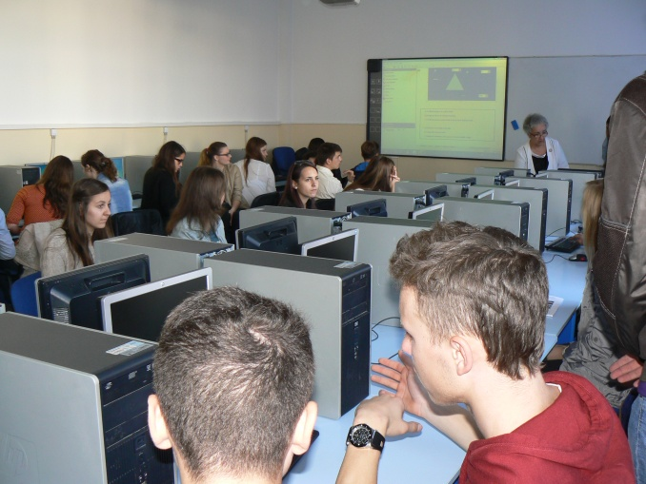
In the afternoon we walked in the Botanical Garden and analyzed the solar clock.
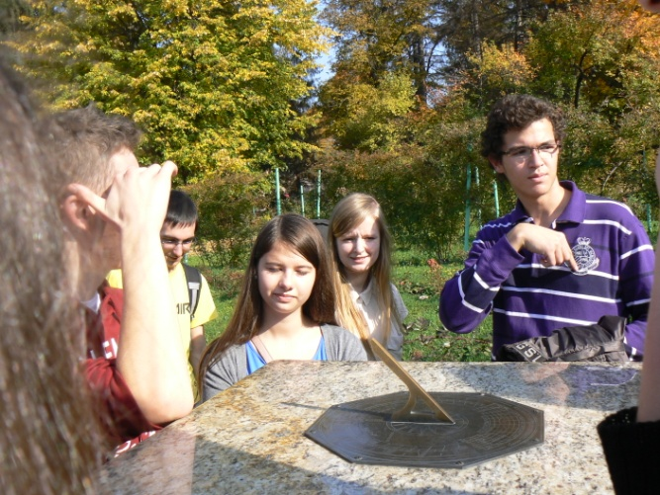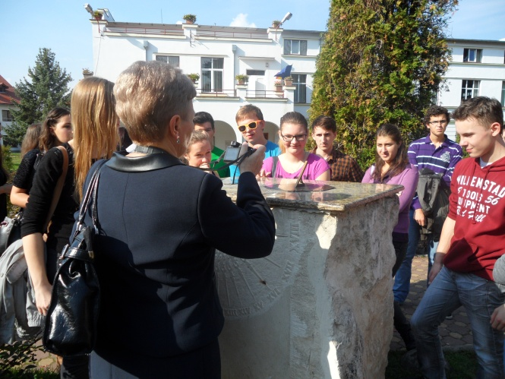
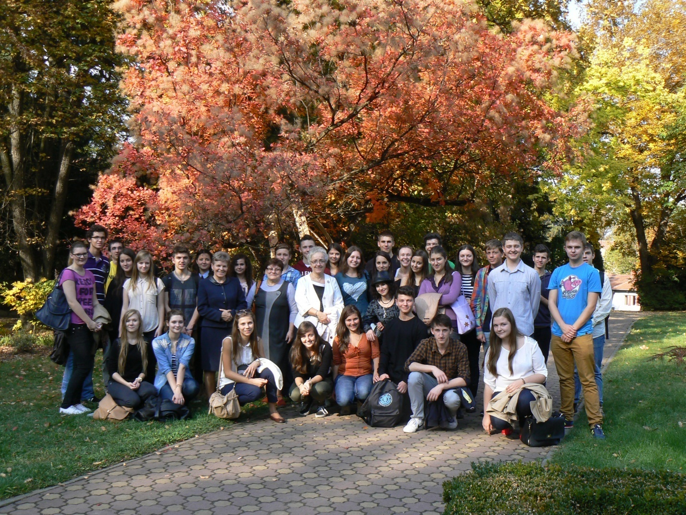
The second day we went to Turda and visited the Salt Mine.
There we have heard an echo about 8 times (it’s an interesting reflection of the sound) and we have determined the depth of the mine with 2 different methods: we measured the gravitational acceleration and the pressure with the Smartphone and we calculated the depth from their differences.

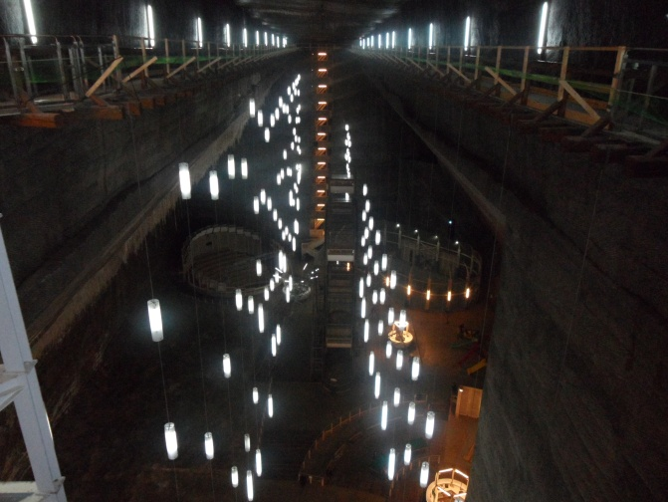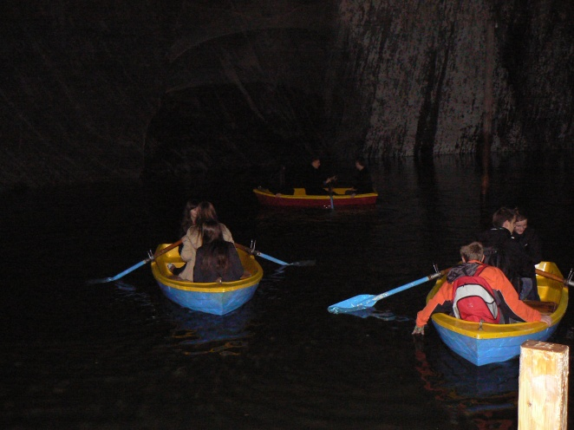

In the afternoon I presented the iStage teaching units Space Travel and Swinging Bodies. The students could understand better the Physics phenomena.
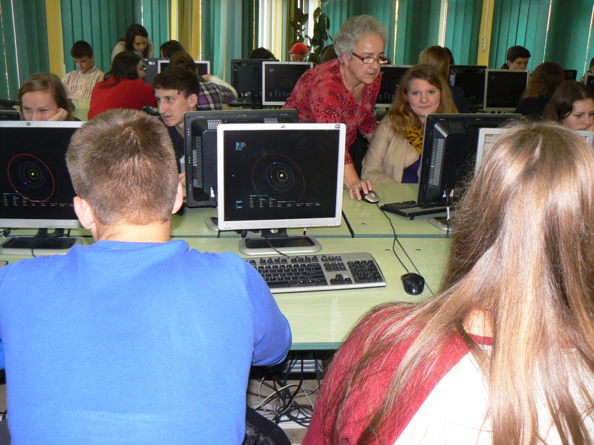

In the next day we have visited the National Institute for Research and Development of Isotopic and Molecular Technologies Cluj Napoca.
The students were very excited when they entered in the Grid Data Centre. They saw where are received and stored the data from CERN. Also they were impressed by the methods of the simulation of the intermolecular forces on PC.

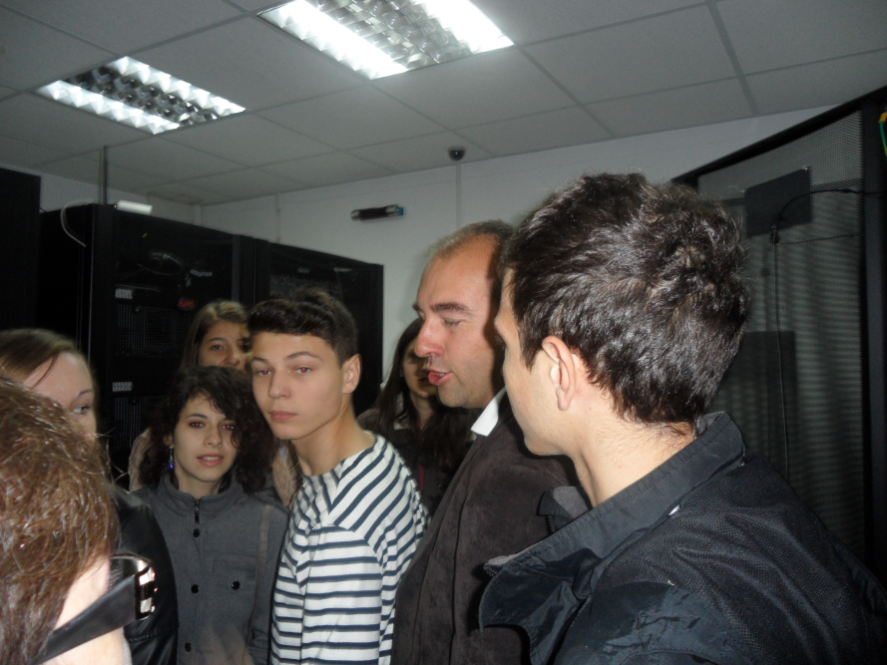

Then we visited the Pharmacy Museum one of the most interesting museums of my town with its ancient collections of pots and alchemists’ rooms.

In the last day we worked in school. I presented the soft Stellarium and how we can determine the period of the rotational movement of Jupiter’s moons (analogy with the oscillations). Then the Polish students presented their works in Physics. We were impressed by their activities in movement analysis, radioactivity measurements and sound analysis.

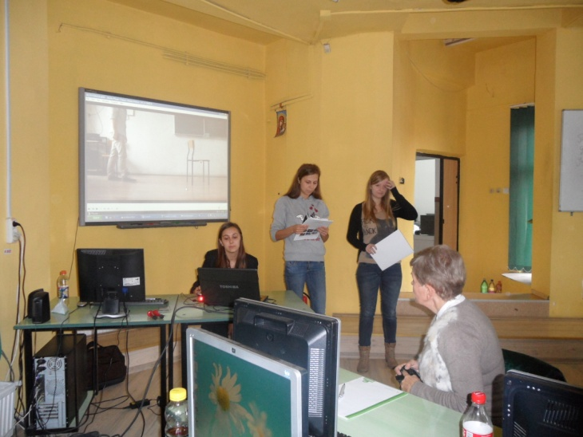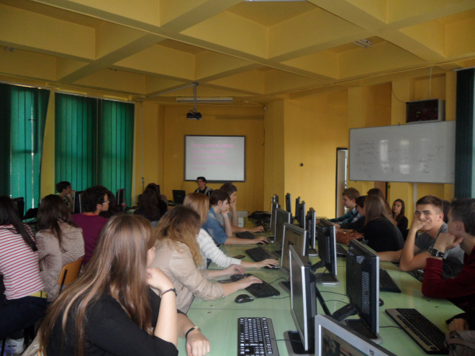

We consider that this kind of project is very usefull for teachers and also for students. Everyone could learn by doing and by seeing not from tales. It was a very good exchange of ideas.
We want to continue this project and to improve our work using the new methods.
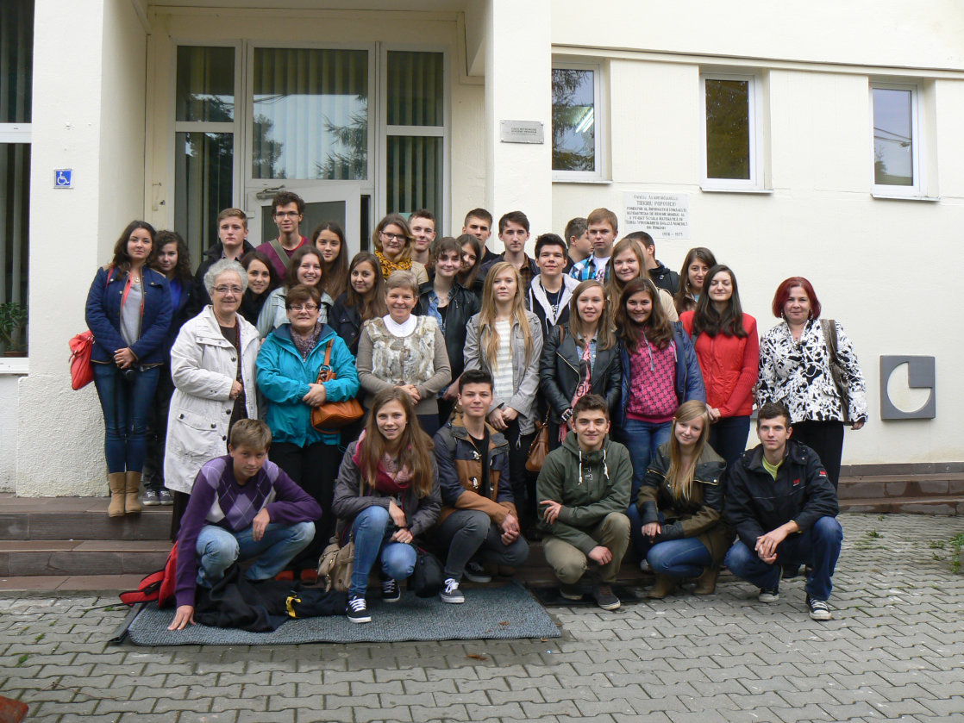

Thank you Science on Stage Deutschland and SAP – now we have new friends!

