**Measuring the Earth’s Magnetic Field**

The method was published in the brochure Smartphones in Science Teaching http://www.science-on-stage.de/page/display/en/7/7/678/istage-2-smartphones-im-naturwissenschaftlichen-unterricht1

The Earth’s magnetic field is more or less like a bar magnet tilted 11 degrees from the spin axis of the Earth.

The purpose of this experiment is to measure the horizontal of the Earth's magnetic field using the Helmholtz coils, a compass and a Smartphone with magnetometer.

First of all the students have to build the Helmholtz coils with special dimensions. The device produces a homogeneous magnetic field in the mid-plane between the two circular coils which are positioned in vertical planes and parallel to North - South direction. The Helmholtz coils magnetic field (BH) is perpendicular to the horizontal component of the Earth's magnetic field (BE). A compass placed in the central position of the apparatus points the vector sum of the two magnetic fields components as shown in Figure 1.

If φ = 450 then and the magnitude of the magnetic field produced by the apparatus, is equal with the horizontal component of the Earth's magnetic field.

|  |  |
| --- | --- |
| $\vec{{\text{B}}_{E}}$ φ $\vec{{\text{B}}_{\text{H}}}$ |  |
| Figure 1 |

.

$${\text{B}}_{\text{H}}\text{=}\frac{{\text{μ}}_{\text{0}}\text{NI}}{\text{R}}\frac{\text{8}}{\text{5}\sqrt{\text{5}}}$$

where  is number of turns in each coil (20 in our case),  is current through the coils in amperes,  is radius of the coils in meters ( in our case), and  is permeability of free space (vacuum).

Using an ammeter together with a variable DC power source, the students can compute the horizontal component of the Earth’s magnetic field.

The coils are positioned **horizontally** and parallel to North South direction.

Now, a compass is placed in the central position of the apparatus. Turn the power supply knob to produce the suggested values of electric current through the coils, resistor and ammeter until the needle aligned with the horizontal. Read the current and calculate intensity of magnetic field generated by coils. In this case, the magnetic field generated by coils and vertical component are equal.

Measure the deflection of the compass and record these angles.

Helmholtz Coils are connected to the ammeter via a current-limiting series resistor  ( in our case).

**PROCEDURE**

|  |  |
| --- | --- |
| Adjust the position of the Helmholtz Coils by rotating them (if necessary) around the vertical axis; their central axis, which points through the center of both coils, must be perpendicular to the compass direction. Turn the power supply knob to produce the suggested values of electric current through the coils, resistor and ammeter. The values are written in the table. Measure the deflection of the compass and record these angles. Calculate  and fill up the third column.  Remove compass from the middle of Helmholtz Coils and put in that place your Smartphone. Measure the horizontal component of Earth's magnetic field. | table |

**ANALYSIS**

Plot two graphs:

*  and
* linearized graph .

Draw the line that best fits the measurement points on linearized graph, choose two points from the line and write down its components (don’t forget on the physical units of components).

Calculate the coefficient of the straight line and find out the connection between coefficient and the horizontal component of Earth's magnetic field.

In Cluj Napoca we obtained these data:

|  |  |  |
| --- | --- | --- |
| I (mA) | φ | tgφ |
| 0 | 0 | 0 |
| 49 | 18 | 0.32492 |
| 100 | 27 | 0.509525 |
| 157 | 37 | 0.753554 |
| 200 | 41 | 0.869287 |
| 251 | 46 | 1.03553 |
| 300 | 51 | 1.234897 |
| 400 | 61 | 1.804048 |
| 489 | 66 | 2.246037 |

In Cluj Napoca we founded B = 20.02 μT and we compared it with the value calculated from NOAA which was 21.551 μT

Relative error is: 6.5% in 25.03.2014

**http://www.ngdc.noaa.gov/geomag-web/#igrfwmm**

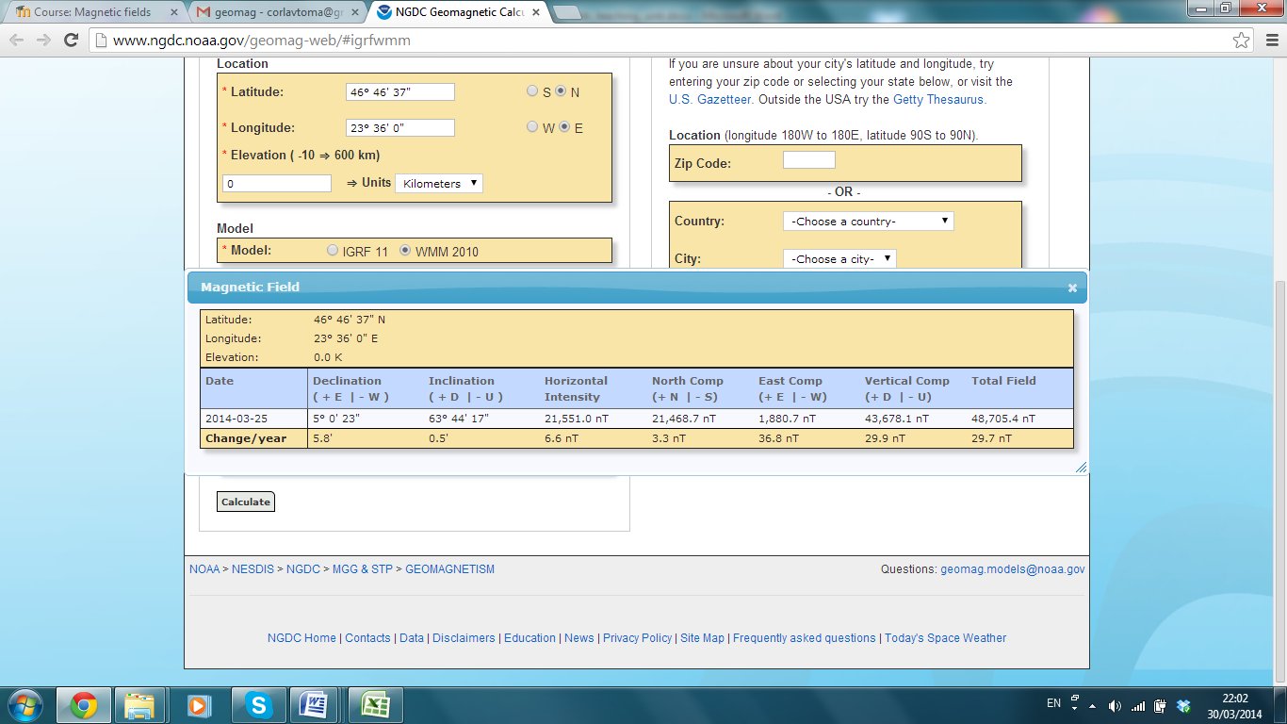

The students measured the horizontal magnetic field in Wielun (Poland) in 10.04.2014. They measured a value of 198 mA for the intensity of the current for Helmholtz coils. Then the B value is **17.795 μT.** In that day **the value there was 18.953 μT.**

**Relative error is: 6.2%**

