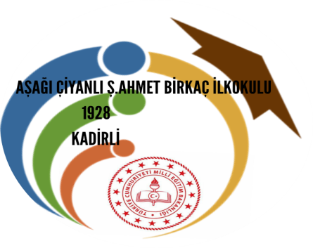
SCHEDULE FOR THE JOINT-STAFF TRAINING EVENT IN KADİRLİ , TURKEY
(November 10th to 16th November 2019)

November, the 10th  SUNDAY | During the day | Arrival of participants and accommodation in hotel
November, the 11th  MONDAY | 09:00 – 12:00  12:00 -13:30  14:00 – 15:00  15:30 – 17:30 | -Official welcome with school and city officials  -Introduction and tour through the school building  -Folk dances presentation  ●Ice-breaking activity ‘Opening Chit Chat’  ●Exchange of school information, city and country.  -Lunch /buffet at school  -Visiting the town hall  -City tour; Ala Mosque, Mosaic Excavation Area, Uzun Çarşı, Kabasakal Park
November, the 12th  TUESDAY | All day | Trip to Hatay ( The city of harmony of all religions and races,Hatay reflects the culture of Muslims,Christians, Jews,Armenians and Arabs.)  -Hatay Archaeological Museum  -Covered Bazaar and old Antioch  -Medical and Aromatic Plants Museum  -Lunch (Konak Restaurant paid in dutch style)  -St. Pierre Church  -Habib-i Neccar Mosque  -Harbiye  -Vakıflı Village  -Hıdırbey Musa Ağacı
November, the 13th  WEDNESDAY | 09:00 – 16:00  12.30 | In the morning: Project meeting at school  - -There will be presentation of the project (objectives,activities, results)  - Project website /Twinspace  - -creating a detailed project schedule  - -defining activities and tasks to meet each results  - -sequence of activities and tasks  - -estimating activity and task duration  - -deciding the exact time for Learning Teaching Training activities  Lunch in the city  In the afternoon: Training Session  -Digital media (Google apps, Skype etc)  -Web 2 tools for education (padlet, prezi, wevideo etc)  - E-book, newspaper, dictionary, handbooks..  -Integration of 4C skills in teaching with innovative practices
November, the 14th  THURSDAY | 09:00-15:00  20:00 | -Visiting Kadirli City Museum  -Karatepe Aslantaş Open Air Museum  -Excursion to Kızyusuflu Village and visiting the rug weaving looms in the village  Lunch (Traditional food)  Art Workshop “Art of Ebru”  Free time till dinner in the city centre  Dinner
November, the 15th  FRIDAY | All day | Trip to Adana Province and Tarsus City  Tarsus St.Paul Church, Tarsus Waterfall ,Saint Paul’s Well, Ulu Mosque, Kırk Kaşık Bazaar, Old Houses of Tarsus, Door of Kleopatra, Eshab-ı Keyf, Derinkuyu and Şahmeran  Lunch (Beyzade Kebab paid in dutch style)  Sabancı Mosque  Adana Central Park  Stone Bridge
November, the 16th  SATURDAY |  | Departure of participants throughout the day  PS: Timetable is flexible because of the connections.

