EPIPHANY ( TA FOTA )
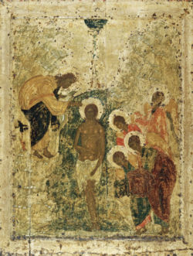 Epiphany in Greece is known as Theofania or Fota( lights). The first sanctification of the Epiphany (The Enlightenment) takes place in church on the eve of the holiday. Afterwards, the priest goes from house to house holding a cross and a basil branch. As he walks through each house, he uses the basil to sprinkle (bless) all the areas of the home. The big sanctification takes place the following day, January 6, the day of the Epiphany in Greece.
On January 6thA and just after the mass, a long procession is formed and heads to the nearest body of water - the sea, a river, a lake or even a reservoir. Up in front of the procession are the priest and the children carrying some icons. In the bigger cities, the procession becomes more elaborate with the addition of music bands.
When they reach the water, the priest throws a cross into the water, and in that way he blesses it.
(You must have in mind that Greece is a nautical country, so you can understand how important is the sea for Greek people. )
Then, those who dare - mostly the younger people - jump in the usually icy water and compete in retrieving the cross. The one who brings the cross up to the surface will enjoy good luck and health for the entire year.

Photos of Epiphany at Chios harbour
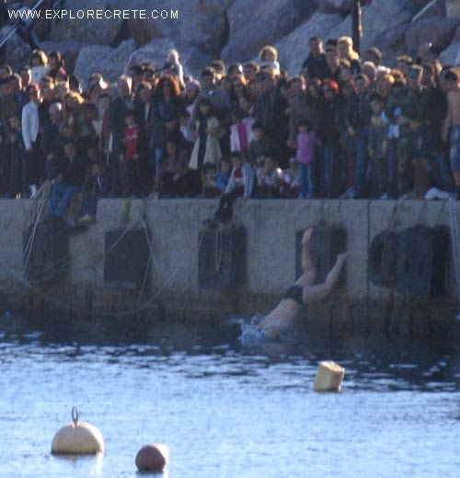
A young man is diving into the sea.

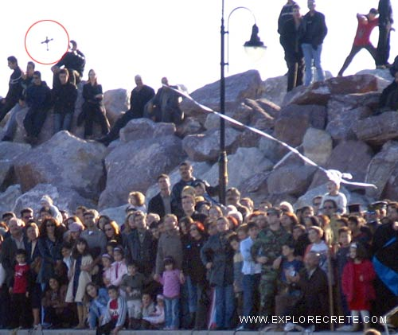
The priest is throwing the holy cross into the sea.

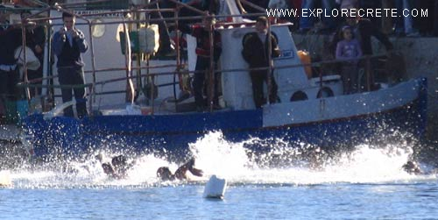
The young men are competing for the cross.

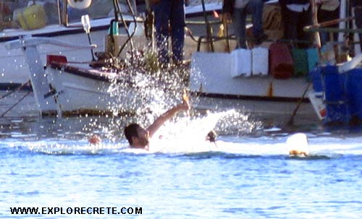
A man has caught the holy cross. He will enjoy good luck during the entire year.
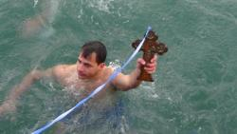

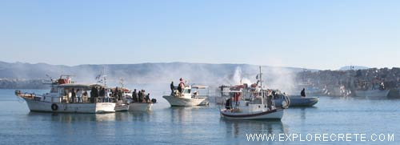
There are boats gathered around and they sound their horns and shoot flares to celebrate the retrieving of the holy cross and the blessing of the water.


