NEW YEAR’S CUSTOMS

VASILOPITA (SAINT BASIL’S BREAD)

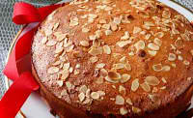

On New year’s Day, family and friends have lunch together. They usually eat pork, potatoes and salads. After the rich meal they all gather around the table because the man of the family is going to cut the Vasilopita and give each one a piece. What is special about this kind of new year’s sweet bread, is that there is a coin in it. The one who finds the coin in his piece is considered to be the lucky one of the year.
It is called Vasilopita,( Saint Basil’s bread), because the church celebrates the name of Saint Basil ( Vasilios in Greek), on the 1st January.

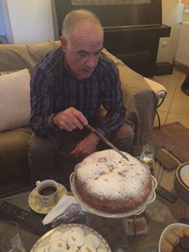 Father is cutting the Vasilopita

New Year's Calanda.MP4

THE BREAKING OF THE POMEGRANATE
On New Year’s Day. the man of each house brings a pomegranate to Saint Basil’s mass. When the family return home they don’t get into the house.
The father must ring the doorbell in order them to open him the door as he mustn’t use his key. Getting into the house as a guest, with his right foot he will be the person who will do good “first footing”, holding the pomegranate on his hand. After entering the house, he throws the pomegranate on the yard in order to break it while he says “with health, happiness and gladness the new year may come and I wish we have so many lyres(gold coins) as the seeds in the pomegranate”.

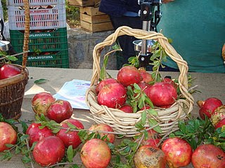

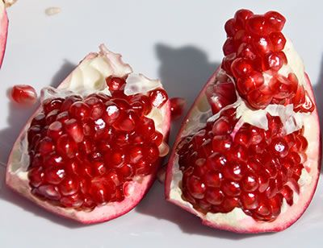
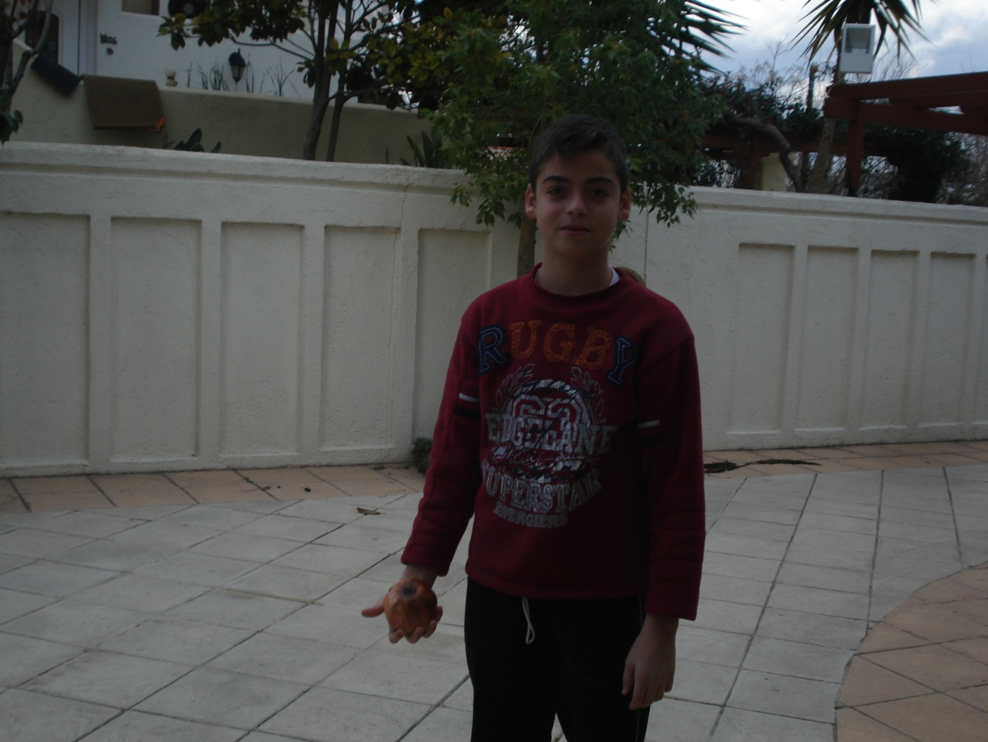

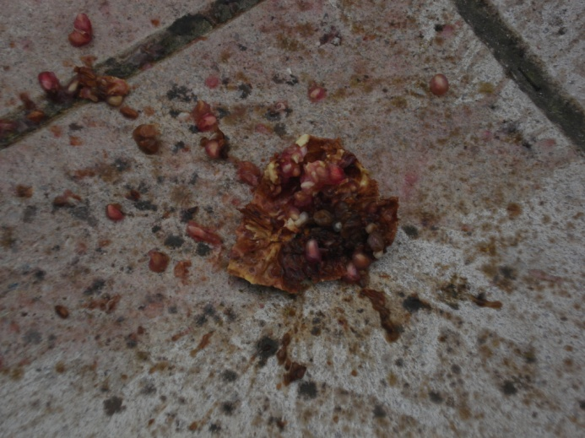
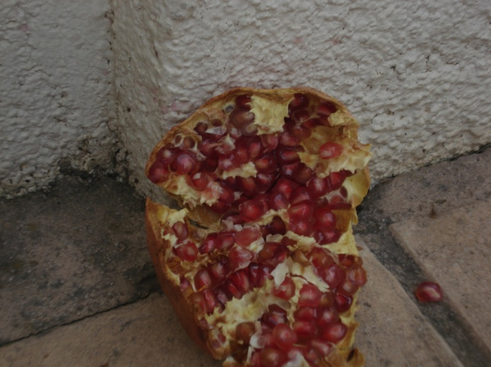

AYIOVASILIATIKA VAPORAKIA (ST. BASIL’S SHIPS)

(A custom that takes place only in Chios)

Every year, on New Years Eve, the traditional event of Ayiovasiliatika vaporakia ( the New Year's small Ships) takes place at the central square of Chios (Vounaki square) or at Homerion Cultural centre. This traditional event began as an honour for the Greek victories in naval battles during the Balkan wars, from the residents of Chios, Psarra and Minor Asia .Several teams from different neighbourhoods of the city get prepared for this day, starting enough months before, by making merchant vessels or battleships 5,5 meters long by hand, according to regulation. Every team presents its small ship, that has a given name by the team and then with the accompany of a trabouka (the pottery drum) or sometimes other musical instruments they sing carols which are wishes for the New Year and many times they satirize local political acts. In the end the best team, which is the one with the best ship and the one who sang the best carols is awarded with money and afterwards they wander their ship through the neighbourhoods of Chios singing carols.

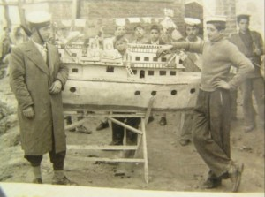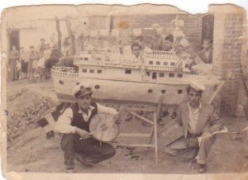

Pictures from the first years of the custom

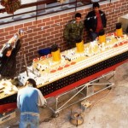
Preparations take a long time and a lot of work

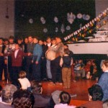 At the cultural centre 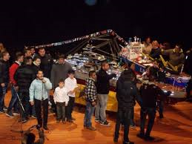 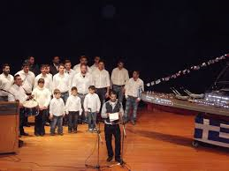

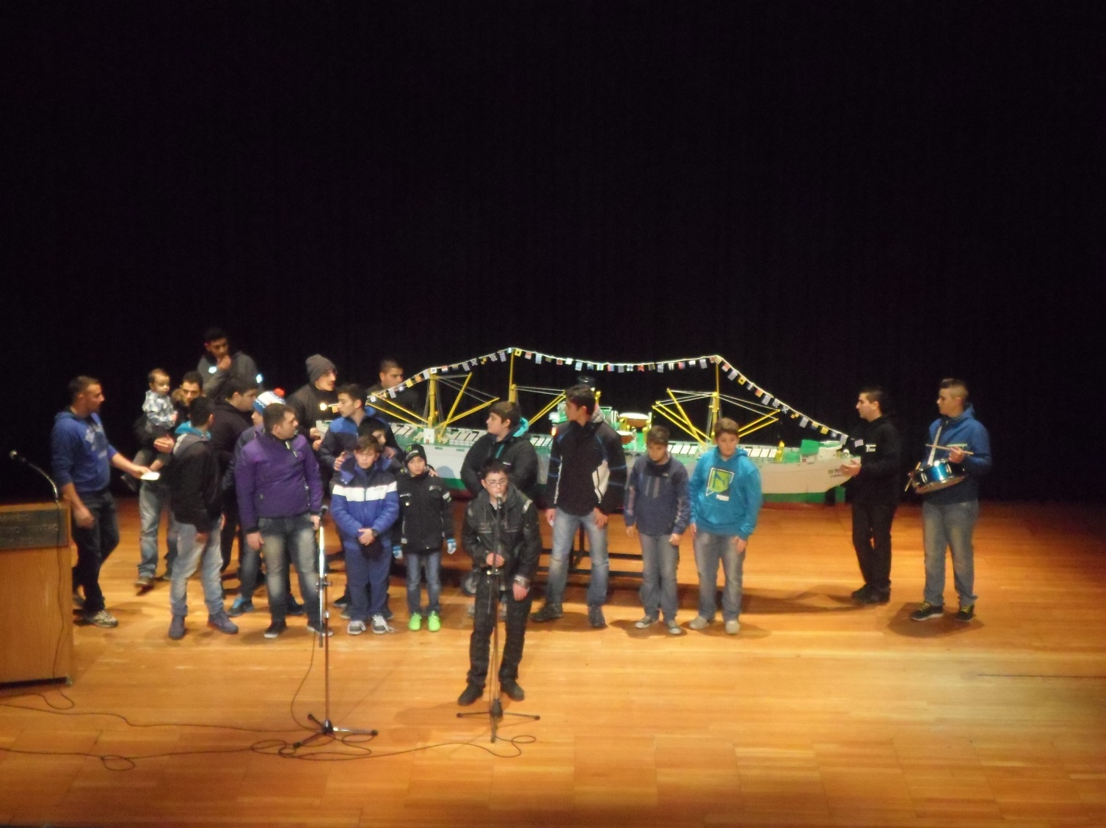

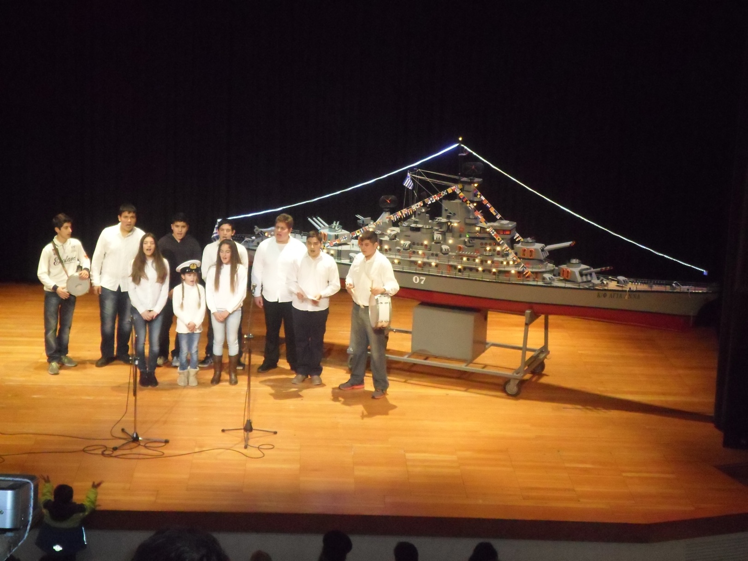

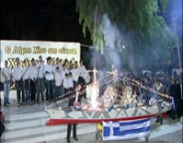

At the square

