What I have to say during the oral about climate change
Diagram about Convection & latent heat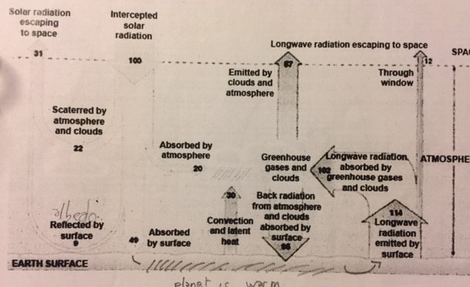
Causes of climate change:
Human activities are changing the natural greenhouse. The industrial activities have raised atmospheric carbon dioxide levels from 280 parts per million to about 417 parts per million in the last 151 years.
A group of 1300 independants scientifics concluded there is more than 95% probability that human activities over the past 50 years have warmed our planet

Reactions face to the climate change: Thunberg and trump and their impact
Greta Thunberg => Swedish vegan teenager with Asperger syndrome has she describe as a “gift” and a “superpower”. Started protesting outside the Swedish parliament in 2018 when she was 15 => to pressure the government to meet carbon emissions targets. Inspiring thousands of young people across the world to organise their own strikes => December 2018 more than 20K students from UK to Japan has joined her by skipping school to protest.
In 2019 she crossed the Atlantic to attend united nations climate conference in NY: most famous speech => told worlds leaders they were not doing enough.
Named Time Magazine’s Person of the year in December 2019. Hillary Clinton thanked her for “her willingness to tell hard, motivating truths”. Kim Kardashian: “brave and courageous”, support by climate activist, scientists, world leaders and the Pope but Donald trump is against Greta: tweeted that she should “work on her anger management problem” and go to a “good old-fashioned movie with a friend”.
Trump: “doesn’t really understand what climate change is about” professor Michael Gerrard => environmental law professor at the University of Columbia so trump is a Climate nihilist.
More than 130 steps the Trump administrations has taken to scale back measures to fight climate change, withdraw from the Paris climate agreement => was “terrible symbolically” and the 187 other countries to keep rising global temperatures below 2C

The connection between plastic waste and climate change
World’s growing production of plastics about 100 million tonnes annually => accelerating climate change. Plastic is one of the most persistent polluants on Earth, 400 years or more. Plastic creates greenhouse gas emissions. Impact of plastic production on the world’s climate this year will equate to the output of 189 coal-fired power stations. Almost all plastics are made from fossil fuel. Extracting and transporting those fuels, then manufacturing plastic creates billions of tonnes of greenhouse gases.
95% of the almost 3 million tonne of plastic is discarded after a single use. Less than 12% is recycled. Landfills or incinerated => pump more than 850 million tonnes of greenhouse gases. The plastic breaks down into more methane and ethylene.
The more plastic we make, the more fossil fuels we need, the more we exacerbate climate change.

What I do in favor of sustainable development?
What I do personally:
- Turn off the valve when I brush my teeth
- Selective sorting and composting for organic matter
- Try to stay as little time as possible in the shower
- Prefer the bike or skate for routes that can be achieved by this kind of transport

What we do in my home:
- Limit the plastic packaging in supermarket
- Limit consumption in general such as clothes and energy
- Promote short circuits for food (vegetables who come from the north of France and not from other countries
- Limit the heater and were a sweat-shirt
- Use washable objects => sponge…
- Made our own cleaning product without chemical component

To sum up, these measures serve to limit water consumption emission of CO2 or other greenhouse gases and the use of plastic.

