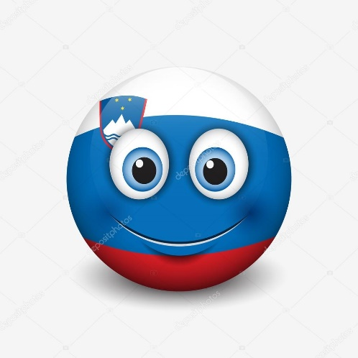
Rotten egg
(Gnilo jajce)

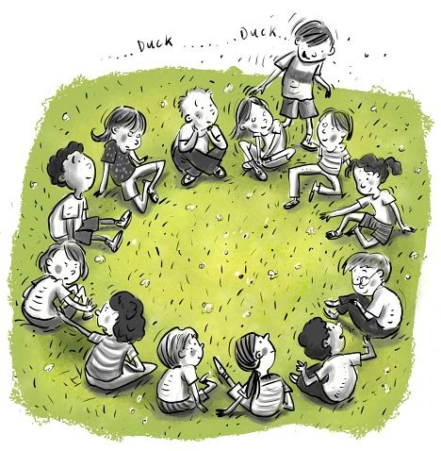
A group of players forms a single circle. They sit on the floor, facing inwards. One player is selected as the runner. While moving around the outside of the circle holding a ball made of crumpled paper (rotten egg), the runner sings the song: "Kanglca, kanglca, vodo drži, kdor se ozira, po hrbtu dobi." (»Don't look around, not even for a few seconds, beware of the bucket of water right here in my hands!«) In the meantime other players are not supposed to look around. They can turn around only when the runner has already passed them, but not while he/she is approaching each individual player. At a certain moment the runner drops the ball behind a player's back sitting in the circle. When the player notices that, he/she has to stand up and start chasing the runner trying to catch him/her before the runner occupies his/her place in the circle. If the runner is caught, he/she is sent to the middle of the circle as a punishment The Social games book 16 SLOVENIA: Rotten egg Rotten egg (Gnilo jajce) until he/she is replaced by another player. The one who has got the rotten egg continues the game as the new runner. If the runner is not caught, he/she keeps his/her position and continues the game.

