How knitting helps building friendships
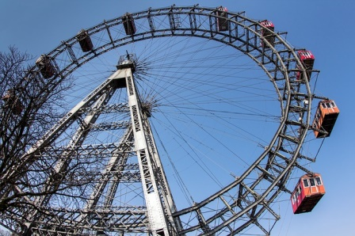
Story 1: Austria, Belgium, Czech Republic
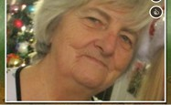
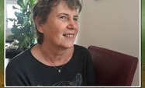
It was a sunny day in Vienna when Rosemarie and Anna went to a knitting competition. Rosemarie was very nervous, because she has never won a knitting competition before. At the age of 64 she was the youngest person in the room. After arriving there a man told all the contestants to build teams of two people.
Everyone had a partner except from Anna and Rosemarie so they met each other for the first time, because they had to be partners. Anna, the old lady with the grey hair, was very happy about that because Rosemarie looked very friendly. Every team seemed to be very skilled in knitting. Only Anna and Rosemarie were not that professional.
Ten minutes before the competition started, they got to know each other. They noticed that they are interested in the same things like cooking or knitting. Besides, both have grandchildren of the same age.
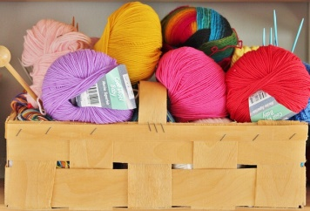
There were only a few minutes until the knitting competition started and they were very excited about that when suddenly …

Rosemarie had a cramp in the finger of her left hand. In the index actually. She didn’t want to say it because Anna was so impatient to start the competition. And she didn’t want to disappoint Anna. She was so friendly. But Rosemarie was slow to knit. She was suffering. The bell rang and the competition started.
Anna worked as hard as ever. She was sweating so much that she could have filled a pool. She wanted to win. Rosemarie was sweating too but for another reason. She was in so much pain. But she wanted to win as well. What could she do? She kept on knitting with a lot of courage.
But the pain was getting worse. Then she thought about her past. About what she had already gone through and she recalled one thing that really helped her. That was a hiking trip.
She remembered a hiking trip with a group of friends a year or two before. They had walked for a few hours in the morning and then after lunch she developed a headache. Unfortunately, she didn't have any painkillers with her and she also ran out of water. She didn't want to trouble the other people so she didn't tell anyone and just kept walking. However, her headache was getting worse and worse and she started to feel like fainting. "What would they do with me if I collapsed?" she thought.
In the end she decided to tell the others. They were not upset or annoyed; they were all understanding and caring. One of her friends had some painkiller in her rucksack and gave two pills to Rosemarie. Another one gave Rosemarie her spare plastic bottle with water. So Rosemarie took the pills and drank some water. The feeling that the others cared and did their best to help her, was probably the best cure for her so soon after, she felt much better and could walk on.
So that is what she remembered at the knitting competition. She decided not to play " a heroine" any more and to tell Anna. When Anna learned about the problem, she was more than understanding and immediately started to think how she could help. She remembered that it had also happened to her some time before and that a piece of chocolate and a glass of salty water helped. However they didn't have any with them.
So Anna started to ask the other contestants and thus they learnt about Rosemarie’s problem. Immediately they proposed that they all could have a coffee break so that Rosemarie had some time to recover and was not disadvantaged.
An elderly lady, Frieda from Austria had some chocolate with her and she gave it to Rosemarie. Another one brought some salt from a nearby restaurant and so Rosemarie could have a glass of salty water. Somebody else recommended washing hands alternating cold and hot water. It was difficult to say what exactly helped, but the truth is that after a few minutes the pain and the cramp were gone. Rosemarie was amazed - so many kind and caring people were at the contest! She felt all right again and the competition could go on.
If you would like to hear that Rosemarie and Anna won the competition in the end, we must disappoint you – they didn´t. It was a hard task to choose the winner as all the hand-knitted mufflers, mittens, caps, cushions ... were really beautiful. However, the panel chose a knitted teddy-bear which was really cute.
In spite of that, all the contestants were proud and happy as their products went to a charity shop to help to raise money for orphans. And Rosemarie was probably the happiest of them all because she made a lot of new caring friends.

A European fair in Brussels
Story 2: Belgium, Czech Republic, Greece
Stanislava is 66 and she loves travelling. What she loves most is meeting people. Nonna is 66 too. She was born in Italy but she has family in Belgium and Luxemburg. She also likes meeting people and discovering new things. So thanks to their grandchildren, Stanislava and Nonna met on the net and they decided to organize a fair in the European capital city: Brussels!
They decide to organize different workshops at the fair. The workshops are for their friends and their grandchildren. Before going to the big room, they want to have a guided visit of Brussels. So they contact Alois’ grandpa, because he knows a lot about history! And Alois’ grandpa agrees to do it. Great!
Stanislava and Nonna continued to plan their great event. They need different people to take care of the workshops: they want Jindriska and Ilona to teach the grandparents and their grandchildren to play the piano. Both agree and decide to prepare a small concert with their new students! Stanislava and Nonna continue to think about their workshops: one to learn to play cards, another one to do yoga, one to learn a play. They could do it before the concert. Everything is going well. But there is one thing they didn’t think about...
It was Alois, an educated, experienced and caring man from Austria, who saw the problem. He was aware of the fact that a trip to Brussels and staying there for a day or two was not a cheap thing and probably not all grandparents together with their grandchildren could afford to pay for it. And all of them wanted to go and the project was really great and enriching for them. So what could they do?
He wrote to Stanislava and Nonna about it and they started to think about how they could raise some money that would pay for the transport and accommodation.
First they decided to check if there was a kind of European programme that they could apply for. Unfortunately, they didn't find any.
The second idea was to address a few companies and firms in their regions and ask them for some financial support. They sent off a few applications and waited for the replies.
The three of them also wrote the other participants and asked them about their opinions and suggestions. The response was great - all of them wanted to contribute and do something to raise the money, e. g. to make and sell knitwear (some women in their team were quite skilled at knitting), to paint or draw pictures and sell them during an exhibition (again those good at painting could help with it), to organize sponsored hikes (quite a few of them were into travelling and hiking so they offered to look after it), or to grow flowers and sell them in the market (remember that there were quite a few people who love gardening).
Their grandchildren wanted to help too. They discussed options at school with the teachers and head teachers and at each of the schools involved they came up with different ideas …. In one school they decided to have a sponsored marathon in reading, in another they created beautiful handmade birthday cards and bookmarks and sold them at a school market, others collected recipes, printed them and sold them.
All together they managed to raise enough money so that everyone who wanted to go to Brussels to the fair but who couldn't afford to pay for the whole trip by themselves could get a reasonable financial support. However, it turned out that there was one more thing they hadn´t think about …..
The weather was really bad and all of the grandparents were worried because they didn’t know how they would travel to Brussels for the fair. They wanted to go there so much…
So, they decided to take the risk and went to the airport. Although all the other flights were cancelled, their own was just delayed. Thus, they waited patiently for one hour and then they boarded on the airplane.
The trip was difficult and it felt like the airplane was shaken out of the sky. Everyone was frightened but after some time they finally arrived to their destination, Brussels. There they met with Stanislava, Nonna and Alois’ Grandpa and the first thing they did was a guided tour to the capital of Europe. Last, they went to the fair and they had the best time together…
Stray cat finds a home
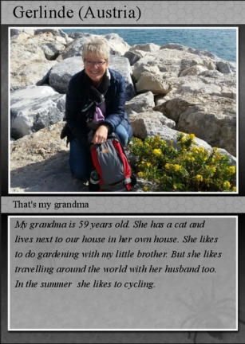
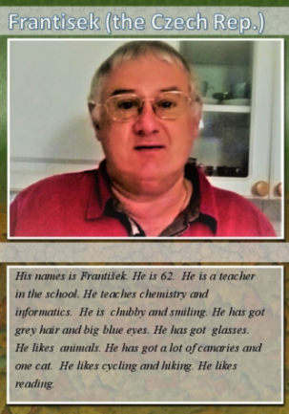
Story 3: Czech Republic, Greece, Moldova
Frantisek lives in a small town in the Czech Republic. He hasn´t retired yet, he teaches IT and chemistry at a secondary school. That is why he can't go on holiday whenever he wants but when it is school vacation. He has a lot of hobbies – but above all he likes gardening. He also loves animals and has a cat and a lot of canaries. He really enjoys reading. He is into sports too - together with his wife Ilona he often goes hiking and cycling.
Last July František and his wife decided to spend a few days cycling in Austria because it is the neighbouring country and both the landscape and towns are beautiful there. They booked a double room in a small hotel in Braunau am Inn as he had seen an interesting documentary about this region. They asked their granddaughters Eva and Anna to take care of their cats and canaries as well as to water the plants in their garden. As both of them like cycling, they put their bikes onto their car, the luggage into the car boot and early in the morning they drove to Austria.
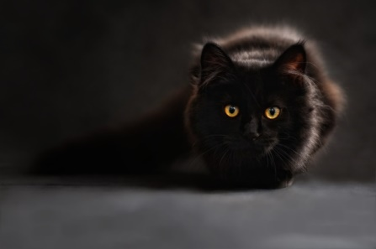
In Braunau they checked in the hotel first and then they picked some information leaflets at the tourist office. Then they got on their bikes and went on their first trip there. When they were riding in the outskirts of the town, in the middle of the road they saw a stray cat. It was cute and very friendly.
They understood that it had got lost and it was clear that if they don't help it, it might be ran over and killed by a car.
Frantisek and his wife were not only caring but sensitive as well. That’s why it was difficult for them to ignore the cat. They both were fond of animals and they would have been really disappointed if they hadn’t helped it. The cat had pretty crystal blue eyes and its fur was as white as snow. Suddenly, while they were talking about what they would do with the cat the ‘Stray Animal Service’ showed up. The stray animal officer went close to them and asked Frantisek whether he was the cat owner.
Frantisek said that they had just found the cat and they were still wondering what they would do with it. He also added that the cat seemed hungry and nervous and he suggested feeding and examining it. The officer agreed and recommended to search for the owner of the cat together. As soon as they agreed to start their search for the owner the cat started running away……
The cat was easy to follow as it was white and they kept running after it. But it was fast and soon they lost sight of it. The cat felt threatened and kept running as fast as it could. Being a stray cat was not easy and when people follow you that couldn’t have been a good thing. It had a very unpleasant experience just a couple of days ago. So it just ran and ran. Finally it got to some carts full of suitcases, found refuge and a safe place right in the middle of one of the carts and as tired as it was it fell asleep.
It was an airport luggage cart and soon it was loaded into a plane to fly to Vienna. The cat was too tired to feel anything and slept soundly. The can got woken up by the loud sound of the breaks when the plane landed. It couldn’t understand where it was or what was the sound, which scared it even more.
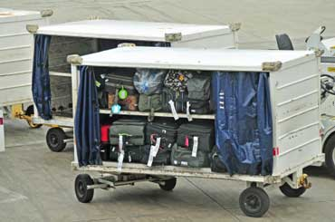
Meanwhile Frantisek put an add in the local newspaper with a picture that he had managed to take before the cat ran away.

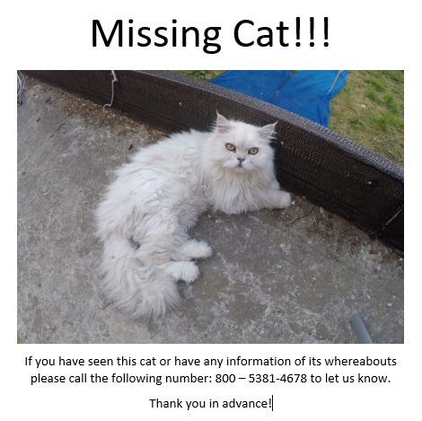

He had also put adds all around the place. He and Ilona took long trips on their bikes to check the places around Braunau am Inn but the cat was nowhere to be found.
Gerlinde was in the Vienna airport she had been at a Gardening Conference in Vienna and was going back to Braunau am Inn. She checked in and was waiting by the gate. The bus came to take them to the plane and she was ready to get on the bus when she saw a dirty, hungry looking, white cat. She was a cat lover and couldn’t ignore the cat. She had a piece of a sandwich and she offered it to the cat. The cat was shy but hungry enough to take the offer and Gerlinde petted the cat. The cat followed her and Gerlinde decided to take her on board of the plane with her and put it in her bag.
The flight was short and it didn’t take Gerlinde long before she was in Braunau. As she was getting off from the taxi she took from the airport, she saw Frantisek’s add and recognised the cat. It was unbelievable! How did the cat get to Vienna? Maybe it wasn’t the same cat? She called right away and told Frantisek to come to her house.
When he and Ilona came, they told her all about the cat, they were surprised to learn that Gerlinde found it in Vienna airport. They were having tea when Gerlinde’s grandson came to visit her. He saw the cat and jumped with joy. He kept running around saying “You got me the cat you have promised! Thank you grandma!”
Frantisek and his wife were confused but Gerlinde was smiling. She told them that she had promised to buy her grandson a cat. Frantisek, Ilona and Gerlinde looked at each other and didn’t say anything. They mutually agreed that the cat found an owner. Now the cat’s journey was over and so was Frantisek’s and his wife’s. They had to go back to Czech Republic but they felt good about the trip as they have met nice people in Austria and they have understood that everywhere in the world there are people like them who like animals and would care about them even if they are stray.
The Mystery of the White Monkey
Story 4: Greece, Moldova, Poland

One sunny day Nadejda, who loves animals, decided to go to the zoo of her hometown in Moldova. Ilona, on the other hand, made her way to Moldova all the way from the Czech Republic where she lived to visit the amazing zoo in Moldova which she had heard so much about.
Nadejda was already in the zoo. She was hanging around watching different animals when she saw an empty cage. Ilona was standing in front of the empty cage as well, wondering what might have happened while other zoo visitors seemed rather alarmed or even panicked. ‘What’s going on?’ asked Ilona. ‘I think an animal has escaped’ answered Nadejda.
The picture on the entrance of the empty cage showed a beautiful small white monkey with blue eyes.
Both Ilona and Nadejda went straight to the zoo manager and asked about the missing animal. It was a rare species, the manager told them but it was in danger. The two women volunteered to help and left the zoo. They went nearby to a café to make a plan how they would catch the monkey. While having coffee they heard on the local TV channel, that a mysterious white monkey was spotted in the open market stealing things from the stalls…
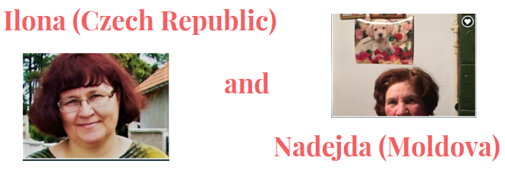
Nadejda was a passionate reader of detective stories.
As a child, she had read all Conan Doyle books about Sherlock Holmes and Dr Watson, as well as Agatha Christie's stories. This was a perfect opportunity for her to engage in a real adventure, investigate a real case and help the zookeepers. Ilona was just as enthusiastic about it as Nadejda. She had an idea about the monkey. There were monkeys of the same species in the Prague zoo. Since the monkey was of a very rare species she thought that she could arrange with the zookeepers a partnership. But they needed to find the monkey first. So, they set on a search.
When they heard on the news that the monkey was spotted at the market, they went straight there. They went around the market asking people if they didn’t see a monkey. Nobody seemed to have seen it when finally, a lady told them that she saw a monkey that was stealing bananas from her neighbour, but when he tried to catch it, it ran away.
The two ladies saw a banana peel on the ground not too far away from where the lady said she saw the monkey. Then there was another one further away… Nadejda and Ilona followed the banana peels. They were sure on the right track.
They got to a dark corner between the Dairy and Fishmongers Pavilions and there were two more banana peels. But there was no monkey. They spotted some white hairs which they linked to the monkey’s fur. The monkey had been there. But where was it now?
Not far from the corner was a beggar. They asked the beggar if he didn’t see anything strange that day. He looked at them, then looked around and then whispered that he saw a beautiful little white monkey and two suspicious looking men who went after it. They went between the pavilions and when they came back one of them had a sack on his back and in it there was something but it wasn’t moving. Ilona and Nadejda understood that the monkey was probably sedated and that it was in danger.
Nadejda and Ilona followed the men. Suddenly they came to a forest. The women were a bit frightened, but they still went behind them. They walked for a long time, when they came to a forest glade, the thieves pulled out the monkey from the bag. The animal was woozy. The women started to worry and Nadejda decided to call the police. Ilona watched them for a few minutes. Unfortunately, one of the men saw her. She started to run away, he stopped when Nadejda put her left leg forward. He tripped over it and fell down.
The woman applied the grip that she learned during the karate lessons. Luckily, the second thief had to deal with an animal that was starting to feel better. The police appeared, and they were shocked how such a small woman coped with such a tall man. The second thief started to run, but Ilona helped the police to catch him.
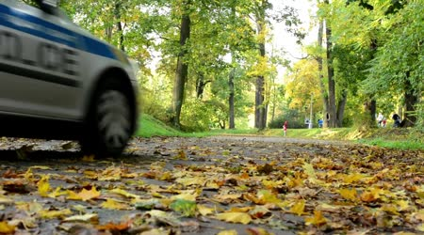
The women called the vet (Miromir Zivkocic from Serbia), who helped the animal. The monkey was a little shocked. It spent five days in a veterinary clinic. Nadejda and Ilona visited the monkey as well as Miromir in the clinic and they together started to help the ill animals. They were really happy to help the ill animals.
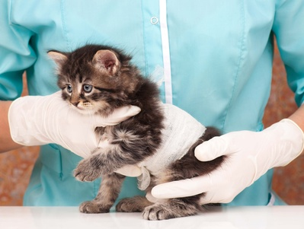
The women had to make a statement to the police and the thieves were punished by paying a fine for an organization that was helping the animals.
The monkey went back to the ZOO.
The women started to visit the animals in the clinic and helped the worker to take care of the ill animals.
Nadejda, Ilona and Miromir together started to organize the fundraising events to help the ill animals.

The Football Adventure
Story 5: Moldova, Poland, Serbia

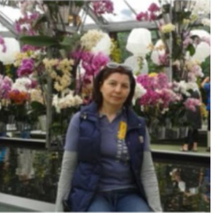
It was a beautiful, sunny summer day in Chisinau, Moldova. Liuba was in the “Valea Morilor” Park, taking her usual morning walk.
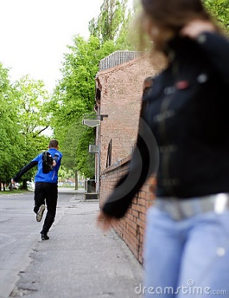
Young and happy she was walking around the lake when she saw a tall man with a moustache walking in the park too. Liuba thought “What a handsome man!” Suddenly a man in black ran by, stole her purse and ran away. Right away the man with the moustache ran after him.
Liuba said to herself “What a hero! He is such a brave man”. It didn’t take him long to catch the thief and very soon the man in black was on the ground and Liuba was calling the police. While the police was on the way Liuba had a small talk with the mysterious man.
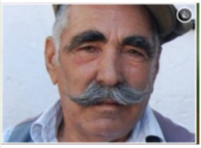
He was not from Moldova. He told her that his name was Dobrica and he was from Serbia. He was there to support Serbia’s team in the game Moldova - Serbia that was on that night. He was a football fan.
Soon the police came and took the thief but Dobrica and Liuba didn’t want to part and went for a walk together. Time flew and they didn’t even notice when it was evening. They spent the whole day talking. And Dobrica asked Liuba if she would like to join him to watch the game that night. Liuba has never been to a football game before but she gladly agreed to go.
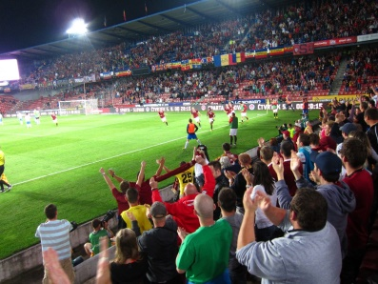
She liked this kind man with thick eyebrows and thoughtful eyes. They talked about different things, they laughed and the world was only theirs.
The football game was a hit!

Liuba loved when people stood up to cheer and she liked the excitement in Dobrica’s eyes when one of the teams was close to a goal. Only from time to time a shade of sadness could be seen on both of their faces. They knew that the next day Dobrica had a flight back to Serbia.
At home, she was thinking about Dobrica. He was really friendly and clever. They called each other every day and talked about grandchildren, about their childhood. Every day they talked longer and longer, they cannot wait for the phone time.
One day Dobrica arranged a meeting with Liuba, and asked her:
"Can you come to the football match next weekend?". She said: "Yes, I think that's a good idea". They couldn’t wait for this meeting. He took her from the airport and went to the stadium. They were very happy to meet. The match was really exciting and they had fun. They talked all the time. After the match, they went for a dinner to Liuba’s hotel. During the dinner Dobrica and Liuba saw very weird woman in a black cap, dark hoodie and blue jeans. She was wearing sunglasses, but there wasn't any sun. She was talking on the phone. Liuba heard that the woman said: "I saw him, he is with his friend. They're talking, but... Oh no! “ Lubia was really scared, but he knew that the woman was his wife. Liuba wanted to solve the mystery.
The woman looked at them all the time. Liuba and Dobrica ate the dinner and agreed on meeting the following day. When Dobrica left the hotel, Liuba came to the woman and asked her: “Who are you? Why were you watching us?” The woman said that she is Milanka, and she was Dobrica’s wife.
The women talked together for a long time. Milanka told Liuba some interesting facts about Dobrica. The next day Liuba packed her bags and went back to Moldavia, she had no idea what to do in this situation. She missed Dobrica, but when Dobrica came to the hotel he noticed that Liuba‘s room is closed. He asked himself “What happened?”Dobrica was very sad…
When he returned home, his wife told him that she met a very interesting woman that night (very wise, wasn’t she…). She was a foreigner, and asked her some direction in Russian. She was confused, at the beginning, but then she remembered her Russian from school, and they spent three hours in a lovely and friendly conversation. Dobrica was very surprised to hear that her name was Liuba, and that she was from Moldova. In the next few months the two grandmothers exchanged many letters, and got fond of each other.
Dobrica had to fit into their friendship. So they finally arranged to meet in a nice Greek island of Thassos, where they all went with their grandchildren.
It was unforgettable holiday for all of them, and they kept in touch in the next years….
THE END…..
OR A NEW BEGINNING…

The Cooking Contest
Story 6: Poland, Serbia, Slovakia

It was a beautiful, sunny day in Serbia. Stojan’s daughter came to his birthday party. He was very surprised when he saw his present. It was a ticket for a cooking competition.
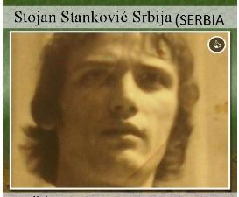
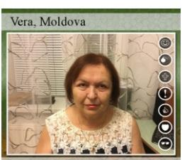
When Stojan came there, he saw a woman named Vera. She arrived there from Moldova.

They talked for a short time because the contest started.
Their first task was: to prepare a vegetable soup. Stojan noticed that Vera was a good cook, he did not think about his soup, but looked at his rival. She was smiling and also from time to time looked at him. When he noticed that time is almost over he started to prepare his soup really fast.
The jury decided that Vera made the best soup. He was surprised to win the second place. After the competition Stojan came to the Vera and said:
“Congratulation! Your soup was the best, could we go for a coffee?” She agreed.
They talked for a long time, she told him that she was from Moldova, and she loves cooking as well as listening to music. He informed her that he has a music band and invited Vera to his concert. After the meeting, Vera thought about the handsome man and the concert.
Vera decided to go to the concert. She didn`t have anything to do that evening, anyway. Stojan’s wife died three years ago, and the music was his best friend. He loved the time he spent with his guitar, as well as cooking...
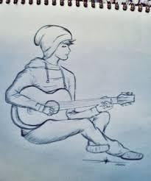
The concert was very good. Vera enjoyed it very much, but when Stojan went down the stairs, to greet her he fell down and twisted his ankle. Vera was with him when he went to the hospital. He had to stay there for two days, and that meant that he was not going to be able to continue the cooking competition...
Next part of the competition was much more complicated. Vera talked to Stojan about the meal she wanted to prepare, and he gave her a few very good tips. She was nervous, but Stojan made her laugh, and she calmed down. The next day while cooking, she kept thinking about Stojan’s jokes, and felt very relaxed. She won the first prize in main meals competition and went to celebrate it with Stojan who was still in the hospital....
When Vera came to the hospital to visit Stojan the next morning, he was so sad! She asked him, why he was so sad. Stojan looked at her with tears in his eyes. And he told her that he lost the sense of smell and taste. He was really devastated because of this disorder he couldn´t cook. NEVER AGAIN.
Stojan came home from hospital but he still had pains. Vera came to the hospital to visit Stojan but a doctor told her that he had been released the day before. So Vera made a decision that she should go visit him.
She walked around the park and she saw Tom and Grey’s Grocery shop, so she bought some ingredients. Later, she knocked at his door and his daughter opened. Vera started to cook some delicacy. Stojan joined her. Joint cooking was successful. They had dinner with St0jan’s daughter. She was amazed and registered them to the cooking competition.
They had to cook Ratatouille and it was amazing. They won. Stojan had no sense of taste but he gained the taste of life.

Only laughs
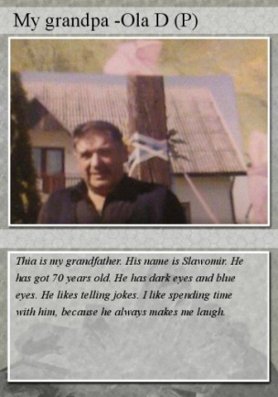
Story 7: Serbia, Slovakia, Austria
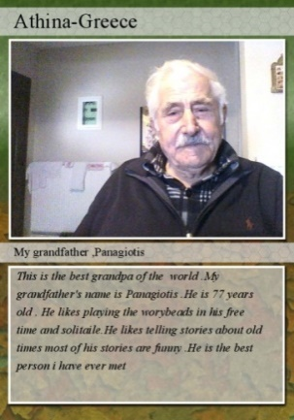
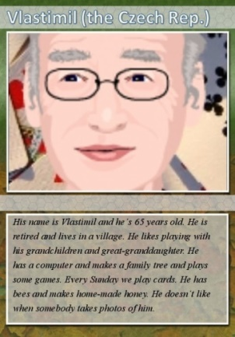
Three strangers went to the seaside long time ago…
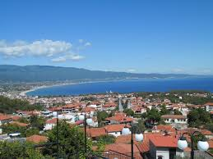
They were just over 20 years old. One from Poland, one from Czechoslovakia (now the Czech Republic), and one from Northern Greece. They all went to Stavros, never expecting a great adventure ahead of them...
It happened, they all went to the same beach, stayed in the same hotel, liked drinking beer in the same place, and always joked and laughed a lot, but they never met. One day, Vlastimil (he was 15 years old then) went on the pedalling boat, but one of the pedals broke and he couldn't return back.
Slawomir (20 years old) and Panagiotis (27 years old) went pedalling too, on their own. They went the same way as Vlastimil did, but from other parts of the beach. They both had some friends with them, and laughed a lot. They saw Vlastimil waving at them and they waved, too.
He tried to shout and tell them he is in trouble, but he didn't speak any foreign language, so he waved and waved, jumped and made funny faces… Slawomir and Panagiotis were so amused, that they wanted to meet such a funny boy.
Slawomir thought that Vlastimil was a sea beggar and went to him to give him some small change. When he came to Vlastimil, the Czech boy was really confused, that he offered him money. But he said to himself: Every money is good. And he took the coins. But he still needed help.
Panagiotis thought that Vlastimil was his long lost brother who had been missing for many years. So he went closer to have a look at him. When he approached the two men, it came out that it was not him. But they clearly had a problem. Perhaps he could help.
Panagiotis realised that Vlastimil´s boat was broken. He took a string from his colourful swimming shorts and tied the broken boat to his. Now he was able to pull him to the beach.
Suddenly, a thunderstorm started! The waves were growing bigger and bigger. Slawomir threw all his coins into the sea not to attract the lightning. The other two thought he was dancing a ritual dance so they started to imitate him. Accidentally, Panagiotis fell in water. The bad thing was, his swimming shorts were very loose. He couldn't swim, because he wouldn't be able to hold them.
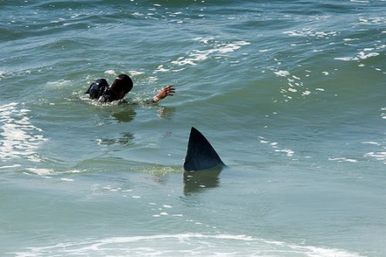
He started to drown. “Oh, what a new style of swimming,” Slawomir and Vlastimil thought. After a while they could not see him anymore. So they jumped to save him. However, they had not heard the warning that the area was full of sharks...
Slawomir and Vlastimil had been searching for him for a long time, but they couldn't find him. The water was deadly dull.
They were extremely exhausted, flustered and sad. They had no more glimmer of hope to save the young man. So they decided to get back to their boats when suddenly Slawomir felt something strange on his left leg. He got into a panic and screamed loudly. He felt extreme mortal agony. “I am too young and too handsome to die! Please, little sweet shark, take the others, but don't grab me!!!!”
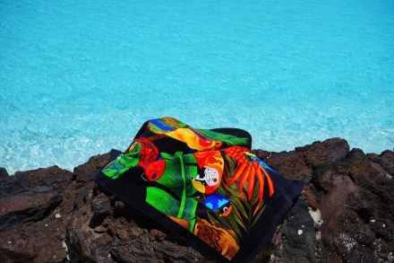
Vlastimil noticed that the strange thing was Panagiotis´ swimming shorts and went into fits of laughter. In the meantime Panagiotis was swimming to the beach to get help. When he realized that he was naked, he quickly took the first towel he saw – unfortunately a small one - and wrapped it around his athletic body.
On his way to the coastguard he was walking like a penguin constantly fearing to lose the towel. He informed the coastguard that two other guys were still on the sea.
After a few minutes they found the two shivering men holding on to each other in one boat. In front of their boat a little shark was swimming and everybody could see a giant shark approaching. Slawomir and Vlastimil tried hard to chase away the shark with Panagiotis’ swimming shorts.
The coastguard had to act quickly to save the two men in distress at sea. They threw some fish and blood into the water to distract the sharks.The tactics worked. The sharks quickly swam towards the quarry. Vlastimil and Slawomir were saved!
All´s well that ends well. Panagiotis, Vlastimil and Slawomir got friends and every year they meet in Stavros again to remember their great adventure.
Meeting in the heart of Europe
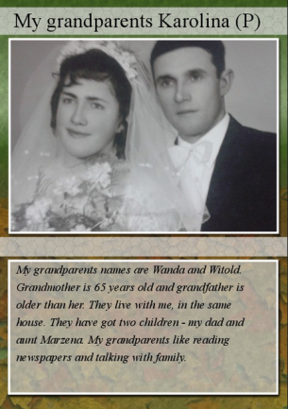
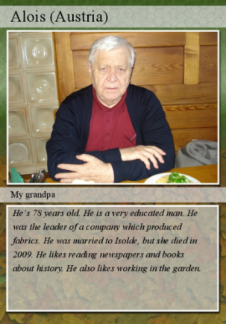
Story 8: Slovakia, Austria, Belgium
A Polish couple, Wanda and Witold, came to Slovakia 20 years ago. They wanted to visit Bratislava with its castle. In a newsagent's under the castle they bought a Slovak newspaper. However, they realised they did not understand Slovak so well, and decided to go to a bookshop to buy a dictionary.
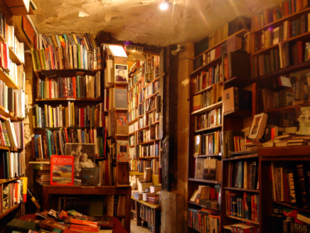
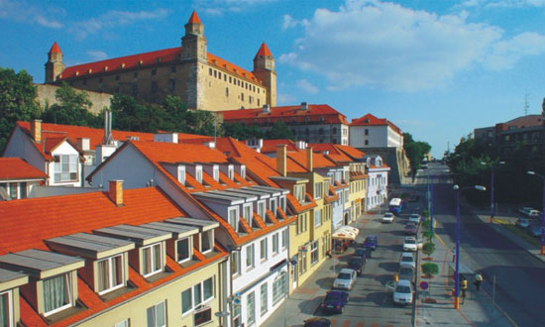
Alois, a very educated Austrian man who spoke Slovak, English and Chinese was at the bookshop, too. He came there to look for information about Slovak traditional technique of colouring fabrics in blue. He could not find it so he asked two strangers for help.
It turned out that they were just tourists and even more confused than he was. He tried to communicate with them in Slovak but that didn’t help. He also tried to speak English with them but that didn’t work out either. Alois gave up and went to look for the seller.
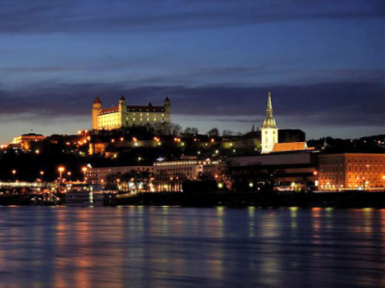
Meanwhile, Wanda and Witold were thinking about how interesting that man was that they totally forgot about the dictionary they were searching for. When they realised that it was getting pretty dark outside they became quite worried because they did not know the city well enough to find their hotel in the crawling darkness.
They were walking out of the bookshop and noticed a familiar man in front of them. It was the man who tried to tell them something apparently very important. They decided to follow him, not knowing why exactly.
Alois was lost in thought how to get information about this traditional technique of colouring fabrics. Then he saw the couple again, but he did not dare to contact them again. So he decided to go to a restaurant. After a while he noticed, that the couple was following him.
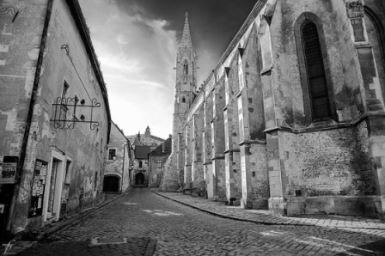
Suddenly he turned around and looked at them in a strange way. Wanda and Witold decided to go away because they were a bit scared of him. They went faster and faster until they were running. Alois followed them, because he wanted to clear up the situation and of course he did not want to scare anybody.
As Wanda saw that the man took something strange out of his bag, she started screaming, because she thought it was a gun. They could not run anymore because they were too scared. The strange man slowly came closer and closer and now Witold started screaming too.

Alois didn’t know what to do, because he was very confused about the situation. He didn’t know why they were screaming because he only took out his smartphone.

As he couldn´t find what he was looking for, that is Slovak techniques of colouring fabrics, he just wanted to tell them about the important thing!
The important thing he wanted to tell them was that when he was a young boy, he used to come on holiday to his grandparents. His grandparents were Polish too. And he recognized Wanda! And they lived next to Wanda´s house. When he was on holiday in Poland, he liked to visit Wanda´s parents, because her mother always gave him cakes and biscuits while her father took him on a fishing day.
That's what he wanted to tell them, because he was grateful to them and he has so good memories.

