Waste or Save? Reduce water consumption

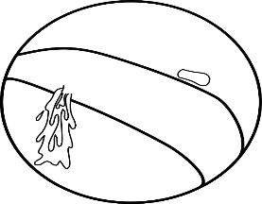
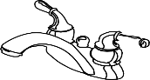
TOPIC: Reduce water consumption

Objectives
Students will
- identify ways that water is wasted and conserved
- sort pictures and classify them into two categories
- develop speaking skills through a discussion of the use of water in everyday life
- gaining roles in water conservation

Age group: Teens

Level: A1/A2

Time: 40 minutes

Materials Needed

Video

Save water 5

https://www.youtube.com/watch?v=K8iaHwZ_4dQ&ab_channel=EnglishMoralStoriesWithTed%26Zoe

Paper A4

Colored pencils

Worksheets

Play tip tank game from “ Water use it wisely site”

https://wateruseitwisely.com/kids/games/

Introduction

This lesson looks at the causes of water shortages locally and internationally and learners will produce a poster encouraging saving water in the home or in the school.

Procedure

Warm up activities

Sts answer the drive question “Saving water is important because…….”

They use answergarden tool

Task 1

-Sts watch the video “Save water” and they identify some good or bad habits to save or waste water.
- WASTE OR SAVE CARDS GAME (In alternative wordwall game). Cut the worksheet save or waste? Devide the class into two teams, in turn each st for each team picks up a card and asks Waste or Save? 15 minutes

Some drive questions to help them could be: Do you waste or save water? Is there any shortage of water in the world? What are some ways that people waste water? (e.g., leaving the water hose on too long, leaving the tap on while brushing teeth, etc.). What are some ways that you can help save water? (e.g., turning off water while brushing teeth, telling a parent about a leaky faucet, etc.)

Water word search.
TASK 2 Devide sts into groups and ask them to create a digital leaflet per group with slogans encouraging to save water.
15 minutes
TASK 3 Ten ways to save water Ten tips to remember to save water
Invite sts to make a digital poster (Canva/Postermywall)
10 minutes

Testing time

Play tip tank game from “ Water use it wisely site”

https://wateruseitwisely.com/kids/games/

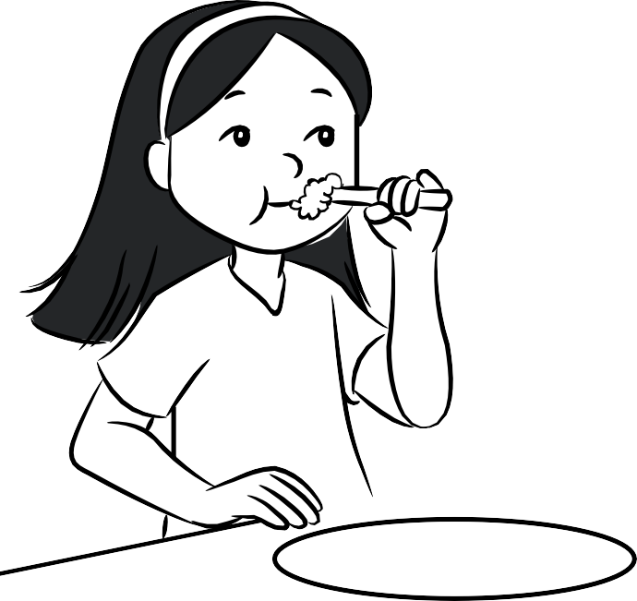
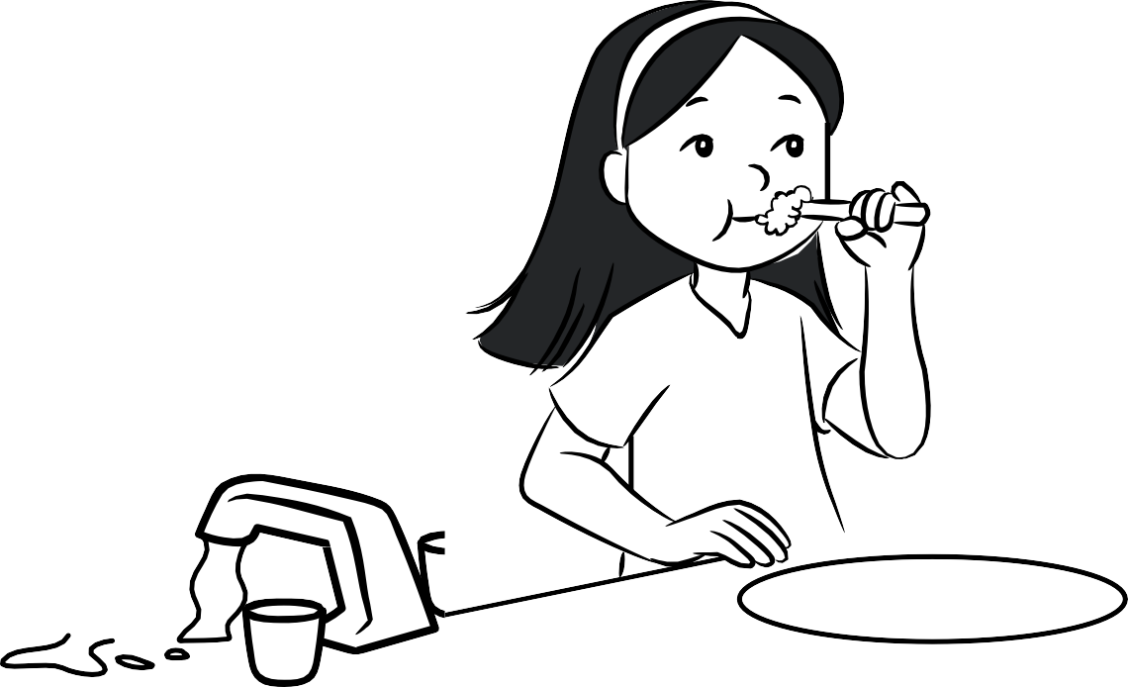
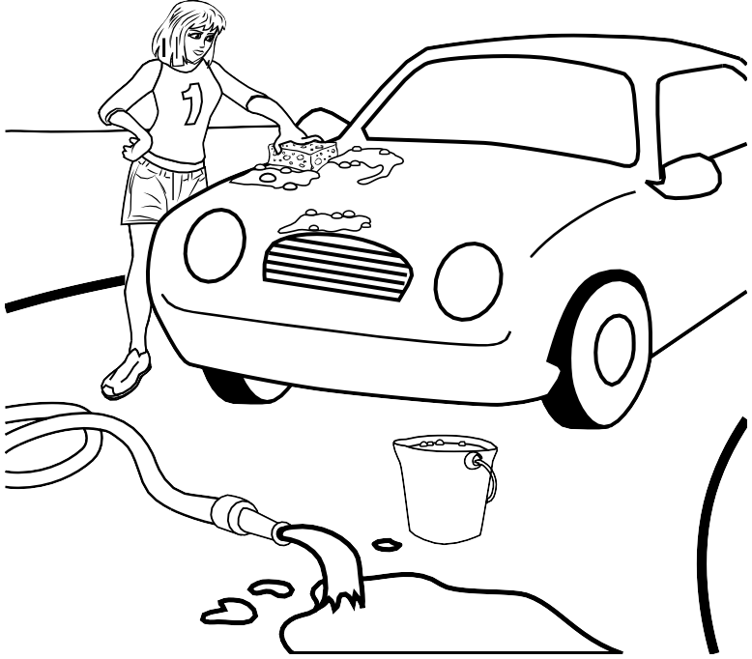
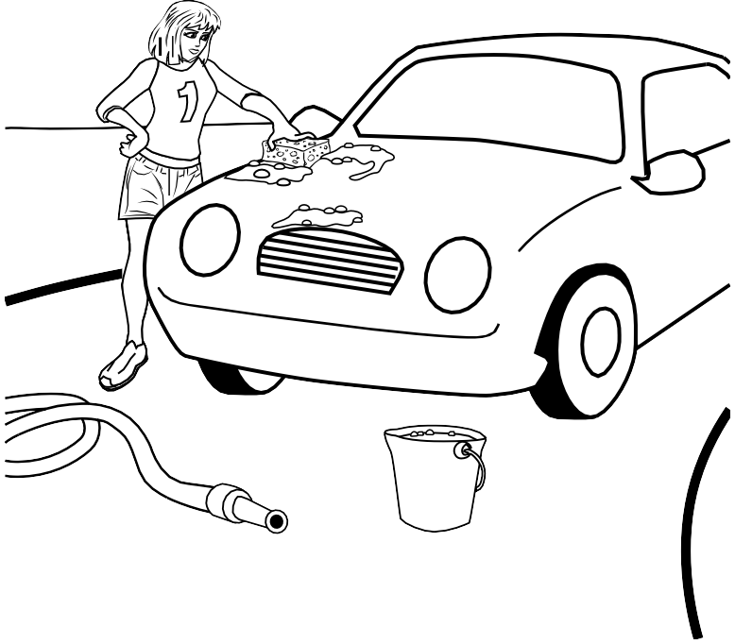

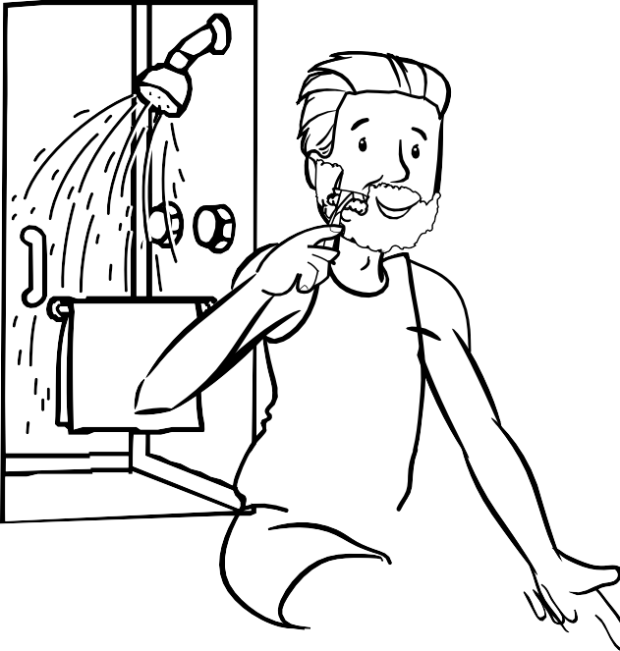
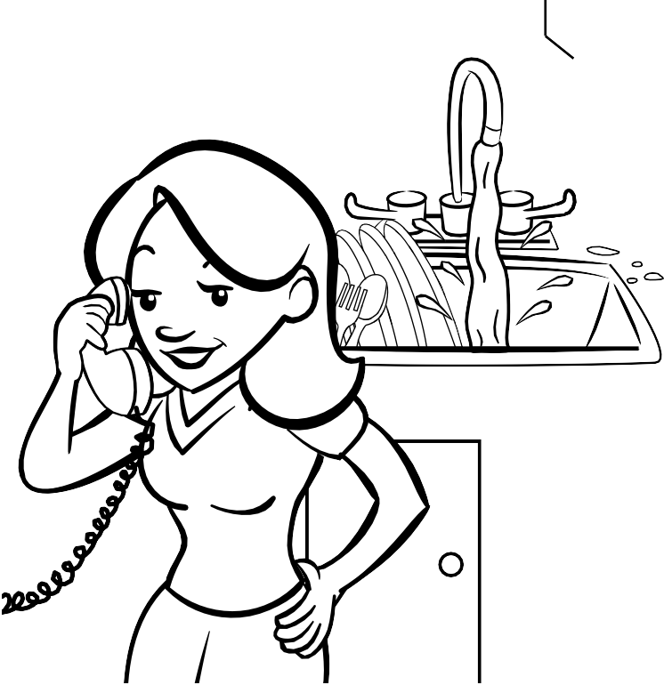
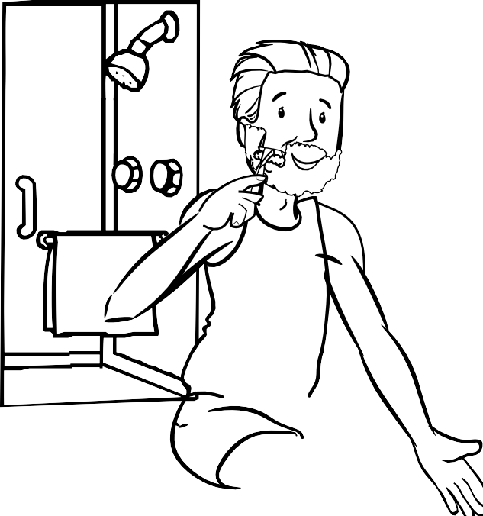
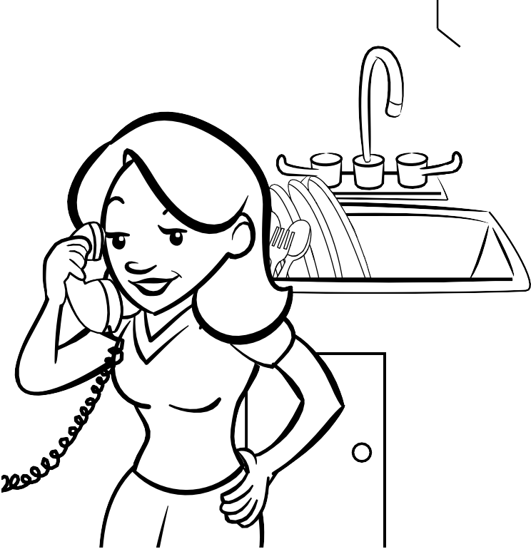

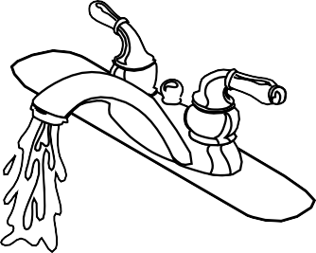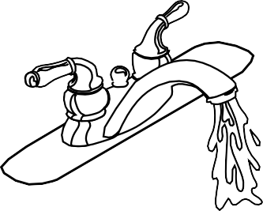

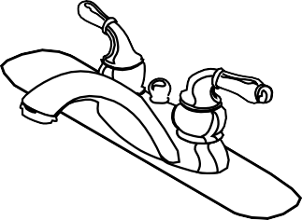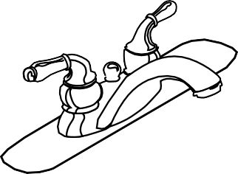

Draw a picture of a way that you can help save water.

