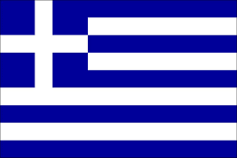
60o Nipiagogio Irakliou
“Let’s eat together, everybody around the table”
Seminar with a dietician- nutritionist
According to the programme of the project, we had a seminar with a dietician- nutritionist in February.
Prior to her visit, we had discussed with the children how many meals a day they had and what these meals included. ( The questionnaire results helped us have a picture about this, but we wanted to involve the children more and make them more aware of what they eat). Since they couldn’t agree about what is the “normal” number of meals or what should be included in them, they decided it would be better to call a “specialist” ( a chance to practice “jobs” and discover the proper name of the specialist we needed).
The first thing the dietician did ( after introducing herself and getting to know the children) was to measure the height and weight.
.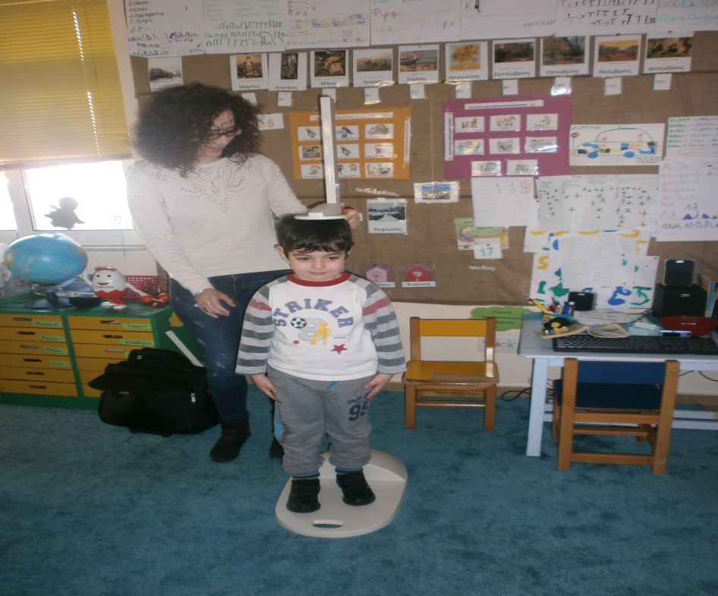
She then showed them pictures of a typical breakfast..
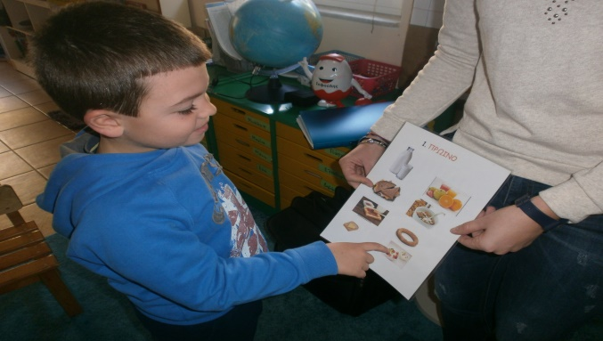
…. snack (morning and afternoon)…
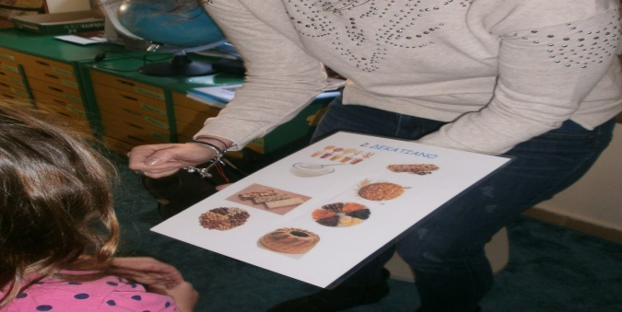
lunch and dinner.
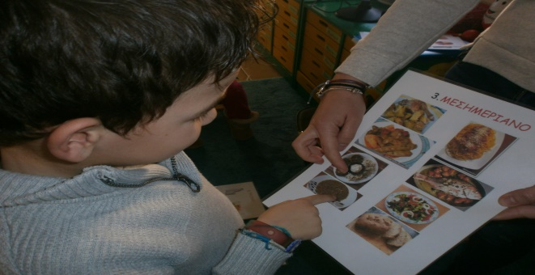
And asked them which they preferred and what they think is healthy for them.
She explained that the main meals should include foods from the four main categories (fruit, vegetables, meat and cereal).
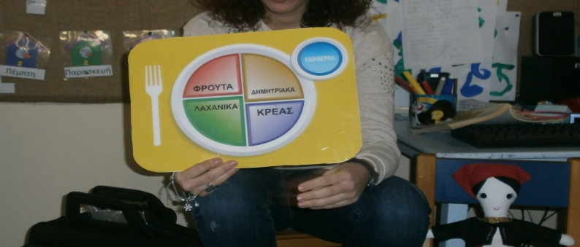
The children had to place the foods in the correct category.
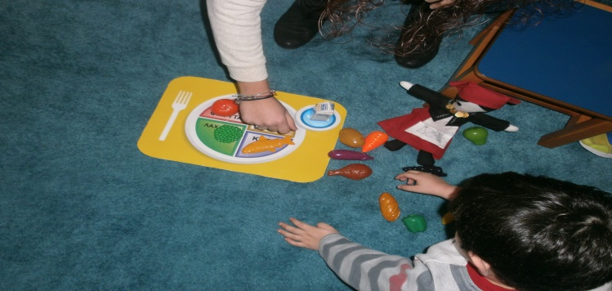
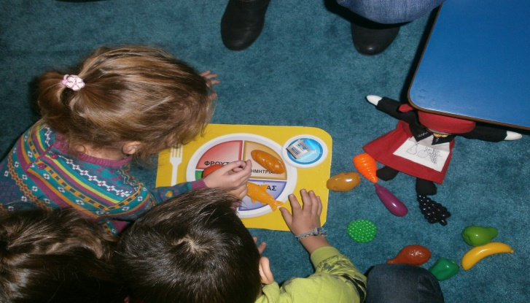
Mr. Smartfood and his friend Lisa talked to the children about the importance of having at least three meals a meals a day and answered their questions.
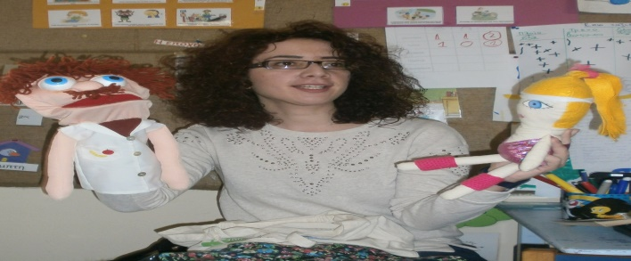
We had a separate meeting with the parents, where she answered questions and gave the main guidelines for healthy eating habits.
Two worksheets were given to the children following this visit: one about “What I like to eat”…
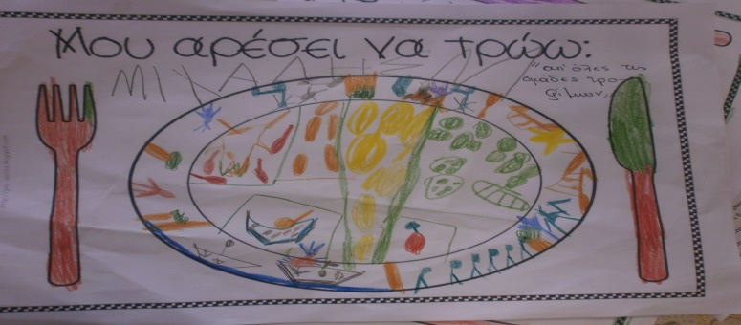
..and the other combined art, breakfast and perception. The children had to find out from which painting each picture came.
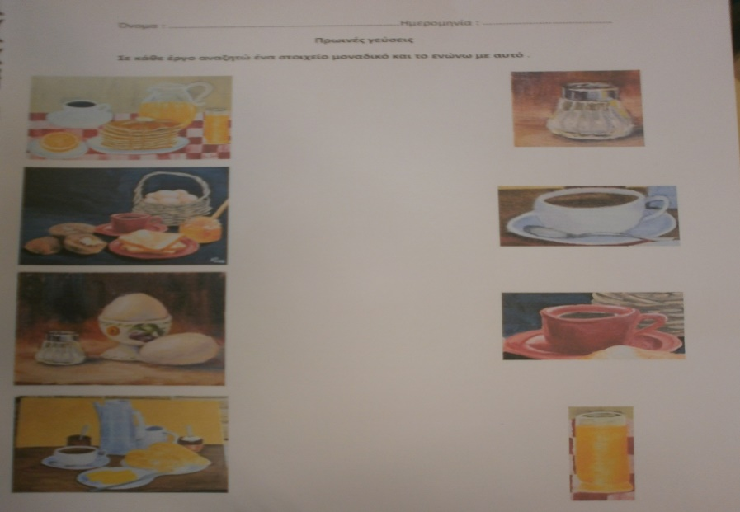
All in all we would call the seminar quite successful. The children enjoyed themselves while learning new things and the parents found answers to questions that bothered them.

