ITLP AT EASE
Improving Teaching-Learning Process at an
Entrepreneurial and Sustainable Establishment

This project has been funded with support from the European Commission. This publication [communication] reflects the views only of the author, and the Commission cannot be held responsible for any use which may be made of the information contained therein.

ACHIM DISSEMINATION
CATO BONTJES VAN BEEK – GYMNASIUM, ACHIM – A SCHOOL WITH A PROFILE !
When you walk through the entrance of our school, you will immediately see our profile.

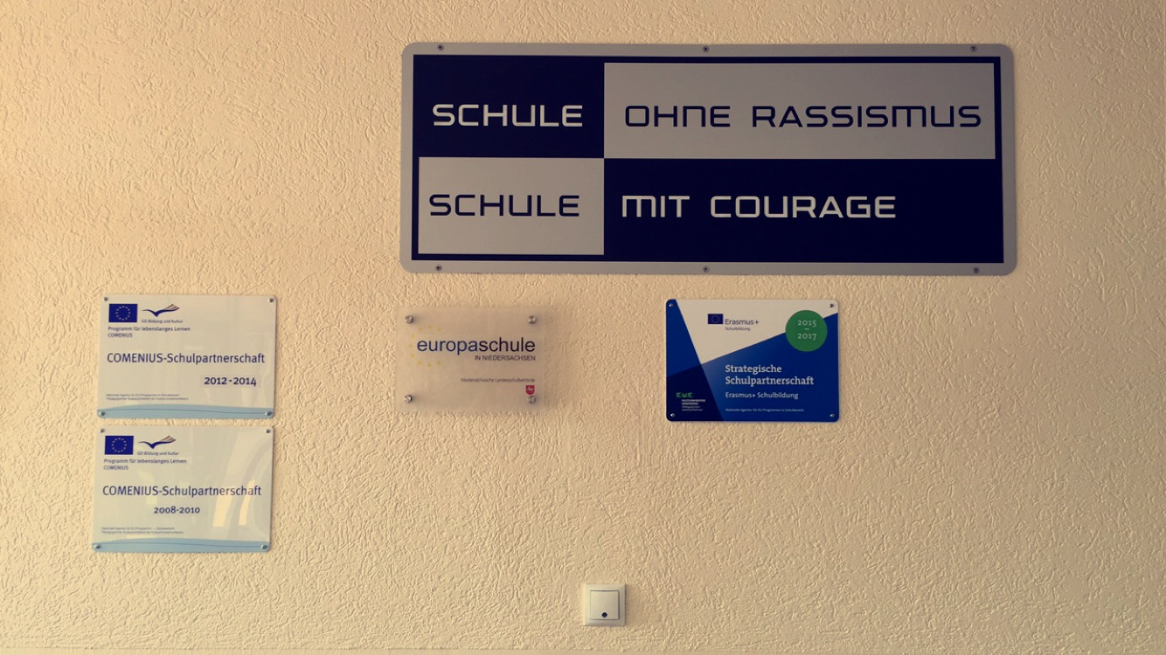

We are
“A school without racism – a school with courage”
and “A European School / Europaschule”

We have participated in two COMENIUS partnership projects
between 2008 and 2014, and ERASMUS + is our latest activity.

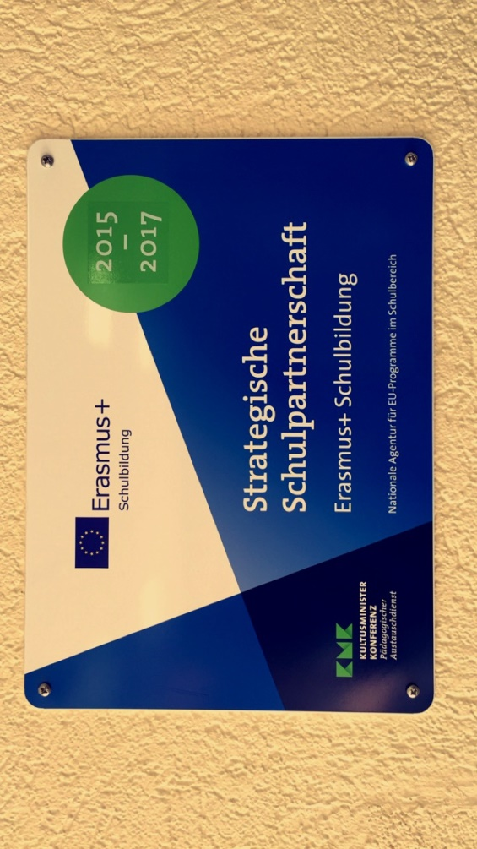
And right opposite the entrance, students, teachers and visitors cannot miss the showcase informing everybody about our project.

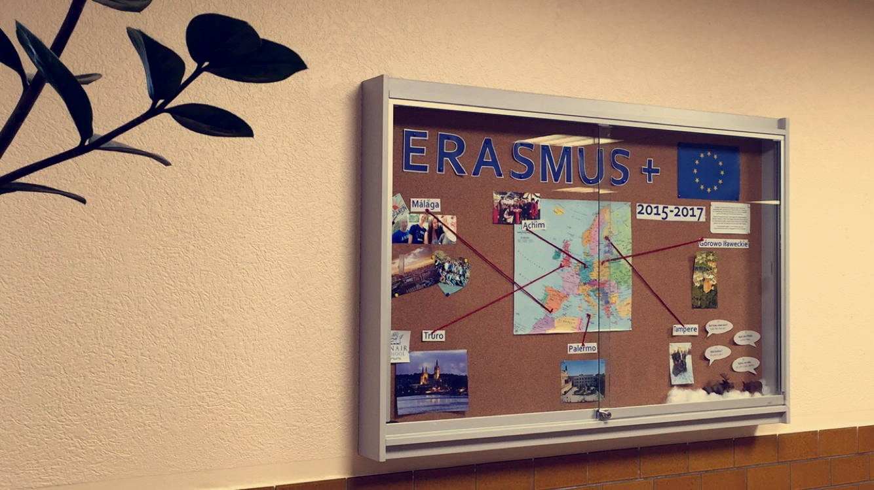

Of course, it still looks a little empty, as the project has just arrived
at half-time. Yet more pictures are soon to come…

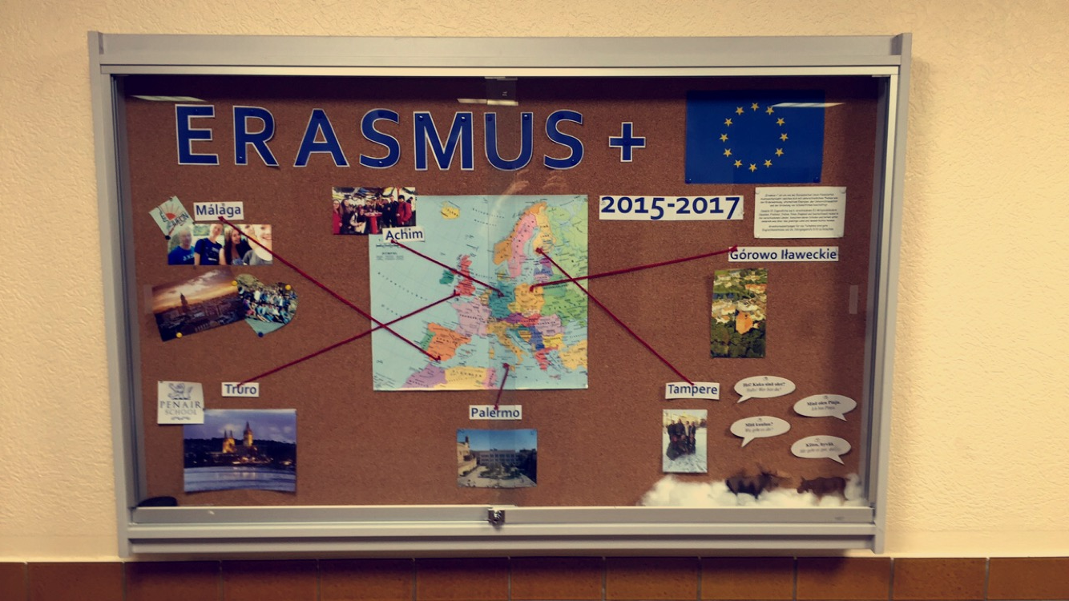
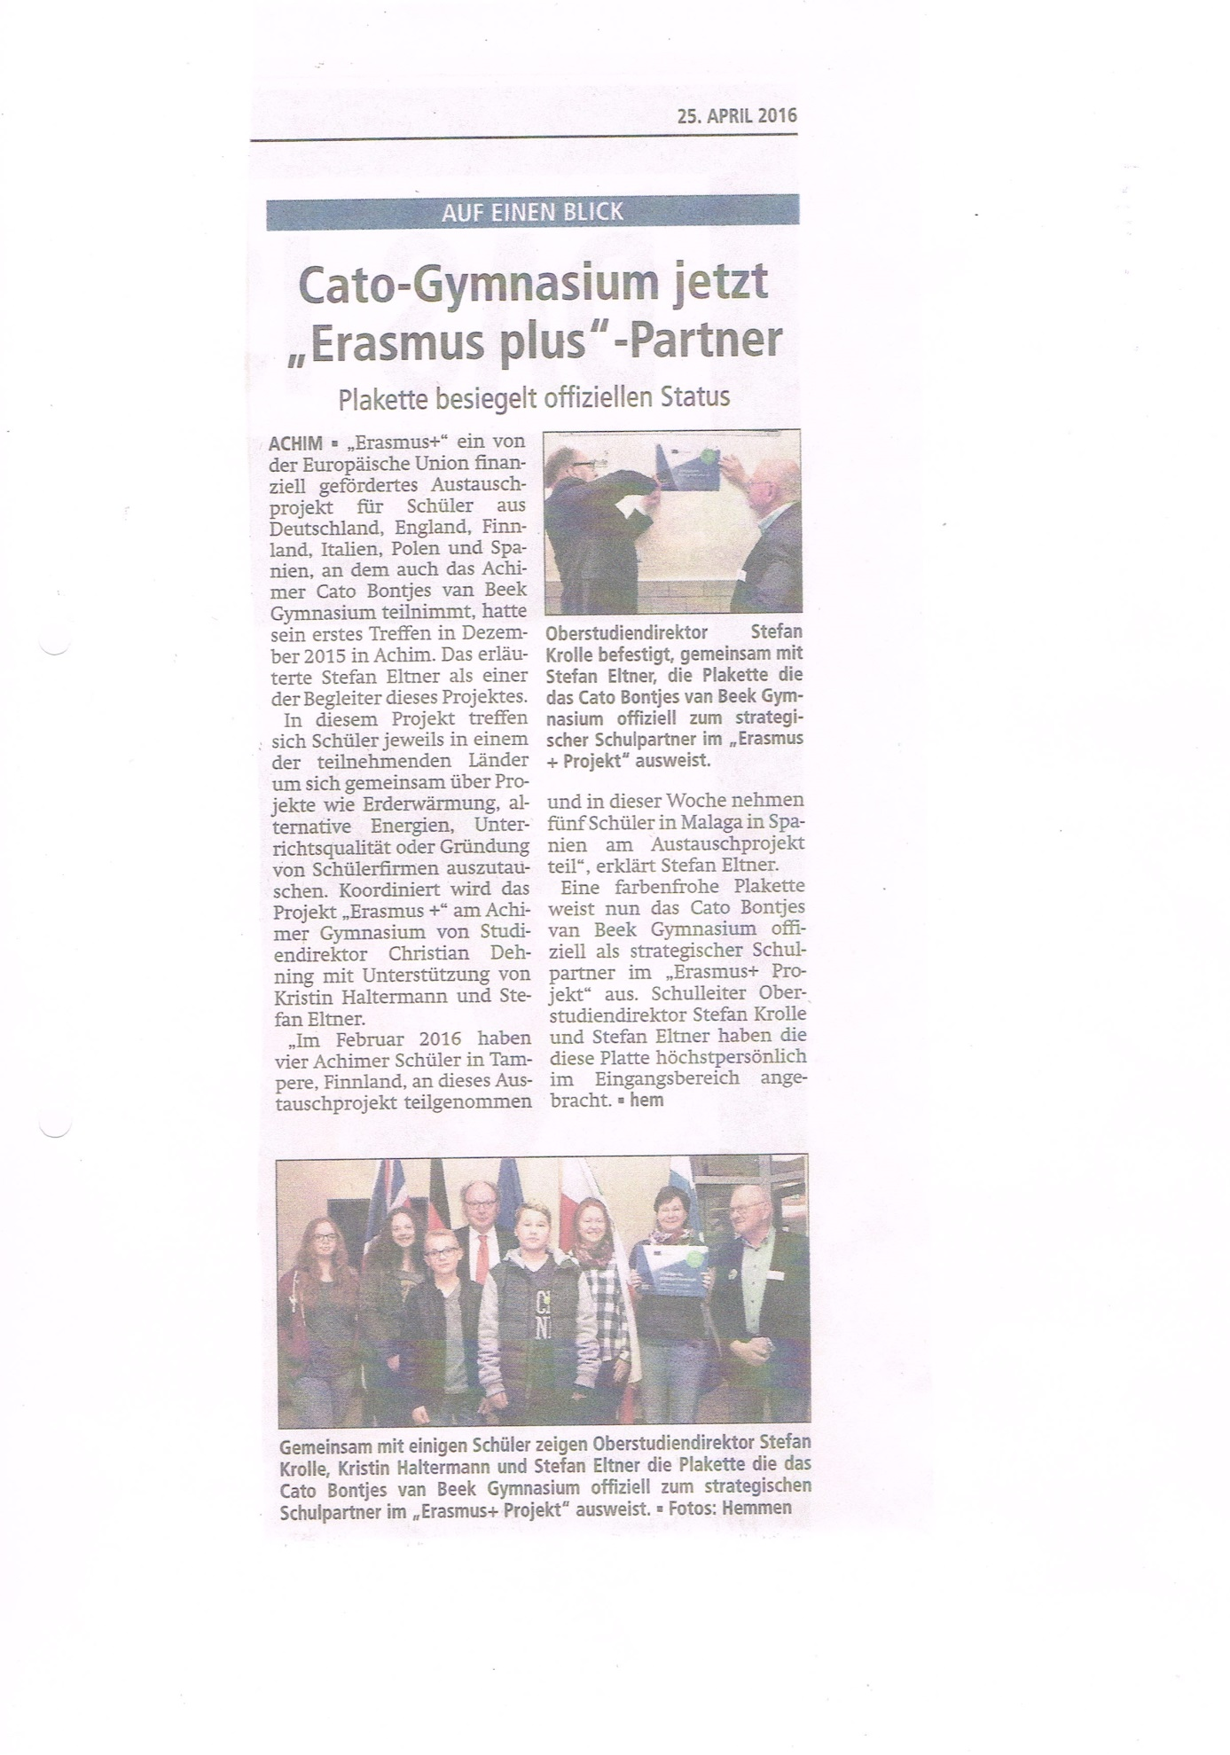

DISSEMINATION OF THE ERASMUS + PROJECT IN ACHIM

* Visitors to the school cannot miss the plaques on the wall of the entrance.
They inform about the school´s approved manifold profile, including Erasmus +.

* Right opposite the entrance, a showcase illustrates the activities and the current
state of affairs of the Erasmus + project 2015-2017.

* The project is regularly promoted in the regional press. We have even been asked
for a press conference after the forthcoming Málaga and Palermo mobilities.

* Young students interested in attending our school are, together with their parents,
introduced to our large variety of activities, including the Erasmus + project,
during an “open house”-day in April.

* Needless to add that all our Erasmus + activities are presented on the school´s
website:
http://www.gymnasium-achim.de/index.php/17-berichte/145-erasmus-2016-3

MÁLAGA DIVERSITY
Here is some information for you about our “Language Learning Class”:

- Germany`s first “Language Learning Class” (LLC) was founded 4 years ago.
- A LLC is a special class for refugees.
- At our school we have 1 LLC.
- In the town of Achim there are 5 LLCs.
- In Lower Saxony, there are about 70 LLCs.
- Up to 16 students go to one class, but pupils who have never been in school count twice.
- In our class, we have 14 refugees.
- They come from 8 different nationalities.
- We deal with 5 different languages.
- The students attend 16 lessons of German every week , plus other subjects like history,
maths or sports.

The aims:
- to teach them German
- to inform them about our culture
- to offer maximum possibilities of integration

Lesson observation of Kristin Halterman – Málaga 26 April 2016
The lesson I observed was an English lesson for the lower set, some of which were repeating the level. It was mainly comprised of boys.
The topic of the lesson was the use of the passive voice.
The teacher played a very active role in the lesson, he explained very patiently and repeatedly the grammatical rules. The students’ participation seemed to be mainly voluntary, and some of them appeared very eager to learn.
The main medium was the board where the rules were written out and the exercises were solved. The noise level was (to my ears) quite intense.
It was a very interesting lesson from my point of view since lessons in Spain and in Germany seem to be very differently structured and the objective was quite dissimilar. Whereas in Germany we are taught that most of the activity is supposed to come from the students and they have to copy everything and do all the exercises in their notebooks / workbooks, in Spain the role of the teacher seems to be quite more active. As this means that the work is made much more stressful and demanding, I had a lot of respect for the teacher. It also seemed to me that in Germany we more or less force the students to be active by grading for oral participation; Spanish teachers are much more dependent on the goodwill of the students since apparently oral participation does not factor hugely in the final grades.
So all in all it was a very interesting and educational experience.

This work is licensed under the Creative Commons Attribution-NonCommercial-ShareAlike 4.0 International License. To view a copy of this license, visit http://creativecommons.org/licenses/by-nc-sa/4.0/.

