This project has been funded with support from the European Commission.
This publication [communication] reflects the views only of the author, and the Commission cannot be held responsible for any use which may be made of the information contained therein.
ELEMENTS OF A RUBRIC
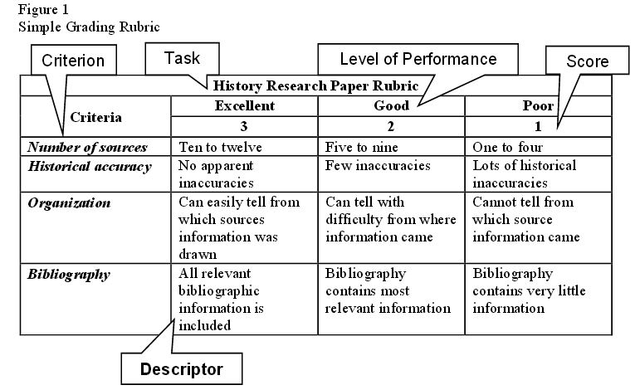
1) CRITERIA OR DIMENSIONS: identify the trait, feature or dimension which is to be measured and include a definition and example to clarify the meaning of each trait being assessed. Each assignment or performance will determine the number of criteria to be scored. Criteria example for a term paper: Introduction, Thesis, Arguments/analysis, Grammar and punctuation, Spelling, Internal citations, Conclusion and References.
2) LEVELS OF PERFORMANCE OR ACHIEVEMENT: are often labeled as adjectives which describe the performance levels. Levels of performance determine the degree of performance which has been met and will provide for consistent and objective assessment and better feedback to students. These levels tell students what they are expected to do. Levels of performance can be used without descriptors but descriptors help in achieving objectivity. Words used for levels of performance could influence a student’s interpretation of performance level (such as superior, moderate, poor or above or below average.
Levels of performance example:
1) Excellent, Good, Fair, Poor; 2) Master, Apprentice, Beginner; 3) Exemplary, Accomplished, Developing, Beginning, Undeveloped; 4) Complete, Incomplete, 5) Yes, No.
3) SCORES: make up the system of numbers or values used to rate each criterion and often are combined with levels of performance. Begin by asking how many points are needed to adequately describe the range of performance you expect to see in students’ work. Consider the range of possible performance level.
Score example: 0,1,2,3; 1, 2, 3; 1, 2, 3, 4, 5; or 2, 4, 6, 8.
4) DESCRIPTORS: are explicit descriptions of the performance and show how the score is derived and what is expected of the students. Descriptors spell out each level (gradation) of performance for each criterion and describe what performance at a particular level looks like. Descriptors describe how well students’ work is distinguished from the work of their peers and will help you to distinguish between each student’s work. Finally, the same descriptors can be used for different criteria within one rubric. For example, the three level of performance: Excellent, Good, Fair and Poor can be used for the separate criteria of Accuracy, Organization, Punctuation & Grammar, and Spelling. Descriptors should be detailed enough to differentiate between the different level and increase the objectivity of the rater.

TEACHER ASSESSMENT
 | POOR | GOOD | EXCELLENT | SCORE
CRITERIA | 1 | 2 | 3
Punctuality | often is over 5 minutes late to class | occasionally is over 5 minutes late to class | Never is late to class
Times teacher asks sts if they have understood the task | Usually asks once if students have understood the task in a class | asks twice or thrice if sts have understood the task in class | Asks many times if sts have understood the task
Times the teacher moves around the class to check sts’ progress | Not usually | Usually | Quite often
Uses mixed-ability activities | Not usually, follows the book strictly | Usually | Quite often
Exam concessions | No concessions | A few concessions | Arrange them based on particular needs
Variety of assessment tools | Uses written exams and are 90% of final mark | Uses written exams and occasionally oral exams and are 70% of final mark | Uses exams and are 50%/60% of final mark. Uses a wide range of assessment tools
Materials and resources | Uses the same, occasionally uses the digital board | Uses a moderate variety, changes | Uses a wide range, every day sth new
Speed in answering any questions that are raised | Rarely answers, not quickly and efficient | Usually answers, quickly and efficient | Always answers, excellent

This work is licensed under the Creative Commons Attribution-NonCommercial-ShareAlike 4.0 International License. To view a copy of this license, visit http://creativecommons.org/licenses/by-nc-sa/4.0/.

