This project has been funded with support from the European Commission.
This publication [communication] reflects the views only of the author, and the Commission cannot be held responsible for any use which may be made of the information contained therein.

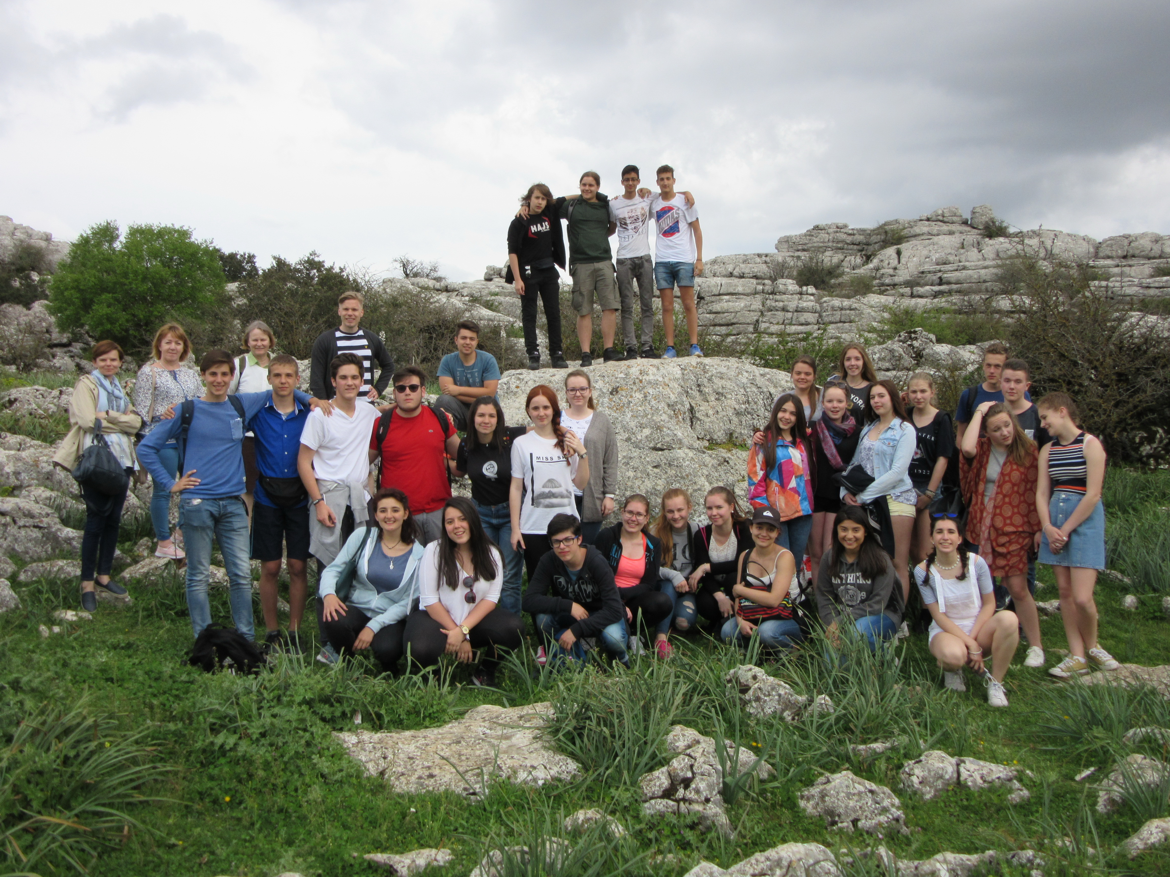
TRIP TO THE TORCAL NATURAL PARK ON THURSDAY 28 APRIL
Antequera, The Antequera fertile Plain
-The Romans called it “Antikaria (meaning “ancient”) and was renamed “Medina Antaqira” by Spain’s Arab invaders, who ruled the town until 1410, when the Moorish castle that dominates the town fell to the Christian armies of the Reconquest. And, henceforth, it became a border town between the kingdoms of Castile and Granada.
-It is the geographical centre of Andalusia. It was even thought to locate the Andalusian Parliament here, but finally it was decided to sit it in Seville.
Known as the city of Spires for its many Churches and with Antequera’s museums housing approximately 80% of all the art treasures in the province of Malaga, there is no shortage of things to see and do. Here is short selection of some of Antequera’s highlights.
-It is well known for the production of Christmas goodies as almond or cinnamon and sesame/’sesami/ cookies. (Mantecado from “Manteca”, “Lard”, as it was originally made with lard and cereal/’siarial/). The first information we have of these crumble cakes are of the sixteenth century, caused by the surplus /’se:plas/ of grain and lard. There are different opinions about its origin. Some people say that it comes from Estepa and others from Antequera. Everything indicates that was Antequera where it came from the original recipe, maybe because there were factories that supplied to the Royal House.
-It is also famous a local bread called “mollete”, which is soft and sweet and tastes excellent.
The prehistoric dolmens of Antequera are very close to be declared a UNESCO World Heritage Site. The decision on the site will be announced in June or July 2016. If the application is successful, a UNESCO grant will be awarded for maintenance of the site, and the added attention and publicity will be welcome for the historic town of Antequera, with its Moorish fort and Roman remains, and the surrounding area. The five items included in the candidacy presented to UNESCO are the dolmens of Menga and Viera, the beehive tomb or Tholos of El Romeral, and two natural mindscape features: The mountain known as La Peña de los Enamorados and the karst landscape of El Torcal. The prehistoric caves and dolmens ( large tombs from megalithic era) represent some of the largest and most complete megalithic structures in Europe.
Spain has no other megalithic monuments recognised by UNESCO, while the UK has three: Stonehenge, Avebury and Heart of Neolithic Orkney.
The Menga Dolmen is the largest in Europe at nearly 30m long. The largest upright stone weighs 180 tonnes. By way of comparison, the heaviest stone at Stonehenge, in Wiltshire in the UK, weighs 40 tonnes. It is famous for its significant geographical location - on the summer solstice, 21 June, the morning sun shines over the peak of the Peña de los Enamorados and straight along the dolmen's entrance corridor. This very exact positioning would have had mystical importance for the prehistoric tribes who built the dolmen thousands of years ago.
The dolmens are described in the UNESCO World Heritage nomination list (2015) as "outstanding examples of megalithic architecture and... amongst the most recognized and quoted in the world." For more on the nomination see this post on our blog.
-The Lovers’ Rock is an enormous crag of limestone, 880 metres high. The name comes from a local legend. There are several versions of the legend. This type of story is part of the historical narrative of the late Middle Ages that deals with love episodes and raids along the border of Arabs and Christians (As is the case of Antequera in the XV century). The most reliable version is one passed down through generations and mentioned by Juan de Vilches, a humanist from Antequera: Vilches disclosed the names of the two lovers: Alhaiar Hamet, servant of the king of Granada and famous Arab gentleman, and Tagzona, a beautiful girl from the nearby Archidona. The boy, hearing such a beautiful woman, he moved to the city of Archidona and met her at a fountain. They loved at first sight. Hamet kidnaps the girl making her companions to raise the alarm. The maiden’s father sends his soldiers to hunt Hamet down. The gentleman reached the famous rock, situated at the Guadalhorce river and midway between Antequera and Archidona, and harassed by Tagzona’s father’s troops, took her up to the top of the cliff. As the girl's father sees her daughter accompanies Hamet without being forced, desisted from persecution and authorizes the match. After descending from the rock they reached the meadow (going to Granada for the king to marry them). Some shepherds, inflamed by Tagzona’s beauty, wanted to abuse the girl at her beauty, and they killed the lover Hamet. Tagzona, seeing such a cruel murder, took the sword of her lover and committed suicide.
The best known version, however, is about an impossible love affair between a young Christian man from Antequera and a beautiful Moorish girl from nearby Archidona, who were driven to the top of the cliff by the Moorish soldiers, where, rather than renounce their love, they chose to hurl themselves into the abyss.

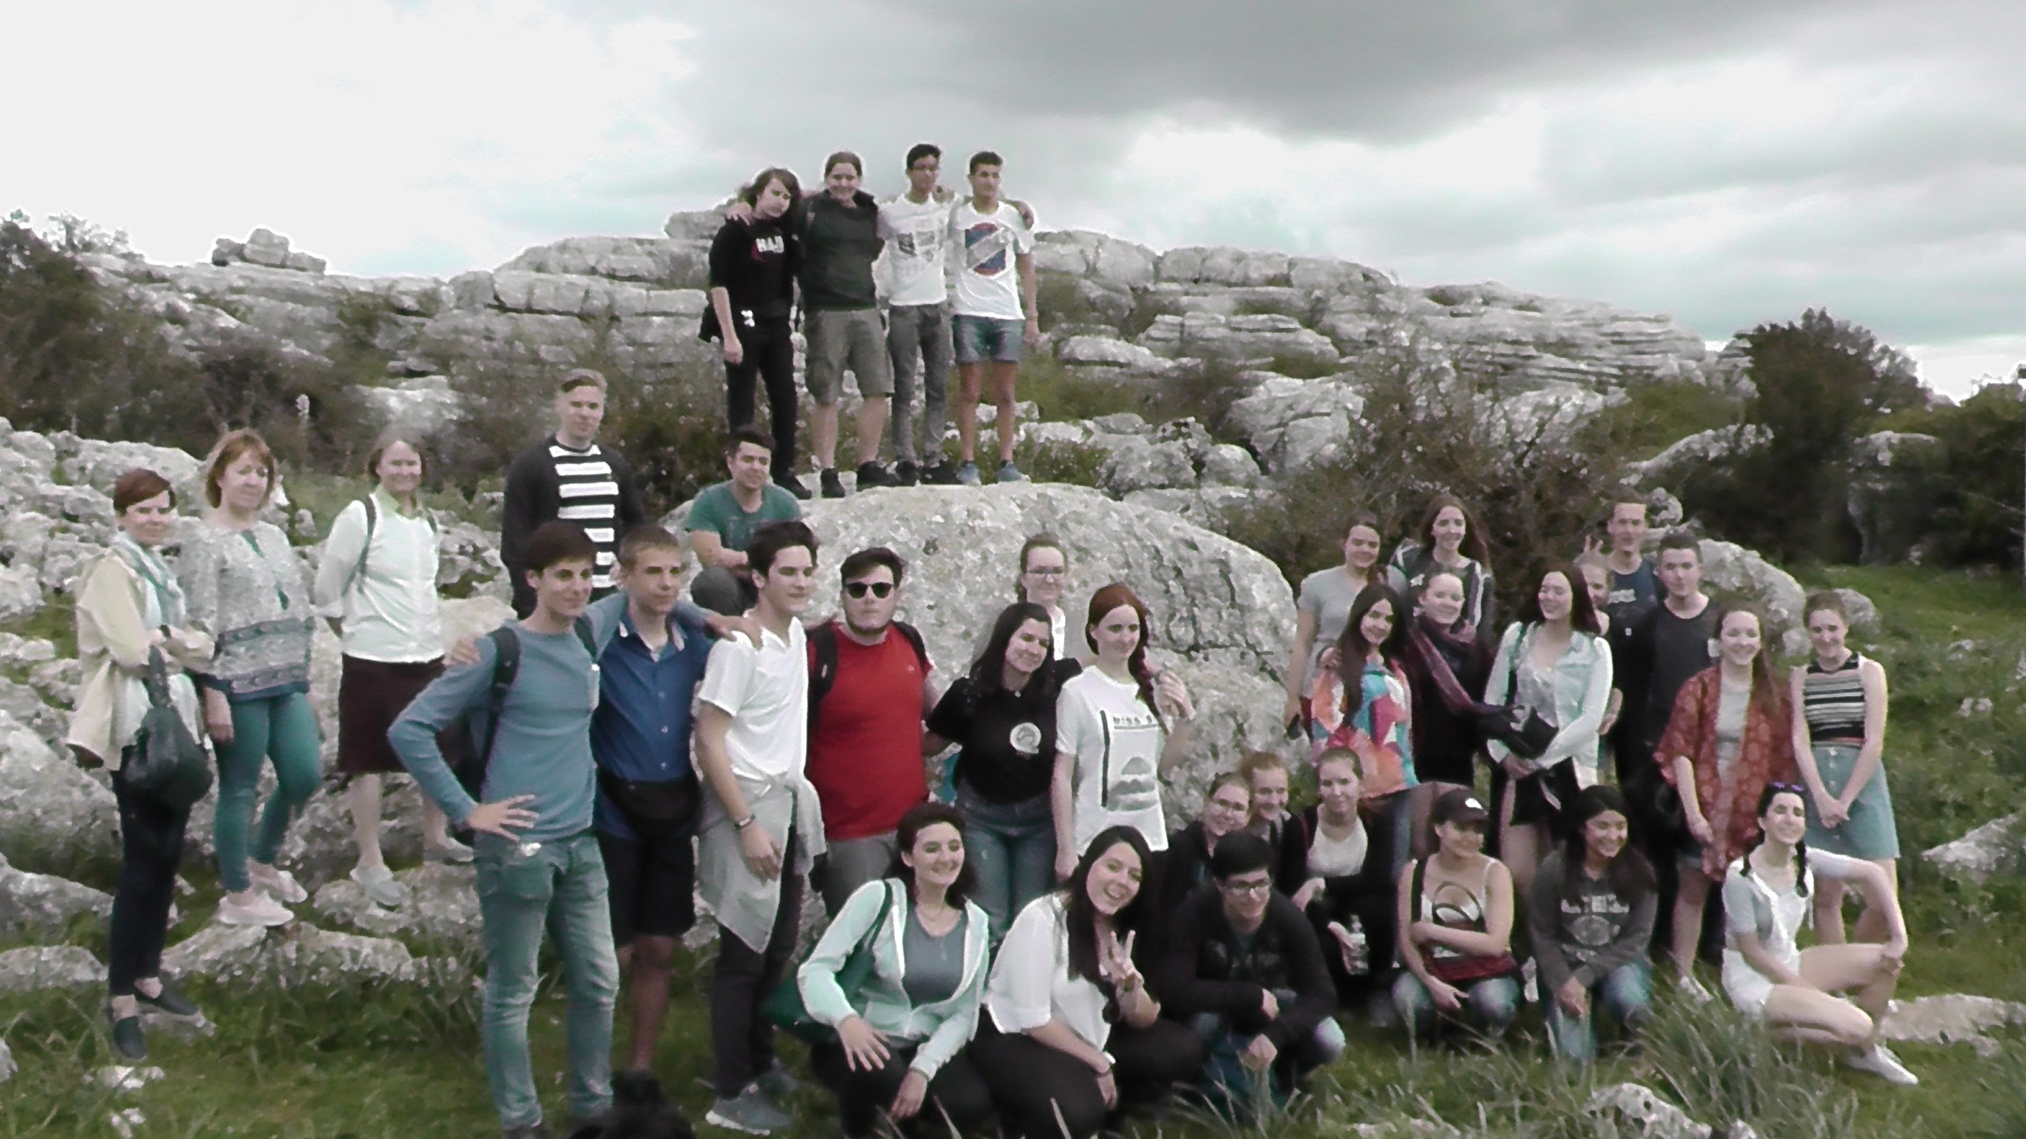

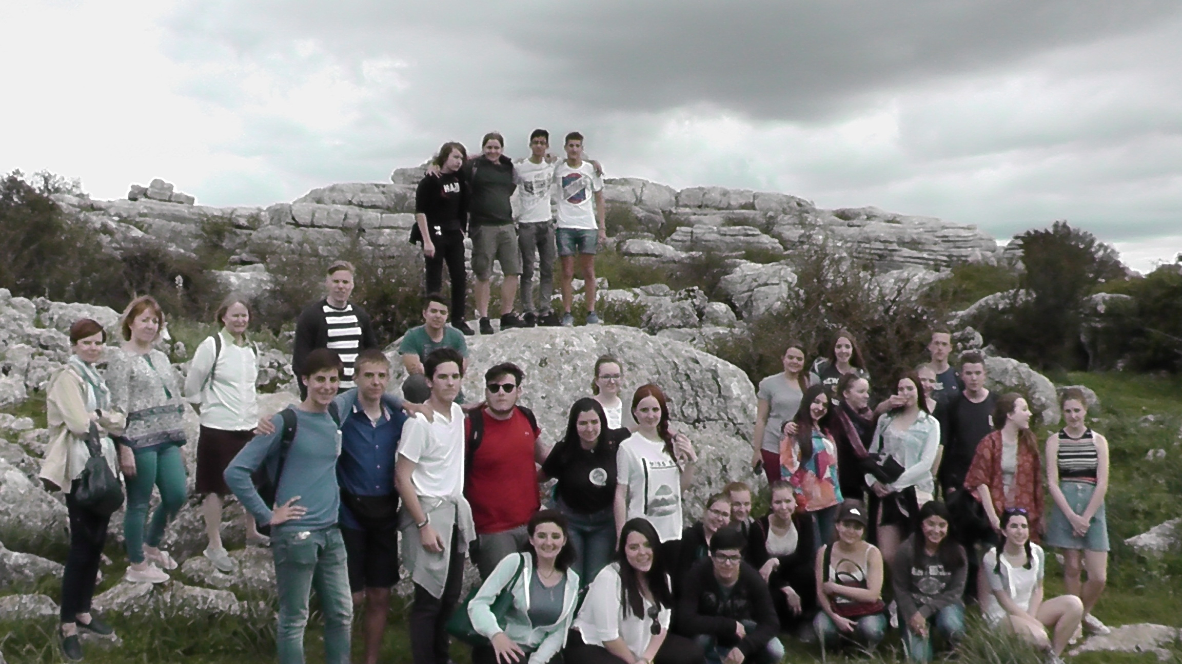
-“El Torcal”, a Park Nature Reserve, is known for its unusual limestone rock formations. It is one of the most beautiful impressive landscapes in Europe. The limestone kept its layered horizontal formation. Because of this, over the millions of years the rain and wind have been able to chisel away at these layers to form incredible shapes. The rocks are live as they continue to grow and move with fossilized sea life as those were once covered in sea water until one hundred million years ago.
It is situated approximately 30kms from Malaga, right on Antequera’s doorstep. The nearest village is called “Villanueva de la Conception.” The area was classified as a Natural Site of National Interest in 1929, and a 17 km2 Natural reserve was created in 1978.
The Torcal also has numerous caves, including the “Cueva del Toro” (Cave of the Bull), famous for the discovery of Neolithic artifacts.
It is known for its unusual limestone rock formations. It is one of the most beautiful impressive landscapes in Europe. The limestone kept its layered horizontal formation. Because of this, over the millions of years the rain and wind have been able to chisel away at these layers to form incredible shapes. The rocks are live as they continue to grow and move with fossilized sea life as those were once covered in sea water until one hundred million years ago.
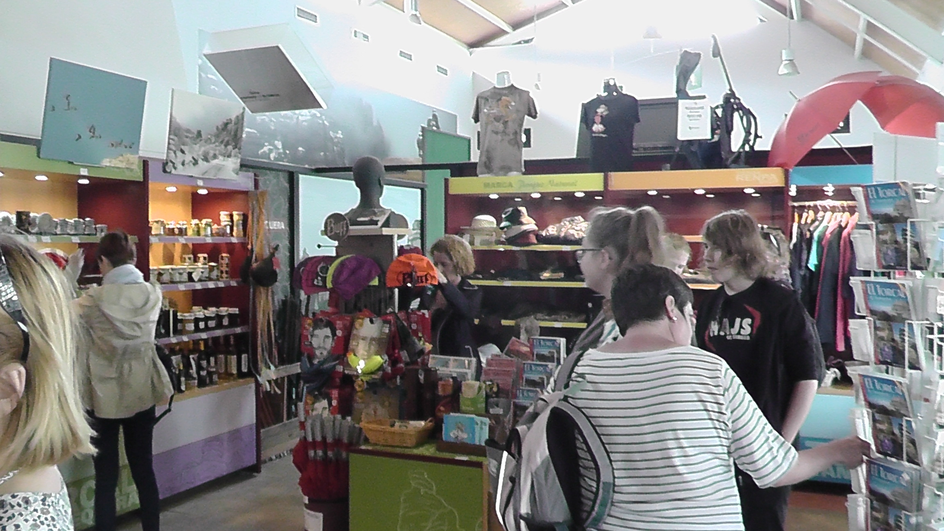

Despite the very arid conditions and being at a relatively high altitude, the reserve has a large array of flowers and fauna. Some endemic to the Torcal. The most famous being the Montpelier snake, which can grow up to two meters in length!
Due to temperature extremes it is recommendable to visit the Torcal in spring or autumn.Or when doing so in the summer months, bringing plenty of water and sun screen.
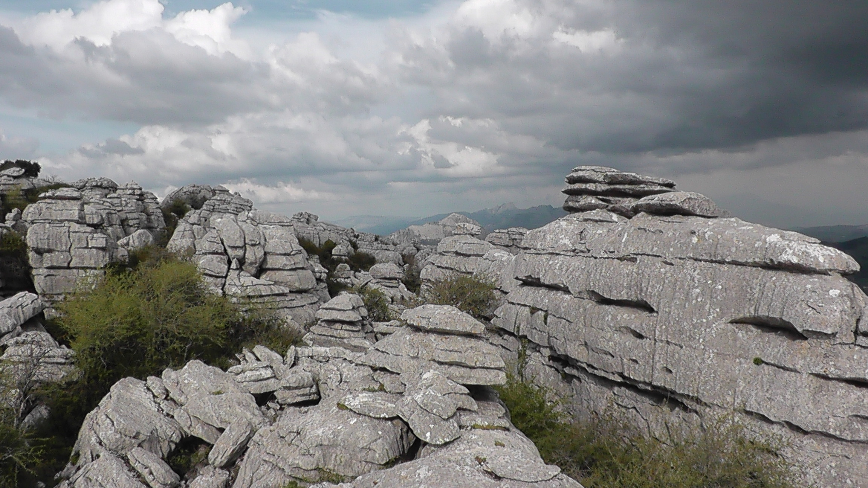
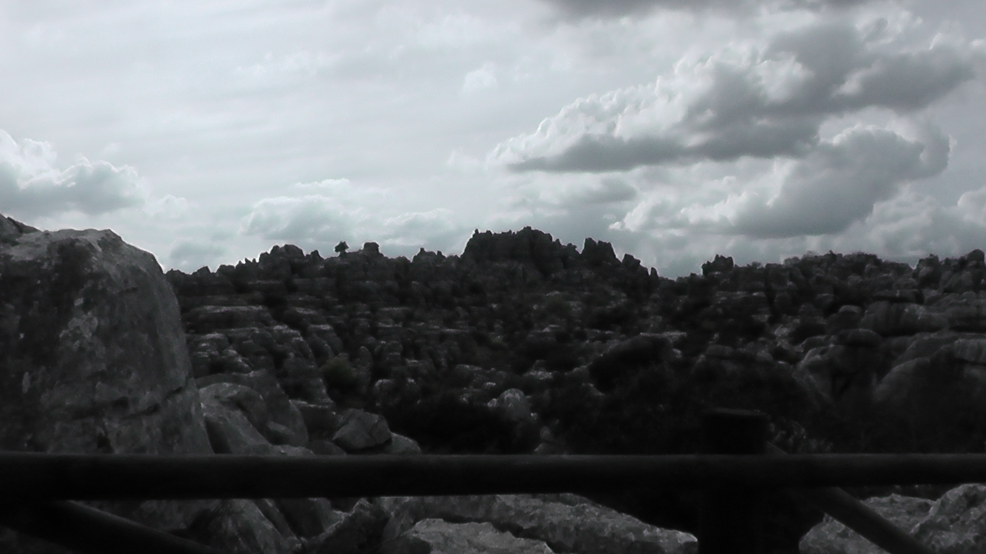
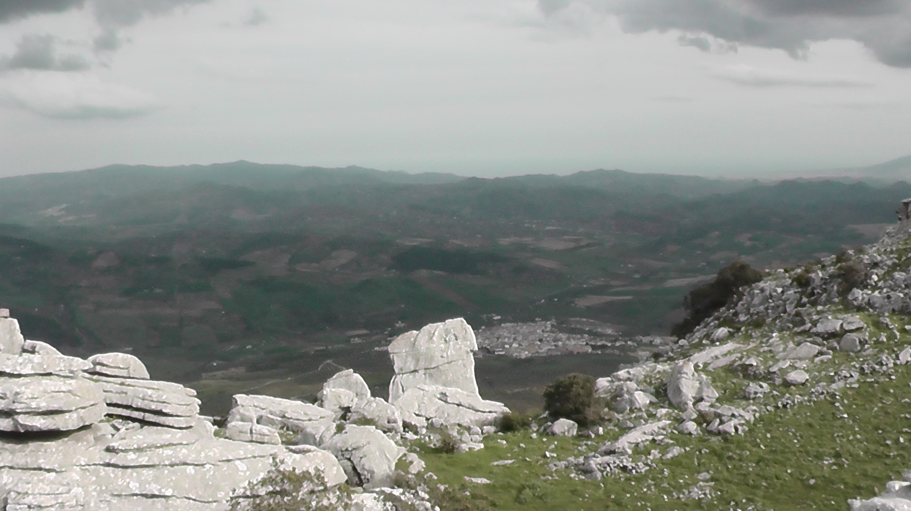
Villanueva de la Concepción
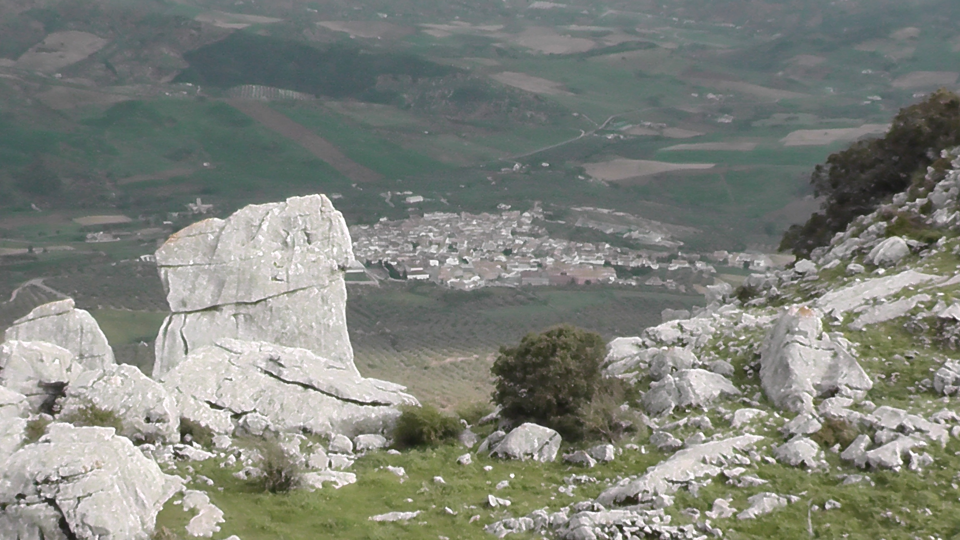
Villanueva de la Concepción
-Finally, of note, it is the “Efebo of Antequera”. Spains’s highest artistic quality and best conserved bronze sculpture discovered in the ruins of an old town on the plains of Antequera in 1955.
VINEYARDS/OLIVE FIELDS/ORANGE GROVES OR FIELDS OF ORANGE TREES

Fuente de Piedra
is a must-stop for birds migrating to or from Africa, and this is why it is so important. On January 11, 1984, it was designated as a Nature Reserve. Covering 1,354 hectares /’hekteaz/ha, Fuente de Piedra is the largest lake complex in Andalusia and one of the most important wetlands in Europe. Many bird species make their nests here –foremost among them, flamingos– and this make it an area that needs to be protected. In fact, it is the second most important flamingo nesting area in Europe and the Mediterranean, behind Camargue in France.
One of the characteristics of this lagoon is the salinity of the water. Normally this does not constitute an attraction for a non-marine bird, however in the case of the pink flamingo it is this very concentration of salt in the water which determines the presence of microscopic organisms, such as seaweed and crustacean/kras’ teisha/ which are the basis of their diet. During times of scarcity, the flamingos may go as far as the Doñana National Park to find food.
The optimum time to observe these magnificent birds is around the end of January, which is when they arrive from their winter quarters to spend the spring and summer months engaged in the all consuming activity of breeding.
One of the special treats given to Fuente de Piedra is the ringing of flamingos in July or August, depending on the environmental and bird factors. The ringing of flamingos has grown into a (necessary) environmental festival where people show their solidarity. Towards the end of summer, mainly during the months of July and August, an impressive example of technical expertise takes place which closely resembles a military operation, rather than a purely scientific activity. Typically, a team of more than 200 volunteers coming from all over Spain, and even from foreign countries, advance on the lagoon before daylight; their mission being to label the thousands of young flamingos which are still unable to fly. To be able to accomplish this task, the birds are driven into a type of pen where they are huddled together and labeled. Sometimes blood is extracted for later analysis, after which the birds are set free. This activity has been in effect since the year 1986 when the reproductive activity of these birds was appreciated as being of vital importance in order to understand and analyse the life of the flamingo. Thanks to such labelling it is now possible to learn the flamingos migrating routes, their ages and other biological aspects.

-“May the sun come out in Antequera”(Que salga el sol por Antequera)
The phrase is used with two endings: 1) “and let it be what God wants”(y que sea lo que Dios quiera) and 2) “and set wherever it wants” ( y póngase por donde quiera).
There are several hypothesis about the origin of this saying, but all of them place it in the War of Granada.
1) According to José María Iribarren in his book “El por qué de los dichos” 1996, it comes from the phrase “ May the sun rise in Antequera and set wherever it wants”, which was exclaimed by the Catholic King and Queen in their camp in Santa Fe in 1491 when they decided to launch the final attack on the city of Granada the following day. The phrase has an ironic sense. The key to understand the phrase is that Antequera is on the west of Granada, which is completely impossible for the sun rise in Antequera. Thus, to say “may the sun rise in Antequera”, it is like ordering something which is not proper.
2) Another version places the origin of the phrase not in the Christian kings but in the Sultan of Granada Muhammed XIII az-Zaghall(Boabdil’s uncle, the last Nasrid ruler of Granada) called by the Christians “el Zagal” (The valiant, the Brave or the Fearsome), he used to ask his soldiers for courage to fight the well-equipped catholic troops: What does the death matter, if it would come sooner or later? So, if the sun rises in the east and does not in Antequera, What does it matter? Wherever the sun rises, the honour had to be saved. The phrase has been stood for a motto of bold people meaning the die is cast.
3) In the mid 14th century, the Christians began to conquer Malaga’s lands. The first important conquest was the taking of Antequera in the beginning of the 15th century, 1.410, by the ruling Don Fernando, known as Fernando I from Aragon, also known as Fernando from Antequera from that time onwards, uncle of Fernando II, the Catholic, from Aragon, the one who married Isabella from Castille, who were both known as “The Catholic King and Queen”. During the early 15th century, Antequera found itself under Moorish domination. The Christian troops were continuing their advance southwards conquering large swathes of Andalucia. Unsure what would be the best village to take, Fernando de Aragon was witness to an apparition of a beautiful lady surrounded by lions, who told him not to doubt and “tomorrow, may the sun come up in Antequera and may whatever God ordains happen”. Antequera is in the north of the province of Malaga, and is surrounded by mountains. This makes the sun visible later than in other plain places.
In the morning, Fernando pronounced the phrase before the definite assault on the city, and Christian troops conquered the city the next day – 16 September 1410. After eight days siege their inhabitants surrendered in exchange for life and freedom, emigrating to the Nasrid capital (Granada) to found the quarter of Antequeruela.
It is a saying used to express uncertainty about the result of some action, and serves as an inspiration or determination for people to face up to whatever challenges life presents them with. It means that an action is going to be taken in spite of what happens, whatever results or consequences there may be, or although something unthinkable could happen.

This work is licensed under the Creative Commons Attribution-NonCommercial-ShareAlike 4.0 International License. To view a copy of this license, visit http://creativecommons.org/licenses/by-nc-sa/4.0/.

