How many earths would we consume if everybody lived as you do?
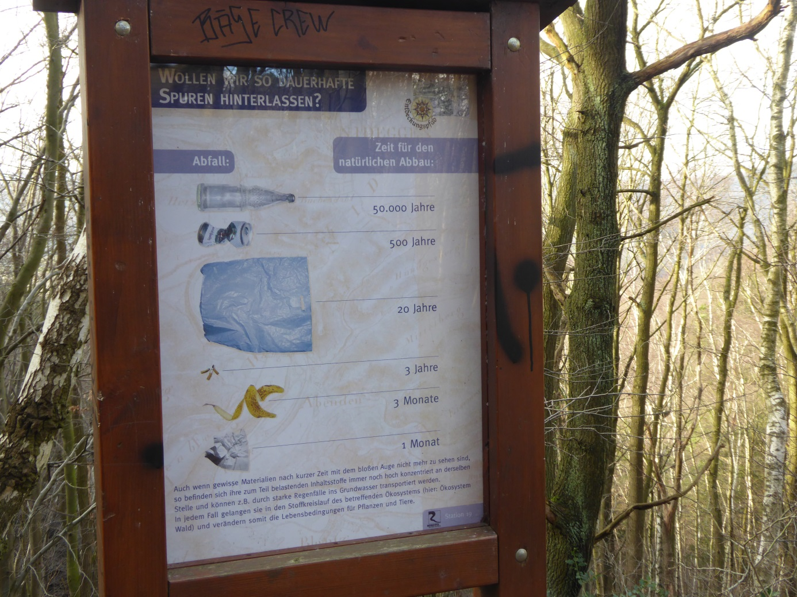
This internet page calculates your environmental footprint. You only have to answer a few questions about the following topics:
Energy consumption:
- Do you live in a detached house or in a flat?
- How many m² do you live on (at your home)?
- How do you heat your home (oil, gas, etc.)? Is your electricity provider an ecological or conventional one? Do you heat very much (up to more than 25 degrees) or do you heat economically?
- How often do you use electronic devices? Do you turn off the lights when you don’t need them any longer?
Water consumption:
- Do you wash your clothes every day?
- How much time do you spend under the shower?
Waste separation and the avoidance of waste:
- Do you use a plastic bag or a reusable bag for shopping?
- Do you reuse/recycle/recover old stuff and used things?
- Do you use second-hand articles?
What kind of food do you eat?
How often do you eat meat and other animal products? Are the food and the water you eat and drink fresh and bio?
Fuel consumption:
- How often do you travel by car / do you fly (travel by airplane)? Are there alternatives to using the car and maybe travel by bike?

At the end of the test, they show you how many earths we would need, if everybody lived as you do and they give you many tips how you could live environmentally sustainable. All in all, the test is a good opportunity to help people think about their ecological footprint.

The results:
The youths in our group need between 1.2 and 3.0 earths, with an average of 2.4 earths. They need between 2.3 to 4.8 hectares to live on with an average of 3.6 hectares. The average German needs 4.8 hectares. The difference can be explained by the fact that we do not drive cars yet.

