Our Library
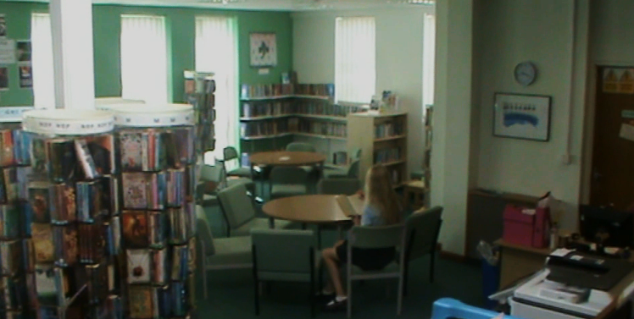
Penair School, England.

Welcome to our library

What people think
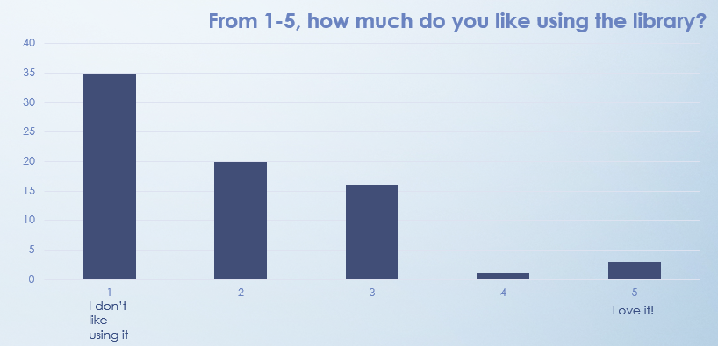

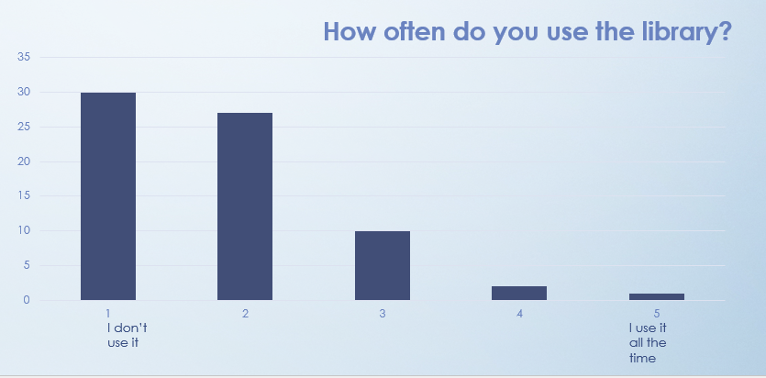

Our dream library
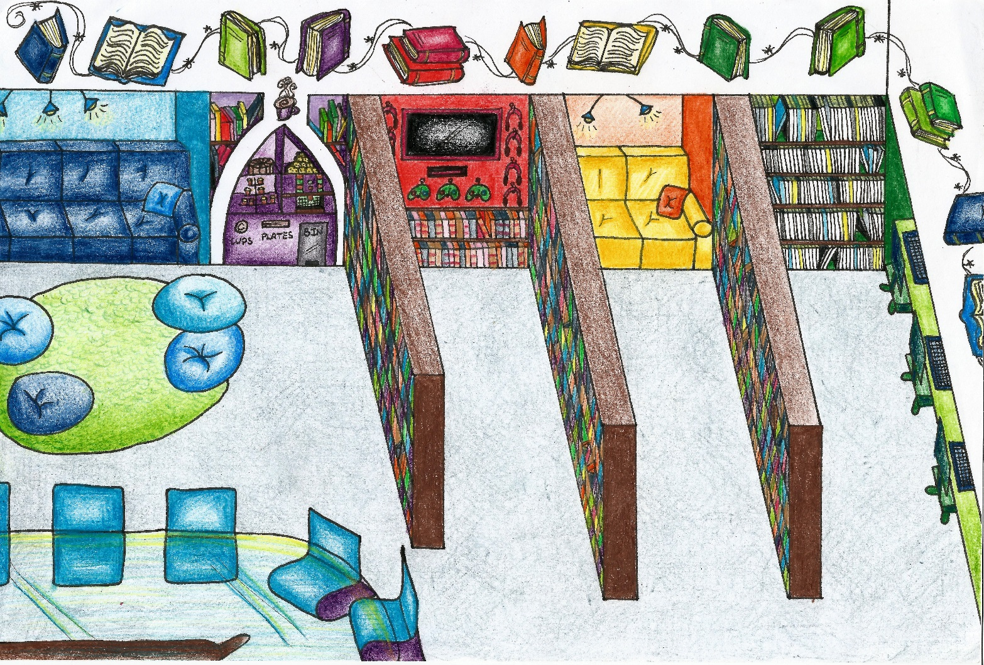
Based on pupil’s ideas, this is what the library would look like:

Interview of our librarian –
Ms Perryman
- What’s Ms Perryman’s favourite part about the library system at Penair School?
- She thinks that “the library system is quick and it’s ready available to all students; no matter what age group. They can just come along, they can take any books out and if we don’t have them then we will order them.”
- Is there anything she would like to change about the library?
- She would like the students to use it more often, especially a mix of students from all years. This is because she finds that more KS3 students use it compared to older KS4 students.
- What would Ms Perryman like in her dream library?
- Access to any book that’s been printed on the market, whether it’s on a Kindle or any electronic system. She wants students to ask for a book and be able to get it instantly.
- What does she think that we have in our library that other libraries should have?
- Ms Perryman thinks that “we have a really well coming approach, the staff that work in here a very approachable. I think students and staff mix well in the library.”
- On a scale from 1 to 10 how many students does Ms Perryman think use the library?
- Year 7 to 9 - 10, years 10 and 11– 5.
- What does she think is the general attitude towards the library at Penair School?
- “I think students like the library. I think they fell like is good to come into, is a good place to work, specially form an early age, years 7 and 8 do love it, but as they get older, they stop coming to the library as much. But it think is a nice friendly place to study and I think that’s the good thing about it.”

