OER of languages
Video lessons and printables:
https://en.islcollective.com
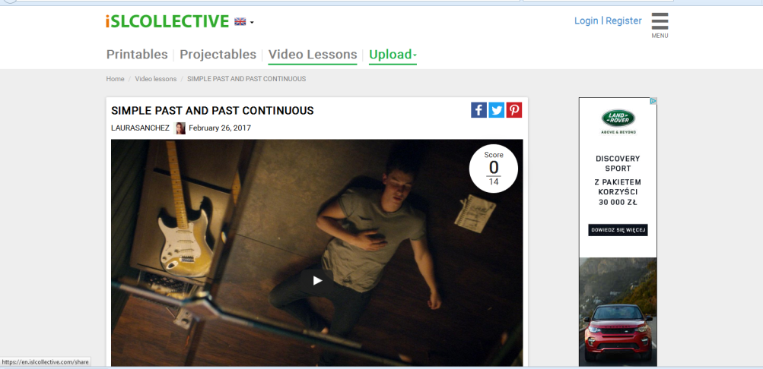
Gramma:
http://www.really-learn-english.com
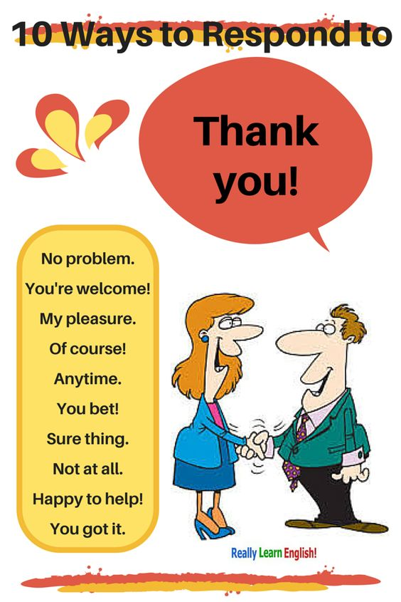
www.angielski.edu.pl
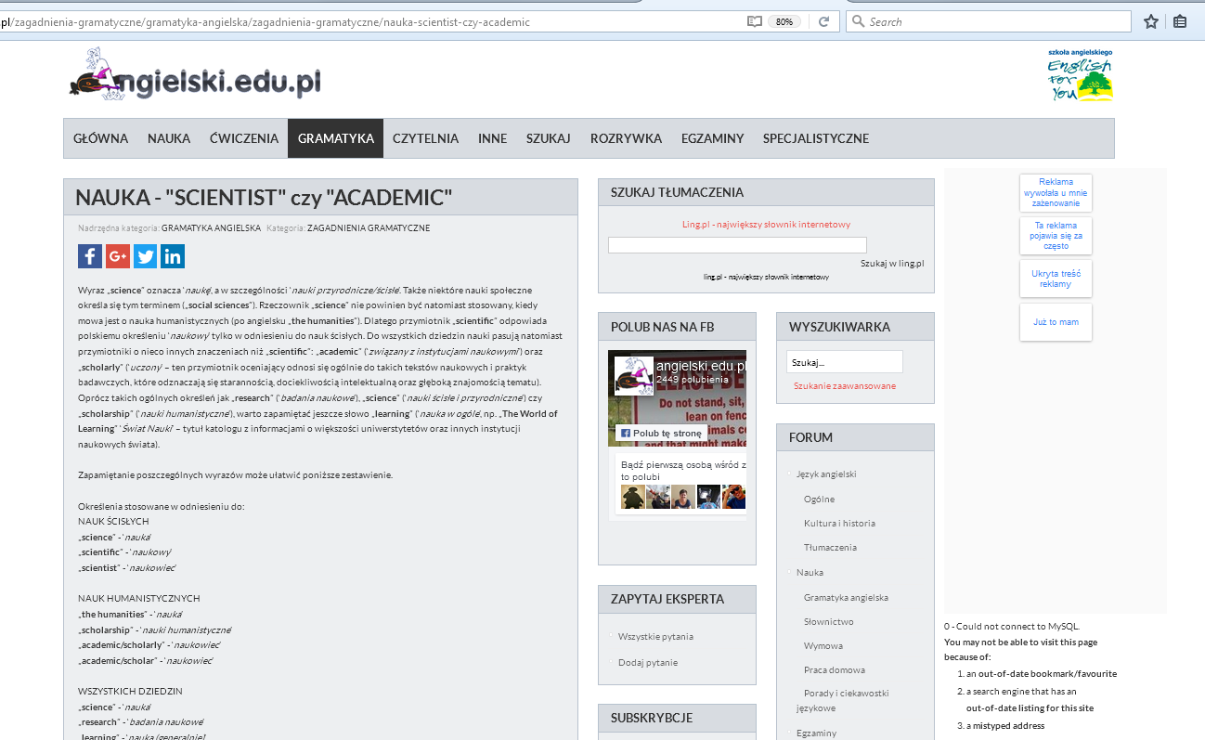
Social media:
www.facebook.com
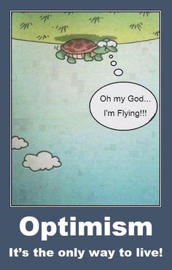
www.twitter.com
Images:
Scoop.it
Pinterest.com
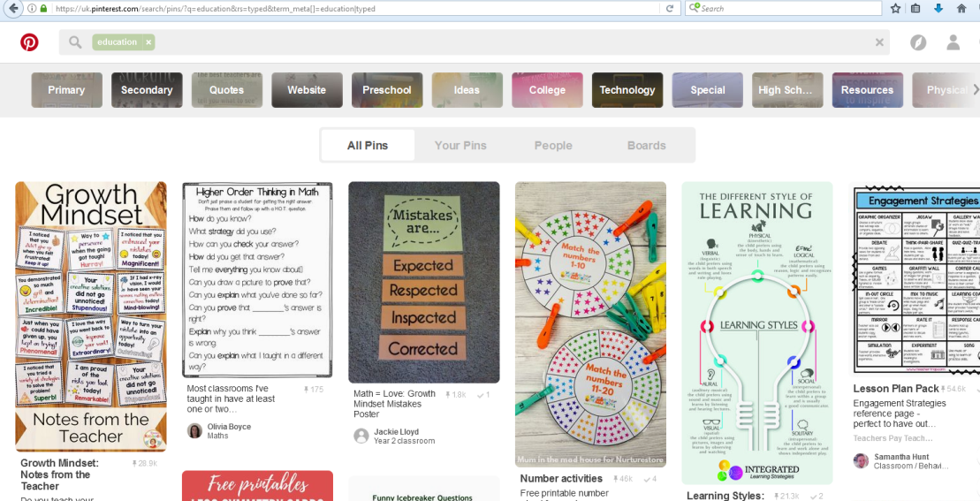
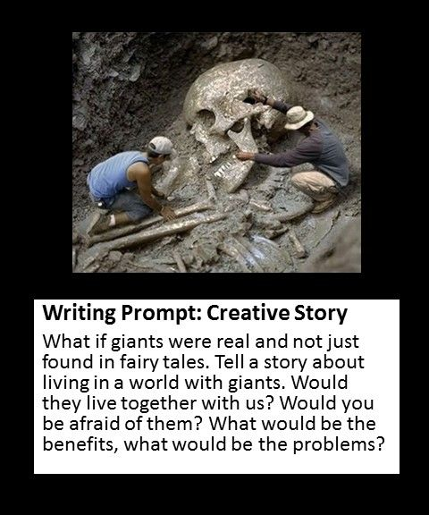
Funny:
www.daytranslations.com
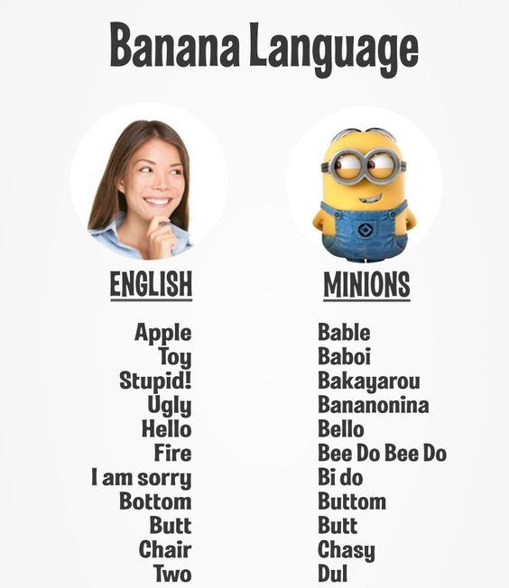
http://www.playbuzz.com
http://www.gocomics.com
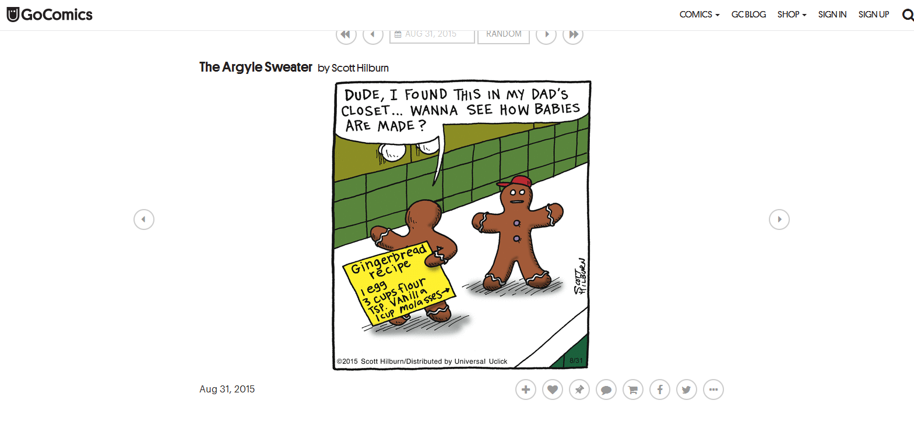
http://www.lovethispic.com
Blogs:
http://alove4teaching.blogspot.com
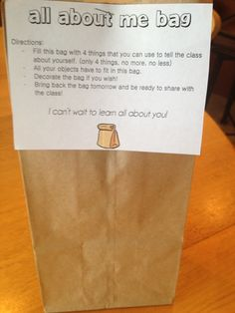
http://oncewelove.blogspot.com
http://askpaulenglish.blogspot.fr
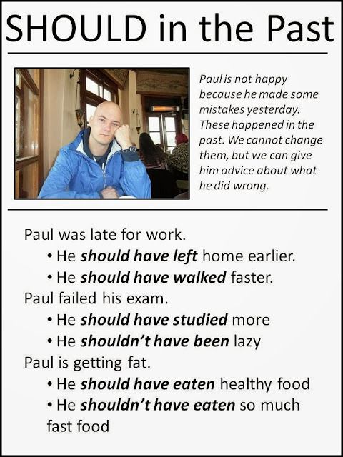
http://www.ladieslearnenglish.com
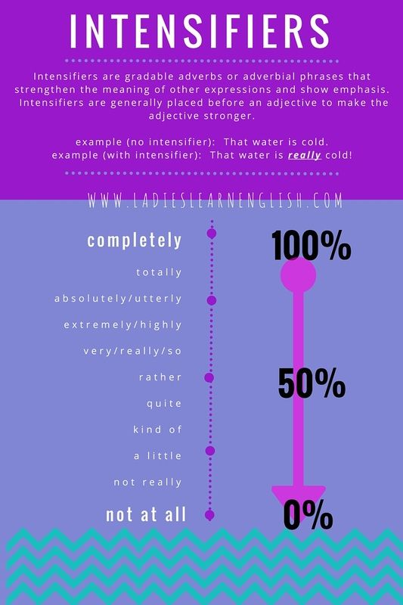
Quotes:
http://www.lifehack.org

Songs:
http://www.readingandwritingredhead.com
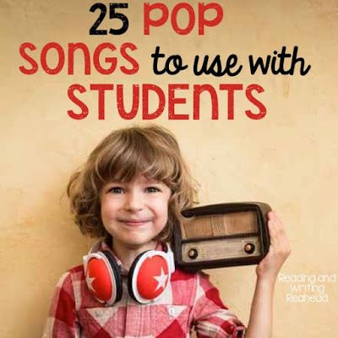
http://www.e-ang.pl/
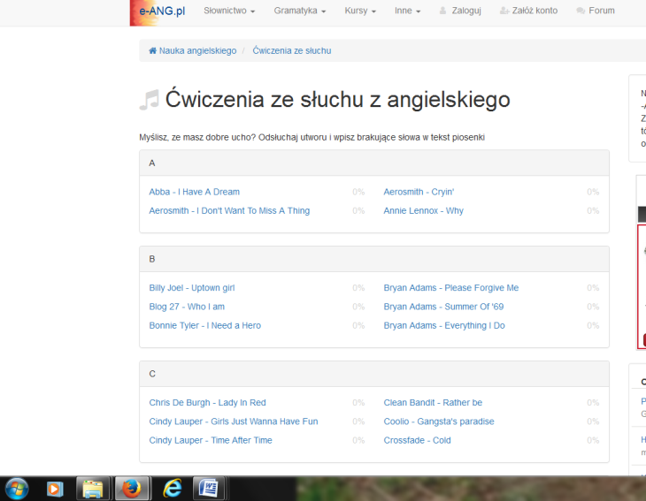
Dictionaries:
www.diki.pl
WWW.ling.pl

