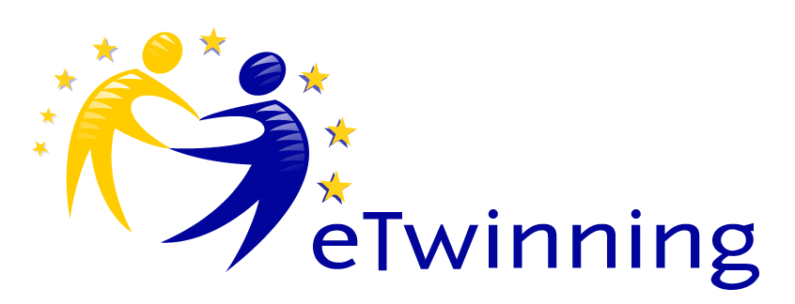

THIS IS AN ETWINNING AND ERASMUS+ PROJECT FUNDED BY THE EUROPEAN UNION
“IMPROVEMENT THE TEACHING-LEARNING PROCESS AT AN ENTREPRENEURIAL AND SUSTAINABLE ESTABLISMENT”
“ITLP AT EASE”
___________________________________________________________

The project was created by IES Huelin in Malaga, as a strategic partnership Erasmus+ project, in order to submit it to the European Commission for approval. We have committed ourselves to using eTwinning in our project as it is a great collaborative tool.
The project was started when some teachers identified some needs which should be met. We broke down the needs into topics and subtopics:
1) Improving teaching-learning process: open educational resources, innovative methods as project and problem-based learning activities, school library dynamization, improving outcomes especially for students with learning difficulties and discapabilities, combating the school absenteeism, teacher and student assessments,…
2) Renewable energy: energy efficiency, climate change, reducing CO2, waste management, energy bills study, saving in costs both at home and school,…
3) Fostering the entrepreneurial spirit: creating a mini business, setting up a time bank at school,…
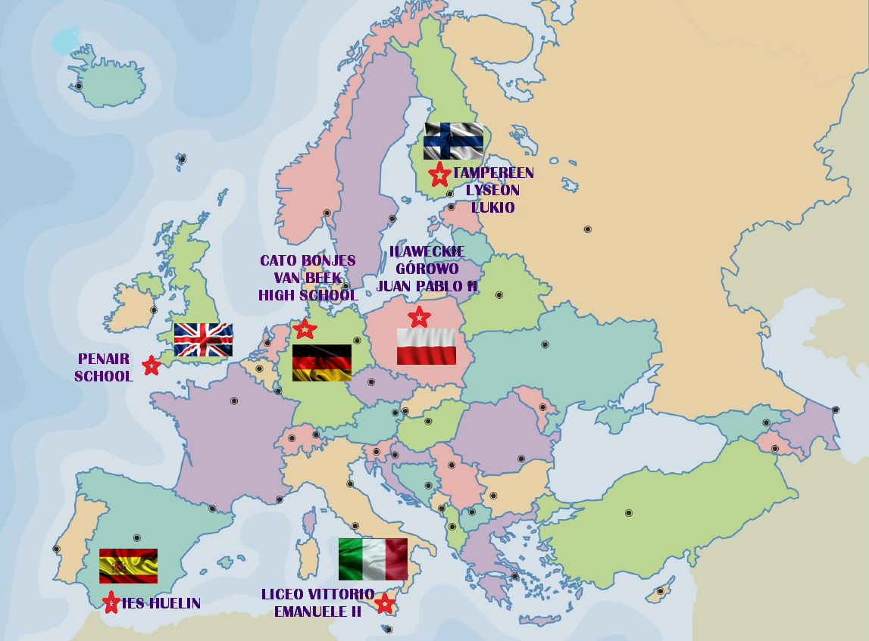
The participant schools know each other as we carried out a Comenius project from 2012 to 2014. There are 6 schools: Penair School in Truro England, Liceo Vittorio Emanuele II in Palermo Italy, Tampereen Lyseon Lukio in Tampere Finland, Cato Bonjes van Beek High School in Achim Germany, Ilaweckie Górowo Juan Pablo II in Poland, and IES Huelin in Malaga Spain.
The project consists of 6 mobilities from 2015 to 2017. Two teachers and 4 students from each school will travel in each mobility. Each school has to select 20 students to participate directly in the project, though other students can participate as well.
Every school has their strengths and weaknesses, but we believe that every school community will gain in many aspects after the completion of this project.
Through our dissemination plan we expect our experience to reach other schools and institutions, encouraging them to collaborate in the future. Our dissemination plan goes from a local or regional level in newspapers, television channels, associations, town halls, local educational authority platforms,… to a national and European level in platforms such as the Spanish Ministry of Education and the European Commission (VALOR). In addition, every country will design their own dissemination plan.
We will have activities before (coordination and preparation), during (collaborative working, brainstorming, brainwriting, making materials, sharing and exchange, job shadowing, visits, evaluation) and after the mobilities (presentations,monitoring, putting into practice, evaluation dissemination).
Finally, we have to say that one of the motives that encouraged us to start this project was its sustainability, in terms of maintaining the results of the project over the three topics and continual improvement.

