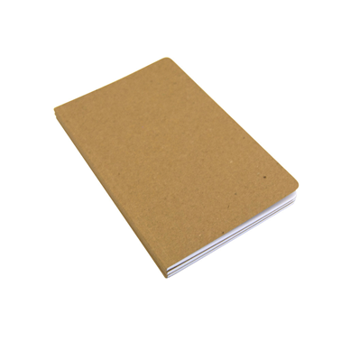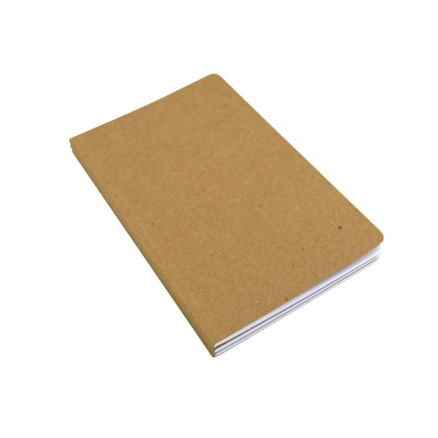

**Send production tools to schools so they can get involved.**

**Helps to get people to do something and gives people a decent job and keeps them off the streets.**

NotExpensive

**It will encourage young people to recycle for a good cause and it will benefit more people in the future.**

**Using clean recycled paper to make notebooks for students. They won’t be expensive, and will provide a cheaper alternative to brand new books.**

**Provide resources to LEDCs to create small scale economy. Allowing employment and books for developing schools.**