LICEO CLASSICO “VITTORIO EMANUELE II” PALERMO

Erasmus KA1 – ITLP AT EASE
Improving Teaching-Learning Process at an
Entrepreneurial and Sustainable Establishment
This project has been funded with support from the European Commission. This publication [communication] reflects the views only of the author, and the Commission cannot be held responsible for any use which may be made of the information contained therein.
This work is licensed under the Creative Commons Attribution-NonCommercial-ShareAlike 4.0 International License. To view a copy of this license, visit http://creativecommons.org/licenses/by-nc-sa/4.0/.
14 Nov – 19 Nov 2016 Palermo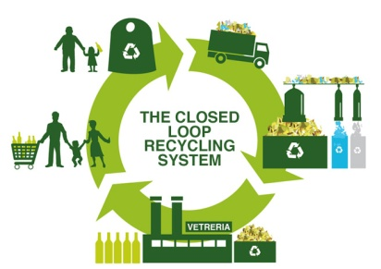

Monday 14 November

9.00 Meeting at school ( Secondary Building Via del Giusino)
9.00 – 9.15 Meeting room . Welcome ( Headteacher + Coordinator )
9.15 -9.35 International groups
Most of the students already know each other some new students are from Gorowo and Truro. To socialize students are divided in 6 international groups. Each student in the group will
- Introduce him / herself
- Say something about him/herself
- Say something relevant about his/her country
- Say something about her/his school
- Share poem or short text they have chosen to be read during the week as an activity (before arriving each student chooses a short poem or sentence from a book they like . In their own language. It will be shared in international groups on the first day (maybe each student can say the reason why he /she likes it) then at home with their partners each text will be written, copied, printed on a card/ sheet , decorated – see activity on 16th November afternoon.
(they will use a little ball/object to role play max 15 minutes)
9.35 – 9.50 Students and their partners visit school, central building . One Italian teacher goes with them
9.50-10.00 - Some information about the program will be given by the Italian teachers( food fair, photo exhibition, reading context , flash mob and rehearsals, book for Open air library)
10.00- 11.00 International groups : theme “Environment and recycling” On the basis of what they already know/ learned they have to decide about an idea for the flash mob to be performed on the 18 Nov in the city centre . Students will use cardboard to present their idea . The aim of this activity is to raise awareness on environment and recycling ( students don’t need to prepare anything in advance, they can only think about the flash mob related to the theme )
11.00 – 11.20 break ( EU students will meet other Italian students)
11.20 -11.45 Presentation of the project “Tappi di plastica” by Professor Gianluca Sarà (University of Palermo)
11.45 - 12.00 Each international group presents ideas for the flash mob (using cardboards)
12.00 – 12.20 all the Teachers plus 2 students (from different groups) will vote the best idea of the flash mob to be performed.
12.20 – 12.40 Presentation of the project “Be Scientist” by some students (Linda and Mauro from class 5G) of the Italian school.
12.40-13.15 Science OER teachers/students presentation and uploading on the platform or collection of materials on Pendrive (Emilio) (Remember: before arriving students from each country only need to prepare a list of links and a brief comment of each link (OER SCIENCE) on a WORD document . If they want they can show 1 or 2 .

Free afternoon / free evening 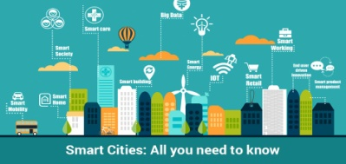

Tuesday 15 November
9.00-9.40 Presentation of the project “Smart City” by Engineer “Comune di Palermo” Antonio Mazzon (30min plus debate 10 minutes )
09.50 – 11.00 Theme : Library
9.50 – 10.00 The Italian Teacher Carmela Barbaria will give a speech (max 10 minutes)
10.00-10.10 The Spanish teacher Carmel will tell us about the Spanish school experience (max 10 minutes)
10.10 – 11.00 6 International groups : Each country will report about their school library ( before arriving each country prepares a short report or bullet points about their school library ) (8 minutes per group ) The Italian students will also present some new projects related to the school library,(Flaccovio) , the Regional Library (Archivio Giornale L’ora)

11.00- 11.20 break

11.20- 11.40 Talking about libraries with some experts and people who run special reading projects in Palermo
- Leonora Cupane “Biblioteca Invisibile” (centro Studi Narrazione “Le Città invisibili”) (20 minutes)
11.45 -12.05 Six national groups . Students
- discuss “the ideal library for my school”( their ideas will be presented using cardboards)
- students write down the main ideas learnt from other schools to enliven their library. ( their ideas will be presented using cardboards)
12.05- 12.20 each national group presents ideas
12.20 – 13.30 Flash mob rehearsals , ( gym or meeting room) the students will be helped by the Italian Gym teacher Mrs Graziano
12.20 – 13.00 teachers meeting ( 13.00/13.30 teachers watch students’ rehearsals)

13.30 free lunch / free afternoon

Students by their own . In the afternoon (soon after school / lunch) the students and their twins will visit the open air library Piazza Monte Santa Rosalia di (Mr Pietro Tramonte) Each students is invited in donating one book to this particular library ( each student brings any kind of book in their own language). Mr Pietro Tramonte will welcome the students.

Dinner : Teachers at Lucia’s house
Wednesday 16 November 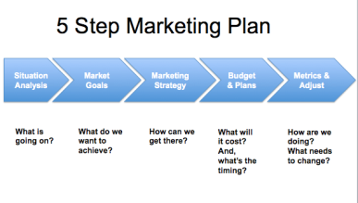
9.00 – 9.45 Entrepreneurship – “Marketing Plan”. Students’ presentations in six international groups . Students will share the marketing plan of their companies, they will talk about how their mini companies are going on, they will analyze the sales techniques, how they present their product and the pricing (before arriving they need to prepare a word document with this information) . If they wish they can also have it in a more attractive format, but Word format is imperative.
9.45-10.00 The project coordinator Mr. Emilio Guzman will show a short guide to do the mini company financial plan. (planning Truro Mobility)
10.00 – 10.30 In International groups , each school bring a short presentation (in a Word document to be done before arriving) about how their school and educational system deal with the work-based learning and the transition between school and working life. Italian students will present ” Alternanza scuola –lavoro ”
10.30 - 11.00 Professor Riccardo Alessandro (University of Palermo ) speaks about DI.BI.MED (an important scientific discovery made by a team of researchers in Palermo).
11.00 -11.20 break
11.20 – 12.15 flash mob rehearsals
12.15 -13.15 students and teachers will visit some Unesco monuments (Quattro Canti, Piazza Pretoria, Santa Maria dell’Ammiraglio and San Cataldo ) guided by some Italian students (classes 5G 5A) and by the art teacher Mrs. Terry Montesanto.

After visiting Santa Maria dell’Ammiraglio the students will stop tourists or people from Palermo, they will tell them they are part of a European Project and they will read them the poem or text chosen (the text is in their own language) . Aim : the pleasure of donating, of reading for someone, dissemination of our European Erasmus project.

Free lunch / free afternoon
Thursday 17 November

8.00- 17.00 full day visit to Isnello “Astronomical Park” Gal Hassin and Cefalù

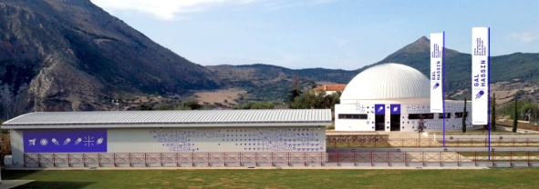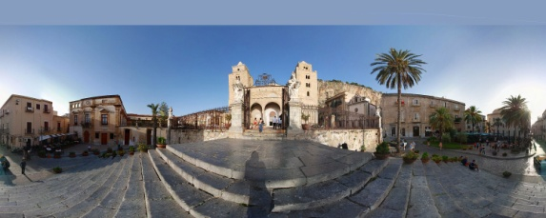

Friday 18 November
8.30 – 9.15 general rehearsal for the Flash Mob
9.30 - 10.00 Flash Mob ( Via Maqueda ) 30 min ( flash mob lasts 1 minute or less)
Students and teachers gather in Via Maqueda ( before “Piazza Villena”) Students will perform their flash mob in order to raise awareness on environment and recycling.
10.15 back to school feedback ( as a feedback students can say /write the way they felt while doing it, they can be recorded by other students)
10.20 – 10.45 General Feedback related to all the activities. Students will be given a sheet of paper they will write a word/ sentence to give a feedback of the week in Palermo. Some students will tell how they feel about this mobility and others will record them (make videos).
10.45 – 11.30 Students will be split in 2 groups. Group 1 : photo exhibition to be organized / group 2 Food fair to be organized
All the students will contribute to the photo exhibition with 2 pictures (one taken during school activities and another during their free time activities. The students are responsible of printing their photos (foreign students will be helped by their partners). Before Friday 18 the students have to decide how to show their pictures in order to prepare the needed materials. All the pictures will be later uploaded on the FB page of the Project by the students , the teachers will be responsible of uploading the pictures on the e-twinning . As for the food fair each country will contribute bringing some typical food (not big quantity! ) The Italians will also be responsible of bringing to school table clothes, glasses, plates, cutlery etc.
11.30 Certificates will be given to teachers and students
12.00 - 13.00 Food fair and photo exhibition . Greetings
