PRESENT PERFECT TENSE
(WHAT QUESTIONS, TRUE/FALSE)

- What have you eaten? 2. What have you done?
I have eaten some pasta. I have tidied my room.
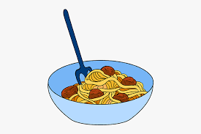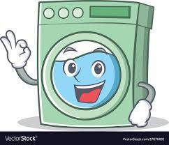

3. What have you written? 4. What have you bought?
I have written on e-mail. I have bought a red dress.
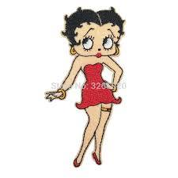

5. What has he got? 6. What has she got?
He has got a soccer ball. She has made a cake. 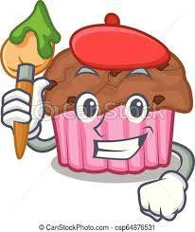

7. What have day watched? 8. What have you won?
They have watched a movie. We have won some money.

9. What has Jane cut?
She has cut her hair.

