lychee cocktail
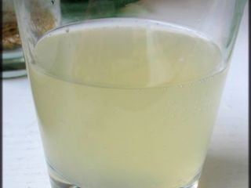
ingredients:
- 1 tin of lychees in syrup
- Chopped crystallized ginger
- 1 bottle of fresh champagne
Preparation
The day before, pour into a large bowl, the juice box lychee and ginger.
Put one litchi in every glass
Mix the with flavored syrup and pour into glasses
serve immediately

