Easter traditions in Umbria

There are many Umbrian Easter recipes, but the most used ones (and also my favorites) are, for example, the “agnello fritto” and the “torta al formaggio”.

Fried lamb chops: An easy and tasty dish to bring to the table for Easter lunch.
Fried with double breading, based on eggs, flour and breadcrumbs, for a crunchy and tasty exterior that preserves a tender heart. Frying with oil at a slightly lower temperature guarantees a perfect and good result, soft inside and crunchy outside, (guaranteed by grandma’s recipes).

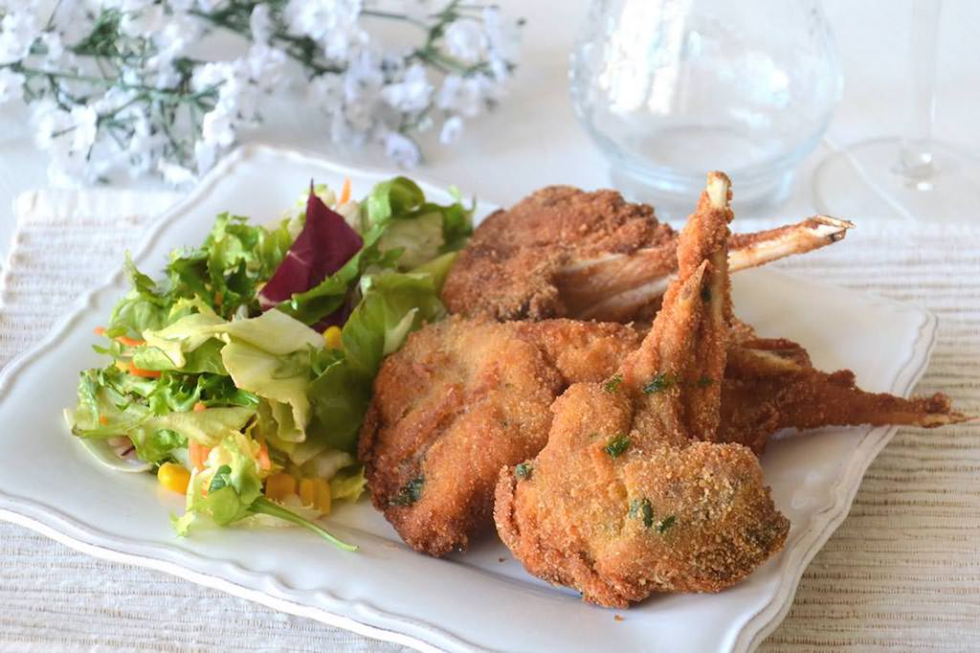
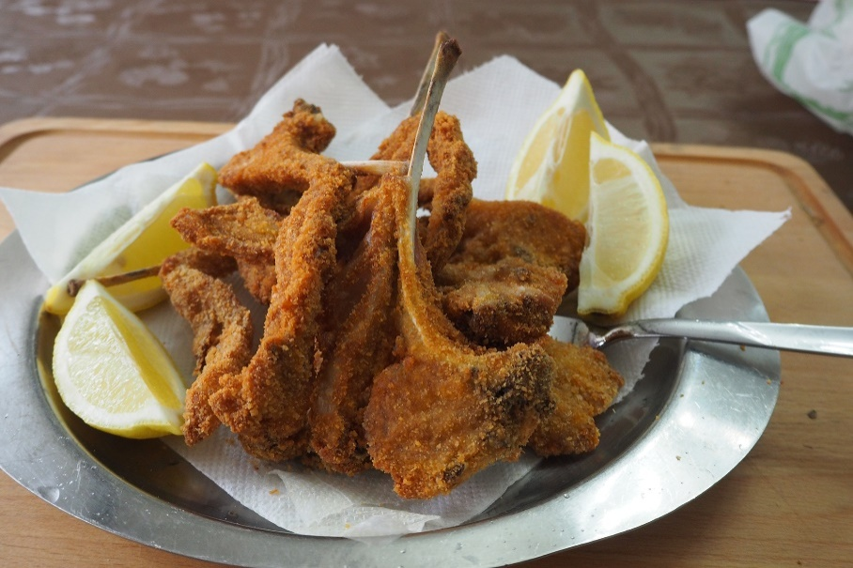
The cheese cake: it is a typical Umbrian recipe and it is prepared during the Easter period. It is a soft and very tasty cake, made of a mixture of aged cheese such as pecorino and parmesan, with the addition of soft cheese cut into cubes. Traditionally, the cheesecake is eaten on Easter morning for breakfast, with cold cuts and hard-boiled eggs, (guaranteed by mum’s recipes).

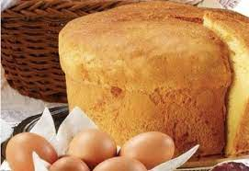
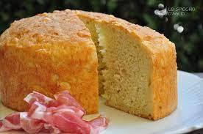
Chiara Bevilacqua 2° A Erasmus

