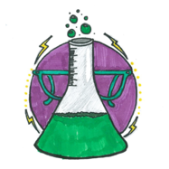
Full STEAM ahead for better education
Lesson plan
Sixth Class/ 12 Years

TEACHER: Mrs Vorria Matula 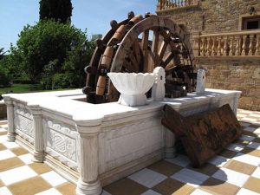

Title/ Τίτλος:: The Capstan Well : When the wheel spins...

Aim/Στόχοι | Measurements in space using measuring tape  Developing the skill of solving math problems and their application in everyday life
Tools I need/Εργαλεία | measuring tape, music (for drama/acting games)
Preparations/Προετοιμασία | Visiting the place, imaginary scenario, working groups, worksheets, drama/acting games
What to do/ Δραστηριότητες | measuring length, surface, volume – the principle of the interconnected pipes
What I get / results/ Αναμενόμενα Αποτελέσματα | The pupils become acquainted with basic mathematical principles and how people have made good use of these principles in their everyday life. They are also asked to provide solutions to problems

The STEAM approach/ Προσέγγιση STEAM:

S | Search/Ερευνώ | The pupils improve their mathematical skills
T | Think/Σκέπτομαι | They use strategies to solve a problem
E | Experience/Δοκιμάζω- Βιώνω-Εφαρμόζω | They get to know the Capstan Well , which in older times was a special way of irrigating the orchards in the area of ‘Kampos’ on Chios.
A | Active learning/ Ενεργητική Μάθηση | The pupils count, estimate and play
M | Motivation/Κινητοποίηση | The pupils present what they have learned through a drama/acting game

Ressources / Links:
Πηγές

