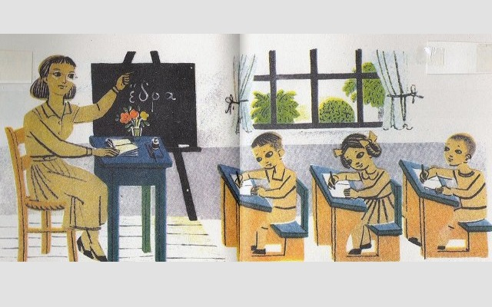
Evaluation of the program
«Let’s walk on the paths of tradition...»
Kindergarten of Douneika Ilias ,Greece- Xatzidimpa Panagiota
The program «let's walk on the paths of tradition...» started in October and lasted during the while school year kept the interest of all children teaching them different kinds of tradition. During the course they learned how to work with each other, got experience and knowledge. They played, sang and danced. Communicated with each other and learned how to present their actions. To conclude their were taught to esteem and cherish the tradition and love everything man-made from the last. We would like to thank you for this amazing course and cooperation!!

