Radioactivity
Definition:
Radioactive decay occurs in unstable atomic nuclei – that is, ones that don’t have enough binding energy to hold the nucleus together due to an excess of either protons or neutrons.
It comes in three main types. These are:
- Alpha
- Beta
- Gamma

*In case you’re wondering: The atomic nucleus is the small, dense region consisting of protons and neutrons at the center of an atom.

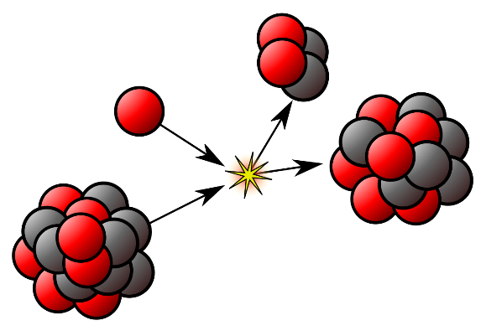
Alpha decay:
What’s it?: An alpha particle is identical to a helium nucleus, being made up of two protons and two neutrons bound together.

What it does?: It initially escapes from the nucleus of its parent atom, invariably one of the heaviest elements, by quantum mechanical processes and is repelled further from it by electromagnetism, as both the alpha particle and the nucleus are positively charged.

Process: The process changes the original atom from which the alpha particle is emitted into a different element.

Its mass number decreases by four and its atomic number by two. (For example, uranium-238 will decay to thorium-234).

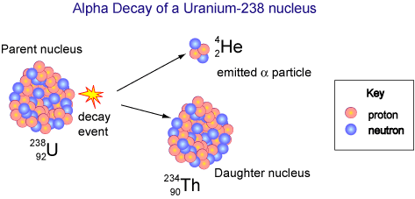
Sometimes one of these daughter nuclides will also be radioactive, usually decaying further by one of the other decays.

Beta decay

Beta decay itself comes in two kinds: β+ and β-:

β- emission occurs by the transformation of one of the nucleus’s neutrons into a proton, an electron and an antineutrino. Byproducts of fission from nuclear reactors often undergo β- decay as they are likely to have an excess of neutrons.

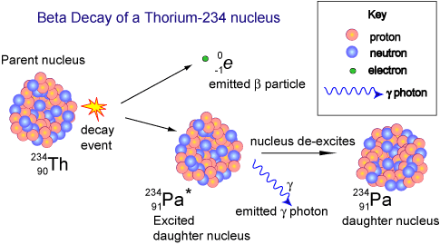
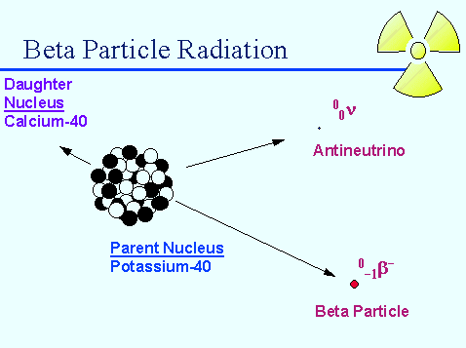
β+ decays is a similar process, but involves a proton changing into a neutron, a positron and a neutrino.

Gamma decay

What happens?: After a nucleus undergoes alpha or beta decay, it is often left in an excited state with excess energy.

Abilities: Just as an electron can move to a lower energy state by emitting a photon somewhere in the ultraviolet to infrared range, an atomic nucleus loses energy by emitting a gamma ray.

Gamma radiation is the most penetrating of the three, and will travel through several centimetres of lead.

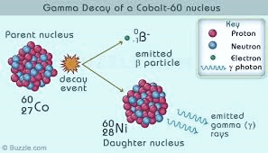
Beta particles will be absorbed by a few millimetres of aluminium, while alpha particles will be stopped in their tracks be a few centimetres of air, or a sheet of paper – although this type of radiation does the most damage to materials it hits.

The effects on human health
What it does?: Radiation causes health problems by killing cells in the body, and the amount and type of damage done depends on the dose of radiation received and the time over which the dose is spread out.
There are two main health effects caused by radiation, which act over the short- and long-term and also at shorter and greater distances.
- The dose limits for emergency workers in the event of a nuclear accident are 100 mSv if protecting property or 250 mSv in a life-saving operation.
Between that upper limit and 1 Sv received within a single day, exposure is likely to cause some symptoms of radiation poisoning, such as nausea and damage to organs including bone marrow and the lymph nodes. Up to 3 Sv these same effects are more serious with a likelihood of acquiring infections due to a reduced number of white blood cells in the body – with treatment, survival is probable but not guaranteed.

- Larger doses will, in addition to those symptoms above, cause haemorrhaging, sterility and skin to peel off; an untreated dose of more than 3.5 Sv will be fatal, and death is expected even with treatment for doses of more than 6 Sv.

The radiation level decreases with the square of the distance from its source, so someone twice as far away from an external source will receive a quarter of the radiation.
The effects on human health (Part No2)
Receiving a high dose in a shorter time usually causes more acute damage, as greater doses kill more cells, while the body can have had time to repair some damage with more time having elapsed between doses.

However radioactive material that is spread to a wider area can cause longer-term health effects via prolonged exposure, particularly if they enter the food chain or are inhaled or ingested directly.

Taking radioactive materials into the body also presents the greatest danger from atoms that undergo alpha-decay, as alpha particles are not very penetrative and are easily absorbed by a few centimetres of air. It was alpha-emitting polonium-210 that was used to murder Alexander Litvinenko in 2006.

Cancer and Radioactivity:
Radioactive isotopes of iodine, which undergo beta-decay, can build up in the thyroid gland and can cause thyroid cancer. Attempts to prevent this involve distributing pills that include nonradioactive iodine-127 and which flood the thyroid, preventing uptake of radioactive iodine.

For one-off doses, such as those from medical scans, the risk of later developing cancer is estimated at around 1 in 20 000 per mSv received.
Absorbing an accumulated dose of 1 Sv over a longer period of time is estimated to eventually cause cancer in 5% of people.

*However there is disagreement over whether very small doses comparable to the level of background radiation actually contribute to health effects.
Common sources of radiation
- "Man-made" radiation:
- Smoke detectors
Smoke detectors make use of the isotope Americium-241. This isotope emits alpha-particles at energies up to 5.4 MeV. The energetic alpha particles are used to ionize air. Once the air is ionized, a small current runs through it. When smoke enters the chamber, the current experiences an increase in resistance and a circuit sounds the alarm.
- Coal-burning power plants
Coal is an impure fuel, and it usually contains 1.3 ppm of uranium and 3.4 ppm of thorium (not to mention arsenic, mercury, and sulfur). When coal burns, these isotopes are emitted into the atmosphere, where they enter our ecosystem. This leads to the astounding fact that the population effective dose equivalent from coal plants is 100 times that from nuclear plants.

- Nuclear weapon detonations
The hundreds of atmospheric nuclear weapons tests that occurred before they were banned by the 1963 Limited Test Ban Treaty left long-lived radioisotopes in the atmosphere. Some of these are still in the atmosphere and account for some of our daily dose.
- Natural radiation:
- Radon gas
This natural occurring gas comes from soil and is found throughout the world. It emits alpha particles, and can therefore damage DNA and lead to cancer if inhaled. The EPA recommends you check your house for radon gas.

- Cosmic rays
Cosmic rays are energetic particles that originate outside of earth, in the sun, distant stars, galaxies, and supernovae. Most of these are protons. The atmosphere shields us from most cosmic rays, but during air travel, one will accumulate much higher dose.

