Ecology gifts
from recyclable materials
Author: Theodora Chandrinou
Painter - Art Engraver, Educator

Giving a second chance to materials we consider rubbish; we imagine and create something new with them.
So, an old broken necklace, all kinds of materials, even a bottle become the source of inspiration.
Some simple but well-made creations will help us get in the spirit of recycling of materials and of course enjoy ourselves with our creations.

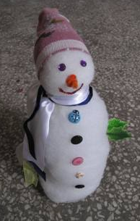
Snowmen
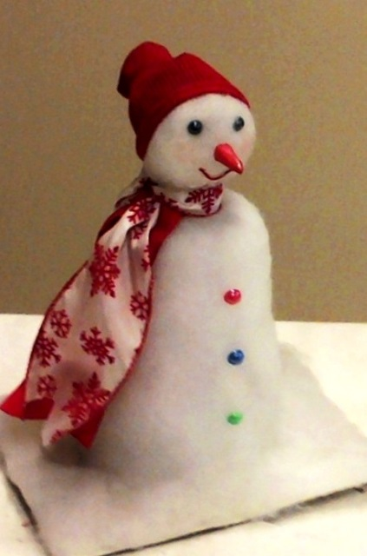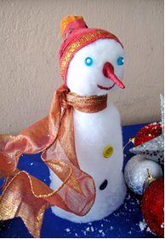

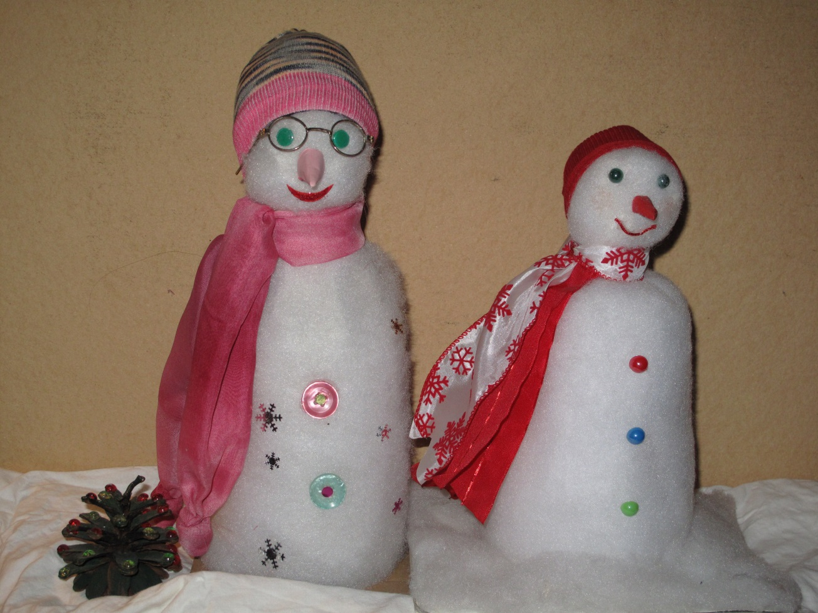
Materials:
- 1 empty water bottle (for body and structure).
- 1 ball made of two pages A4, in the shape of a ball (for the head).
- 1 old socks, spread with glitter or gold-dust (for the beany).
- 1 piece of white cotton (the material we fill pillows with), to wrap around the body.
- Buttons, beads or pins (for eye and body decoration).
- Large ribbon or a piece of cloth (for a scarf).
- A piece of paper or cloth small triangular roll for the nose.
- Wet glue, scissors.
The most beloved creation from young children and older ones. Have fun!!!
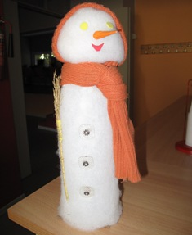

Little snakes
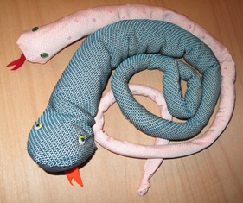
Materials:
- 1 old tie (in good condition).
- 1 piece of pink, red or orange cloth (for the tongue}.
- Needle and thread and crystallized glue (it becomes transparent when it is dry).
- A small quantity of soft material or paper or the material we stuff the pillows with, of course to fill the body of the tie slowly.
- Buttons, beads, pins, glitter, for body and eye decoration.
We can use it as a toy for children’s room or a stop for the door.

Charms
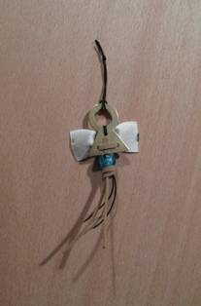

Materials:
- Broken jewelery, beads, ribbons, colorful strings.
- Clay

Each and every ribbon tied with a loop and decorated with anything we imagine, easily gives us a decoration for the tree or tasteful present as a charm for the New Year.

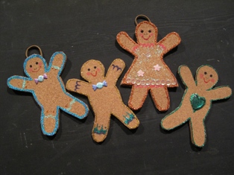

Biscuit-children out of cork
Materials:
- Level cork , preferably not very thick.
- Glittered glues, tinsel, beads, gold and silver crayons.
Beautifully simple, impressive creation at minimum cost.

Beautiful cards - Prints
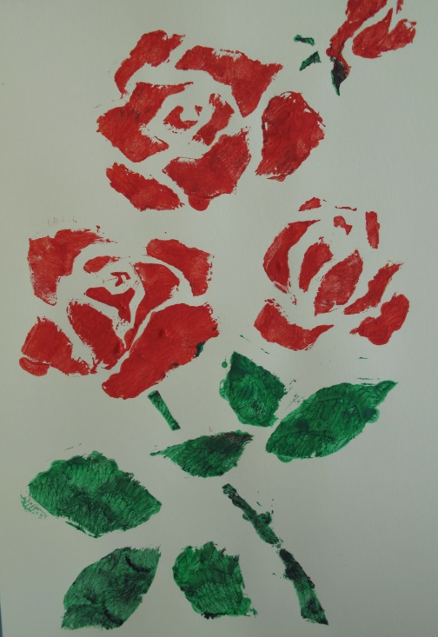

Linocut

Work of a 4th Grade pupil
Materials:
- Stencil, made of plastic surface, or hard cardboard, hardened with glue.
- It can be done with vegetable prints such as potato, cut in different shapes with the use of water-colours.
- Also it can be made with an engraved print. An example is linocut printed on any paper by hand.
We stick our print on a cardboard folded in the middle and the card is ready!

Wreaths
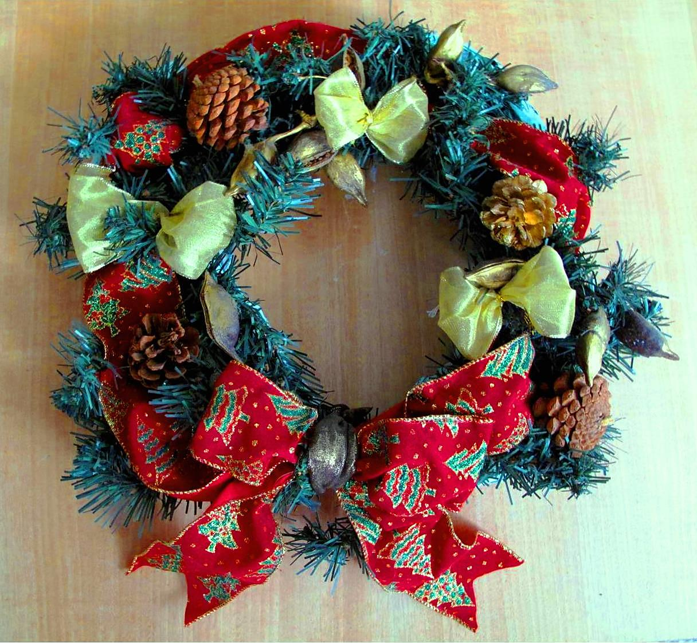
- Wreaths made of newspaper (The inner part) and wrapped up with beautiful materials.
- Also, broken branches of synthetic fir tree, tied in a circle, give the basis for beautiful wreaths.
The decoration is made with pine-cones, nuts, golden painted. With ribbons, ties, clothing materials and recycled children’s ornaments. It gives an excellent result quickly and without expenses.

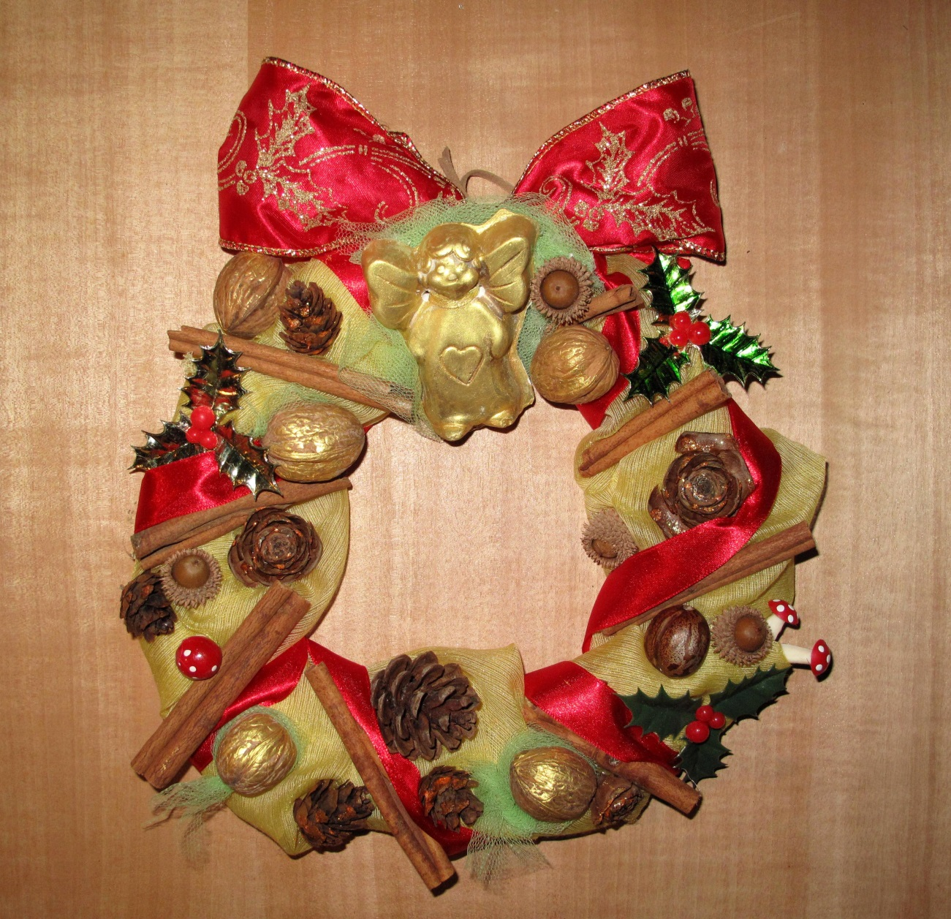

Balls for the Christmas tree
Materials:
- Any kind of crumpled paper in the shape of a little ball.
- They can be painted with anything and of course be decorated according to our good taste.
- Tinsels and beads, ribbons and strings, old metal objects which can be glued together creating infinite combinations
Creations that will be visualized without buying anything!

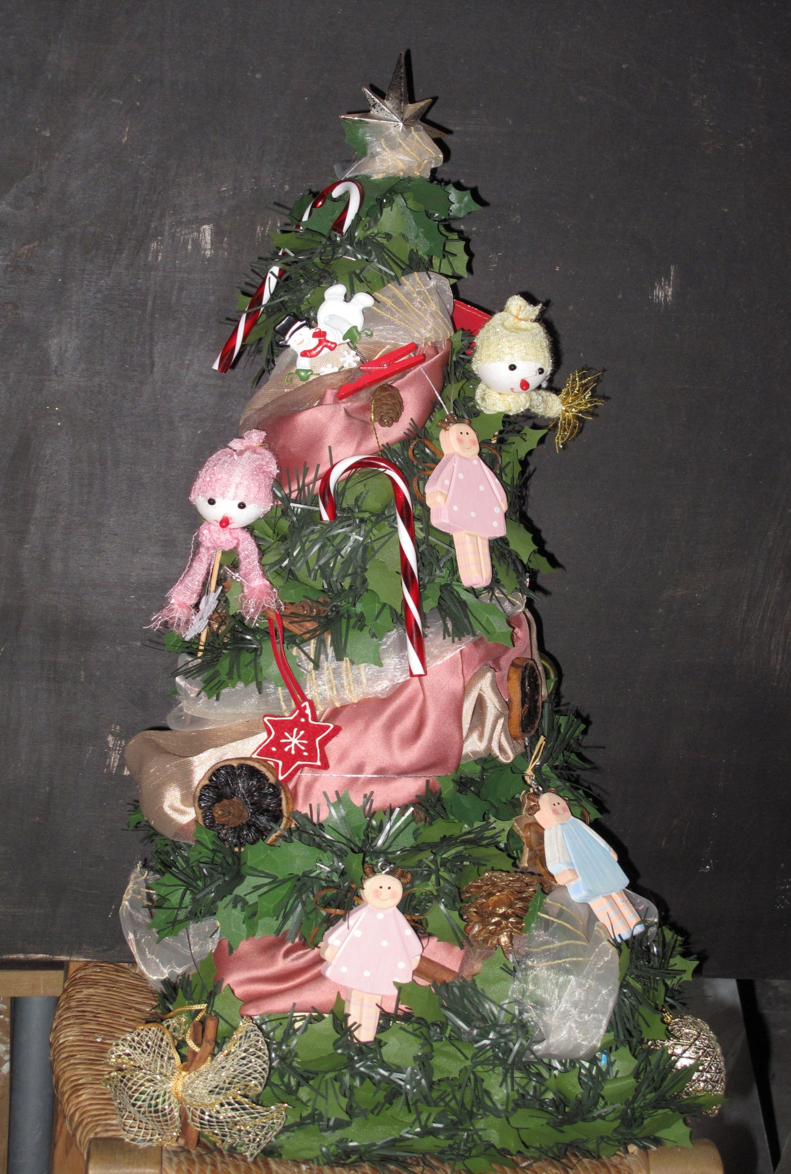

Special thanks for the translation to Evangeline Tzavara – English Teacher.

