APOKORONAS, CRETE
Apokoronas extends from the foothills of the White Mountains north to the coast, in a wide plain with rolling hills. The area is very green and fertile. The Kiliaris river runs through the region. Tourism and agriculture are the major local industries.The students come from different small villages in this region.
Stilos
Stilos is a very beautiful village.It has beautiful houses, two shops, a cafe and many taverns.
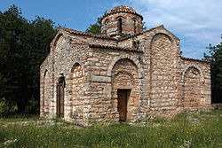
Stylos is at a distance of 10km from the city of Chania . It’s a fertile area,rich in natural water sourses,as it is situated on the feet of the white Mountains.
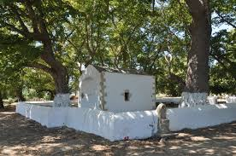
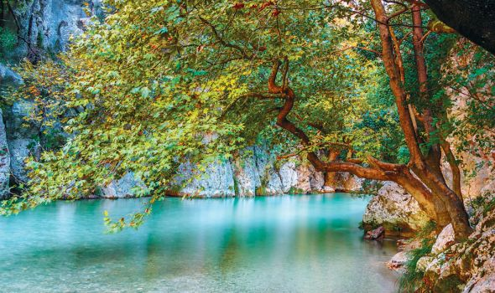
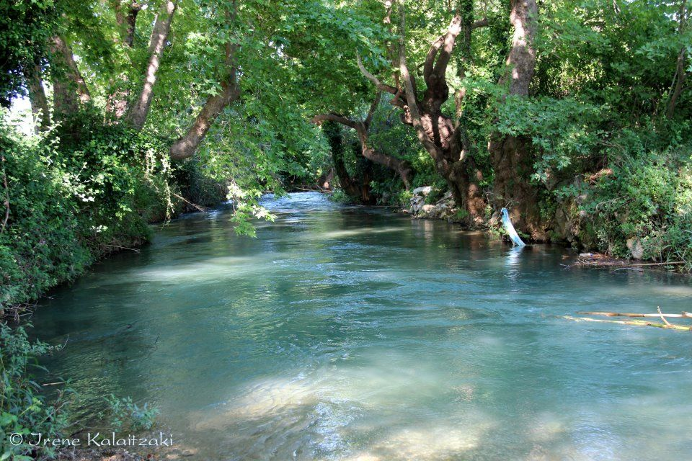
The water of the area is used in the water system of the Apokoronas Region.
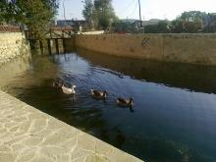
Samonas
In Samonas there are two churches, a cafe and one hotel. There live 30 people.
- 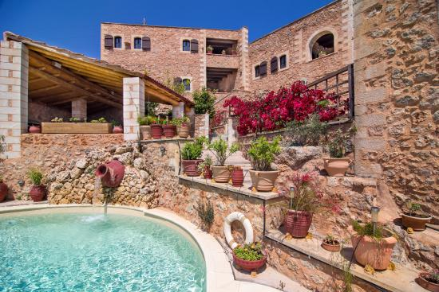

- It has the unique atmosphere of a Cretan village in the mountains.
- It is a perfect place for walking and hiking with trails leading to attractive mountain villages
- The village lives on stock raising and olive cropping.
- There is also an impressive cave with stalaktites and flowstones and a part of it could be visited.
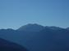

MACHERI
In Macheri there are small houses with beautiful
yards. It has got a theatre where every year are hosted at least 10 perfomances.It is very green and has got a playground.It has high trees with green leaves.
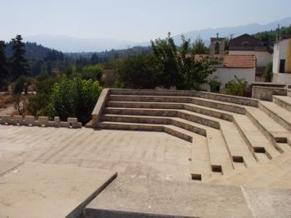
It has got 35 inhabitants.We have 5 churches and I like St John church the most which is built on the mountain.
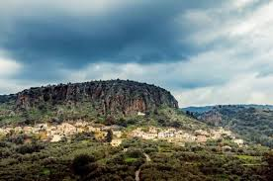
Nio Chorio
Nio Chorio has got 556 inhabitants and many tourists. It has got many trees, bushes and a playground. The village has got 2 villas, 3 cafes, 1 football field and 2 churches: St. Therapontas and St. Thomas.
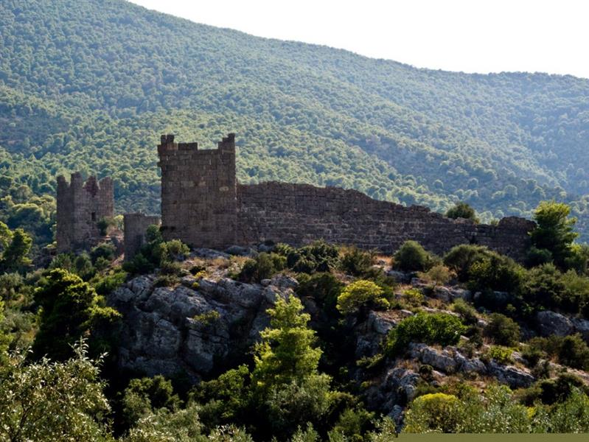
We have a school and small shops. There are a lot of houses, some are new and some are old. All of the people here are friendly and everyone speaks to me. My village is super and I love it here.
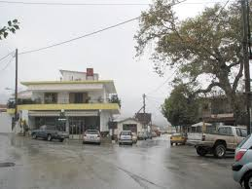
The reason that I like my village is because it has so many trees ,beautiful houses and a big road where I can ride my bike! I don’t want to leave from this small , beautiful and quite village.
