Length of the school year and distribution of holidays, general education, ISCED 1-3, 2016/17

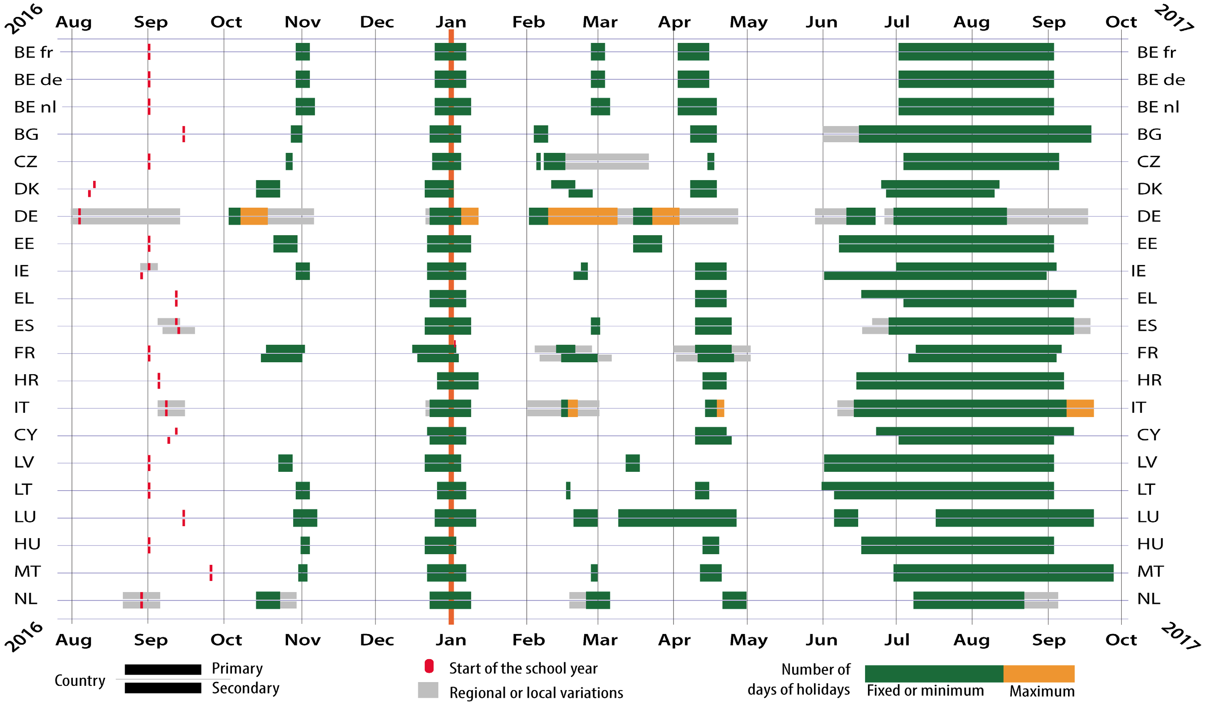

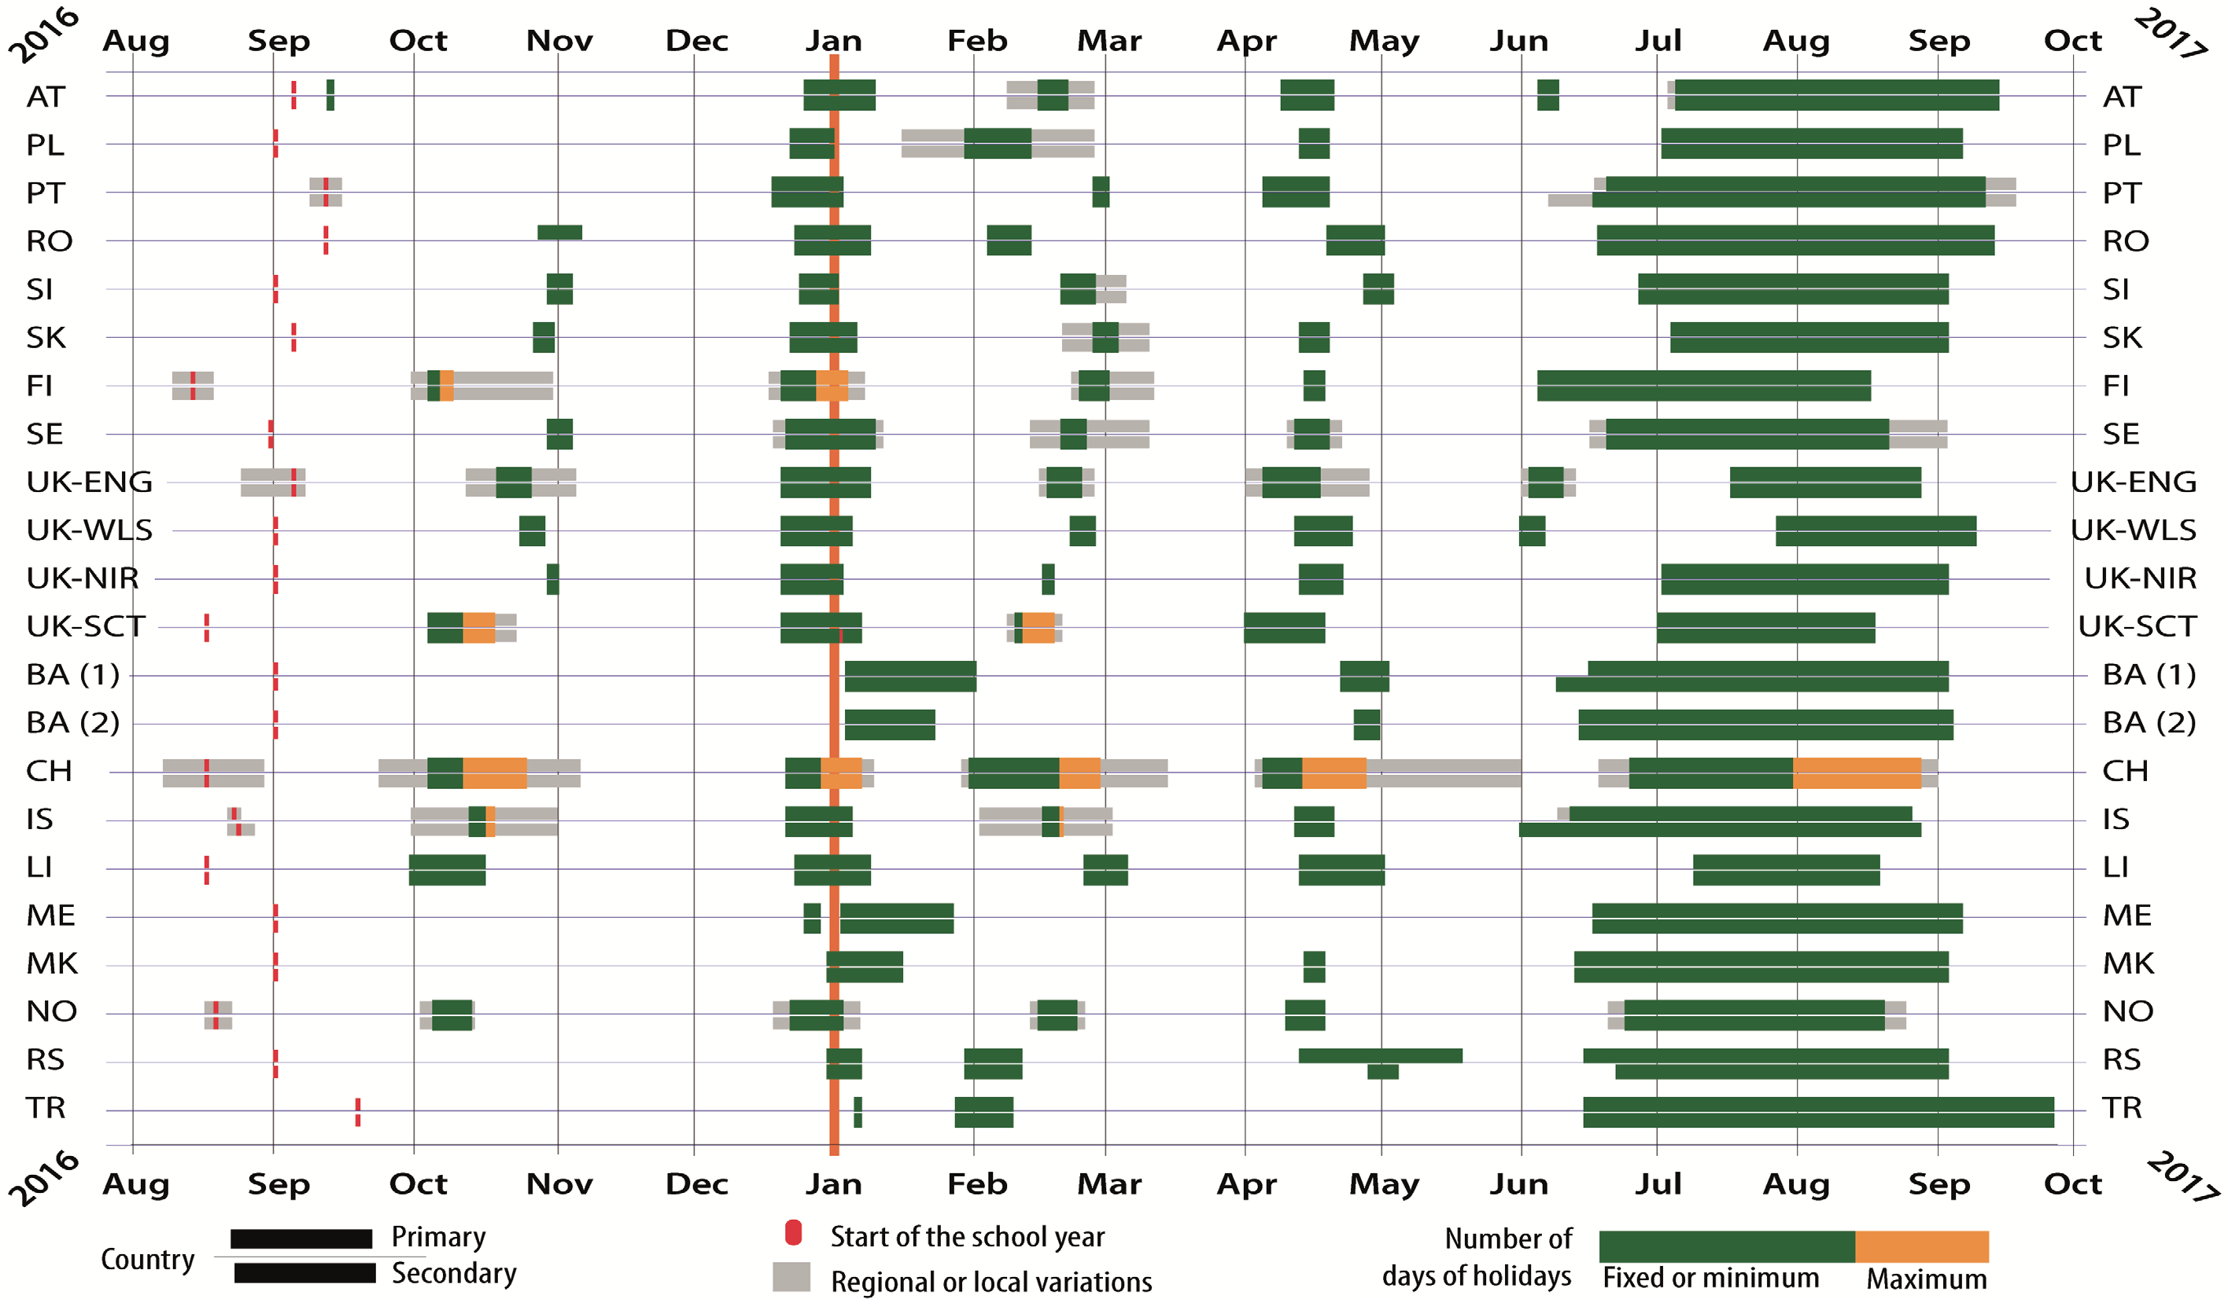

Website: http://ec.europa.eu/eurydice

