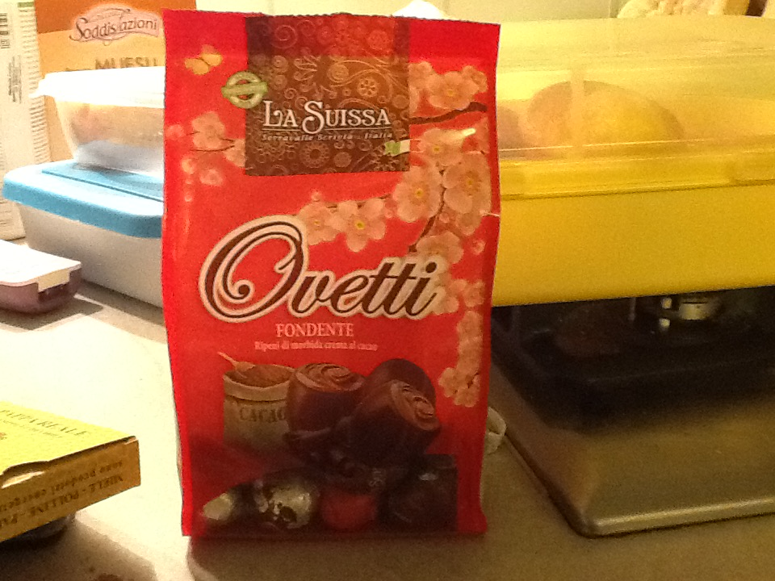
WHERE DO PRODUCTS COME FROM?

I think it comes from Italy...but I
don't have any idea about where precisely. My answer wasn't correct. It comes from Spain. It 1361kms to get to my country!

If this distance was covered by an Aeroplane that would create approximately
305 kgCO2 or 83 kg Carbon

If this distance was covered by a Car that would create approximately
245 kgCO2 or 67 kg Carbon

If this distance was covered by a Train that would create approximately
85 kgCO2 or 23 kg Carbon
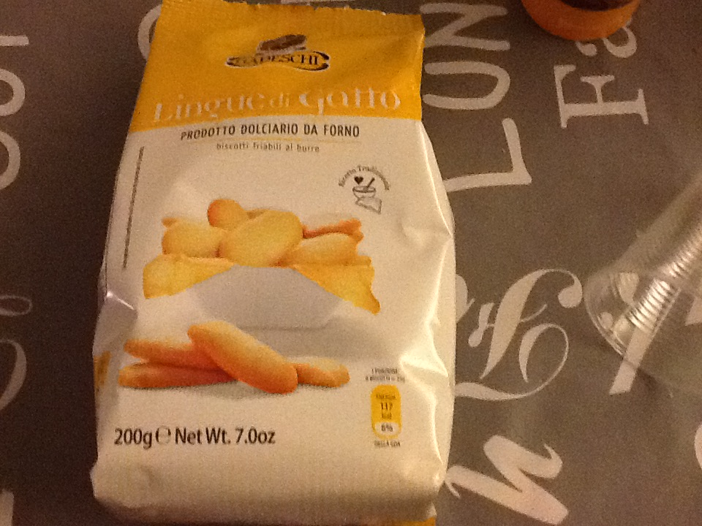

I think it comes from Italy...but I
don't have any idea about where precisely. My answer wasn't correct. It comes from France. It 1105kms to get to my country!

If this distance was covered by an Aeroplane that would create approximately
247 kgCO2 or 67 kg Carbon

If this distance was covered by a Car that would create approximately
199 kgCO2 or 54 kg Carbon

If this distance was covered by a Train that would create approximately
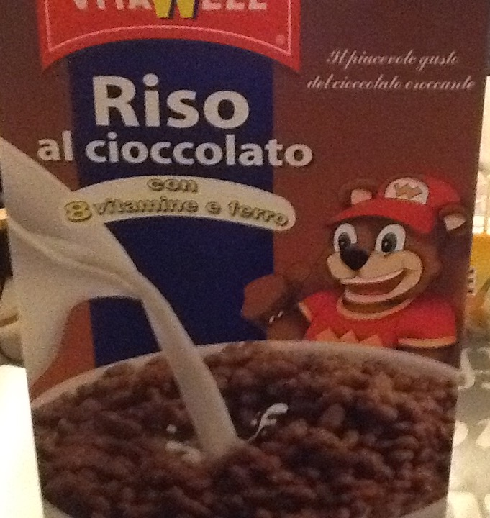
69 kgCO2 or 19 kg Carbon

I think it comes from Italy...but I
don't have any idea about where precisely. My answer was correct. It comes from Italy.

