Italian or not?
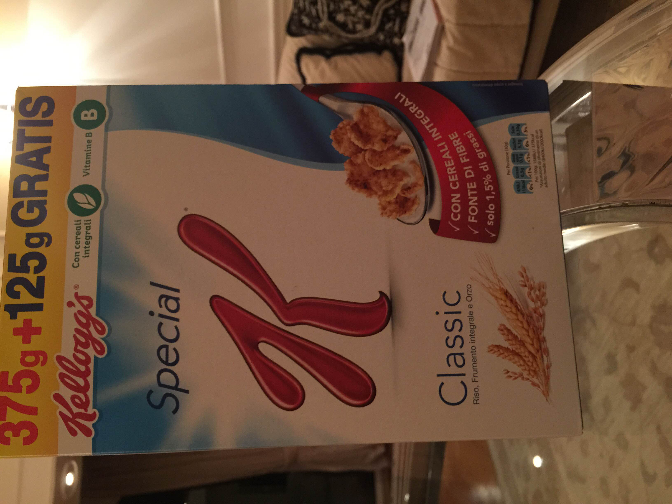
1)Special K, Kelloggs;
-this food doesn't say where is made, it only say's that is made in Europe;
-it's realy strange;

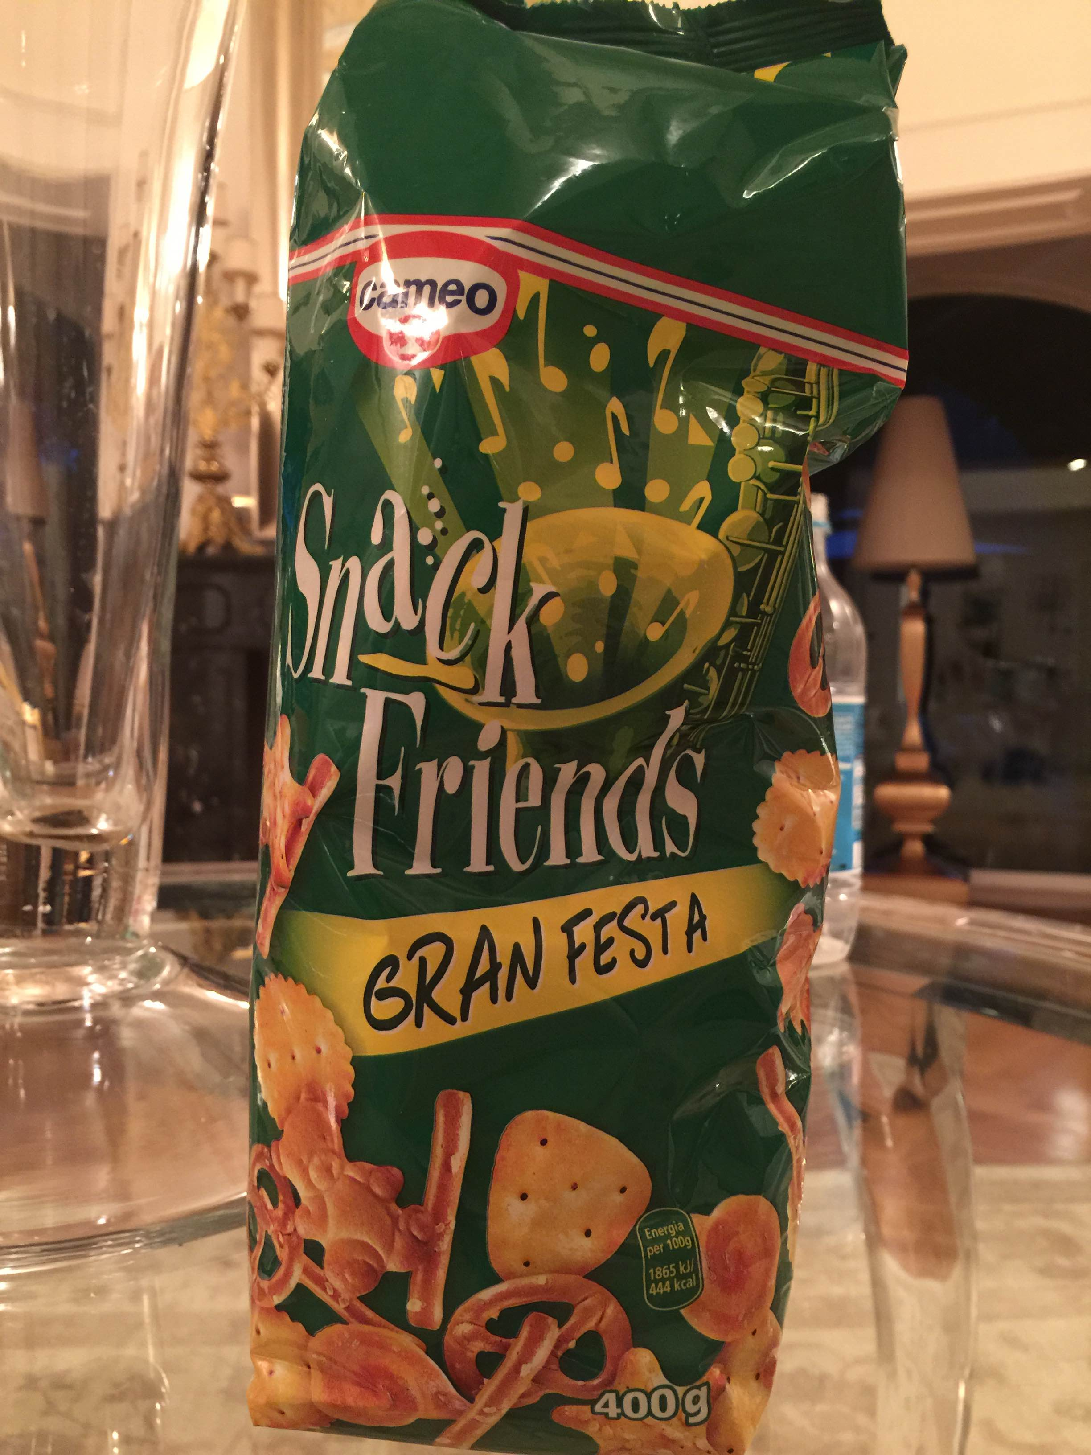
2)-Cameo is an italian food insustry but they also don't say where they do it;

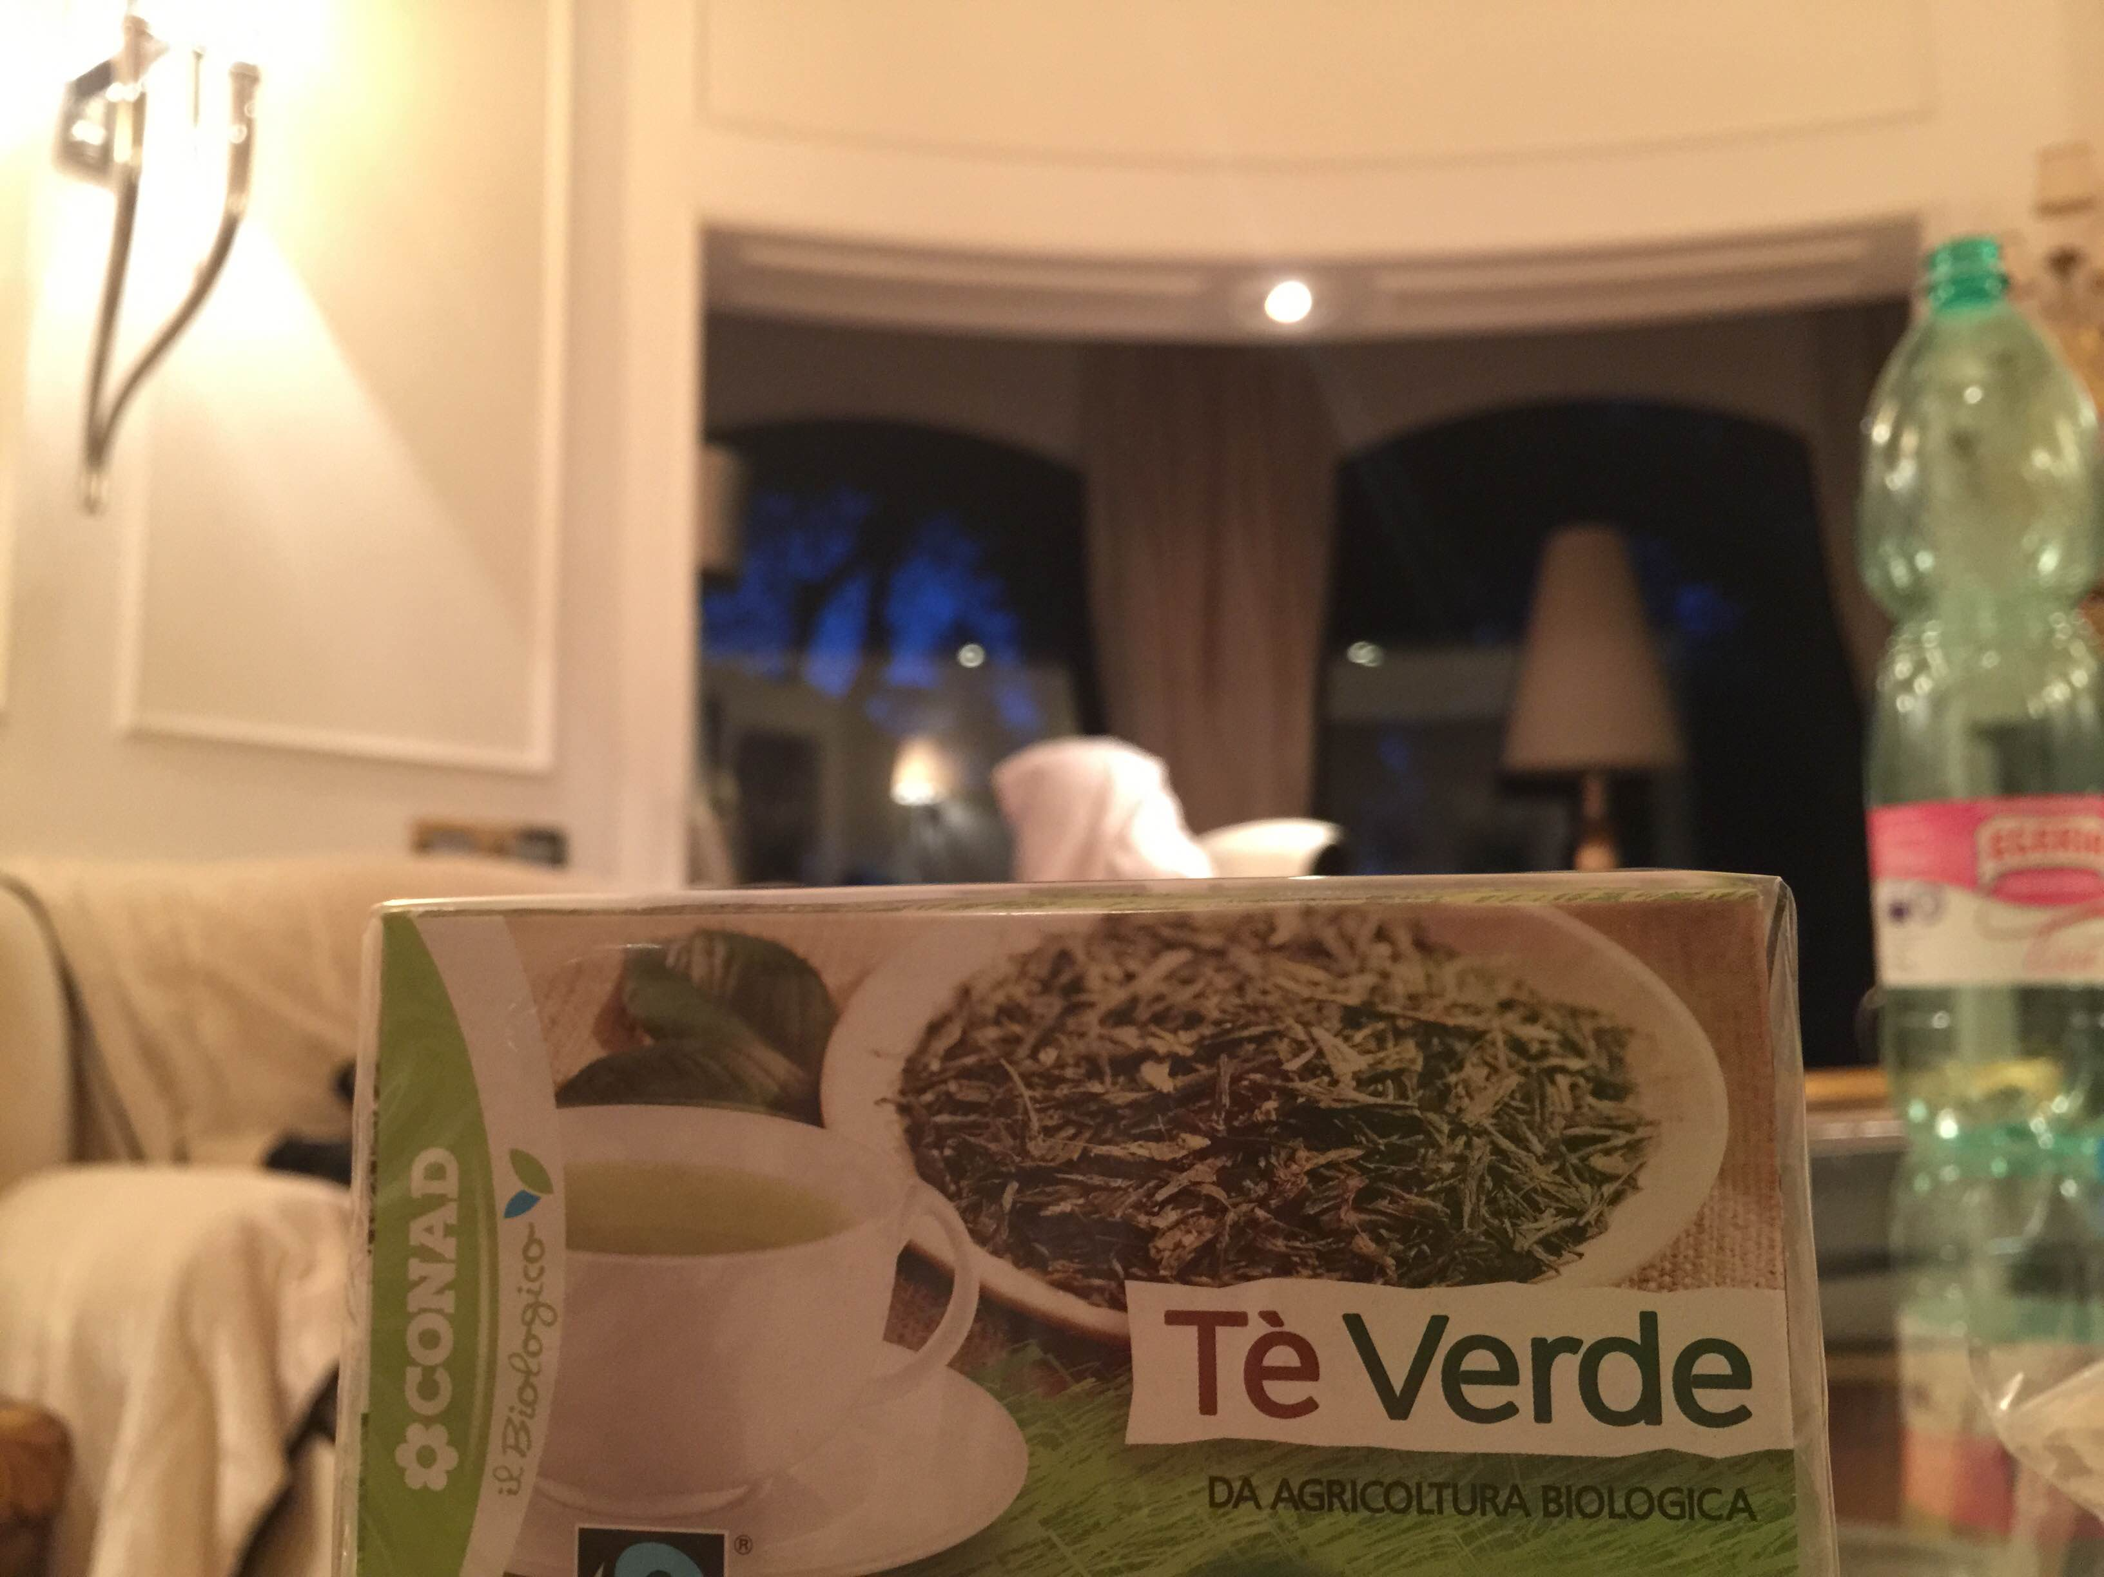
3)This tea is made from conad an Italian supermarket but some of their products are made in India!!! it's amazing!!!;
-are a lot of km from Italy;

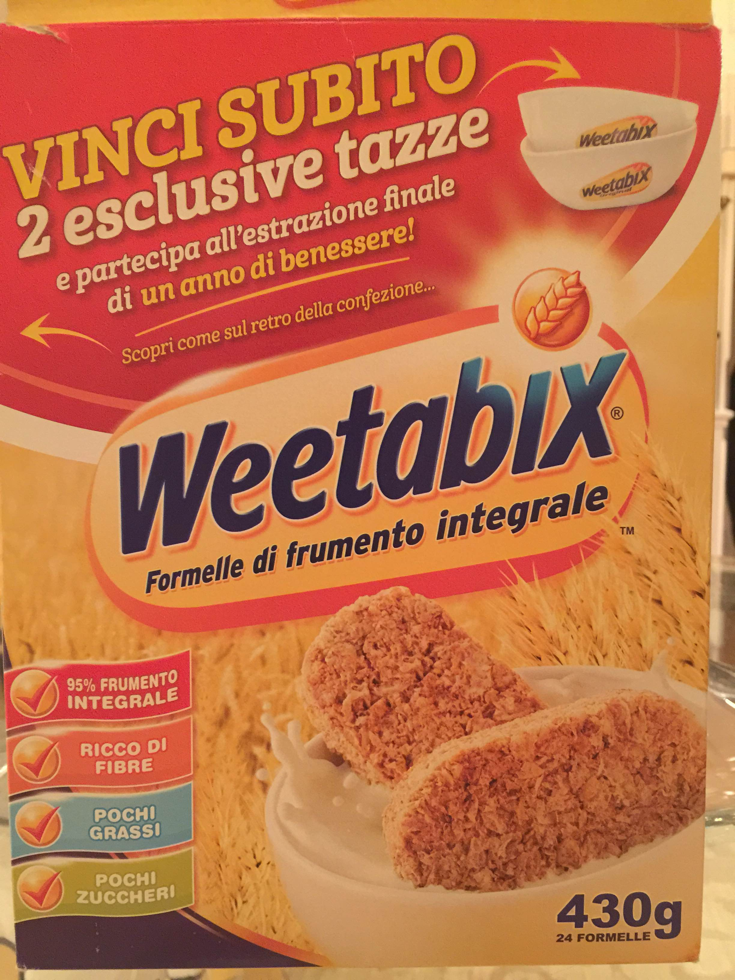
4)-Weetabix are cornflake that are used in the meditarean diet, but they are made in UK;
-It's km 2077,57 from italy

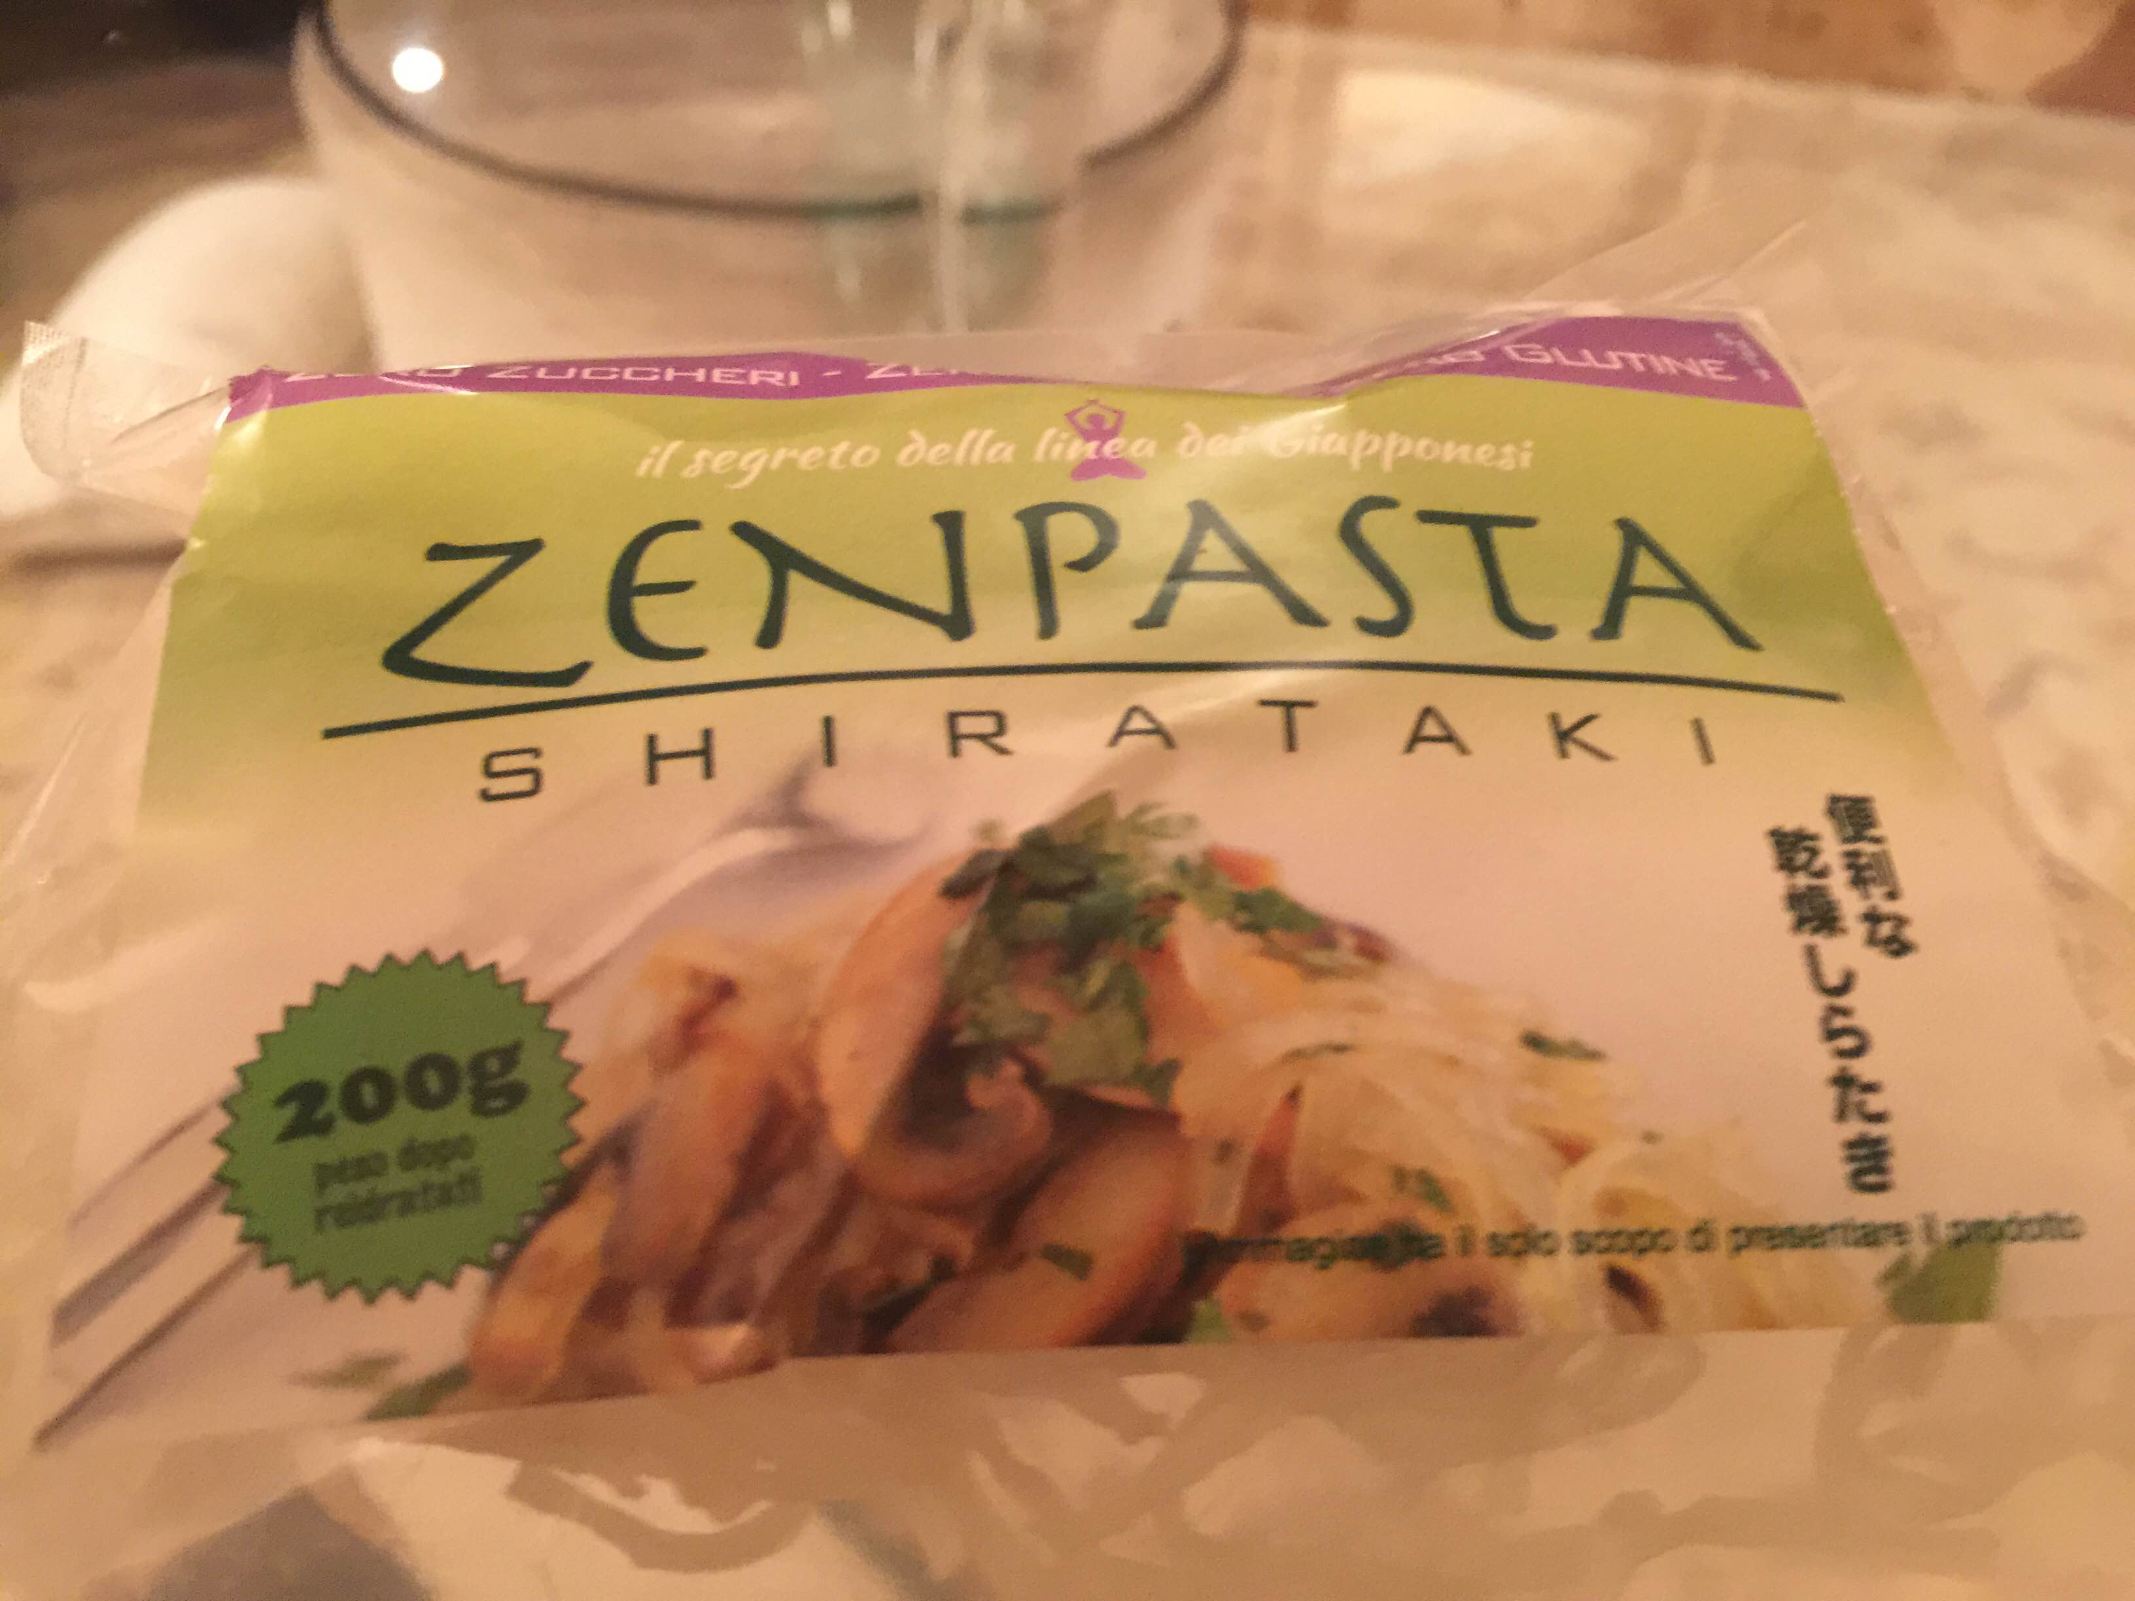
5)I thought that it was pasta, but it isn't, are vegetable with the form of tipical italian pasta (spaghetti), but is made in Japan.
-the etwinning site wasn't functioning;

