Where products come from

I thought they were an Italian product... I were right!
This product is from Italy, so it doesn't create a lot of CO2 and carbon.
Due to the origin source (Italy) I think I won't stop buying this product!
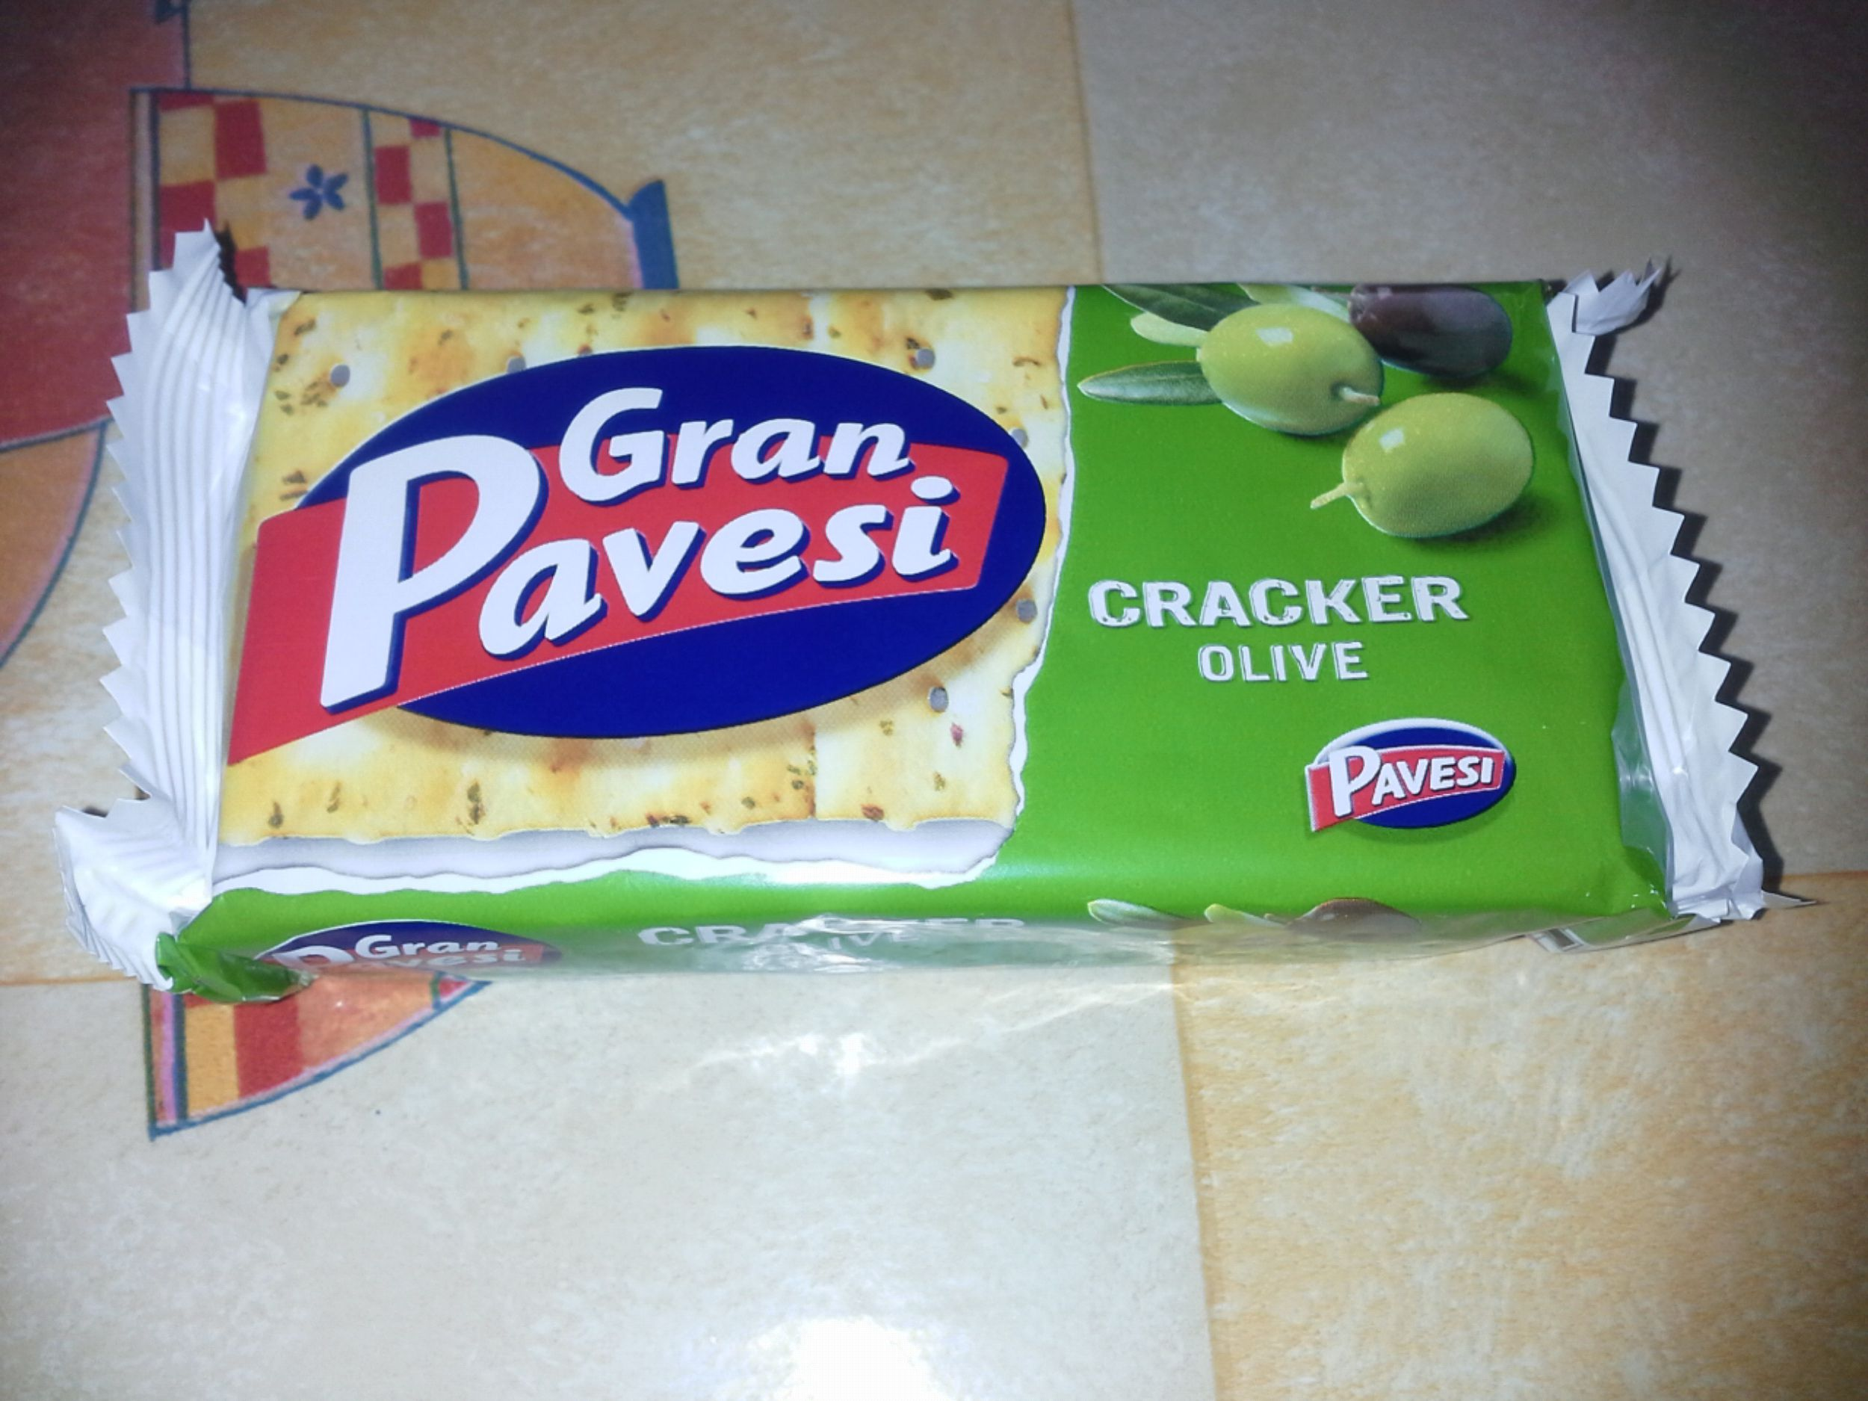

I was sure this product was Italian and I was right!
This product comes from my country, so it doesn't pollute!
I think I'm going to continue buying this product.
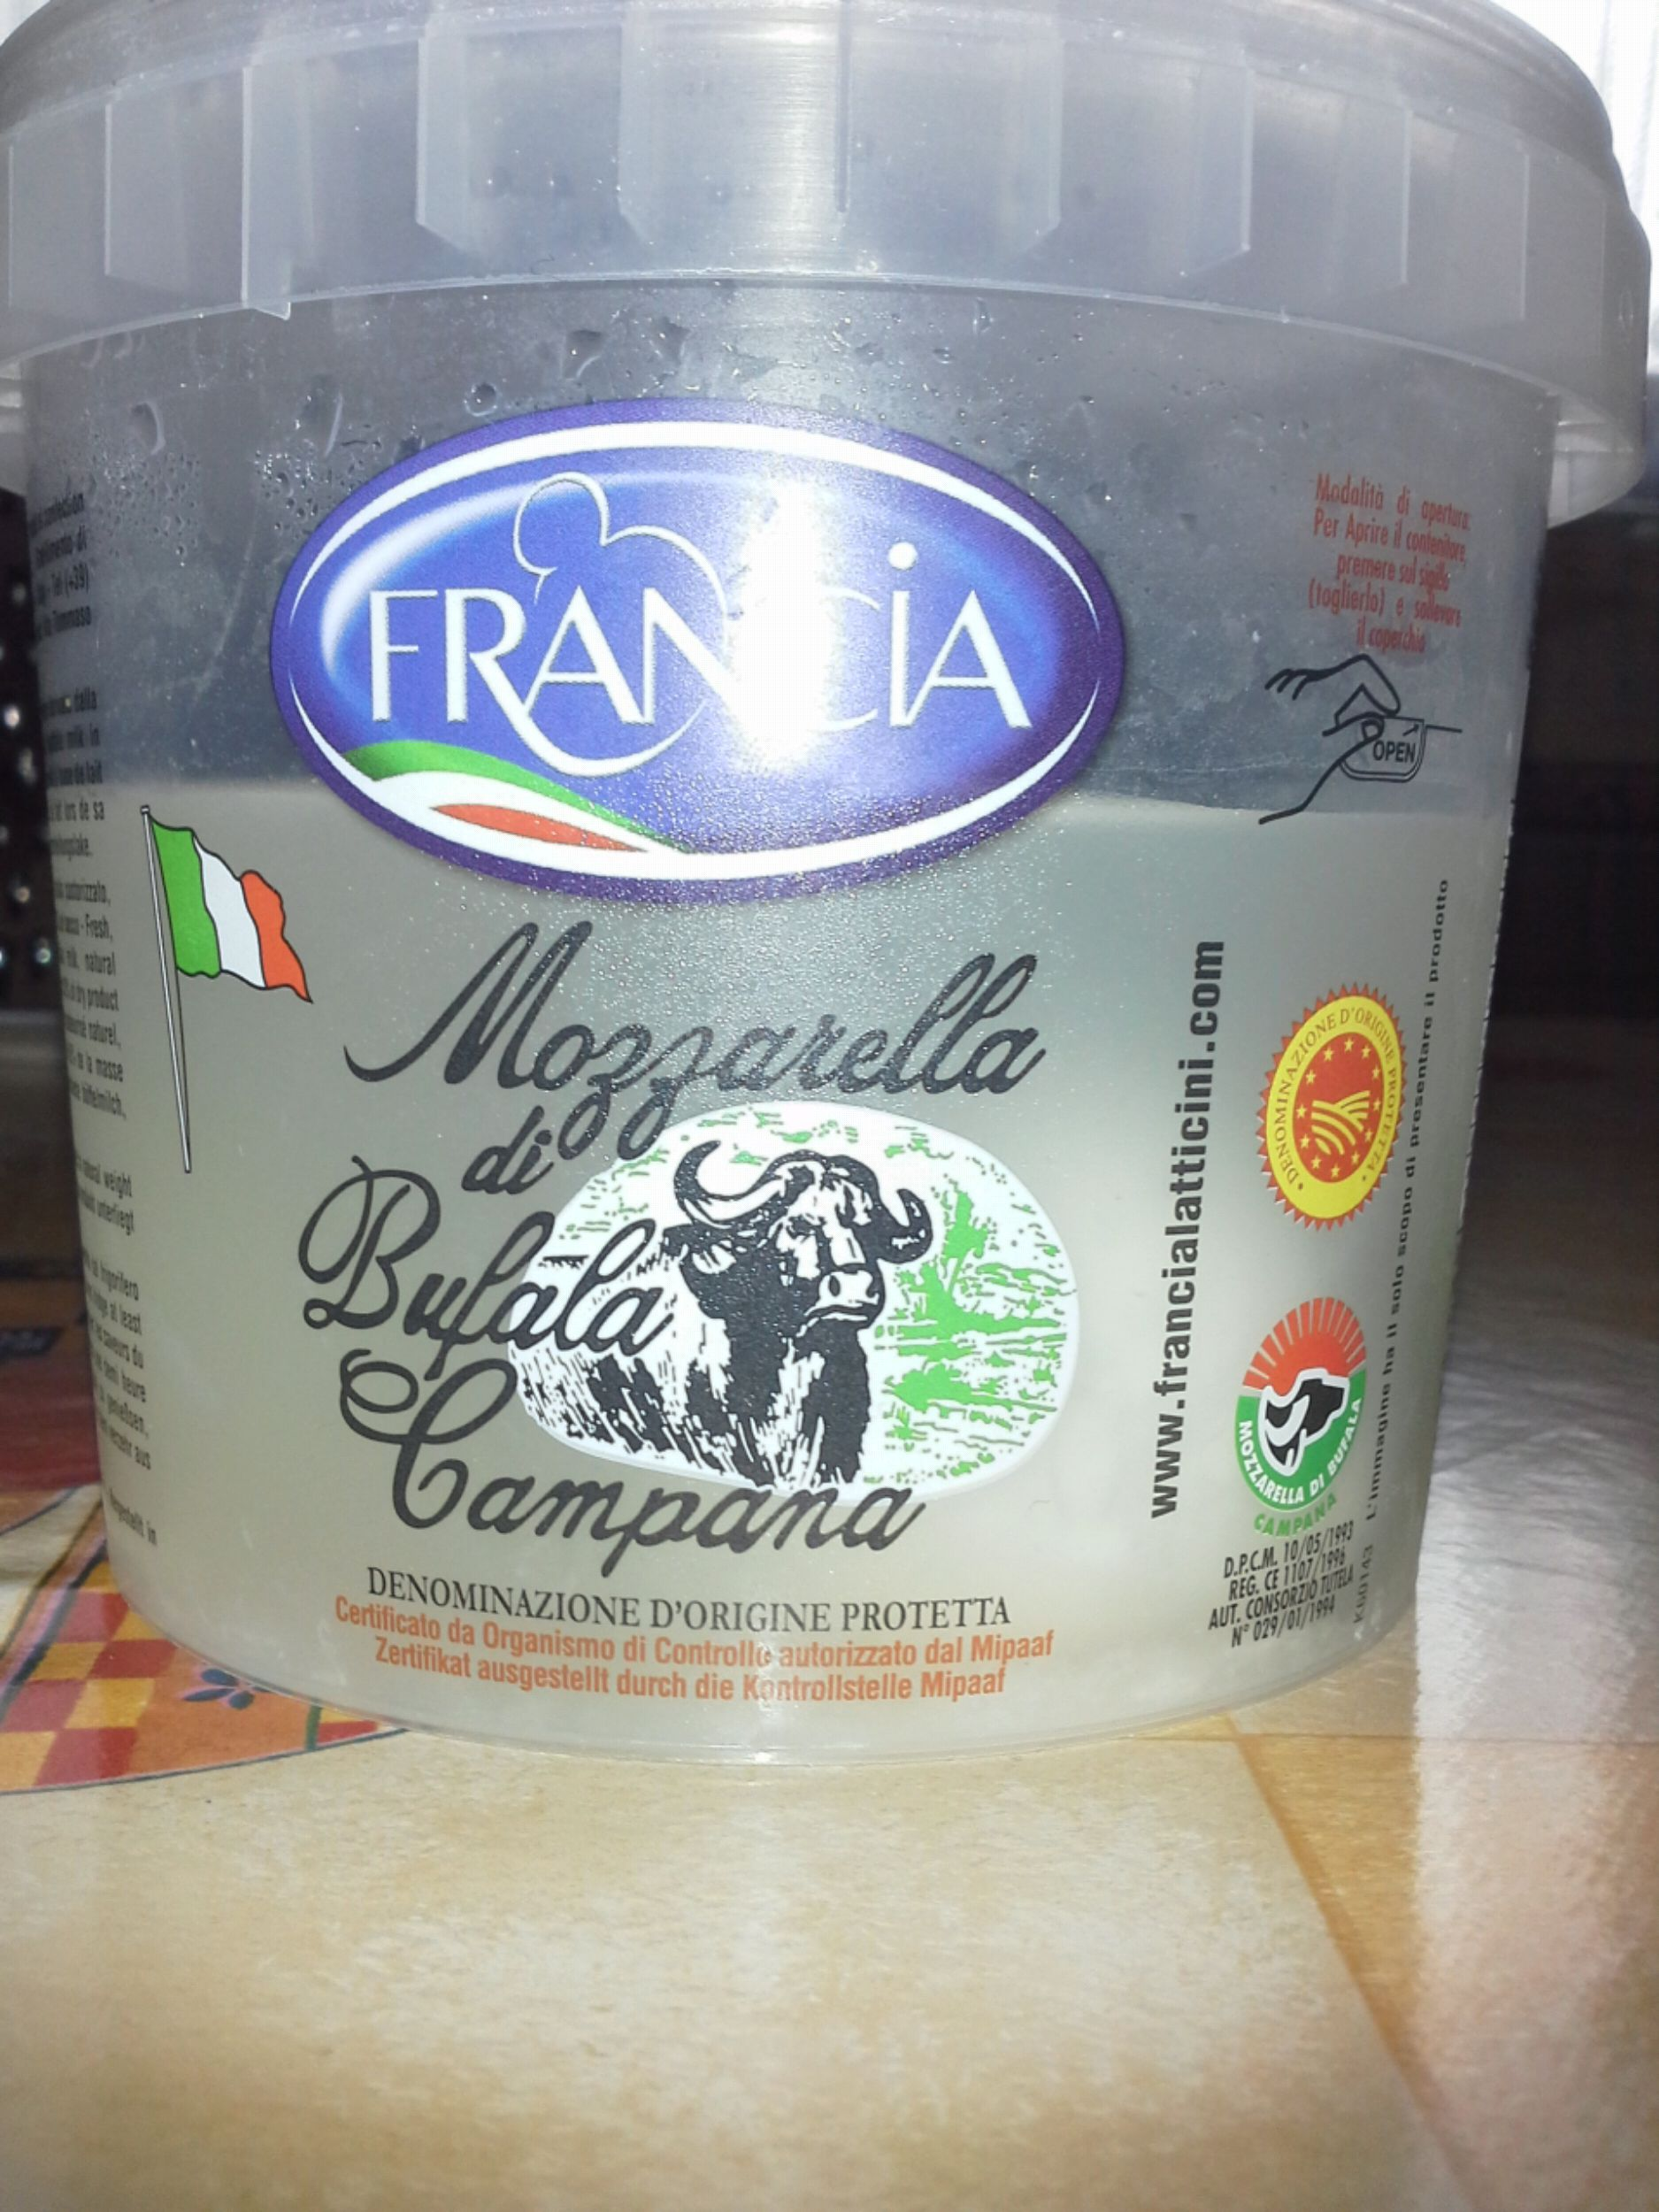
I thought this product was from Scandinavia, but I was wrong: it's from Germany!
This product travels 1182 km to arrive in my country!
If this distance was covered by an aeroplane it would create approximately 265 kg CON or 72 kg carbon
If this distance was covered by a car that would create approximately 213 kg CON or 58 kg carbon
If this distance was covered by a train that would create approximately 73 kg CON or 20 kg carbon
I don't think I'll buy this jam any more!

I thought this product was from Italy: I was right!
This product is Italian so it doesn't create lot of CO2 or carbon!
I'll continue buying this product!
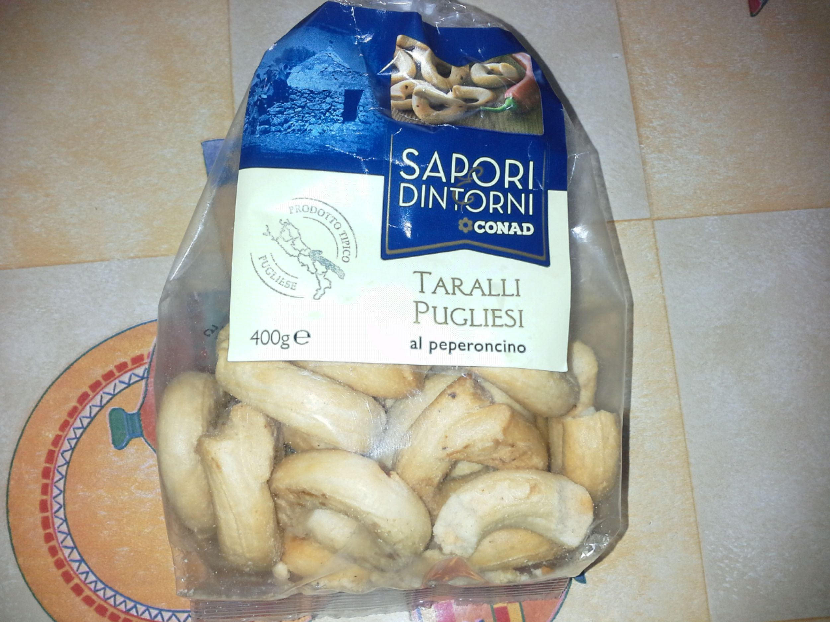
I thought that this product was Italian and I was right!
This product is made in Italy so it doesn't pollute a lot to arrive in my city!
I'm sure I'll buy this biscuits again!

