European Cultural Heritage Year 2018 QR Code Quiz

Download a QR Code scanner (e.g. https://www.scan.me/) on your Smartphone and start this quiz by scanning the QR codes. Use your Smartphone to find the answers online and then write down your answers down here:

Answer to QR code question 1:
Answer to QR code question 2:
Answer to QR code question 3:
Answer to QR code question 4:
Answer to QR code question 5:
Answer to QR code question 6:
Answer to QR code question 7:
Answer to QR code question 8:
Answer to QR code question 9:
Answer to QR code question 10:
Answer to QR code question 12:
Answer to QR code question 13:

QR code question 1:

QR code question 2:

QR code question 3:

QR code question 4:

QR code question 5:

QR code question 6:

QR code question 7:

QR code question 8:

QR code question 9:

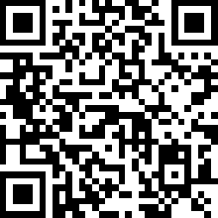

QR code question 10:

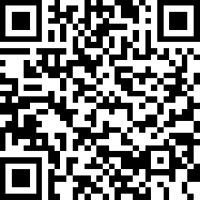

QR code question 11:

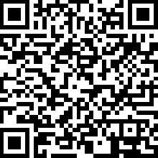

QR code question 12:

QR code question 13:

